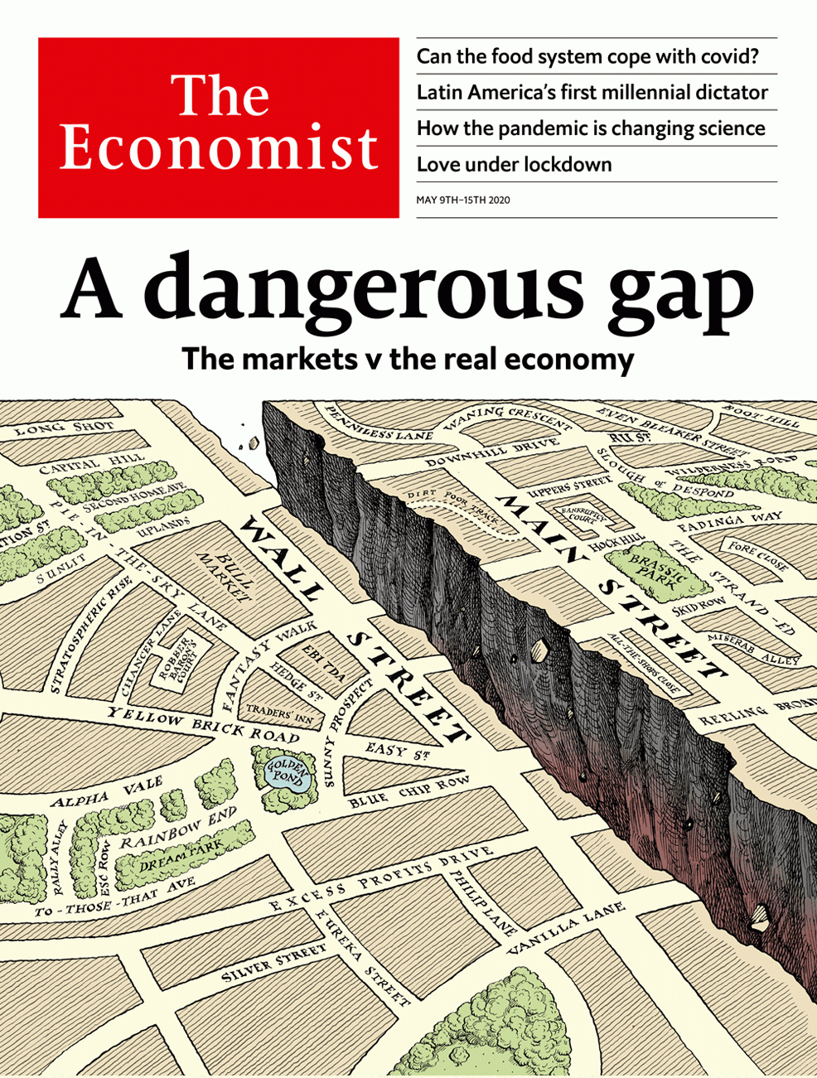

# Table of Contents

The world this week

Politics this week

Business this week

KAL’s cartoon

Leaders

The market v the real economy: A dangerous gap

Supply chains and the pandemic: The food miracle

El Salvador: My tweet is your command

America and China: The new scold war

Scientific publishing: High-speed science

Letters

Letters to the editor: On children, Mozambique, lockdowns, tracking covid, Japan, Labour, liberty

By Invitation

The world after covid-19: Margaret MacMillan on a turning point in history

Briefing

Food security: The tables not yet turned

United States

America v China: Superpowered insults

Measuring inequality: How the 0.1% did

Trumpian governance: Watchdogs in the doghouse

Steve King under pressure: The ninth inning

The electoral college: Going rogue

Education and society: The social experiment

Lexington: What’s in store

The Americas

El Salvador: The rise of the house of Bukele

A battered brand: The synonymous crown affair

Bello: The long wait

Asia

Developing countries and covid-19: Bargain abatement

Politics in Kazakhstan: Bye-bye Nazarbayeva

Press freedom in the Philippines: Blank screen

Afghanistan and covid-19: Gunmen with thermometers

Thailand’s armed forces: In the doghouse

Sunbathing in Indonesia: Hot spot

Banyan: Lockdown lock-up

China

Social security: Socialism’s precariat

Christianity: Heaven’s outposts

Middle East & Africa

Lebanon: From crisis to crisis

Solar power: Rays of hope

Africa’s data deficit: Start counting

Benin: Voodoo v virus

Hemp in Africa: Pot of gold

Europe

European law: Seeing red

Russia: Journalists are revolting

Care-home covid deaths: Getting to the truth

Italy: Caffè to go

Turkey: Istanbully

Charlemagne: All Europe’s a stage

Britain

Offices: The shape of things to come

First orders: The return of fun

Scientists and politics: Of white coats and grey suits

Tracing: App exceptionalism

The politics of lockdown: Climbing the walls

Vulnerable children: A different danger

Newspapers: Stunt men

Bagehot: Contra mundum

International

Virtual dating: Fever when you hold me tight

Domestic abuse: No safe haven

Special report

International banking: Parallel universe

Global banks: Credit clout

International currencies: Redback on track

Payment systems: Piping up

After covid-19: The dark side

Business

The business of health: Prognosis: mixed

Drugmakers: Convalescent

Big business in France: Reargardère action

Disney: Cruising for a bruising

Office culture: The presenteeism premium

Bartleby: Don’t stand so close to me

Schumpeter: The mavericks of oil

Airlines: Eyeing the sky

Finance & economics

Credit-rating agencies: Markers marked

Commodities: Custom of the country

The stockmarket rally: Uppers and downers

Emerging markets: QE too

Finance in India: Bright spot

Gig workers unite: All worked up

Free exchange: Unprofitable arguments

Schools brief

Humans and the carbon cycle: Where nature ends

Science & technology

How covid-19 is changing science: Reaping from the whirlwind

Covid-19’s many faces: The body snatcher

Treating covid-19: Hope rears its head

Road safety: Touchy drivers

Crewed space flight: A new Moon race

Books & arts

Cinema in America: After the intermission

John Maynard Keynes: Alive in the long run

Historical fiction: A kind of freedom

The Troubles: Ghost town

The hereafter: A place on Earth

Home Entertainment: The comforts of suburbia

Home Entertainment: Bake your way through the lockdown

Economic & financial indicators

Economic data, commodities and markets

Graphic detail

Covid-19 and politics: Following the leader

Obituary

Willie Levi: A midwestern parable



### Friday, May 8, 2020

|  |  |
| --- | --- |
| The world this week | 3 |
| Leaders | 5 |
| Letters | 1 |
| By Invitation | 1 |
| Briefing | 1 |
| United States | 7 |
| The Americas | 3 |
| Asia | 7 |
| China | 2 |
| Middle East & Africa | 5 |
| Europe | 6 |
| Britain | 8 |
| International | 2 |
| Special report | 6 |
| Business | 8 |
| Finance & economics | 7 |
| Schools brief | 1 |
| Science & technology | 5 |
| Books & arts | 7 |
| Economic & financial indicators | 1 |
| Graphic detail | 1 |
| Obituary | 1 |

|  |  |  |
| --- | --- | --- |
|  | Sections | Leaders |

The world this week

Politics this week

.

Business this week

.

KAL’s cartoon

.

|  |  |  |
| --- | --- | --- |
|  | Sections | Leaders |

|  |  |  |  |
| --- | --- | --- | --- |
|  | Articles | Sections | Next |

# Politics this week

May 9th 2020 |

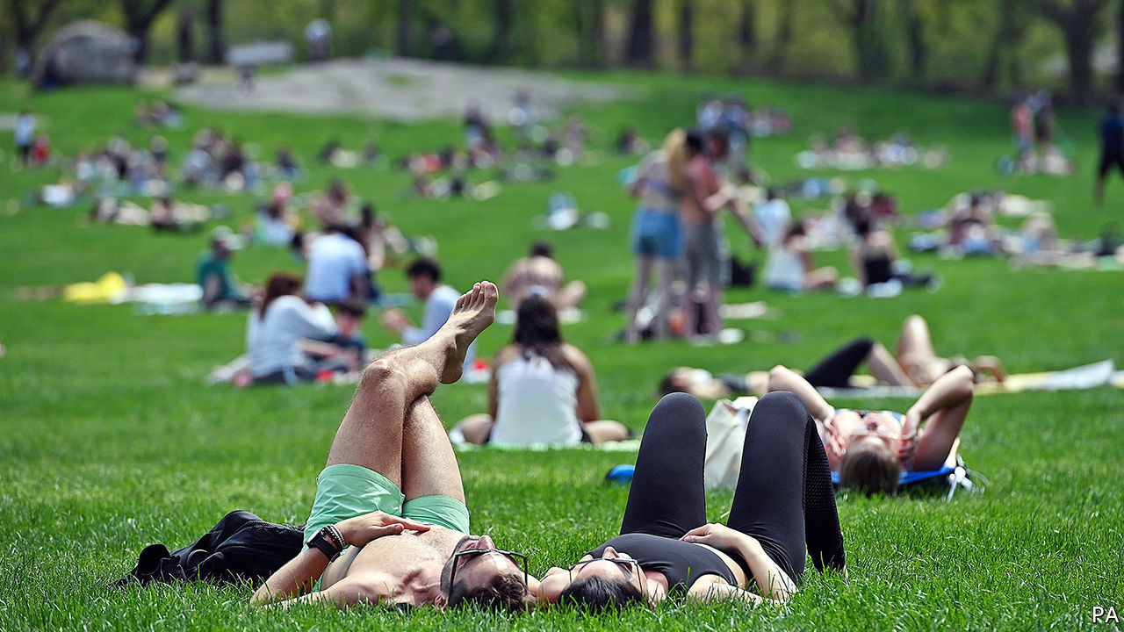

Reversing course, Donald Trump said that America’s coronavirus task-force would continue, but also focus on rebooting the economy. More states began easing their lockdowns. Florida allowed shops to trade if they limit customers, except in the heavily populated corridor between Miami and Palm Beach. In Michigan, the scene of rowdy anti-lockdown protests, the Republican legislature refused a request from the Democratic governor to extend her stay-at-home order. She extended it anyway.

America’s Supreme Court worked remotely for the first time, hearing arguments via teleconferences. The normally reticent Clarence Thomas, a justice on the court since 1991, asked questions, only his third comments during hearings in more than a decade. Ruth Bader Ginsburg, who is 87, was in hospital with an infection and took part from there.

America’s secretary of state, Mike Pompeo, said there was “enormous evidence” that covid-19 came from a laboratory in Wuhan, but did not provide any. China reacted angrily. State television called him “evil”. See article.

A Chinese journalist who had worked for state media was sentenced to 15 years in prison for “picking quarrels and provoking trouble…and bribery”. “Picking quarrels” is a term often used by the government to describe political dissent.

Kim Jong Un, North Korea’s dictator, resurfaced without explanation after a three-week absence. State media published images of him touring a fertiliser factory.

A regulator in the Philippines ordered ABS-CBN, a big television network, to stop broadcasting after its licence expired. Rodrigo Duterte, the president, had previously complained about bias and had threatened to take it off the air. But officials insist that Mr Duterte has no strong feelings about renewing the licence. See article.

Dariga Nazarbayeva was removed as the head of Kazakhstan’s Senate and thus as the first in line to the presidency. Her father, Nursultan Nazarbayev, resigned as president in 2019, but remains head of a powerful committee in charge of national security. The personal lives and financial affairs of Ms Nazarbayeva and her sons have been the subject of legal proceedings in London in recent months. See article.

Israel’s Supreme Court refused to block a power-sharing deal between Binyamin Netanyahu, the prime minister, and Benny Gantz, his old rival. It also rejected petitions that aimed to disqualify Mr Netanyahu because he faces prosecution on corruption charges. The rulings pave the way for a new government to be sworn in.

Iraq’s parliament approved a new prime minister, nearly six months after the previous one resigned amid big protests. Mustafa al-Kadhimi, a former intelligence chief, was acceptable to both America and Iran. But he faces big challenges at home, where the coronavirus has frozen the economy and oil and gas revenues have plummeted. Earlier, Islamic State carried out several attacks in Iraq, killing at least 18 people.

The government in cash-strapped Lebanon adopted an economic-reform plan and requested assistance from the IMF. This came after protesters, defying a coronavirus lockdown, took to the streets to vent their anger over a deteriorating economy and poor governance. See article.

A leaked letter from Zimbabwe to the IMF warned that the country is heading towards economic collapse and that it needs assistance in clearing its existing debts to unlock new funding. The letter said Zimbabwe’s economy could shrink by 15-20% this year.

In a decision with potentially huge implications Germany’s constitutional court declared that the European Central Bank had acted improperly in buying government bonds under a quantitative-easing programme. Many legal experts fear that because the ECB is supposed to answer only to EU institutions, not to member governments, a constitutional crisis is being created. See article.

Italy partly emerged from eight weeks of lockdown, having been the first country in Europe to impose one. People can now go out to exercise, cafés have reopened for takeaway service and travel to visit close relatives is now permitted. See article.

Canada banned assault-style weapons with immediate effect following a gun massacre in April.

Venezuelan forces intercepted two boatloads of men allegedly trying to overthrow the country’s dictator, Nicolás Maduro. Eight of the men were killed. Mr Maduro accused America and Colombia of plotting the attack. As evidence, a captive was paraded, post-interrogation, on television. Meanwhile, a security contractor based in Florida claimed responsibility for the “daring amphibious raid”. The governments of America and Colombia denied any involvement.

The new chief of Brazil’s Federal Police, Rolando Souza, transferred the head of the force in Rio de Janeiro. Mr Souza became police chief after the Supreme Court blocked the man initially chosen by Jair Bolsonaro, the Brazilian president, who is a friend of the president’s family. Mr Bolsonaro is facing claims that he tried to influence investigations, centred on Rio, into his family, which he denies. Coronavirus briefs

## Coronavirus briefs

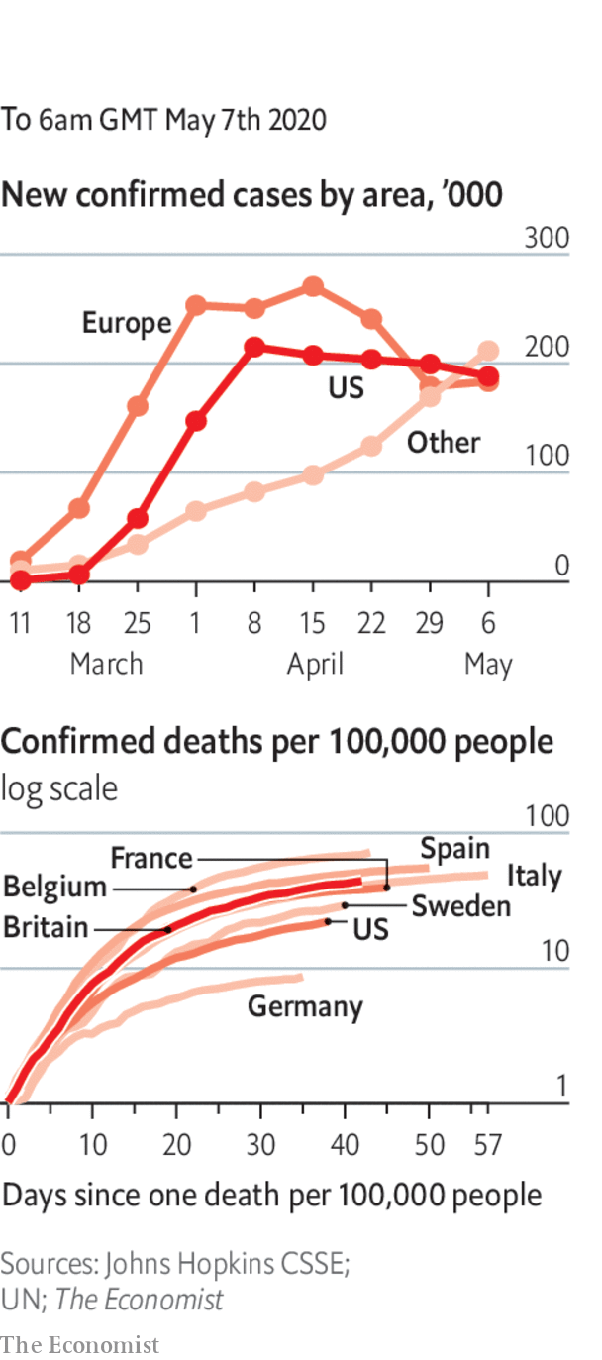

The worldwide death toll from covid-19 rose above 250,000.

Infections surged in Russia, to over 10,000 a day. Mikhail Mishustin, the prime minister, tested positive for the disease.

The first infection was officially confirmed in Sana’a, Yemen’s capital, which is held by Houthi rebels.

Reports from Nigeria, Somalia and Tanzania of a sharp rise in unexplained deaths suggested that official tallies of covid-19 are misleadingly low. See article.

New Zealand’s prime minister, Jacinda Ardern, said border restrictions would remain for “some time to come”. But she would like a quarantine-free travel “bubble” with Australia.

In Germany shops were allowed to reopen, with social distancing. Football matches will resume in the Bundesliga, but without spectators.

This article was downloaded by calibre from <https://www.economist.com/the-world-this-week/2020/05/09/politics-this-week>

|  |  |  |  |
| --- | --- | --- | --- |
|  | Articles | Sections | Next |

|  |  |  |  |
| --- | --- | --- | --- |
| Previous | Articles | Sections | Next |

# Business this week

May 9th 2020 |

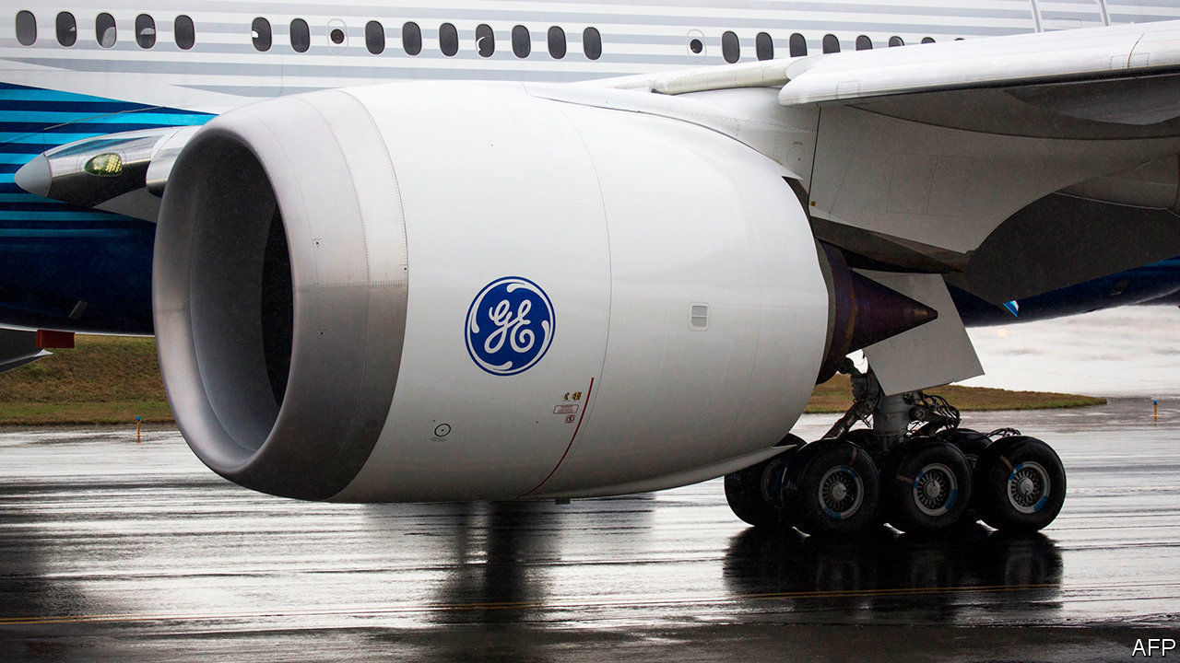

More swingeing job cuts were announced in the aviation business, an industry that has been hammered by the restrictions on travel. General Electric said 13,000 jobs would go in its aviation division; Rolls-Royce, which makes engines for Boeing and Airbus, was reportedly considering 8,000 lay-offs; Virgin Atlantic announced plans to reduce its workforce by a third and close its operations at London Gatwick; and Ryanair said it would reduce its headcount by 15%. Michael O’Leary, Ryanair’s abrasive boss, criticised the recent government rescues of Air France-KLM and other carriers as “state-aid doping” for weak airlines.

## Bailing out

Adding to the gloom, Warren Buffett’s investment company dumped the stock it held in America’s four biggest airlines. Berkshire Hathaway recorded an almost $50bn net loss in the first quarter, as its portfolio of shares took a pounding during the stockmarket rout.

Boeing, meanwhile, successfully closed a $25bn bond offering. Because of the “robust demand” in markets for its debt, the aerospace company does not anticipate having to turn to the government for aid. It is cutting 10% of its workforce and curbing production.

Alan Joyce, the chief executive of Qantas, said that it will take years for international travel to recover from the crisis. The Australian airline has shelved plans for non-stop flights from Australia to New York and London that were due to begin in 2022.

Airbnb forecast a 50% slump in annual revenue and said it would cut its workforce by a quarter. The online home-rental firm thinks coronavirus will forever change its market because people will want to travel to places that are closer to home and relatively safe. Airbnb had been expected to float its shares on the stockmarket this year.

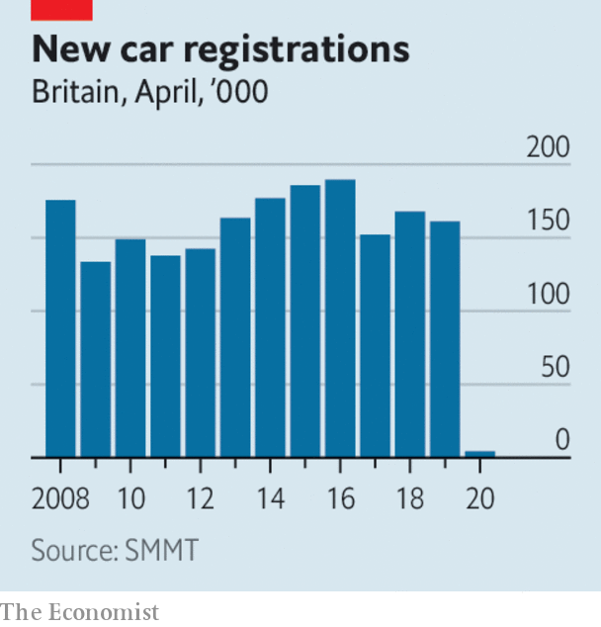

Just 4,321 new cars were registered in Britain last month, a drop of 97% compared with April 2019, according to the Society of Motor Manufacturers and Traders. The Italian and Spanish markets saw similar declines; in Germany registrations were down by 61% and in France sales fell by 89%. That stands in stark contrast to China, where, according to a Volkswagen official, the car market has rebounded.

Hertz was granted a reprieve from bankruptcy when a group of creditors extended the deadline for a missed debt payment. The car-rental company has seen its business collapse as airports shut shop.

America’s Treasury Department said it would auction a new 20-year bond on May 20th. It expects to borrow almost $3trn of debt in the second quarter, a record that far exceeds its quarterly borrowing requirements during the financial crisis of 2007-09.

China recorded a surprising increase in exports, which grew by 3.5% in April compared with the same month in 2019, the first rise this year.

Marathon, America’s biggest oil refiner, posted a $9.2bn quarterly loss, because of the pandemic and price “tensions”. Oil markets remained choppy. The price of Brent crude rose above $30 a barrel for the first time in weeks. See article.

In the most aggressive action it has taken so far to enforce regulations in the state that bolster the rights of workers in the gig economy, California filed a lawsuit against Uber and Lyft for misclassifying their drivers as independent contractors. Uber, which is helping its drivers find extra work at 7-Eleven and other companies during the crisis, said it would contest the suit in court. See article.

Lee Jae-yong, the de facto head of Samsung Group, apologised for the various corruption scandals that have beset his company. In a remarkable statement, Mr Lee, who was convicted of bribery in 2017, pledged that he would be the last person from his family to lead the conglomerate. He also overturned a decades-long policy at Samsung that stops workers joining a union.

Telefónica, Spain’s biggest telecoms company, announced the merger of its o2 mobile brand in Britain with Virgin Media, a broadband and wireless provider that is owned by Liberty Global. The £31bn ($38bn) deal creates a behemoth in Britain’s telecommunications industry.

Peloton, which sells expensive internet-connected bikes, recorded a surge in sales in the latest quarter, as it doubled the number of subscribers to its workouts. With many people forced to exercise at home during lockdowns, the company is expanding its customer base beyond svelte hipsters to suburban mums and dads.

## The windmills of his mind

Tesla’s share price recovered from the drubbing it took after Elon Musk tweeted that it was too high, which wiped $15bn off the company’s market value. Soon after, Mr Musk, a critic of lockdowns, tweeted another abstract thought: “Rage, rage against the dying of the light of consciousness.”

This article was downloaded by calibre from <https://www.economist.com/the-world-this-week/2020/05/09/business-this-week>

|  |  |  |  |
| --- | --- | --- | --- |
| Previous | Articles | Sections | Next |

|  |  |  |  |
| --- | --- | --- | --- |
| Previous | Articles | Sections | Next |

# KAL’s cartoon

May 9th 2020 |

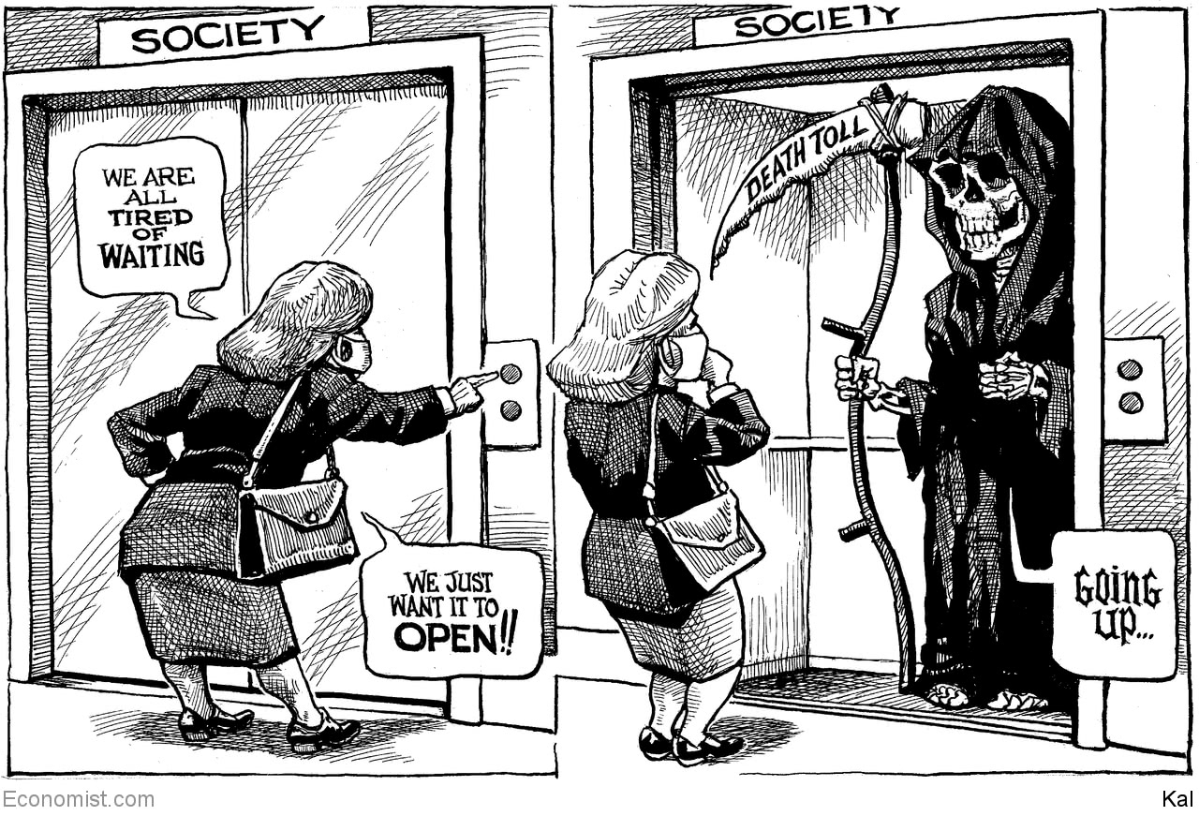

This article was downloaded by calibre from <https://www.economist.com/the-world-this-week/2020/05/09/kals-cartoon>

|  |  |  |  |
| --- | --- | --- | --- |
| Previous | Articles | Sections | Next |

|  |  |  |
| --- | --- | --- |
| The world this week | Sections | Letters |

Leaders

The market v the real economy: A dangerous gap

.

Supply chains and the pandemic: The food miracle

.

El Salvador: My tweet is your command

.

America and China: The new scold war

.

Scientific publishing: High-speed science

.

|  |  |  |
| --- | --- | --- |
| The world this week | Sections | Letters |

|  |  |  |  |
| --- | --- | --- | --- |
|  | Articles | Sections | Next |

#### A dangerous gap

# The market v the real economy

Financial markets have got out of whack with the economy. Something has to give

May 7th 2020 |

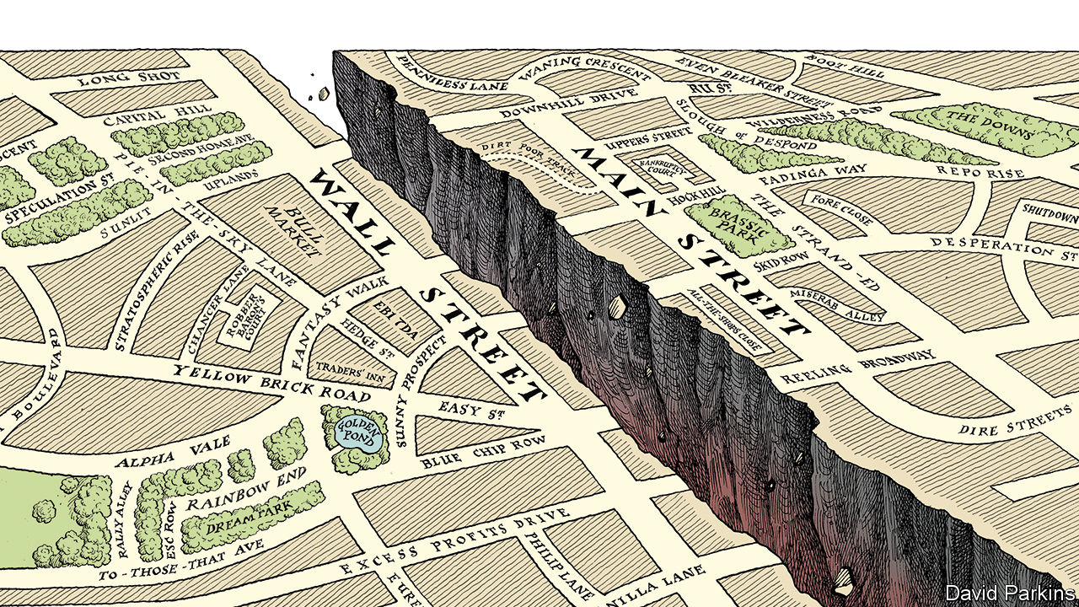

Editor’s note: The Economist is making some of its most important coverage of the covid-19 pandemic freely available to readers of The Economist Today, our daily newsletter. To receive it, register [here](https://www.economist.com/newslettersignup). For our coronavirus tracker and more coverage, see our [hub](https://www.economist.com/coronavirus)

STOCKMARKET HISTORY is packed with drama: the 1929 crash; Black Monday in 1987, when share prices lost 20% in a day; the dotcom mania in 1999. With such precedents, nothing should come as a surprise, but the past eight weeks have been remarkable, nonetheless. A gut-wrenching sell-off in shares has been followed by a delirious rally in America. Between February 19th and March 23rd, the S&P 500 index lost a third of its value. With barely a pause it has since rocketed, recovering more than half its loss. The catalyst was news that the Federal Reserve would buy corporate bonds, helping big firms finance their debts. Investors shifted from panic to optimism without missing a beat.

This rosy view from Wall Street should make you uneasy (see article). It contrasts with markets elsewhere. Shares in Britain and continental Europe, for example, have recovered more sluggishly. And it is a world away from life on Main Street. Even as the lockdown eases in America, the blow to jobs has been savage, with unemployment rising from 4% to about 16%, the highest rate since records began in 1948. While big firms’ shares soar and they get help from the Fed, small businesses are struggling to get cash from Uncle Sam.

Wounds from the financial crisis of 2007-09 are being reopened. “This is the second time we’ve bailed their asses out,” grumbled Joe Biden, the Democratic presidential candidate, last month. The battle over who pays for the fiscal burdens of the pandemic is just beginning. On the present trajectory, a backlash against big business is likely.

Start with events in the markets. Much of the improved mood is because of the Fed, which has acted more dramatically than other central banks, buying up assets on an unimagined scale. It is committed to purchasing even more corporate debt, including high-yield “junk” bonds. The market for new issues of corporate bonds, which froze in February, has reopened in spectacular style. Companies have issued $560bn of bonds in the past six weeks, double the normal level. Even beached cruise-line firms have been able to raise cash, albeit at a high price. A cascade of bankruptcies at big firms has been forestalled. The central bank has, in effect, backstopped the cashflow of America Inc. The stockmarket has taken the hint and climbed.

The Fed has little choice—a run on the corporate-bond market would worsen a deep recession. Investors have cheered it on by piling into shares. They have nowhere else good to put their cash. Government-bond yields are barely positive in America. They are negative in Japan and much of Europe. You are guaranteed to lose money by holding them to maturity, and if inflation rises the losses would be painful. So stocks are appealing. By late March prices had fallen by enough to tempt the braver sort. They steeled themselves with the observation that much of the stockmarket’s value is tied to profits that will be made long after the covid-19 slump has given way to recovery.

Tellingly, though, the recent rise in share prices has been uneven. Even before the pandemic the market was lopsided, and it has become more so. Bourses in Britain and continental Europe, chock-full of troubled industries like carmaking, banking and energy, have lagged behind, and there are renewed jitters over the single currency (see article). In America investors have put even more faith in a tiny group of tech darlings—Alphabet, Amazon, Apple, Facebook and Microsoft—which now make up a fifth of the S&P 500 index. There is little euphoria, just a despairing reach for the handful of businesses judged to be all-weather survivors.

At one level, this makes good sense. Asset managers have to put money to work as best they can. But there is something wrong with how fast stock prices have moved and where they have got back to. American shares are now higher than they were in August. This would seem to imply that commerce and the broader economy can get back to business as usual. There are countless threats to such a prospect, but three stand out.

The first is the risk of an aftershock. It is entirely possible that there will be a second wave of infections. And there are also the consequences of a steep recession to contend with—American GDP is expected to drop by about 10% in the second quarter compared with a year earlier. Many individual bosses hope that ruthless cost-cutting can help protect their margins and pay down the debts accumulated through the furlough. But in aggregate this corporate austerity will depress demand. The likely outcome is a 90% economy, running far below normal levels.

A second hazard to reckon with is fraud. Extended booms tend to encourage shifty behaviour, and the expansion before the covid crash was the longest on record. Years of cheap money and financial engineering mean that accounting shenanigans may now be laid bare. Already there have been two notable scandals in Asia in recent weeks, at Luckin Coffee, a Chinese Starbucks wannabe, and Hin Leong, a Singaporean energy trader that has been hiding giant losses (see article). A big fraud or corporate collapse in America could rock the markets’ confidence, much as the demise of Enron shredded investors’ nerves in 2001 and Lehman Brothers led the stockmarket down in 2008.

The most overlooked risk is of a political backlash. The slump will hurt smaller firms and leave the bigger corporate survivors in a stronger position, increasing the concentration of some industries that was already a problem before the pandemic. A crisis demands sacrifice and will leave behind a big bill. The clamour for payback will only grow louder if big business has hogged more than its share of the subsidies on offer. It is easy to imagine windfall taxes on bailed-out industries, or a sharp reversal of the steady drop in the statutory federal corporate-tax rate, which fell to 21% in 2017 after President Donald Trump’s tax reforms, from a long-term average of well over 30%. Some Democrats want to limit mergers and stop firms returning cash to their owners.

For now, equity investors judge that the Fed has their back. But the mood of the markets can shift suddenly, as an extraordinary couple of months has proved. A one-month bear market scarcely seems enough time to absorb all the possible bad news from the pandemic and the huge uncertainty it has created. This stockmarket drama has a few more acts yet.■

Dig deeper:  
For our latest coverage of the covid-19 pandemic, register for The Economist Today, our daily [newsletter](https://www.economist.com/newslettersignup), or visit our [coronavirus tracker and story hub](https://www.economist.com/coronavirus)

This article was downloaded by calibre from <https://www.economist.com/leaders/2020/05/07/the-market-v-the-real-economy>

|  |  |  |  |
| --- | --- | --- | --- |
|  | Articles | Sections | Next |

|  |  |  |  |
| --- | --- | --- | --- |
| Previous | Articles | Sections | Next |

#### How to feed the planet

# The global food supply chain is passing a severe test

Keeping the world fed

May 9th 2020 |



Editor’s note: The Economist is making some of its most important coverage of the covid-19 pandemic freely available to readers of The Economist Today, our daily newsletter. To receive it, register [here](https://www.economist.com/newslettersignup). For our coronavirus tracker and more coverage, see our [hub](https://www.economist.com/coronavirus)

IF YOU LIVE in the rich world and want an example of trade and global co-operation, look no further than your dinner plate. As the lockdowns began in the West two months ago, many feared that bread, butter and beans would run short, causing a wave of stocking-up. Today, thanks to fleets of delivery lorries filling supermarket shelves, you can binge-eat as you binge-watch.

This capitalist miracle reflects not a monolithic plan, but an $8trn global supply chain adapting to a new reality, with millions of firms making spontaneous decisions, from switching rice suppliers in Asia to refitting freezers. The system is far from perfect: as incomes collapse, more people are going hungry. There are risks, from labour shortages to bad harvests. And there is an irony in seeing the industry grapple with a crisis that probably began with the sale of pangolin meat in a market in Wuhan. But the food network is so far passing a severe test. It is crucial that, during and after the pandemic, governments do not lurch into a misguided campaign for self-reliance.

The supply chains behind an iPhone, or a car component that criss-crosses the Rio Grande, are wonders of co-ordination. But the unsung star of 21st-century logistics is the global food system (see article). From field to fork, it accounts for 10% of world GDP and employs perhaps 1.5bn people. The global supply of food has nearly tripled since 1970, as the population has doubled to 7.7bn. At the same time, the number of people who have too little to eat has fallen from 36% of the population to 11%, and a bushel of maize or cut of beef costs less today than 50 years ago in real terms. Food exports have grown sixfold over the past 30 years; four-fifths of people live in part on calories produced in another country.

This happens in spite of governments, not because of them. Although their role has declined, they still sometimes fix prices and control distribution. The European Union’s farm tariffs are four times those on its non-farm imports. A dozen or so big exporters, including America, India, Russia and Vietnam, dominate staples such as wheat and rice. Half a dozen trading firms, such as Cargill from Minnesota and COFCO from Beijing, shift food around the world.

Concentration and government intervention, along with the vagaries of the climate and commodity markets, mean that the system is finely tuned and can misfire, with devastating consequences. In 2007-08 bad harvests and higher energy costs pushed up food prices. This led governments to panic about shortages and ban exports, causing more anxiety and even loftier prices. The result was a wave of riots and distress in the emerging world. It was the worst food crisis since the 1970s, when high fertiliser prices and bad weather in America, Canada and Russia caused food production to drop.

Despite the severity of today’s shock, each layer of the system has adapted. The supply of cereals has been maintained, helped by recent harvests and very high stocks. Shipping firms and ports continue to move around food in bulk. The shift from eating out has had dramatic consequences for some companies. McDonald’s sales have dropped by about 70% in Europe. The big retailers have cut their ranges and rewired their distribution. Amazon’s grocery e-commerce capacity has risen by 60%; Walmart has hired 150,000 people. Crucially, most governments have learned the lesson of 2007-08 and avoided protectionism. In terms of calories, only 5% of food exports face restrictions, as against 19% back then. So far this year prices have dropped.

But the test is not over yet. As the industry has globalised, it has grown more concentrated, creating bottlenecks. Covid-19 outbreaks at several American slaughterhouses have cut pork supplies by a quarter—and boosted wild-turkey hunting licences in Indiana by 28%. America and Europe will need over 1m migrant workers from Mexico, north Africa and eastern Europe to bring in the harvest. And as the economy shrinks and incomes collapse, the number of people facing acute food shortages could rise—from 1.7% of the world’s population to 3.4%, the UN reckons, including in some rich countries. This reflects a shortage of money, not food, but if people go hungry governments will, understandably, take extraordinary measures. The ever-present risk is that rising poverty or production glitches will lead panicky politicians to stockpile food and limit exports. As in 2007-08, this could cause a tit-for-tat response that makes things worse.

Governments need to hold their nerve and keep the world’s food system open for business. That means letting produce cross borders, offering visas and health checks to migrant workers, and helping the poor by giving them cash, not stockpiling. It also means guarding against further industry concentration which could grow, if weaker food firms go bust or are bought by bigger ones. And it means making the system more transparent, traceable and accountable—with, for example, certification and quality standards—so that diseases are less likely to jump undetected from animal to human.

To understand food as a national-security issue is wise; to bend that understanding to self-sufficiency drives and blunt intervention is not. Already, before this year, food had become part of a trade war. America has sought to manage its soyabean exports and put tariffs on cheese. President Donald Trump has designated abattoirs part of America’s critical infrastructure. President Emmanuel Macron has called for Europe to build up its “strategic autonomy” in agriculture. Yet food autarky is a delusion. Interdependence and diversity make you more secure.

## Cooking up a new recipe

The work of the food-supply system is not yet done. In the next 30 years supply needs to rise by about 50% to meet the needs of a wealthier, growing population, even as the system’s carbon footprint needs at least to halve. A new productivity revolution is required, involving everything from high-tech greenhouses near cities to fruit-picking robots. That is going to require all the agility and ingenuity that markets can muster, and huge sums of private capital. This evening, when you pick up your chopsticks or your knife and fork, remember both those who are hungry and also the system feeding the world. It should be left free to work its magic not just during the pandemic, but after it, too.■

Dig deeper:  
For our latest coverage of the covid-19 pandemic, register for The Economist Today, our daily [newsletter](https://www.economist.com/newslettersignup), or visit our [coronavirus tracker and story hub](https://www.economist.com/coronavirus)

This article was downloaded by calibre from <https://www.economist.com/leaders/2020/05/09/the-global-food-supply-chain-is-passing-a-severe-test>

|  |  |  |  |
| --- | --- | --- | --- |
| Previous | Articles | Sections | Next |

|  |  |  |  |
| --- | --- | --- | --- |
| Previous | Articles | Sections | Next |

#### My tweet is your command

# Nayib Bukele may want to become Latin America’s first millennial dictator

El Salvador’s young president ignores court orders, bullies lawmakers and brutalises prisoners

May 9th 2020 |

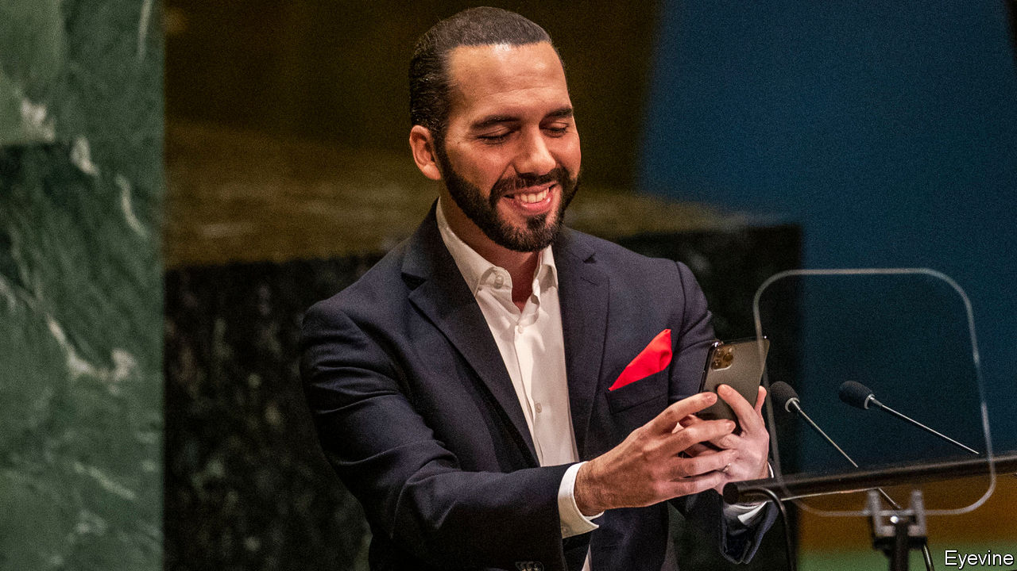

WHEN HE BECAME president of El Salvador last year, Nayib Bukele promised change. A millennial who knows that a selfie is worth 1,000 words, he broke the grip of the two parties that had governed since the end of a civil war in 1992. On their watch El Salvador’s murder rate became the world’s highest and Salvadoreans left the country in droves. Three of the past four presidents have been charged with corruption. “You bastards, return what’s been stolen!” Mr Bukele demanded before the election. He gave his victory speech in jeans and a leather jacket.

But in his 11 months as president he has done more to wreck El Salvador’s democracy than to reform it. In February he entered the Legislative Assembly with soldiers to bully it into financing his crime-fighting programme. With the outbreak of covid-19 his contempt for democratic norms has only grown. Mr Bukele may be on course to become Latin America’s first millennial dictator.

He exemplifies a worrying trend. Until recently democracy seemed established in most of Latin America. The main exceptions were three countries ruled by leftist despots: Cuba, Venezuela and Nicaragua. Now some democracies are wobbling. Honduras’s president, Juan Orlando Hernández, engineered the abolition of a presidential term limit and in 2017 was re-elected in a flawed vote. Protesters in Bolivia forced Evo Morales, another term-limit dodger, out of office (and the country) after he apparently tried to rig his re-election last October. With covid-19 as her alibi the interim president, Jeanine Áñez, is amassing power and seeking to delay an election. Brazil’s populist president, Jair Bolsonaro, eggs on supporters who call for shutting down Congress and the Supreme Court.

Mr Bukele has gone still further (see [article](https://www.economist.com/node/21785985)). He moved fast to contain the spread of covid-19, imposing a national lockdown on March 21st, when the country had just three confirmed cases. In the name of protecting citizens, he has trampled their rights. Police have arrested more than 2,000 people for violating the quarantine rules and confined them for up to 30 days in conditions that make the spread of the disease more likely.

The Supreme Court has ruled that the state cannot detain people without a law to back it up. Mr Bukele has defied it. “Five people are not going to decide the death of hundreds of thousands of Salvadoreans,” he tweeted. Security forces took his orders to enforce his lockdown, issued via Twitter, as lawful commands. (The legislature has now passed a law authorising detentions.)

Mr Bukele lashed out again when murders jumped last month after a long decline. He encouraged police to use “lethal force” on criminals and ordered jailed members of rival gangs to be confined in the same cells. Mr Bukele’s office released pictures of hundreds of near-naked prisoners, packed together closer than battery chickens while their cells were inspected.

So far, Mr Bukele has paid no price for his brutishness. Citizens believe he is trying to protect them. Nearly 80% approve of his handling of the pandemic. In an election due next February, his New Ideas party will probably gain control of the legislature.

How long he plans to hold on to all this power is unclear. Sitting presidents may not run for re-election. Mr Bukele might try to lift that term limit before the election in 2024. Or perhaps one of his relatives, the main powerbrokers in his government, will be on the ballot. Either way, democracy would suffer.

America should rein him in, but will not. Mr Bukele has ingratiated himself with President Donald Trump by agreeing to stop migrants from other countries from heading towards the United States. A pandemic-induced economic slump might erase Mr Bukele’s popularity. But by then it may be hard to get rid of him. Salvadoreans must find ways to check him now. ■

This article was downloaded by calibre from <https://www.economist.com/leaders/2020/05/09/nayib-bukele-may-want-to-become-latin-americas-first-millennial-dictator>

|  |  |  |  |
| --- | --- | --- | --- |
| Previous | Articles | Sections | Next |

|  |  |  |  |
| --- | --- | --- | --- |
| Previous | Articles | Sections | Next |

#### The new scold war

# America v China

A relationship long burdened by rivalry and suspicion has fallen into outright hostility

May 9th 2020 |

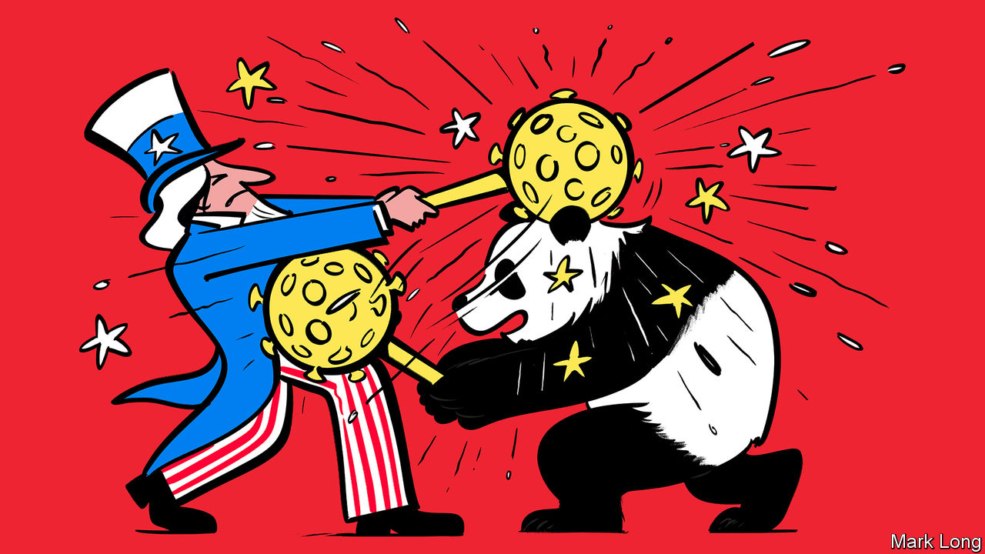

Editor’s note: The Economist is making some of its most important coverage of the covid-19 pandemic freely available to readers of The Economist Today, our daily newsletter. To receive it, register [here](https://www.economist.com/newslettersignup). For our coronavirus tracker and more coverage, see our [hub](https://www.economist.com/coronavirus)

YOU MIGHT have hoped that a pandemic would bring the world together. Instead covid-19 is tearing it apart. As the disease has spread, relations between America and China have plunged into an abyss from which they will struggle to escape.

Mike Pompeo, the secretary of state, says he has “enormous evidence” that the virus behind covid-19 came from a laboratory in Wuhan—though America’s intelligence agencies as well as its closest intelligence partners say proof is still lacking. To punish China for letting the disease spread, the Trump administration has reportedly considered demanding reparations or cancelling some Treasury bonds held by China—though nervous American officials later dismissed this crackpot idea. China has branded Mr Pompeo “insane” and a “political virus” (see article). State-run media are calling for an international investigation into America’s “incredible failure” to deal with the outbreak.

This sniping deepens a bitter rivalry. The dominant view in the United States is that China is fundamentally hostile, a strategic rival that steals American intellectual property and destroys American jobs in the race to get ahead. China, meanwhile, sees America as a decadent and declining power that has resorted to bullying to keep China down because it can no longer compete fairly.

Domestic politics in both countries is likely to intensify the animosity. Now that covid-19 has undone the economic gains that occurred on his watch, President Donald Trump is making confrontation with China central to his re-election strategy including, he hopes, as a way to browbeat his opponent, Joe Biden.

China denies any blame for the pandemic, instead hailing the party’s disease management. At home, propaganda outlets hint that the virus came from America—and are widely believed. Yet America’s complaint that China’s first instinct was to cover up covid-19 is true. Other countries, including Australia, have called for an investigation into the origins of the pandemic. Reuters news agency this week reported on an internal paper prepared for China’s leaders, warning that feelings around the world against their country, led by America, are more intense than at any time since the killings around Tiananmen Square in 1989. China will slap down foreign critics more vigorously than ever.

Tension between two such splenetic powers has consequences. One is the risk of military action. China has occupied and fortified disputed shoals and reefs in the South China Sea in defiance of international law. It has recently sunk a Vietnamese vessel there. America, meanwhile, has been vigorously asserting the principle of freedom of navigation. When tensions are high, so are the risks of an accident. The most dangerous flashpoint is Taiwan. China claims the island as its own territory; America has an implicit commitment to protect it. During the pandemic, China has been testing Taiwan’s defences with aerial sorties and, in March, its first night-time exercise. America may be thinking of sending a high-ranking official to visit.

Neither China nor America seeks war, surely. But they are deliberately hurtling towards an economic separation. The world is thick with talk that more industries should count as strategic. As our special report on banking this week spells out, China is building a parallel financial system that will avoid the dollar-based payment mechanisms—and hence American sanctions. A trade deal between America and China, a minor, pre-covid thawing in their commercial rivalry, may yet fall apart.

Animosity also makes global threats, such as climate change and international crime, harder to deal with. Consider the pandemic itself. This week the European Union held a conference that raised $8bn to finance the search for a vaccine which might save lives and let people go back to work without fear. But America stayed away and China sent an empty-handed ambassador. For those decisions to make sense in Washington and Beijing, something must have gone very wrong.■

Dig deeper:  
For our latest coverage of the covid-19 pandemic, register for The Economist Today, our daily [newsletter](https://www.economist.com/newslettersignup), or visit our [coronavirus tracker and story hub](https://www.economist.com/coronavirus)

This article was downloaded by calibre from <https://www.economist.com/leaders/2020/05/09/america-v-china>

|  |  |  |  |
| --- | --- | --- | --- |
| Previous | Articles | Sections | Next |

|  |  |  |  |
| --- | --- | --- | --- |
| Previous | Articles | Sections | Next |

#### High-speed science

# Speeding up science during the pandemic

Things ought not to go back to the way they were before

May 9th 2020 |

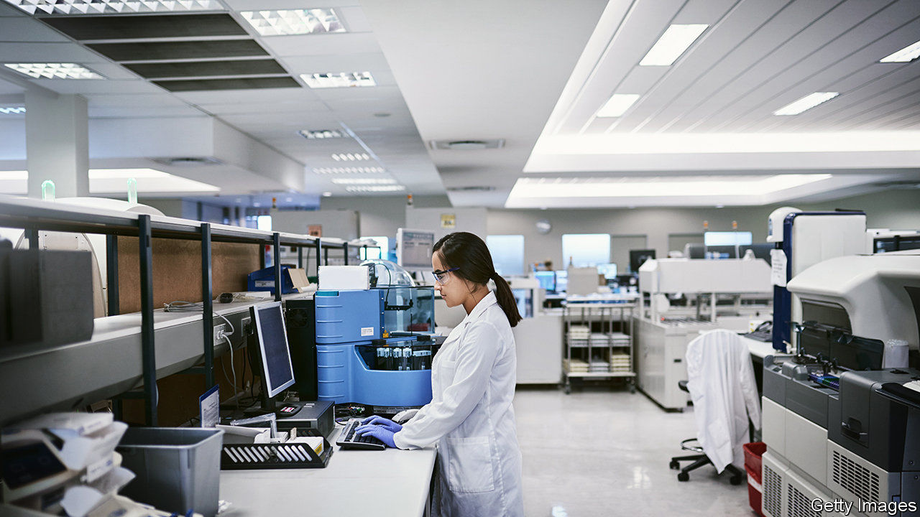

Editor’s note: The Economist is making some of its most important coverage of the covid-19 pandemic freely available to readers of The Economist Today, our daily newsletter. To receive it, register [here](https://www.economist.com/newslettersignup). For our coronavirus tracker and more coverage, see our [hub](https://www.economist.com/coronavirus)

IT IS A testament to the machinery of science that so much has been learned about covid-19 so rapidly. Since January the number of publications has been doubling every 14 days, reaching 1,363 in the past week alone. They have covered everything from the genetics of the virus that causes the disease to computer models of its spread and the scope for vaccines and treatments.

What explains the speed? Much as in other areas of life, covid-19 has burnt away encrusted traditions. Scientific journals have done their best to assess and publish research in days rather than their customary months or years. But a bigger factor behind the breakneck pace of publication is the willingness of biomedical scientists to bypass journals altogether and share their work quickly in the form of preprints—research manuscripts that are posted freely online and which have not been peer-reviewed.

Preprints are not a new idea. They have been an important method of communication in physical sciences and mathematics for decades. Biologists and medical scientists, however, have long resisted them. Unlike number theory or astrophysics, biologists have argued, their findings often directly affect individuals and companies (see Science article). Incomplete or unchecked studies could do them harm.

Arguments against preprints sound reasonable. Unless you are an expert in the field, it is hard to know whether a preprinted study is any good. Without peer-review before posting, the risk of shoddy science may well rise. The research contained in freely available preprints could be misinterpreted or abused by those hunting for scientific cover for their actions.

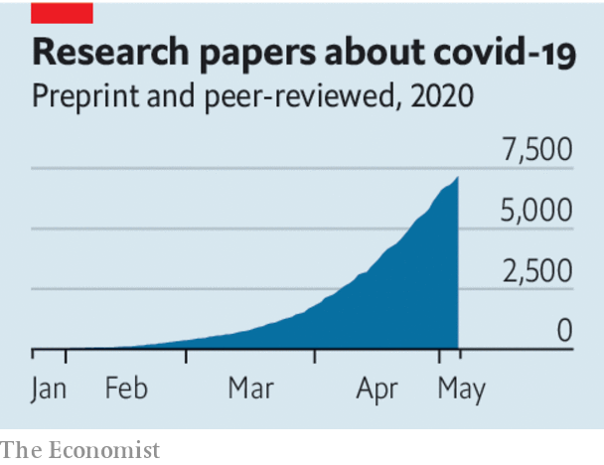

The evidence, however, suggests such worries are overdone. A recent study found that an impressive 67% of the preprints posted on the bioRxiv server before 2017 were eventually picked up and published in scientific journals. A separate study showed that the difference in scientific value, as measured by other researchers, between a preprint and the final version of the same study in a journal was, on average, less than 5%.

Preprints do not avoid peer-review; it just happens after publication (informally and often in public) instead of beforehand (organised by editors and mostly in secret). Manuscripts attract the scrutiny of independent experts, who relish tearing apart bad work. Dissent is easily visible next to the original preprint or just a link away. Authors can update their manuscripts as comments come in or even withdraw them if they conclude they have big flaws. With traditional scientific journals retractions can take months or years, if they happen at all.

In the long run, exposing the messy, argumentative guts of the scientific process could bolster public trust in science itself. Researchers do not follow a straight road to the truth. Rather, they meander, disagree and fumble towards an understanding of the world. In this way all findings are provisional, standing only until later work modifies or overturns them.

Preprints are not perfect. As they grow more common, there may be unpleasant side-effects. If the recent history of other social media is a guide, some people will find ways to game preprint servers and spread disinformation through them. Hosts and users of preprints should prepare for that. To get the most out of them, non-expert users need to step up their scepticism. Policy or journalism based on their contents should identify the source and its limitations.

As the deluge of work on covid-19 has shown, fast, free-flowing scientific information is vital for progress. The virus has changed the way scientists do their work and talk to each other, we hope for good.■

Dig deeper:  
For our latest coverage of the covid-19 pandemic, register for The Economist Today, our daily [newsletter](https://www.economist.com/newslettersignup), or visit our [coronavirus tracker and story hub](https://www.economist.com/coronavirus)

This article was downloaded by calibre from <https://www.economist.com/leaders/2020/05/09/speeding-up-science-during-the-pandemic>

|  |  |  |  |
| --- | --- | --- | --- |
| Previous | Articles | Sections | Next |

|  |  |  |
| --- | --- | --- |
| Leaders | Sections | By Invitation |

Letters

Letters to the editor: On children, Mozambique, lockdowns, tracking covid, Japan, Labour, liberty

.

|  |  |  |
| --- | --- | --- |
| Leaders | Sections | By Invitation |

|  |  |  |  |
| --- | --- | --- | --- |
|  | Articles | Sections | Next |

#### On children, Mozambique, lockdowns, tracking covid, Japan, Labour, liberty

# Letters to the editor

A selection of correspondence

May 9th 2020 |

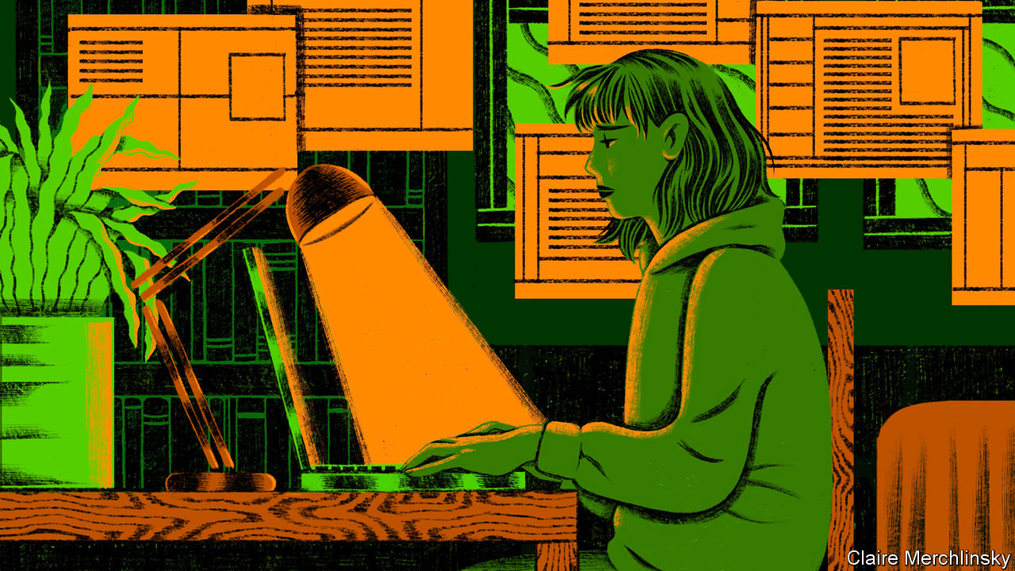

## Suffer the children

You looked at how covid-19 will affect the mental health and psychosocial well-being of vast swathes of society (“[Only connect](https://www.economist.com/international/2020/04/04/how-will-humans-by-nature-social-animals-fare-when-isolated)”, April 4th). However, you barely mentioned children and their caregivers. For most children there is no school, no meet-ups, no sports activities. Many also have to live through the severe distress of parents losing jobs, getting sick and feeling helpless. Even without a pandemic, 10-20% of children and adolescents worldwide experience mental disorders, with half beginning by the age of 14.

We know that covid-19 will have a lasting, though dangerously invisible, impact on children and their families. The longer this outbreak lasts, and the more restrictive response measures are, the deeper the effect will be on children’s learning, behaviour and emotional and social development. Now, more than ever, UNICEF is calling for collective action among governments, donors, and practitioners to address the complex and varying mental-health and psychosocial needs of children and families. This starts with listening to children’s concerns and prioritising their needs both in the short and long term.

HENRIETTA FORE  
Executive director  
UNICEF  
New York

## Conflict in Mozambique

Your leader on Mozambique in part caricatured the nasty, intensifying conflict in Cabo Delgado province (“[Gas, guns and guerrillas](https://www.economist.com/leaders/2020/04/02/jihadists-threaten-mozambiques-new-gasfields)”, April 4th). The Mozambican armed forces were never designed or equipped to combat this type of insurgency; they are having to be restructured and reorientated. In common with other crisis hot-spots in Africa, the nexus of insecurity is in weakly governed terrain along a porous international border, in this case with Tanzania. It is local but with regional and international links that will require private and government security assistance from other countries, particularly to foster development in conflict-prone areas.

Also, energy firms are used to operating in hostile environments. Currently their immediate risks are access to global funding given the collapse in commodity prices and the spread of covid-19 among their workers. They, too, are focused on seeking improvements, including global business and human-rights best practice, by all who partner with them.

ALEX VINES  
Director  
Africa Programme  
Chatham House  
London

## Co-ordinating lockdown laws

“[Booby on the beat](https://www.economist.com/britain/2020/04/04/policing-in-a-lockdown)” (April 4th, 2020) highlighted the problems of policing Britain’s national lockdown. As a fan of “Dad’s Army”, I have not only worked with characters in the police like Hodges, but also Mainwaring, Wilson, Walker and the rest of the platoon.

The principle of policing by consent requires clarity of purpose. It is not the job of police to enforce its own morality, or that of a particular section of society; so said Sir Richard Mayne, one of two joint commissioners of the new Metropolitan Police in 1829. To stop officers imposing their own morality he provided them with a General Instruction book outlining the objectives of policing. Failure to adhere to these could result in an officer being disciplined.

Ahead of the London Olympics in 2012 it was felt that with so many police forces involved there was a risk that different policing styles across a range of tasks might confuse visitors to the games. Potential differences in how forces policed crowds lining the Olympic torch route, how sports stadiums were made secure and how potential evacuations were handled, were avoided by appointing a senior police officer to act as the National Olympic Security Co-ordinator. As someone who liaised between the army and the police, I saw the advantages of this homogenous policing approach, which provides a lesson in enforcing lockdowns.

PAUL MALYON  
London

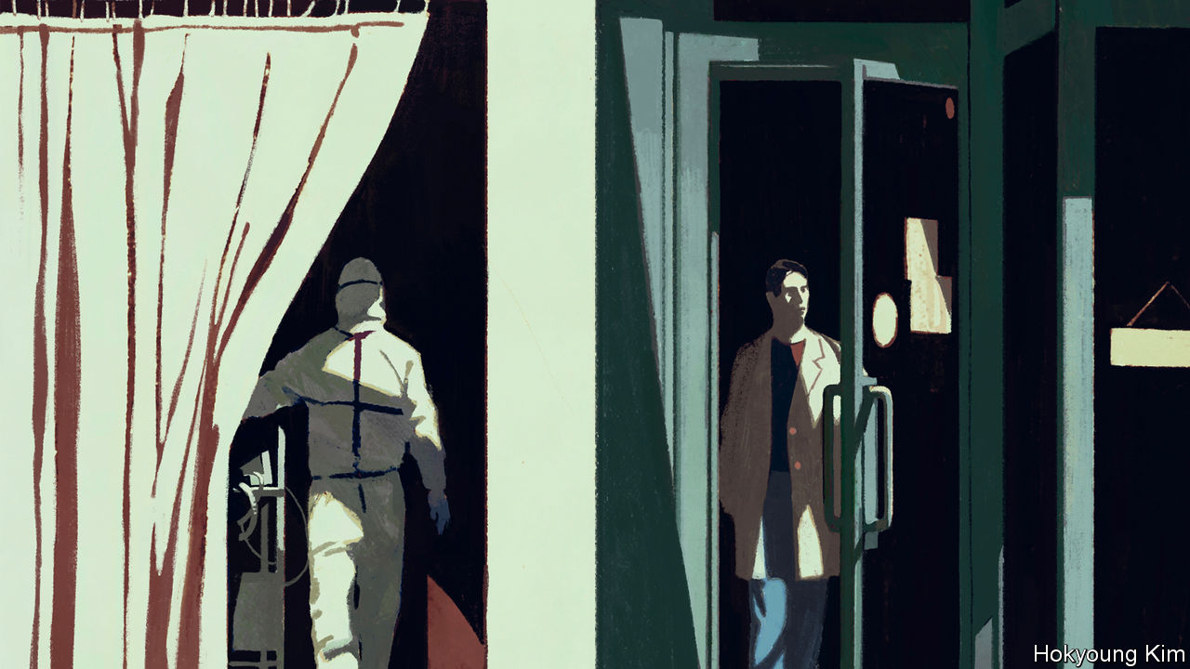

## Tracking issues

Social values are another important factor in any calculus of the pandemic (“[Hard choices](https://www.economist.com/briefing/2020/04/04/the-hard-choices-covid-policymakers-face)”, April 4th). Europeans, for instance, may not like the surveillance methods used in Asia to confirm lockdown and confinement. However, some methods allow contact-tracing to be supported by proximity-tracing using mobile technology.

Sophisticated protocols based on offline and anonymised Bluetooth connections, not satellite data, guarantee privacy and are compatible with EU data-privacy laws. One such project, called Decentralised Privacy-Preserving Proximity Tracing (DP3T), has been developed by researchers from various European countries and will probably be tested by health authorities in seven of them soon. If successful, it will allow us to balance the health benefits with the costs while preserving fundamental democratic values, such as privacy.

MARTIN VETTERLI  
Professor and president  
Ecole Polytechnique Fédérale de Lausanne ( EPFL)



## Zen government

It is not that “the stigma of Japan’s wartime militarism has rendered state power weak” ([Banyan](https://www.economist.com/asia/2020/04/04/abe-shinzo-draws-closer-to-declaring-a-state-of-emergency), April 4th). Rather, the stain of wartime militarism in Japan shifted the locus of state power from flamboyant strongmen to discreet repression of the opposition. On paper, Japan has a multiparty parliament. In practice, parties other than Abe Shinzo’s Liberal Democratic Party have held a majority only twice. Amid large-scale civil protests in 1960, 1968 and the 2010s, the Japanese state never fully acquiesced to popular demands. Under Mr Abe’s leadership, the LDP president’s tenure (in effect, that of the prime minister) was extended to three terms. The list goes on.

Those who consider the Japanese state domestically “weak” may do well to study Yuugen, a principle of Zen aestheticism: subtle yet profound.

VICTORIA EDWARDSLewes, Delaware

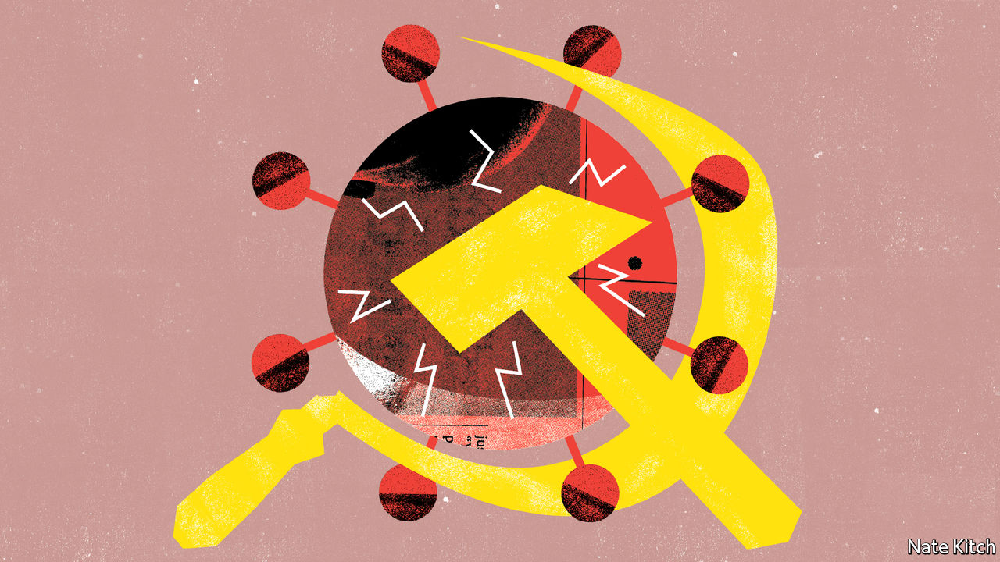

## Labour history

I don’t want to be pedantic, but George Lansbury did not lead Labour into the general election of 1935 ([Bagehot](https://www.economist.com/britain/2020/04/04/labours-new-leader-should-beware-of-war-socialism), April 4th). As a pacifist, he resigned as leader a month before, when the party adopted a policy of “collective military opposition” to Italian aggression against Abyssinia. It was the former deputy leader, Clem Attlee, who led the party into the election. Nor can the result be fairly characterised as a “disaster”. Disappointing, perhaps, but the party gained more than 100 seats, taking back much of the ground it had lost in the truly disastrous election of 1931.

DICK LEONARD  
London

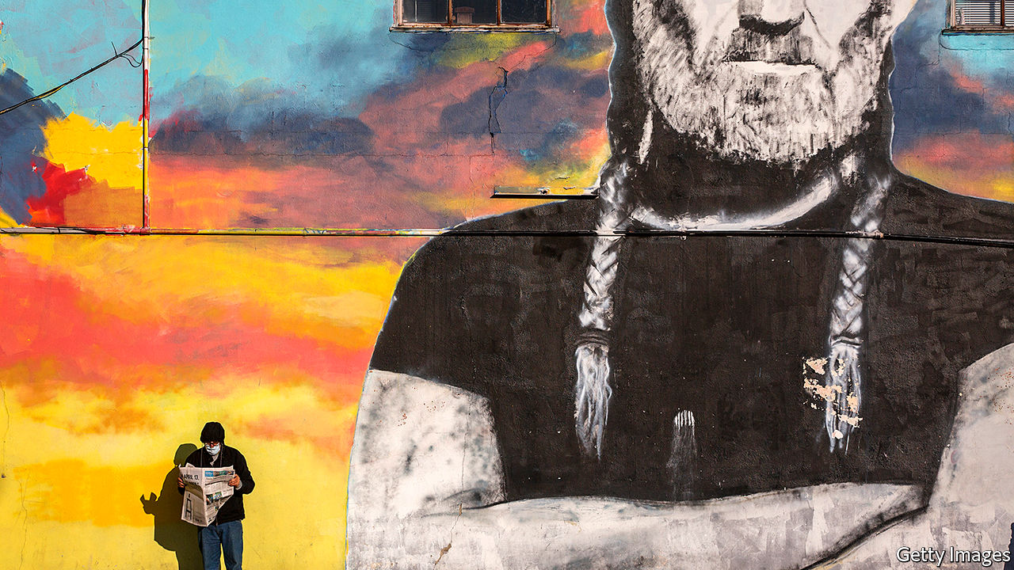

## Infectious ideas

It might be worth pointing out to those marching for liberation from covid-19 restrictions (“[Stir craziness](https://www.economist.com/united-states/2020/04/23/america-begins-easing-restrictions)”, April 25th) that one concept of freedom is the ability to play Russian roulette, if that is your thing. The other concept of freedom does not confer the right to point the loaded gun at others.

ROBERT DRAPERRhode St Genese, Belgium

The WHO’s marker of “people who have recovered from covid-19” seems awkward and long. How about “covidian”?

CHARLES HITSCHFELD  
Edmonton, Canada

This article was downloaded by calibre from <https://www.economist.com/letters/2020/05/09/letters-to-the-editor>

|  |  |  |  |
| --- | --- | --- | --- |
|  | Articles | Sections | Next |

|  |  |  |
| --- | --- | --- |
| Letters | Sections | Briefing |

By Invitation

The world after covid-19: Margaret MacMillan on a turning point in history

.

|  |  |  |
| --- | --- | --- |
| Letters | Sections | Briefing |

|  |  |  |  |
| --- | --- | --- | --- |
|  | Articles | Sections | Next |

#### The world after covid-19

# Margaret MacMillan on covid-19 as a turning point in history

The pandemic exposes our weaknesses and strengths. How the story unfolds will depend on leaders

May 9th 2020 |

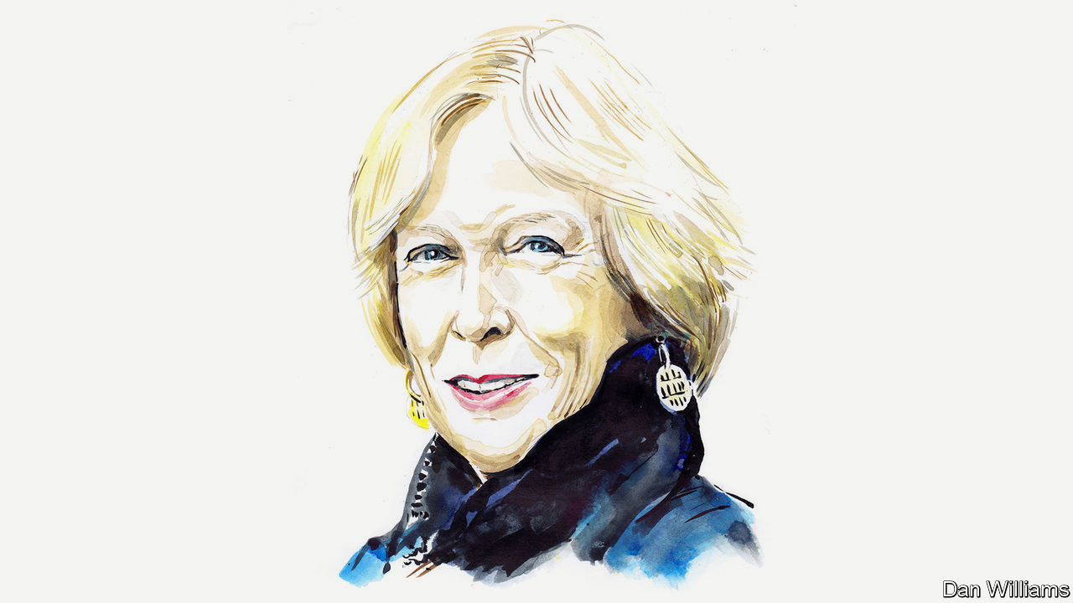

Editor’s note: The Economist is making some of its most important coverage of the covid-19 pandemic freely available to readers of The Economist Today, our daily newsletter. To receive it, register [here](https://www.economist.com/newslettersignup). For our coronavirus tracker and more coverage, see our [hub](https://www.economist.com/coronavirus)

IN THE WINTER of 1788-89, the desperate government of Louis XVI asked the French people to send in lists of their grievances. It was a fatal mistake. The cahiers de doléances served to articulate the public’s unspoken discontent and, equally important, its hopes for a better world. A crucial psychological barrier had fallen: it became possible to imagine a very different France. And the times—the moral and actual bankruptcy of the Ancien Régime, widespread crop failures and hopeless leadership—gave shape to the public’s aspirations. The fuse was lit for revolution.

France in 1789. Russia in 1917. The Europe of the 1930s. The pandemic of 2020. They are all junctures where the river of history changes direction. The covid-19 crisis may be a pivotal rather than a revolutionary moment but it, too, is challenging the old order. Like France’s cahiers, the coronavirus forces questions about what sort of future we want, what the proper role of government is and what makes a healthy society. We face a choice: to build better ways of dealing domestically and internationally with this challenge (and prepare for inevitable future ones) or let our world become meaner and more selfish, divided and suspicious.

Long before covid-19, popular thinkers like Thomas Piketty, the late Tony Judt and Paul Krugman were warning about deep social inequalities and the shortcomings of globalisation. There were sporadic protests like Occupy Wall Street or France’s gilets jaunes. Most of us (such is human nature) carried on living. We worried from time to time about climate change, that our children couldn’t afford houses and that there seemed to be more obscenely rich people along with more homeless ones. Covid-19 has turned a spotlight on the dark sides of our world. We have become aware of the fragility of international supply lines, the disadvantages of offshore sources for critical goods and the limits of international bodies. The chaotic responses and blame games of certain governments have exacerbated divisions in and among societies, perhaps permanently. America has withdrawn from moral and material leadership of the world. It and China have grown more hostile to one another, not less. Rogue states such as Russia gleefully make more trouble and the UN is increasingly marginalised.

When you name things—grievances, say, as the French did—you give them form and make it harder to ignore them. We are doing that now with the flaws in our world and spelling out our hopes for something better. As the French looked at Britain and America as models, we can see that South Korea, Denmark and New Zealand have controlled the pandemic more effectively than other countries, in part because their peoples have faith in the authorities and each other. Without trust—that the water is clean, medicines are safe, or thugs won’t get away with it—societies are vulnerable. Covid-19 has caused fewer deaths proportionately in Germany than elsewhere because of the country’s well-funded health system and its competent state and federal governments. As history shows, those societies that survive and adapt best to catastrophes are already strong. Britain rose to the challenge of the Nazis because it was united; France was not and did not.

Much also depended then, and depends now, on leaders. As weaknesses are exposed, do leaders fix or exploit them? While Franklin Roosevelt was promising Americans a better tomorrow in the 1930s, Adolf Hitler was destroying the Weimar Republic and intoxicating Germans with promises of revenge for the Treaty of Versailles. As we know, that ended in a world war.

For every Jacinda Ardern or Angela Merkel, the leaders of New Zealand and Germany who are talking to their citizens about the difficult road ahead, there is an illiberal, populist demagogue playing to baser fears and fantasies. In Brazil President Jair Bolsonaro dismisses covid-19 as “the sniffles”; in India the ruling Bharatiya Janata Party blames it on the Muslims. President Donald Trump claimed he had “total” authority, demonstrating something about his instincts if not his knowledge of the American constitution.

Wise leaders in the past have been able to steer away from danger. In 1830 Britain was coping with unrest in Ireland, violent strikes at home and demands for more power from the growing commercial and industrial middle classes. The enlightened aristocrats of the new Whig government believed that they had a choice between revolution and reform, even if the latter was at the expense of their own power and privilege. In 1832 their Great Reform Act widened the franchise for Parliament. The Whigs did not remove all grievances, but they muted them. A century later another child of privilege, Roosevelt, brought in the New Deal which helped to save American society and capitalism.

The present crisis could be the opportunity for strategies to produce essential public goods and ensure that citizens have safe, decent and fulfilled lives. People coming out of a calamity are open to sweeping changes. Governments will find it hard to resist demands for improved social programmes now that they are spending as though John Maynard Keynes were in the room. Will the British again accept an underfunded National Health Service? And countries could invest in key organisations like the World Health Organisation and give it greater power to protect the world from disease. Perhaps, just perhaps, bodies such as the G7 and G20 could become forums for unity and not dissent.

Future historians, if there are any who can still research and speak freely, will analyse the choices that individual countries and the world made. Let us hope the story shows the better angels of our nature, in Abraham Lincoln’s words: enlightened leaders and publics creating together sane and inclusive policies, and strengthening our vital institutions at home and abroad. The alternative story will not have a happy ending. ■

Margaret MacMillan is a historian at the University of Toronto. This article is part of a series on the world after covid-19. For more coverage of the pandemic visit [Economist.com/coronavirus](http://Economist.com/coronavirus)

Dig deeper:  
For our latest coverage of the covid-19 pandemic, register for The Economist Today, our daily [newsletter](https://www.economist.com/newslettersignup), or visit our [coronavirus tracker and story hub](https://www.economist.com/coronavirus)

This article was downloaded by calibre from <https://www.economist.com/by-invitation/2020/05/09/margaret-macmillan-on-covid-19-as-a-turning-point-in-history>

|  |  |  |  |
| --- | --- | --- | --- |
|  | Articles | Sections | Next |

|  |  |  |
| --- | --- | --- |
| By Invitation | Sections | United States |

Briefing

Food security: The tables not yet turned

.

|  |  |  |
| --- | --- | --- |
| By Invitation | Sections | United States |

|  |  |  |  |
| --- | --- | --- | --- |
|  | Articles | Sections | Next |

#### Keeping things cornucopious

# The world’s food system has so far weathered the challenge of covid-19

But things could still go awry

May 9th 2020 |

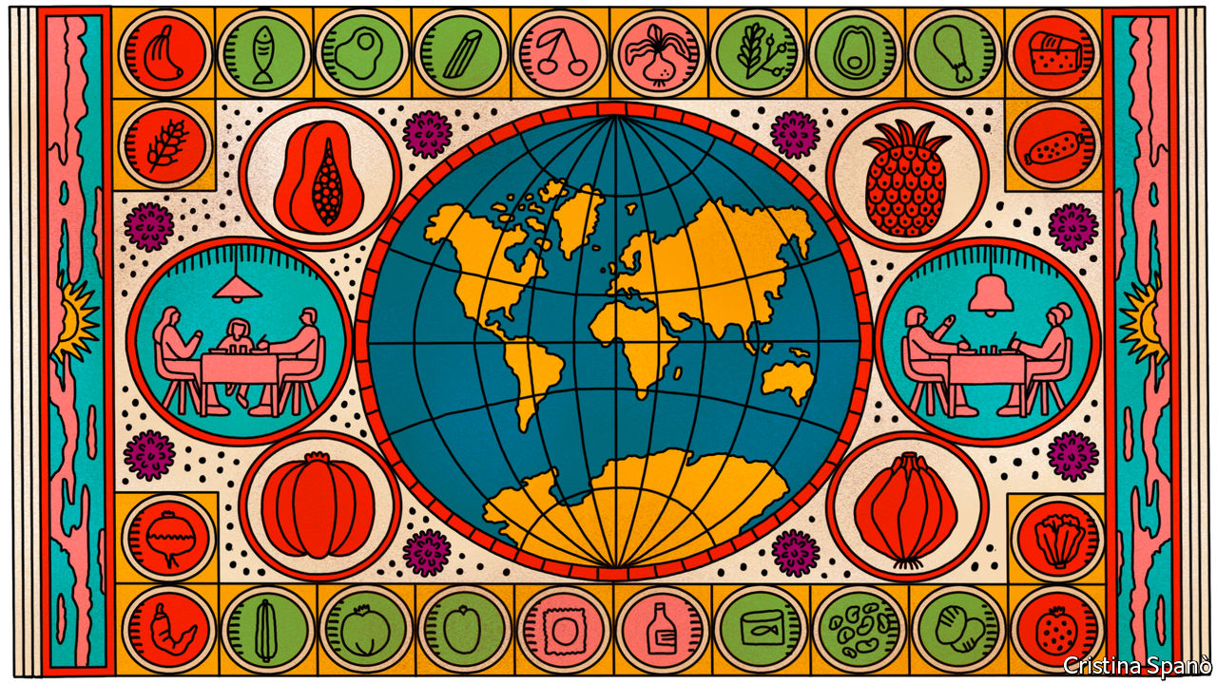

Editor’s note: The Economist is making some of its most important coverage of the covid-19 pandemic freely available to readers of The Economist Today, our daily newsletter. To receive it, register [here](https://www.economist.com/newslettersignup). For our coronavirus tracker and more coverage, see our [hub](https://www.economist.com/coronavirus)

IN LATE JANUARY China banned package tours from heading overseas for the lunar new-year holiday. This gave cold sweats to David Parker, New Zealand’s trade minister. Fewer tourists were a disappointment, but planes that did not bring tourists in one direction would not take agricultural produce back in the other—significantly more worrying, given that China is New Zealand’s biggest customer for the food which is its biggest export.

So as airlines started grounding planes, the government engineered a deal with Air New Zealand; the airline would get a loan if it kept routes to China, Singapore and America open, thus allowing kiwi fruits and other delicacies out into the world even when the cabins above the hold were empty. Mr Parker also offered support to airlines based in the Middle East. “It’s hard to grow some of the things they eat there,” he says. “There was a mutual interest in maintaining connectivity.”

Connectivity is what the world’s agro-industrial complex is all about. Four-fifths of the planet’s 8bn mouths are fed in part by imports; the $1.5trn that was paid for them last year was three times 2000’s bill. Battalions of lorries and fleets of ships connect tens of millions of farms to hundreds of millions of shops and kitchens. The sophistication of the system, and the foresight of players within it like Mr Parker, has meant that, so far, it has held up to covid-19’s impacts on both supply and demand by dexterously swapping sources and rerouting supply chains. Prices for most staples have fallen so far this year (see chart 1).

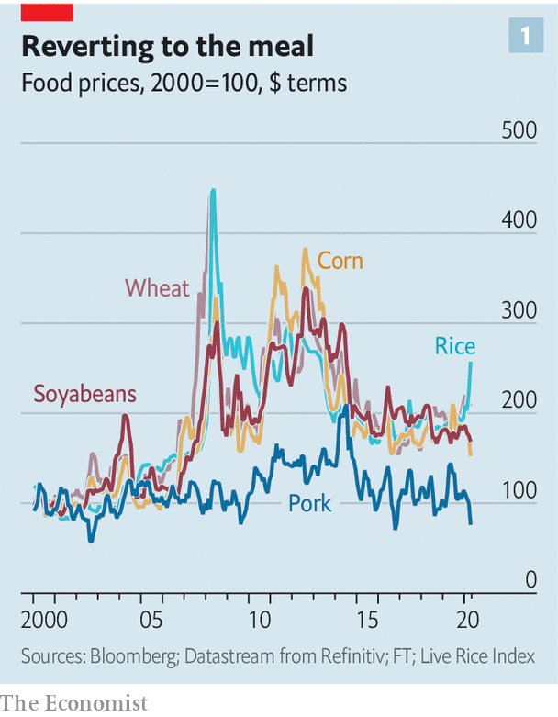

The system’s complex architecture means it has many potential bottlenecks, and the pandemic’s global dislocation has found a fair few of them. Some have been dealt with quite well. The enormous queues of lorries seen in central Europe in March, when concerns about where people were coming from took hold, have been largely eliminated with expedited controls. Others, such as the lack of capacity in America’s meat-processing sector due to slaughterhouse closures, have yet to be fully sorted out.

But the biggest problem lies not in the system’s bottlenecks. It lies in the effects on consumers of almost a billion incomes reduced or lost. The UN estimates that the economic fallout from covid-19 could see the number of people suffering from acute hunger double to 265m over the course of this year. Developed countries are not immune. In America queues at food banks in some cities stretch for kilometres. In these circumstances even quite small dislocations in the food system could, by increasing prices further, lead to great suffering.

## Play on

Although farms are, by their nature, local, much of the rest of the food industry is global. The supplies of seed, fertiliser, machinery and fuel that farmers need come from far afield. The companies that tie the system together—giant middlemen like America’s ADM, Bunge and Cargill, Louis Dreyfus, based in the Netherlands, and Olam International, based in Singapore—all operate on a worldwide basis, sourcing, storing and shipping agricultural commodities for foodmakers like Kraft or Unilever. Their size and global reach lets them make a lot of money on quite narrow margins. They can quickly swap one source for another to accommodate changes in supply or demand, smoothing prices and keeping the system flexible.

In the past 20 years the industry has seen increased concentration of ownership as firms chase the advantages of scale. Half of America’s poultry market—the largest in the world—is now controlled by just four firms. Two of the six largest mergers in the 2010s were between companies in food and drink. Emerging markets, where changing diets and urbanisation create fresh demand, have spawned giants of their own. Brazil’s JBS is the largest meat-processing company in the world. China’s largest food manufacturer, COFCO, has gobbled up a bevy of established traders as it keeps the grain flowing to Beijing.

The potential for efficiency and the capacity to absorb fixed costs that size brings has seen the system become increasingly sophisticated. The world’s breadbaskets have become more capital intensive. Autonomous tractors roam giant fields and machines handle cargo. Images from satellites, increasingly looked at through the lens of artificial intelligence, keep tabs on ships and storms as well as providing estimates of the season’s yields.

## Excess of it

This refinement allows production networks to be very complex. Food, like cars, is often assembled close to the consumer from parts sourced anywhere but. Ukrainian wheat, milled into flour in Turkey, may be turned into noodles in China. Frank van Lierde, who helms the food ingredients and bio-industrial units of Cargill, says it has “a far more diverse footprint” than 20 years ago. Next year the firm will open a factory in Brazil to make pectin, an orange-peel extract used to thicken jam and yogurt, which it will sell worldwide.

This globalisation means more countries depend on imports. Analysis done for The Economist by Josef Schmidhuber and Bing Qiao of the UN’s Food and Agriculture Organisation (FAO) shows that most countries are more dependent on imports today than they were 20 years ago (see map). This has made observers worry that disruptions caused by covid-19 could trigger a repeat of the food crisis of 2007-08, when a sharp rise in prices was exacerbated by panicking governments. Some 75m people were pushed below the hunger threshold, sparking riots from Bangladesh and Burkina Faso to Mauritania and Mexico, and contributing to the conditions that fostered Syria’s civil war.

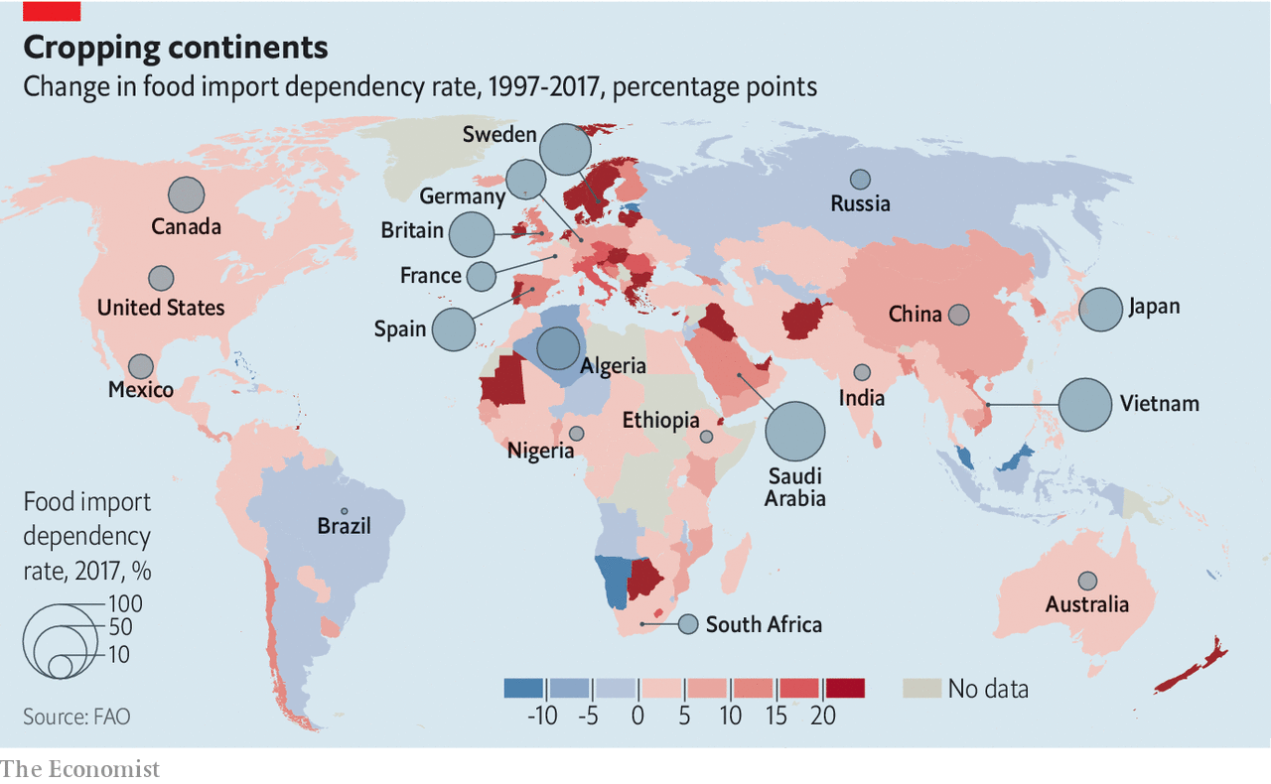

But if most of the world is more import-dependent now than it was then, it is also on a more robust footing. In 2007 there had been poor wheat harvests in Australia and Europe and a poor corn harvest in America; grain stocks were at their lowest since 1973, says Caitlin Welsh of the CSIS, a think-tank. Oil prices were sky high, which made making fertilisers and getting food to market more expensive. It also increased demand for crops, like corn and sugar, that can be used as feedstocks for biofuels.

Today cereal stocks are twice as high as they were then (see chart 2). Bulk shipping is 20 times cheaper and crude oil is just $30 a barrel. That makes all manner of inputs cheaper and pushes the price of fuel feedstocks like corn and sugar lower still to boot. If the number of importing countries has risen for most crops, so has the number of exporting countries. That makes trade more resilient to swings in supply and demand.

Those broad brush benefits do not mean that there are no challenges. Some have been on the demand side. In March lockdowns and the prospect of lockdowns saw households rush to stockpile durable goods. In some countries sales of tinned goods and pasta went up sevenfold. Supply lines emptied. But alternatives can be found. When Indian traders stopped signing new export contracts in April, Carrefour, a French supermarket group, found new rice supplies in Pakistan and Vietnam and opened a beef import route from Romania, says Hani Weiss, who heads the franchise across 37 emerging markets from his base in the UAE. To guard against further trouble the company has increased its stock of essential items from 30 days or less to 90 days, he says. Not only is there produce to put on shelves, there are people to put it there. Tesco, Britain’s largest grocer, got 1.3m job applications in March, over ten times the usual number.

## The appetite may sicken

Demand for such goods has now mostly fallen back to normal. Meanwhile demand for other forms of food is very low. Restaurants, cafés and cafeterias in schools and other institutions account for 30% of all calories consumed—and in many countries these venues are closed. This has left many farmers stranded without custom.

In theory they could redirect their produce to shops. But people staying at home do not just eat the same things they would at work or on an evening out. They tend to favour processed and pre-packaged products many chefs would not touch, and to use more basic ingredients when they cook: mince, not steaks. They also drink a good bit less milk than they would in a world of baristas and lattes.

Even when the food wanted for homes is the same as that which would be wanted by professional kitchens, there is an issue of quantum. Canteen chefs buy flour in 16kg bags; sourdough enthusiasts want it by the kilogram. Changing the size of the packaging is a lot of work for a processor. Getting supermarkets to approve new suppliers is a lengthy process, too.

As a result of these changes, some food producers are in trouble. French fishermen say they are throwing back two-thirds of their catch. Australia is facing an avocado glut. Alain Goubau, a farmer in Ontario, now feeds some of his milk back to his cows. But there is a limit to what can be recycled; most of what cannot be sold will be wasted. Millions of litres of keg beer is going stale. The EU is expecting to lose €400m ($430m) of potatoes. America’s food-waste ratio is set to rise from 30% to 40% this year, according to André Laperrière of GODAN, a group which promotes open data.

On top of changes in demand, there are also transport bottlenecks, some sudden and unexpected. In March Timbues, one of the main ports of Rosario, a region accounting for 80% of Argentina’s food exports, shut for nearly a week because of the disease. But grain still travels. Things are made easier by increasingly automated food handling, says Tom Carr-Ellison, who runs a farm in Uruguay—a trend the pandemic will only encourage. Shipping is working so smoothly that India’s locked-down coastal states have opted to buy soyabean oil from Argentina rather than trucking it from inland.

Moving perishables is more problematic. Fruit and vegetables, along with coffee and meat, usually travel by plane or in refrigerated containers on special ships. Slowdowns elsewhere in the trade system have led some to report problems with refrigerated containers, though these are not universal. Janine Mansour of Port of New Orleans, America’s top coffee importer and second-largest poultry exporter, says throughput from its container business was up in the first quarter. Capacity in the bellies of airliners, though, is a problem for everyone. By the last week of March it was down by 80% worldwide. When the means by which goods get to market vanishes that completely, the price the producer gets collapses. In Thailand wholesale prices of dragon fruit, which is a favourite in China, have dropped by 85%.

Meat offers particularly distressing bottlenecks. Demand is quite low. Carlos Rodriguez of AGRO Merchants, which provides cold storage in 11 countries, says meat fridges that once had spare capacity are now “totally full”. But supply marches on; and animals born must, at some point, be slaughtered. This is hitting America’s pork industry in a big way. Shutdowns in giant abattoirs slashed the country’s pork slaughter capacity by 40%; every five days saw 1m “excess” pigs left alive on farms which have no space for them. President Donald Trump last week took on powers allowing the government to force processors to stay open. Many now are so; but absenteeism has soared.

In the rich world the result of such disruptions is not famine but inconvenience: dearer bacon and blueberries. But three dangers loom—and the longer the crisis lasts, the nastier they are likely to get.

The first is that farmers start producing less. Some lack labour. The closure of American consulates in Mexico could mean many of the 250,000 H-2A visas for agricultural workers do not get issued this year. Britain will see very few of the 90,000 pickers it normally gets from Europe. Replacements are not easy to find. Australia has tapped backpackers taking refuge in the countryside, says David Sackett, who runs a $260m portfolio of farms. In Britain, though, a scheme to move the unemployed to the fields has had a singular lack of uptake. And some farmers say unproductive novices are a waste of money. Farms with capital will be looking ever more keenly at robots, as long as the boffins can get them to handle soft fruit well.

## Withstanding capacity

Some farmers deprived of markets, and thus cash, by restaurant closures and the like will leave crops to rot rather than pay for harvest. Some will go bust. In countries with low interest rates the risk is lessened. American farms pay much less to service their debt than they did in the 1980s, and are thus more secure. Capital-intensive farms in Latin America, where debt-to-equity ratios and interest rates are high, are much more exposed.

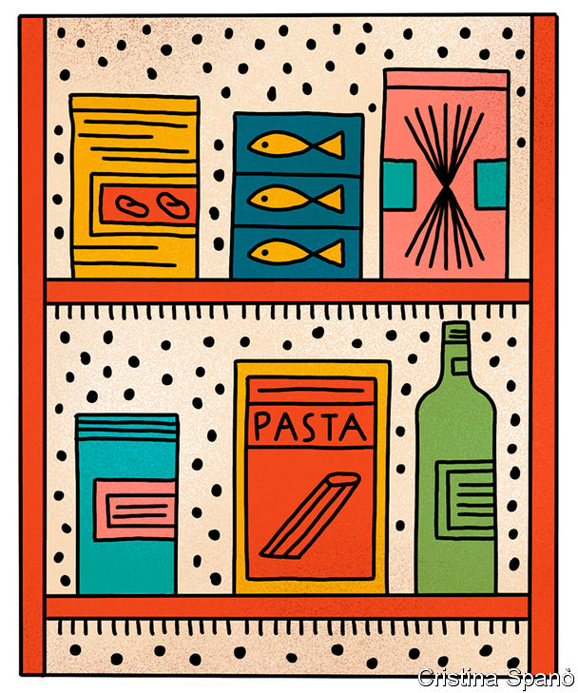

Scarce credit is the second risk. Supply chains run smoothly because short-term loans allow each link to pay for produce before selling it on. As operations slow down, the term of these loans is extended, trapping cash that could be lent elsewhere. And banks are currently wary of financing commodities deals of any sort, says John MacNamara, a former trade-finance boss of Deutsche Bank. Volatile currencies, collapsing oil markets and the falling value of the grain that companies typically offer as collateral have them spooked. Multilateral institutions are doing their bit. Over a fifth of the $425m in emergency trade cash provided by the Asian Development Bank in April covered food-security deals. But an official close to major banks says he “is hearing the cracks” in the system.

The third danger is that governments lose their calm. In 2007-08, 33 countries declared export controls. Those bans caused most of the 116% rise in rice prices seen then, according to a World Bank paper. This time 19 states have so far limited exports and the impact is much less. 2007-08’s control affected 19% of the world’s traded calories; this year’s so far affect just 5%.

But the market is nervous. Relatively small actions can cause a spike, especially in thinly traded markets. Sunny Verghese of Olam, the world’s second-largest rice trader, says only four or five countries grow more rice than they eat. That is why Vietnam’s recent restrictions on exports sent the price up sharply.

And export controls prompt buyers to stockpile, igniting a vicious circle. Many import-dependent nations hold “strategic” grain reserves, which typically cover three months of supply. They may now seek an extra month, says Jonatan Lassa of Charles Darwin University in Australia.

The combined effect of export controls and stockpiling could be devastating to poor countries. Many have seen their currencies tumble and so already pay more to import food. Poverty is increasing at a time when the informal, and often crowded, markets where the poor tend to get their staples are closed in many places. Food inflation anything like that of 2007-08 on top of this would be a humanitarian disaster.

Global co-ordination could help keep that tragedy at bay. Last month 22 members of the World Trade Organisation, who between them account for 63% of the world’s agricultural exports, pledged to keep trade open, a good omen. More transparency on strategic stocks could diffuse tensions. Mr Laperrière suggests that co-operation could help on local levels, too: supermarkets could launch inter-trading platforms, where they can exchange produce when faced with shortages. If such co-operation and interconnection can be maintained, the worst of the covid-19 hunger may yet be averted. ■

Dig deeper:  
For our latest coverage of the covid-19 pandemic, register for The Economist Today, our daily [newsletter](https://www.economist.com/newslettersignup), or visit our [coronavirus tracker and story hub](https://www.economist.com/coronavirus)

This article was downloaded by calibre from <https://www.economist.com/briefing/2020/05/09/the-worlds-food-system-has-so-far-weathered-the-challenge-of-covid-19>

|  |  |  |  |
| --- | --- | --- | --- |
|  | Articles | Sections | Next |

|  |  |  |
| --- | --- | --- |
| Briefing | Sections | The Americas |

United States

America v China: Superpowered insults

.

Measuring inequality: How the 0.1% did

.

Trumpian governance: Watchdogs in the doghouse

.

Steve King under pressure: The ninth inning

.

The electoral college: Going rogue

.

Education and society: The social experiment

.

Lexington: What’s in store

.

|  |  |  |
| --- | --- | --- |
| Briefing | Sections | The Americas |

|  |  |  |  |
| --- | --- | --- | --- |
|  | Articles | Sections | Next |

#### Superpowered insults

# There is less trust between Washington and Beijing than at any point since 1979

What does that mean in practice?

May 9th 2020 | NEW YORK

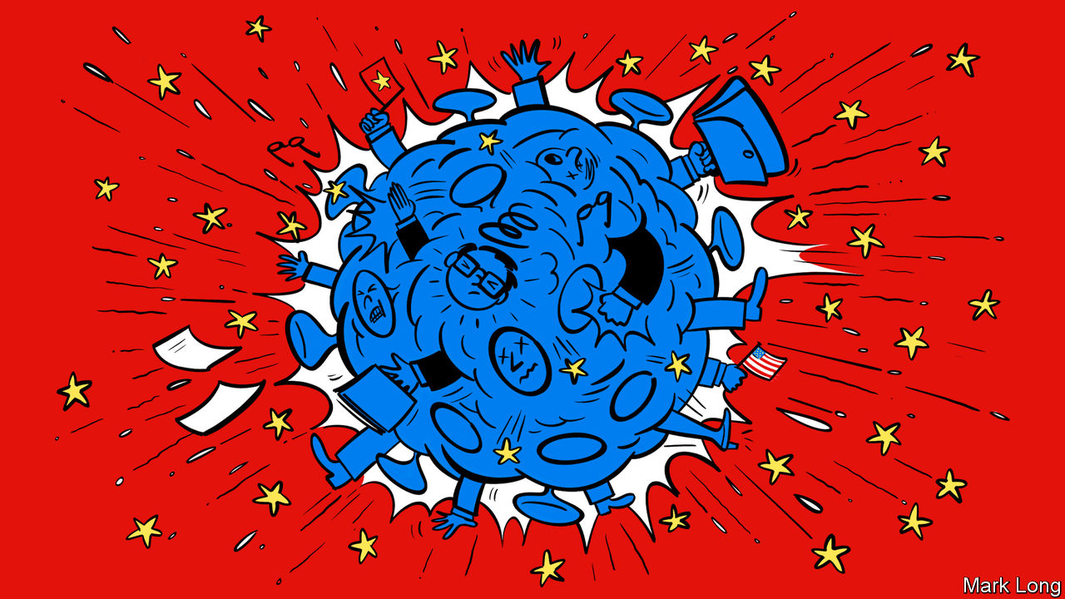

Editor’s note: The Economist is making some of its most important coverage of the covid-19 pandemic freely available to readers of The Economist Today, our daily newsletter. To receive it, register [here](https://www.economist.com/newslettersignup). For our coronavirus tracker and more coverage, see our [hub](https://www.economist.com/coronavirus)

WHEN CONDUCTING war games between China and America, David Ochmanek of RAND Corporation, a think-tank, worries most about an invasion of Taiwan, the security of which is implicitly guaranteed by America. In one scenario the red team unleashes a “joint firepower strike” on Taiwan’s defence forces and on American forces, bases and command-and-control nodes in the Pacific, including on Okinawa and Guam. Many of the blue team’s planes are destroyed on the ground, and its runways disabled. China severs communication links as part of an effort to gain information superiority, part of a full-spectrum strategy called “system-destruction warfare”. Then comes the amphibious assault on the island. American submarines knock out some portion of the invasion force with torpedoes, but surface-level carriers and frigates are hammered by Chinese anti-ship missiles if they venture near the fight. “We always assume that the United States intervenes forcefully and early,” Mr Ochmanek says. But now, in contrast to years past, “I would not have confidence that we would succeed.”

The probability of such a world-changing military conflict between the two countries remains mercifully low. But it is becoming something to ponder beyond simulations, a reflection of how grim their relationship has become. Lesser conflicts may be reignited this year—over trade, technology, espionage and propaganda and disinformation—while the American death toll from covid-19 climbs. The world’s two largest economies, so long intertwined through trade and investment, are heading towards a partial decoupling. There is less trust between the two governments than at any time since the normalisation of relations in 1979. And as an election approaches in November, the chances of misunderstanding, miscalculation and provocation are escalating on both sides.

President Donald Trump had praised Chinese leaders in the early days of the pandemic, after signing a “phase one” trade deal. He has repeatedly expressed admiration for Xi Jinping, China’s president, even as recently as late March, tweeting after a telephone call, "We are working closely together. Much respect!" But in April, as Mr Trump faced intensifying criticism for the failure to contain the epidemic, he swung to attacking China, a strategy which Republican pollsters suggest may help him against Joe Biden, his Democratic challenger. (One attack ad paid for by Trump allies said that “To stop China, you have to stop Joe Biden”; another declared, “China is killing our jobs and now, killing our people”.) On May 3rd Mike Pompeo, the secretary of state and a proponent of the term “Wuhan virus”, tweeted that “China has a history of infecting the world”, implicitly blaming the covid-19 pandemic on “failures in a Chinese lab” in Wuhan. That theory is still in search of some evidence.

In China, too, the political calculus threatens to escalate tensions. In recent days state media have called Mr Pompeo “evil”, “insane” and a “common enemy of mankind”, stoking the fires of nationalism. In Beijing there are signs that leaders are getting nervous. On May 4th Reuters, a news service, reported that an elite think-tank under the Ministry of State Security had warned China’s leaders of an elevated risk of war with America, as the country endures a global backlash not seen since the massacre around Tiananmen Square. On May 4th a hawkish Chinese military strategist, apparently worried that some in China are eager to exploit a moment of weakness in America, warned against taking Taiwan by force, telling the South China Morning Post that it would be “too costly”.

State-sponsored hacking of American government and corporate targets carries fewer risks. The practice had subsided after a deal struck between Mr Xi and Barack Obama in 2015, but reportedly resumed after Mr Trump took office. It is expected to continue as tensions worsen; sensitive medical information, including work on covid-19 vaccines, could be a target. America in turn could decide to open its arsenal of hacking tools, potentially escalating cyber-hostilities to new levels.

Then there is what P.W. Singer, a specialist on 21st-century warfare, calls “like war”, the Kremlin-style use of social media to spread propaganda and disinformation. Mr Singer says China has learned from Russia. Its diplomats and state-media actors have spread the fiction that the American armed forces brought the virus to Wuhan. Xinhua, the official news agency, released an animated video using Lego characters to illustrate America’s efforts to blame China for its failure to contain the virus: “We are always correct, even though we contradict ourselves,” says the Statue of Liberty, while hooked up to an IV drip. “It’s like that scene in ‘Jurassic Park’ where the velociraptors figure out how to turn the doorknob,” Mr Singer says. “That’s what you just saw with China in information warfare.”

In some arenas the rhetoric may be little more than hot air. The “Justice for Victims of Coronavirus Act”, a bill sponsored by Josh Hawley, a Republican senator from Missouri, would allow citizens and states to sue China for damages related to covid-19. Mr Hawley published an op-ed in the New York Times arguing that the World Trade Organisation should be abolished because it has enfeebled America’s economy while enabling China’s rise. Mr Trump is considering action in a few areas—levying new tariffs, imposing sanctions, asking companies to move manufacturing out of China, and ordering federal pension funds not to invest there. News outlets reported the fanciful idea, floated by sources in the administration, that the White House was considering cancelling part of the country’s $1.1trn in debt obligations to China, to “punish” China for the pandemic.

The administration’s push to blame a lab in Wuhan for the pandemic may fall apart if it fails to produce evidence; officials in Britain and Australia have briefed newspapers that America has shared no convincing intelligence under their Five Eyes agreement. But in other ways the row is already taking a real toll. At the United Nations a resolution calling for ceasefires in regional conflicts around the globe has stalled over a squabble between the two countries about whether to name-check the World Health Organisation.

Taiwan is likely to be a flashpoint for increased tensions, if not armed conflict. America is backing the self-governing island’s bid for observer status at the World Health Assembly, the decision-making body of the WHO. A vote is expected later this month. The administration has also allowed a deputy secretary of health and human services to take part in a Zoom conference with a Taiwanese vice-premier about Taiwan’s successful response to covid-19. Mr Trump may consider sending a more senior official to Taipei, which would be taken as provocation by the Communist Party. In that sense the pandemic might provide a saving grace. If such a high-level summit were to be conducted over Zoom, to prevent the spread of the virus, the two governments might at least keep at a safe distance from each other. ■

Dig deeper:  
For our latest coverage of the covid-19 pandemic, register for The Economist Today, our daily [newsletter](https://www.economist.com/newslettersignup), or visit our [coronavirus tracker and story hub](https://www.economist.com/coronavirus)

This article was downloaded by calibre from <https://www.economist.com/united-states/2020/05/09/there-is-less-trust-between-washington-and-beijing-than-at-any-point-since-1979>

|  |  |  |  |
| --- | --- | --- | --- |
|  | Articles | Sections | Next |

|  |  |  |  |
| --- | --- | --- | --- |
| Previous | Articles | Sections | Next |

#### Plutocracy

# Have the top 0.1% of Americans made out like bandits since 2000?

Or have they merely stood still?

May 9th 2020 |

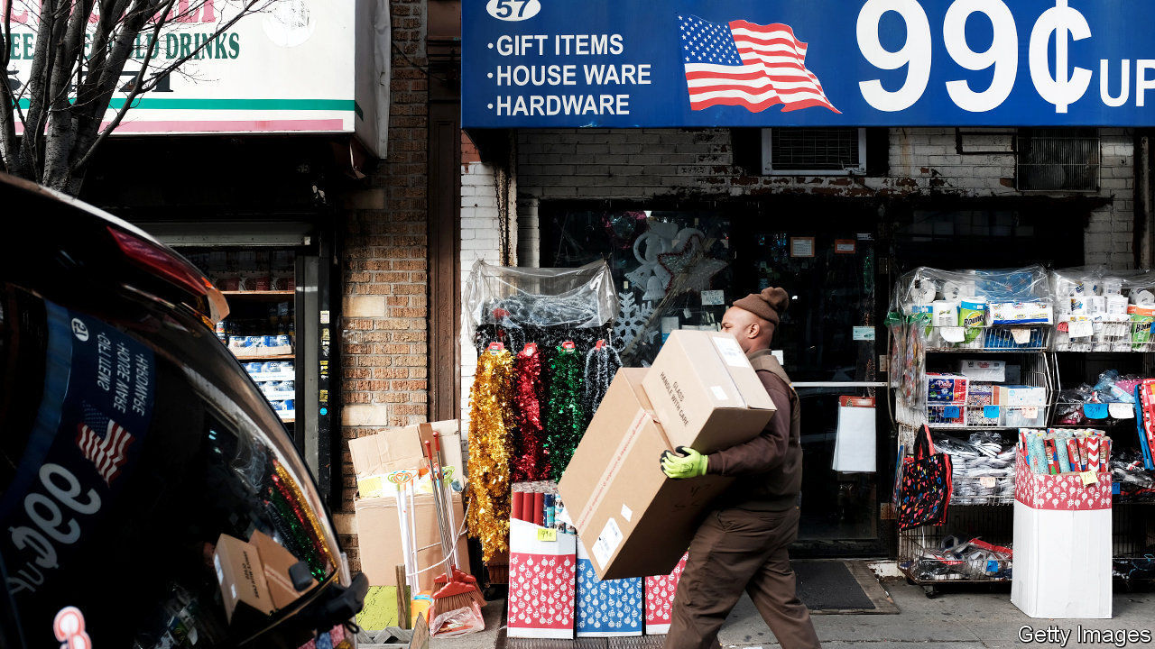

IT IS A truth universally acknowledged that inequality in the rich world is high and rising. Or, at least, it used to be. A growing band of economists are challenging the received wisdom, pointing out that trends in the distribution of income and wealth may not be as bad as is often thought. Two recent studies focus on wealth inequality in America, providing further ammunition to the dissenters.

Measuring wealth is harder than it may seem. People are liable to under-report their asset holdings on official surveys, whereas it is hard to measure the true value of things like private companies and art works. Economists are using increasingly sophisticated methods to get a sense of who owns what. One popular method is to examine income earned on investments, such as interest payments from bonds, assume a rate of return, then multiply up to calculate the value of the investment.

In a newly updated working paper Matthew Smith of the Treasury department, Owen Zidar of Princeton University and Eric Zwick of the University of Chicago use this method to gauge American wealth inequality. Previous estimates have relied on the assumption that all people receive the same rates of return on a given type of investment. That may be misleading. The rich tend to plump for riskier investments, which command higher rates of return—implying, in turn, that the stock of wealth from which they derive that income is smaller than it would otherwise appear.

Allowing for different rates of return, the paper’s headline results suggest that America’s top 0.1% own roughly 15% of the country’s private wealth (see chart). Their share has risen since the 1980s, but by less than other economists believe (some papers find that it has jumped to 20% or more). And according to the new paper, that measure of wealth inequality has been stable since the middle of the 2000s.

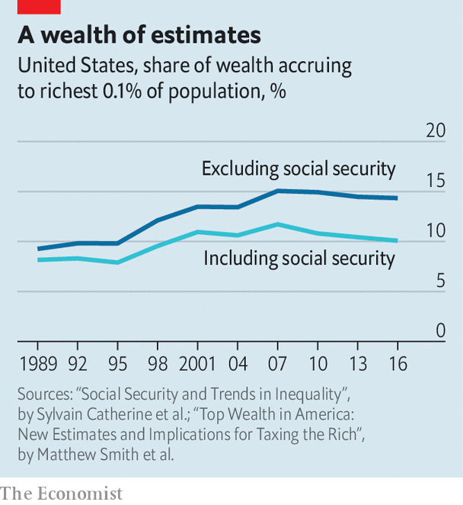

But does it make sense to count only private wealth? In another new working paper Sylvain Catherine, Max Miller and Natasha Sarin of the University of Pennsylvania argue that accrued entitlements to Social Security should also be included. Someone with access to a public pension is surely better off than someone without. Crucially, too, an expansion of Social Security means that poorer folk have less need to save for retirement. That distorts measures of wealth inequality which count only private nest-eggs. (Sweden, surprisingly enough, has very high private-wealth inequality, in part because of its cradle-to-grave welfare system.)

In recent years the value of American Social Security wealth has jumped, in part because the population is ageing. It is also progressively distributed. Messrs Smith, Zidar and Zwick’s paper apportions this wealth between rich and poor. As the chart shows, measured inequality falls, while the wealth share of the very richest has remained remarkably flat over the past two decades. America is a highly unequal society—but it is not becoming ever more so.■

This article was downloaded by calibre from <https://www.economist.com/united-states/2020/05/09/have-the-top-01-of-americans-made-out-like-bandits-since-2000>

|  |  |  |  |
| --- | --- | --- | --- |
| Previous | Articles | Sections | Next |

|  |  |  |  |
| --- | --- | --- | --- |
| Previous | Articles | Sections | Next |

#### Watchdogs in the doghouse

# Donald Trump’s war on inspectors general

The president likes to rid himself of troublesome IGs

May 9th 2020 | WASHINGTON, DC

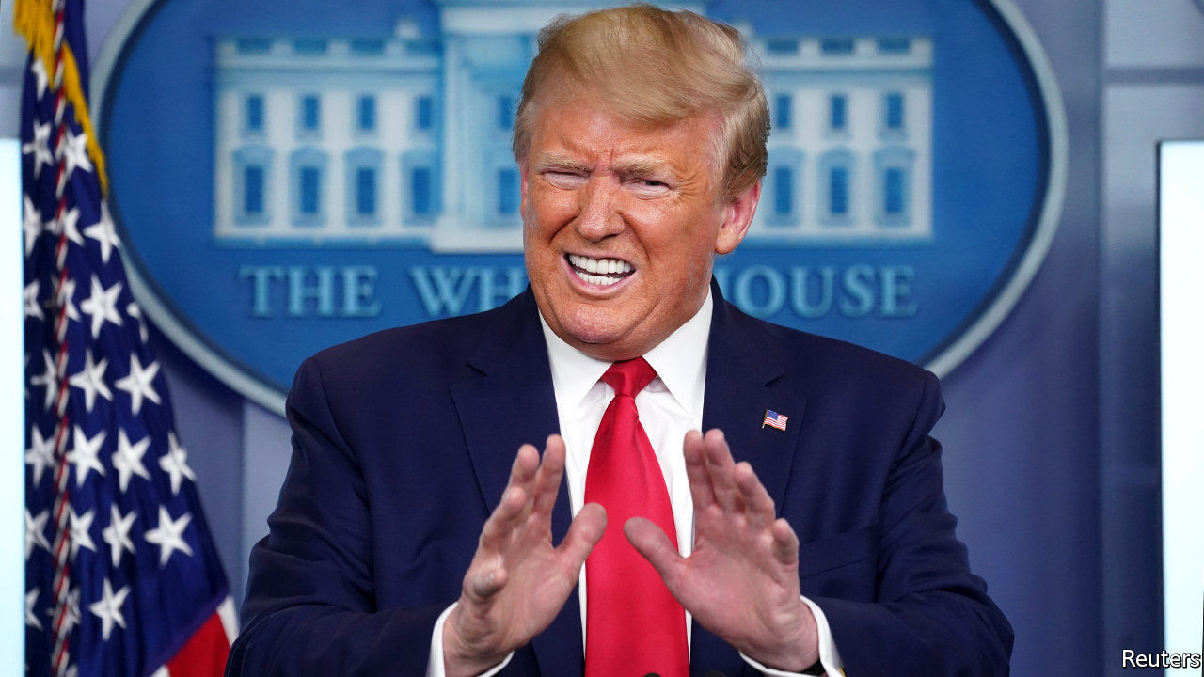

BACK AT THE beginning of April, the Office of Inspector General for the Department of Health and Human Services (HHS) released a report, based on a survey of hospital administrators across America, showing that hospitals were struggling to obtain covid-19 tests, personal protective equipment (PPE) and routine supplies such as loo paper. This did not please the president. At a press conference the same day, he mused, “It’s wrong…Where did he come from—the inspector general (IG)? What’s his name?” Her name was Christi Grimm, and on the evening of May 1st Mr Trump nominated her replacement.

Ms Grimm is the latest in a string of IGs whom Mr Trump has pushed aside. On April 3rd he removed Michael Atkinson, the intelligence-community IG, who alerted Congress to the whistle-blower’s complaint that led to his impeachment. On April 7th, Mr Trump ousted Glenn Fine from both a new role as chairman of the Pandemic Response Accountability Committee, created to oversee $2.2trn in federal relief spending, and from his post as acting IG for the Department of Defence. According to the sprightly Project on Government Oversight (POGO), a watchdog, 14 statutory federal IG positions are now vacant. Six have been so for more than a year.

The Inspector General Act of 1978, passed in Watergate’s wake, established IGs in 12 federal agencies. The number has since grown to 74. Of those, 36—generally those for larger organisations, such as cabinet departments—require a presidential nomination and Senate consent. The rest, largely for more obscure agencies such as the Pension Benefit Guaranty Corporation, are nominated by the agency’s boss, which can be a person or board.

However appointed, an IG’s role remains the same. They audit and investigate to prevent waste, fraud and abuse; they review legislation that pertains to their agency and promote administrative “economy, efficiency and effectiveness”. Although IGs are supervised by their agencies’ heads, they enjoy substantial independence. The agency boss cannot assign or block investigations; IGs have subpoena power and hire their own staff.

Ronald Reagan, the first president to inherit IGs, asked them all to resign when he took office. After an outcry from Congress, he relented and invited most back. Since then, presidents have tended to accept their predecessors’ IGs, and many—such as Mr Fine and Ms Grimm—have served in multiple administrations and agencies.

Mr Trump’s reasons for removing these IGs look vindictive. Ms Grimm released a report with conclusions that displeased him. Mr Atkinson said he believed Mr Trump sacked him because he “faithfully discharged [his] legal obligations”. As the Defence Department’s IG he looked into allegations that the Pentagon steered a large contract away from Amazon, whose boss, Jeff Bezos, Mr Trump loathes. (His report found the Pentagon’s procedure was “consistent with applicable law”, but reached no conclusion on White House interference because “presidential communications privilege” discouraged testimony.)

Mr Trump’s attack on independent watchdogs sparked a rare moment of bipartisanship. After Mr Atkinson’s removal, senators from both parties demanded substantive reasons from the White House. It has so far provided none. As for Mr Trump, he seems to see only the political headaches that IGs cause, not those they solve. When a lot of federal money is spent quickly—for instance, $2.2trn in covid-19 relief—inevitably some goes where it should not. Fraud and misappropriation risk embarrassing the administration. Capable IGs can sometimes catch it before it happens. But only if they have not been fired first.■

This article was downloaded by calibre from <https://www.economist.com/united-states/2020/05/09/donald-trumps-war-on-inspectors-general>

|  |  |  |  |
| --- | --- | --- | --- |
| Previous | Articles | Sections | Next |

|  |  |  |  |
| --- | --- | --- | --- |
| Previous | Articles | Sections | Next |

#### The ninth innings

# Steve King, Iowa’s most noxious politician, looks vulnerable

In each election cycle a few congressional races take on national importance. In 2020, Iowa’s fourth will be one

May 9th 2020 | CHICAGO

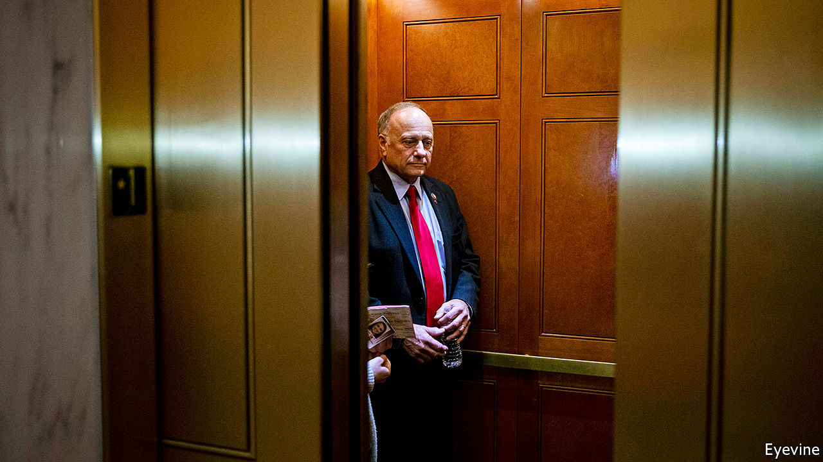

GIVING OFFENCE is Steve King’s stock-in-trade. The congressman for Iowa’s fourth district has suggested heaven is off-limits to gay people, spoken up for white supremacy and posed with Marine Le Pen, Geert Wilders and other far-right populists. He has likened immigrants to animals. Many are smugglers, he once said, adding that migrant men have “calves the size of cantaloupes” from lugging bales of drugs. A decade before Donald Trump proposed walling up the border, Mr King was America’s leading xenophobe. He even posed in Congress with a model of a concrete barrier topped with electrified wires. Zap foreigners, he said, to keep ’em out.

Rural Iowans have swooned at that, and at how he has enraged urban, liberal folk. His admirers say that in person he is charm itself. After nine election victories, usually by huge margins, he has seemed entirely secure. In some counties he takes over 70% of the votes, thanks to a base of conservative Christians—Dutch Reform, evangelical, Catholic and Lutheran. They like his opposition to abortion, even in cases of incest or rape. He has also picked up protest votes. As family farms have died and home towns have dwindled, Mr King’s rage at the modern world seemed fitting.

And yet, after 17 years, he looks vulnerable. Republican leaders no longer coddle Mr King. Corporate donors are rejecting him. He has a paltry $43,000 on hand for re-election and faces a tough primary election on June 2nd. One poll suggests that Randy Feenstra, an equally conservative state politician with $416,000 in the bank, is just behind him in a field of five. The party (and Dutch Reform voters) back Mr Feenstra. This week the US Chamber of Commerce endorsed Mr Feenstra, as have other Iowan bigwigs.

On the face of it Mr King’s troubles date to January 2019, when he wondered aloud why “white supremacy” was an offensive term. Party leaders booted him off the congressional committees he sat on, which include agriculture (a perch that matters a lot to Iowans). Mr Feenstra says that marked Mr King as a failure. In fact, Mr King’s views on white supremacy are hardly new. His feeble showing three months earlier in the 2018 election was, however. “He is no longer a safe bet,” says Rachel Paine Caufield of Drake University, because he only scraped a narrow victory over J.D. Scholten, a first-time Democratic opponent.

Mr Scholten is a personable, lanky ex-professional baseball pitcher, who counts as a celebrity in Iowa’s fourth congressional district. A Republican strategist says there is a risk that the Democrat would win in a rematch; worse, she says, if Mr King lingers then voters in November may shun other Republicans, notably Joni Ernst, a senator in a tight re-election race. Mr Scholten reckons that plenty of Trump supporters back him. He also notes that last time he got 25,000 more votes than there were registered Democrats. That put him within 3% of winning. He also raised $2.3m, a mighty sum for a first-timer who supposedly had no chance. This time the money is gushing even faster.

The reason for this, he argues, is not just voter fatigue with Mr King, but mounting anger about the economic troubles that were evident long before coronavirus hit. Mr Trump’s trade war with China has suppressed prices for soyabeans and other agricultural commodities. Bail-outs have largely been grabbed by the biggest farmers. The ethanol industry is in the dumps. Workers in the meat industry and livestock farmers have been walloped by coronavirus. Mr Scholten thinks voters are warming to his call for antitrust measures to break the grip of a few giant firms over agriculture in the state.

Is Mr King doomed? No one knows how virtual campaigning and the use of postal ballots in the primary (and maybe in November) may skew things. He may do better in a presidential year than he did in the mid-terms. The incumbent likes a fight, and says “never-Trumpers” backed by “coastal elites” are conspiring to stop him. He could yet win the primary. Mr Scholten is eager that he does, to get that re-run from two years ago. After all, in baseball a team gets nine innings; Mr King has had his. ■

This article was downloaded by calibre from <https://www.economist.com/united-states/2020/05/09/steve-king-iowas-most-noxious-politician-looks-vulnerable>

|  |  |  |  |
| --- | --- | --- | --- |
| Previous | Articles | Sections | Next |

|  |  |  |  |
| --- | --- | --- | --- |
| Previous | Articles | Sections | Next |

#### Going rogue

# America’s Supreme Court considers the rights of “faithless” presidential electors

The constitution is pretty clear that electors can do whatever they want. This is a problem for originalists

May 9th 2020 | NEW YORK

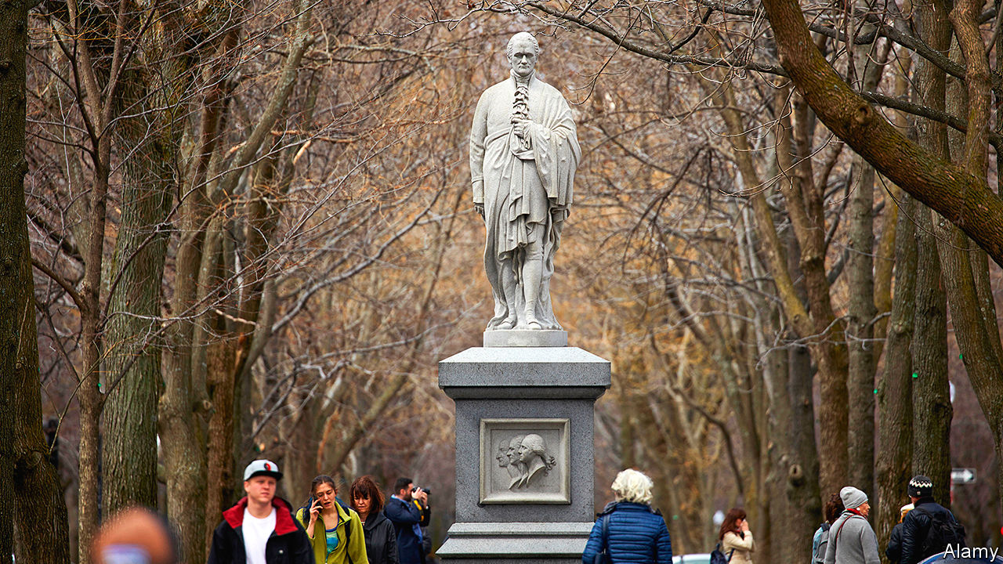

MOST AMERICANS would like to abolish the electoral college, the idiosyncratic institution that picks presidents six weeks after election day. Twice this century, candidates who received more votes in the nationwide tally watched their rivals move into the White House the next January. But in 2016, when Hillary Clinton, the popular-vote winner, was vanquished by Donald Trump, another electoral-college flashpoint came to light.

The controversy over whether America’s 538 electors are free to deviate from their pledges comes to the quarantined Supreme Court live by telephone on May 13th. So-called “faithless” electors are rare, but nothing new. Ninety electors since 1796 have cast a ballot for someone other than their party’s elected nominee, including 63 who sought to replace candidates who had died after the general election. Some 27 electors have simply scrapped their pledged candidate in favour of another.

These switches have never turned an election. But like the emoluments clauses, the rights of electoral-college members were a constitutional obscurity until the Trump era. Activists seeking to subvert Mr Trump’s victory in 2016 spurred seven electors to break their pledges—short of the 37 needed, but more than in any previous presidential election. Some defectors ran into legal trouble. Peter Chiafalo from Washington was fined $1,000 when he selected Colin Powell rather than Mrs Clinton in an attempt to throw the election to Congress. Michael Baca of Colorado found himself replaced with a more obedient elector when he tried to change his vote from Mrs Clinton to John Kasich, the former governor of Ohio. Both men say the constitution protected their right to do so.

The plaintiffs have ample support from the founding era. Alex Keyssar of Harvard’s Kennedy School, the author of a forthcoming book on the electoral college, says there is no “serious doubt” that the framers “envisioned electors as free agents, actors who would deliberate and could decide whom to vote for.” Lawrence Lessig, a Harvard law professor arguing the electors’ case, notes that Samuel Johnson defined electors as people who have “a vote in the choice of any officer”—quite distinct from “agents” or “delegates” who merely “act on behalf of others”. In the words of Alexander Hamilton in the Federalist Papers No. 68, electors would be chosen for their “discernment” and would be “most capable of analysing the qualities” of a potential president.

Congress, which tallies the electoral-college vote, has never refused to count faithless electors’ ballots. And until 2016, no state tried to stand in their way. But Washington state argues that the anomalous voters’ arguments “crumble under examination” and “pose dangerous risks for our democracy.” A Supreme Court ruling that turns electors into free agents—and subjects them to outside pressure following a close general election—could have “bizarre and dangerous consequences,” the state warns. Presidential elections where electors enjoy “unfettered discretion” would become “hollow exercises” and “profoundly undermine public confidence in the value of participating in our democracy.” Forty-five states and the District of Columbia have filed a court brief asserting their power to hold electors accountable for their votes. An “unbridled electoral college”, they say, would sow chaos.

Both sides cite an article by Keith Whittington, a political scientist at Princeton, who acknowledges the founders’ discretionary view of electors but argues the vision has long been passé. If the justices liberate electors to exercise their own judgment, Mr Whittington fears, they will ignore the electoral college’s evolution into a pro-forma ratifier of the state’s popular vote and could “throw the American constitutional system into crisis”.

This tension between principle and practicality makes Chiafalo v Washington compelling. Laurence Tribe of Harvard Law School, wonders if conservative justices—who claim to hew to the constitution’s original meaning—will uphold the founders’ understanding of the electoral college, even if it means empowering electors “in whose judgment the voters this November 3rd will not in fact be placing any trust.”

The justices are wise to tackle this now, rather than in the midst of the November election. But Edward Foley of Ohio State University, who filed a brief arguing that the founders saw electors as autonomous, cautions that America could still face a crisis rivalling Bush v Gore in 2000. Electors may go rogue no matter how the court rules, and states could try to replace their votes. “Can Congress decide which electoral votes to accept,” Mr Foley wonders, “or is Congress bound by the court?” ■

This article was downloaded by calibre from <https://www.economist.com/united-states/2020/05/09/americas-supreme-court-considers-the-rights-of-faithless-presidential-electors>

|  |  |  |  |
| --- | --- | --- | --- |
| Previous | Articles | Sections | Next |

|  |  |  |  |
| --- | --- | --- | --- |
| Previous | Articles | Sections | Next |

#### Social experiments

# ASAP is more important than affirmative action

Meet one of the least-known and most effective programmes to boost social mobility in America

May 9th 2020 | CHICAGO AND NEW YORK

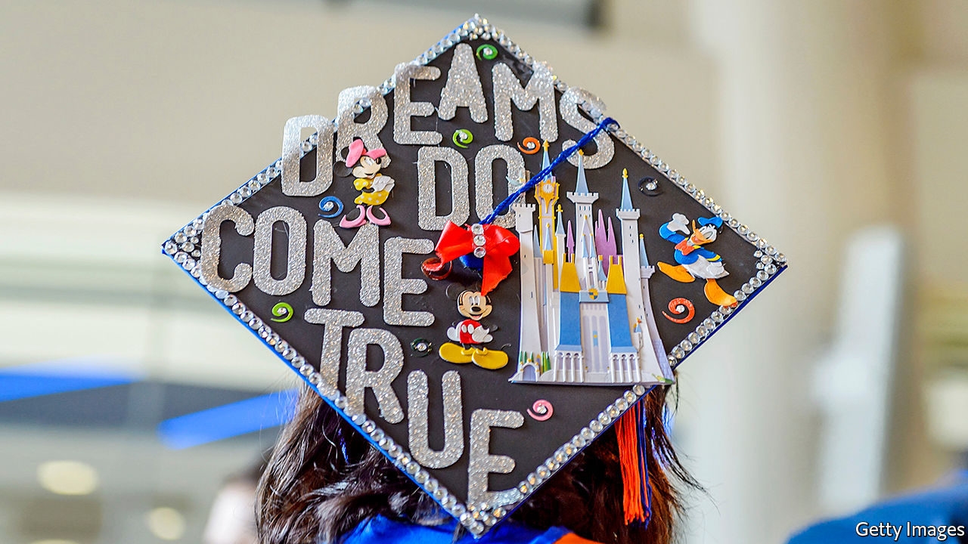

GROWING UP IN Morris Heights, a poor neighbourhood in the Bronx where violence was omnipresent, Joel Cabrera thought his future would be either “death or jail, because that’s what the outcomes are here”. Middle school was like “a juvenile-detention facility”. High school did not interest him enough to finish. Had he stopped there, he would have faced a life on the edge of penury. Among high-school dropouts nationwide, average earnings are only $600 a week. To avoid that, Mr Cabrera enrolled in courses offered at his local community college. There he came across a scheme called ASAP (“Accelerated Study in Associate Programmes”) that sought to push pupils like him—city residents without family wealth or familiarity with universities—to complete two-year degrees.

ASAP is designed to address a simply stated problem. Many low-income minority students enroll in college. But few finish. Only 34% of black men finish their bachelor’s degree within six years, compared with the average rate of 60%. Those individual decisions to drop out collectively amount to society-wide stratification. The racial gaps in earning college degrees have hardly budged since 1995.

Simple as the problem may be to describe, the approach taken by ASAP is complicated. Rather than target one thing that derails students, the programme tries to tackle many at once. Pupils are given financial help, including money for textbooks and free MetroCards to get around the city. They must meet academic and career advisers several times a month. They are tracked by a data operation that detects pupils in precarious positions before they quit. This worked for Mr Cabrera, who continued to a bachelor’s degree, a few internships and a series of good jobs after that.

He is not unusual. Students in the ASAP programme have a three-year graduation rate of 53%—more than double the 25% rate in the rest of the City University of New York (CUNY) system and close to triple the national average. In 2015, when external researchers tested these impressive outcomes by randomly assigning students—the gold standard for social science—they found effects of the same magnitude. The greatest gains went to black and Hispanic students, as well as those receiving Pell grants (most of which go to students with annual family incomes of $20,000 a year or less). Since then, the programme has grown and community-college systems across the country are trying to replicate it.

In New York the average cost of the additional supports amount to $3,500 per student. But such schemes benefit college finances too, by increasing their revenue. Georgia State University’s programme to provide micro-grants, which began in 2012, seemed to boost both graduation rates and university finances. “That’s actually a big driver of this completion movement [because] enrolments are not going up,” says Patrick Methvin of the Gates Foundation, which has funded research in the field. “The economics on this are going from nice to necessary.” Though not small, the cost also looks like a pittance compared with many ideas to alleviate intergenerational poverty. A child born poor who gets just a high-school degree has a 50% chance of remaining in poverty as an adult; with a college degree, the chances decline to 17%.

More evidence is accumulating to show that the approach works beyond New York. Starting in 2015, three community colleges in Ohio imported the ASAP model, with some modifications (such as offering money for petrol rather than for the subway). A randomised controlled trial by MDRC, a research outfit, found it nearly doubled the chances of completing degrees (35% compared with 19% in the control group). Two community colleges in West Virginia are set to try the system next. “We’re quite pleased to see that the model has been attempted in other places, and the numbers tend to look good too,” says Félix Matos Rodríguez, the chancellor of the CUNY system.

Perhaps the strongest corroboration that the ingredients are indeed right comes from Chicago, where a similar programme has improved the lot of students in the local community-college system. One Million Degrees (OMD), a project started in 2012, provides tutoring, professional development and cash grants to qualifying students: 80% of them black and Hispanic, 90% qualifying for Pell grants and 60% first-generation students. It is similar to the New York programme because, “if you really ask students what they need and observe what the challenges are”, you arrive in a similar place, says Paige Ponder, the organisation’s CEO. Initial results of a randomised controlled trial conducted by the University of Chicago Poverty Lab of 4,000 applicants found that participants were 35% likelier to persist through the first year of college. Talk to the students in the programme, and you find that no single element boosts their chances of finishing university as much as the whole cocktail.

This well-tested, cost-effective scheme has largely escaped national attention. To many, the whole question of equity in American universities can be reduced simply to the racial make-up of the Ivy League institutions. Besides ignoring the incomes of students at those colleges, who tend to be rich whatever their race and colour, this also assigns central importance to the controversial affirmative-action policies of highly selective universities. Although the share of black students attending Harvard is symbolically important, the situation of those happy few is divorced from the continued social immobility among successive cohorts of black students. Endless debate about affirmative action—which could soon wind up before the Supreme Court yet again—is a diversion from a less controversial method that works. ■

This article was downloaded by calibre from <https://www.economist.com/united-states/2020/05/09/asap-is-more-important-than-affirmative-action>

|  |  |  |  |
| --- | --- | --- | --- |
| Previous | Articles | Sections | Next |

|  |  |  |  |
| --- | --- | --- | --- |
| Previous | Articles | Sections | Next |

#### Lexington

# Ode to the shopping mall

How palatial shops, threatened by the virus, shaped America

May 7th 2020 |

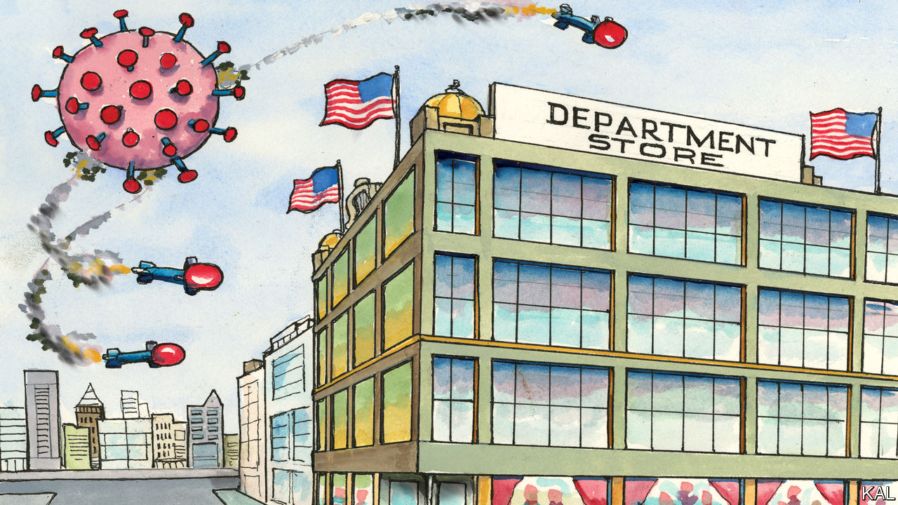

IN ALMOST all its modern crises, America has looked to its merchants for leadership. In 1914 John Wanamaker, the greatest retailer of the age, made headlines by dispatching 2,000 tons of food aid to Belgium—then suggesting America buy the little country to make the peace. In 1942 his New York rival, Macy’s, announced it was cancelling its annual Thanksgiving parade and donating 650 pounds of balloon rubber to the war effort: “We’ve enlisted!” Department stores, America’s temples of commerce, could always be relied upon to sell war bonds with panache. In a Younkers store in Des Moines, Iowa, a coffin for Adolf Hitler was lowered mechanically from the ceiling to the floor whenever a sale was made.

Masters of self-promotion, the great retailers did not suffer by being associated with patriotism. Yet rather than deplore their opportunism, Americans celebrated the consumption it was designed to promote. During the Great Depression, they rallied to the retailers’ “Buy Now” campaigns. Shopping was not merely the surest way to boost the economy; it was urbanites’ main community activity. As recently as September 2001, President George W. Bush hinted at that dual truth when urging Americans to shrug off terrorism and hit the stores. By contrast, the current crisis is the first in over a century in which retailers have provided no comfort.

Online ones are thriving but unloved. The biggest, Amazon, is battling damaging headlines over its patchy service and treatment of workers. Traditional retailers are meanwhile looking into the abyss. This week J.Crew filed for bankruptcy. JCPenney, whose low-cost innovations helped it survive the Depression and proved inspirational to one of its employees, Sam Walton, founder of Walmart, is also struggling under a heavy debt load. Macy’s, America’s biggest department store by sales, lost its place in the S&P 500 last month while all its 775 stores were closed. It reopened 68 this week but expects them to do around 15% of their regular trade: more a death rattle than a recovery. By one estimate, over 300 department stores could go under by the end of next year.

Losing your custom overnight will do that. Yet bricks-and-mortar retailers were struggling long before the virus struck, against e-commerce and other stresses, including Donald Trump’s tariffs, which many decried. The president was never going to turn to them as Herbert Hoover did to his friend J.C. Penney in 1929. Yet a weary sense of inevitability about legacy retail’s demise should not obscure how traumatic a development it is. Many of America’s shuttered cities were shaped by department stores: they would not have developed as they did, or at all, without them. Nor would the consumer economy; nor elements of American democracy.

The emergence of palatial, multi-line stores in New York, Chicago and other big cities in the mid-19th century was a first-world phenomenon, pioneered in Europe. Yet merchants such as Wanamaker, who opened his first department store in Philadelphia in 1876, added American characteristics. Their stores tended to be bigger than European ones and packed with extravaganzas; Wanamaker’s flagship store boasted 2m square feet and the world’s biggest organ. America’s retailers also poured their huge profits into advertising, which shored up the free press. And they were more egalitarian than Europeans, especially to women, as both customers and employees. By 1918 42% of Macy’s buyers were women.

Many promoted their enterprises as morally improving. Wanamaker, who also formed the world’s biggest Sunday school, described his stores as “beautiful fields of necessities”. With steepling cast-iron structures and acres of plate-glass, flooding them with light, they were America’s answer to Europe’s cathedrals.

Such stores’ impact on cities surpassed even their footprints. They feminised and commercialised them. They fostered civic identity as well as consumerism. To be from Philly was to know and shop at Wanamaker’s. Thereby the great downtown stores became synonymous with the forces that had fuelled their growth, industrialisation, urbanisation, democratisation. To this day famous names such as Macy’s, which retains its giant flagship store in Herald Square, Manhattan, retain an exalted place in the culture: over 3m turn out to watch its annual parade.

This is despite the fact that most Macy’s and other department stores are now in the suburban malls that began mushrooming after the second world war. They are less loved. Where Hollywood invariably depicts downtown stores as places of innocence and Santa Claus, it portrays malls as anonymous and prone to zombie attack. Those contrasting views are linked—the suburban expansion having devastated many cherished downtown areas. But the contrast is also unjust. Most Americans seem to associate malls with relaxation and family—a truth your columnist learned while staying on American bases in Afghanistan and Iraq. All the bigger ones had a rudimentary mall, selling fast food, sportswear, cheap carpets and Celtic swords, where the soldiers loved to saunter and unwind. Even conventional malls build social capital in a way it is hard to imagine e-commerce ever could.

## Shop till you drop

Moreover, following a period of intense competition in the 1980s, America’s malls have increasingly come to resemble the extravagant old emporia. New Jersey’s $5bn American Dream mall, which opened last October, has an indoor ski slope, Legoland and Ferris wheel. The Grove shopping centre in Los Angeles takes its homage to early retail even further. It is a mock-up of a 20th-century town centre, including a tram-line and Art Deco cinema.

Such enterprises aim to retain a place in American life even as face-to-face retail recedes from it. The developers of the American Dream mall aimed to let only 45% of their area to retailers before the pandemic—and have since slashed the figure to 30%. That would seem realistic. Except, what if the virus persuades a generation of Americans to stay at home for their entertainment, as well as their shopping? And what kind of America would that be?■

This article was downloaded by calibre from <https://www.economist.com/united-states/2020/05/07/ode-to-the-shopping-mall>

|  |  |  |  |
| --- | --- | --- | --- |
| Previous | Articles | Sections | Next |

|  |  |  |
| --- | --- | --- |
| United States | Sections | Asia |

The Americas

El Salvador: The rise of the house of Bukele

.

A battered brand: The synonymous crown affair

.

Bello: The long wait

.

|  |  |  |
| --- | --- | --- |
| United States | Sections | Asia |

|  |  |  |  |
| --- | --- | --- | --- |
|  | Articles | Sections | Next |

#### Hungry house

# Nayib Bukele’s power grab in El Salvador

A young president is weakening democratic institutions and empowering his family

May 9th 2020 |

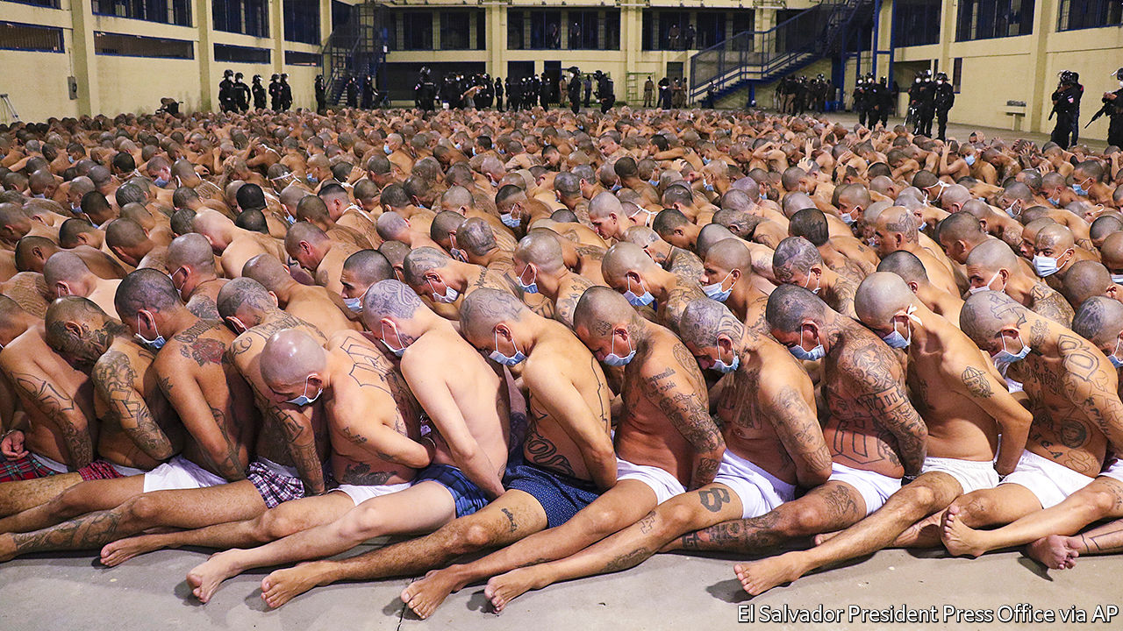

ON MARCH 13TH Carlos Henríquez Cortez returned to El Salvador from a two-day business trip in Guatemala. The 67-year-old engineer planned to quarantine at home. He knew that, to control the spread of covid-19, the government was holding returning travellers and visitors in “containment centres”. The elderly were exempt, or so Mr Henríquez thought. Airport guards detained him anyway. His containment centre had no toilet paper or space for social distancing, he told his wife. Mr Henríquez developed a fever. Authorities told him he could not have covid-19 because no cases had been reported in Guatemala. In hospital he tested positive for the disease. He died on April 22nd.

Mr Henríquez was a casualty of El Salvador’s lockdown, which is among the strictest in the world. The 2,394 Salvadoreans detained since April 6th for violating quarantine have faced 30 days of confinement. Other countries, such as Peru, Panama and Russia, detain violators for up to 48 hours. The architect of El Salvador’s measures is Nayib Bukele, the country’s 38-year-old president. He claims that his draconian lockdown is the only way to protect Salvadoreans from the pandemic. His critics think he is using the crisis to destroy the institutions that upheld democracy since the end in 1992 of a ruinous civil war.

Mr Bukele, a law-school dropout who spent much of his 20s managing nightclubs in which his family had invested, has a bond with El Salvador’s poor but aspirational youth. He seldom wears a suit and tweeted every 25 minutes on average during April. As mayor of San Salvador, the country’s capital, he rebuilt the city’s central squares. That wrested control from gangs, he claimed. In last year’s election campaign he fulminated against the corrupt rule of the two parties that have alternated in power since the war, the left-wing FMLN (to which he once belonged) and the right-wing Arena party.

Emigration from El Salvador has dropped since Mr Bukele became president. That may be in part because Salvadoreans expect him to reduce the crime and poverty that have driven many abroad. Four-fifths approve of his handling of the pandemic. His New Ideas party looks set to win big in legislative elections, which are due in February 2021.

But Mr Bukele does not seem content to govern through ordinary democratic means. The first warning was what Salvadoreans call “9F” (for February 9th). At loggerheads with the Legislative Assembly, which is still dominated by the FMLN and Arena, over financing for his security programme, Mr Bukele entered the chamber with gun-toting soldiers and sat in the speaker’s chair. Covid-19 emboldened the president further. When the Supreme Court issued rulings, starting in March, that he could not enact his quarantine without permission from the legislature, Mr Bukele pressed ahead. Salvadorean lives matter more than the opinions of “five people”, he tweeted. This week the legislature belatedly gave him the authorisation.

More brazen was his behaviour when the legislature met to override his veto of a bill that would repatriate citizens stuck abroad. A deputy coughed. Minutes later, Mr Bukele tweeted that his epidemiological team “had detected a significant suspicion of covid-19” in the chamber and that it should be shut down. So many frightened lawmakers left that the assembly lost its quorum. The president acted “like the kid who didn’t do his homework pulling the fire alarm at school”, says a businessman.

Like many a caudillo, Mr Bukele entrusts power mainly to members of his family. His wife, Gabriela, picked much of the cabinet. Mr Bukele’s uncle is commerce secretary. The father of his godson runs the export-promotion agency. Childhood friends control the port authority and the agriculture ministry. In March Mr Bukele’s party elected a new president—his cousin.

People who deal with his government say his most influential associates are his brothers: Karim, Ibrajim and Yusef. Some observers see Nayib as a budding dictator. But his presidency is more a “corporatist family project” to establish the Bukeles as one of the country’s most powerful clans, says an economist.

Salvadoreans’ tolerance for that project will depend on whether the president makes headway in solving problems that have driven much of the population to emigrate. The signs are not encouraging. The murder rate, which began falling in 2015, has continued to do so under Mr Bukele. But for four days in April the number of killings jumped. The reasons are unclear.

The president responded harshly. He tweeted that police could kill gangsters to defend themselves or others and ended the policy, in place since 2004, of keeping the two main gangs apart in prisons. In a theatrical twist on April 25th the government forced hundreds of gangsters, stripped to their underwear and with hands tied behind their backs, to huddle in rows. Their face masks reassured no one. When foreign observers objected, Mr Bukele tweeted that “it is incredible, the international support that the maras [gangs] have.”

The covid crackdown has not made citizens safer than those in more relaxed countries nearby. El Salvador’s 695 confirmed infections and 15 deaths are comparable to the toll in Guatemala, a much bigger country. To soften the economic effect of the lockdown the government promised one-off payments of $300 to 1.5m poor households, triple what many workers earn in a month. But with public debt at 70% of GDP it cannot afford much largesse. The next round of aid will take the form of 2m food parcels.

Mr Bukele’s pre-pandemic ambitions are slipping away. A five-year plan drafted by consultants “fell apart”, says an insider. No progress has been made on pledges to raise the minimum income-tax threshold and to spruce up 50 town centres. A Commission Against Impunity, created in September, never looked like a serious effort to fight graft. It lacks the money and legal structure to do its job. The pandemic has helped to extend Mr Bukele’s honeymoon. It may not last much longer. ■

This article was downloaded by calibre from <https://www.economist.com/the-americas/2020/05/09/nayib-bukeles-power-grab-in-el-salvador>

|  |  |  |  |
| --- | --- | --- | --- |
|  | Articles | Sections | Next |

|  |  |  |  |
| --- | --- | --- | --- |
| Previous | Articles | Sections | Next |

#### The synonymous crown affair

# As cases of coronavirus grow, what about cases of Corona beer?

Mexico’s beloved brand must now share its name with a pandemic

May 4th 2020 | MEXICALI



Editor’s note: The Economist is making some of its most important coverage of the covid-19 pandemic freely available to readers of The Economist Today, our daily newsletter. To receive it, register [here](https://www.economist.com/newslettersignup). For our coronavirus tracker and more coverage, see our [hub](https://www.economist.com/coronavirus)

PICTURE THIS. You are lounging on a faraway beach and have nothing to do but listen to the sound of rolling waves. The confining walls, niggling tasks and dreary routines in your life are but distant memories. In their place, palm trees rustle and turquoise water stretches to the horizon. A beautiful somebody relaxes at your side, safe and free.

If this sounds like an upgrade on life in lockdown, you now know why the marketing for Corona beer has been so successful. In the 1980s Grupo Modelo, the Mexican brewer that created it, began exporting Corona to the United States, projecting an image of “fun, sun and beach”. Unlike branding for other beers, which merely invited drinkers to unwind, Corona offered escape. Save for Huawei, a Chinese telecoms mammoth, Corona is the most valuable global brand not from the rich world, according to Interbrand, a consultant. Or it was: 2020 has been riddled with rotten luck.

Start with a brutal clash of names a century in the making. Grupo Modelo began producing Corona in Mexico City in the 1920s. The crown that adorns the beer’s label and bottle-cap first appeared in 1963. Around that time, virologists crouched over microscopes in southern England identified a new kind of pathogen in humans. Its distinctive petal-like patterns on its edges “recall[ed] the solar corona”, wrote Nature in 1968. Soon afterwards, Corona beer began to conquer the world; by 2018, estimated Forbes, its sales reached $6.6bn. The coronavirus group bided its time.

In 2020, thanks to the pandemic, the word “corona” has ceased to be the plaything of marketeers at AB InBev, the giant brewer that bought Grupo Modelo in 2013. The term is now a battlefield on which glamour and calamity collide. Whether “corona”, a year or two from now, elicits thoughts of beaches and limes or of hospital beds and quarantines, is potentially a question worth billions.

The first shots fired in this battle were jokes. As the coronavirus spread, amateur comedians flocked to the images of far-flung exotica posted daily on Corona’s Instagram account. Some sardonically urged the brewer to “please stop killing innocent people”. Others suggested that Corona change its name to something with fewer negative connotations, “like Ebola”. Corona’s social-media team stopped posting on March 13th. It is safe to say that a lengthy furlough awaits them.

Could the bad vibes from the coronavirus prove more than a passing joke? Many experts in marketing psychology are sceptical. The term “coronavirus” will probably become less salient with time. “Corona” is not uniquely tied to the beer, which shares its name with a neighbourhood in New York and the sun’s aura; corona is also Spanish for “crown”. It may help that Corona is drunk mostly by the young, many of whom regard the pandemic as a nuisance rather than a trauma.

And yet Corona’s custodians must wonder if their beer will get through this unscathed. A brand’s power lies in its ability to trigger subconscious associations in consumers’ minds. But who can now hear the word “corona” without thinking of plague? At best, that may dilute Corona’s escape-to-the-beach message. At worst, it could drown it, getting consumers to think of suffering rather than pleasure, quarantine boredom rather than coastal escape, and of disease or bad hygiene. Many cite the unfortunate precedent of Ayds, a weight-loss candy whose sales plummeted in the 1980s. Its makers changed its name.

There are some ominous signs. This year Corona’s “buzz score”—a measure compiled by YouGov, a pollster, tracking whether people have heard positive and negative things about brands—has fallen by a third, to its lowest ever. But any evidence of lasting damage to the brand would be slow to emerge, points out Tom Meyvis, a professor of marketing at the Stern School of Business, at New York University. Market research amid a lockdown is unreliable, as is purchasing behaviour during a global recession. Sales at Constellation Brands, which makes and distributes Corona for drinkers in the United States, were “superb” in March, Bill Newlands, its chief executive, told CNBC, though “some of that’s obviously pantry loading” ahead of a lockdown.

Those who know Corona note that it has defied the odds to reach the top. Mexico had no beer-making pedigree with which to win foreign drinkers’ trust, but images of Mexican beaches soon became a novel, glamorous and world-beating selling-point. Corona’s transparent glass bottle causes the beer to spoil easily when exposed to sunlight, but a “nothing to hide” marketing slogan was a hit. On hearing that Californians were putting a slice of lime in the bottle before drinking it, Corona’s master brewers were horrified it would ruin the taste and wanted it stopped. It is now a cherished rite for drinkers across the world.

The beer’s success abroad has mattered deeply for its homeland. Its rise occurred in tandem with the opening of the Mexican economy. Corona took advantage of loosening trade barriers to enter new markets, and became a national ambassador for Mexico in faraway places. By the 1990s the secretary for commerce, Jaime Serra Puche, was boasting that “Mexico exports two fluids: crude oil and Corona”. It was perhaps the first product that asked Americans and others to pay more, rather than less, for something with a “Made in Mexico” label. That forged a path for other Mexican wares, from tequilas to tacos, to be branded as “high-end”.

It is a happy story curtailed by the unlucky events of 2020. But Corona’s woes this year go beyond its name. On March 21st and 22nd a controversial Corona brewery for Constellation Brands, already under construction in Mexicali, on Mexico’s border with California, was put to a public vote. Opponents said the brewery used too much water in a dry region. Constellation said its pledge to pay for fixing the region’s leaky pipes meant the water supply would be improved rather than imperilled. Mexicali’s mayor, Marina del Pilar Ávila Olmeda, said the debate around the brewery “has been politicised”, and that a decision to scrap it would affect the “legal certainty” that foreign investors seek in Mexico and cities like Mexicali. Turnout for the vote, at just 36,781 in a city of nearly 1m people, was itself depressed by the coronavirus. Of those, 76% voted to scupper the plant.

In the days before the referendum your correspondent visited the brewery site, 20 minutes’ drive south of Mexicali’s centre. The towering tanks were already built and painted creamy white, with a strip of Corona Gold on the top. Fields of dirt were soon to become car parks and offices for the plant’s 3,000 workers. Constellation had already spent $900m on the $1.4bn project, which now cannot be completed. Constellation, which has two other breweries in northern Mexico to serve thirsty Americans, is now unsure where—or whether—to build a replacement. For the first time, the Corona Americans drink might not be brewed only in Mexico.

Worse was to come for Corona in April, when the Mexican government belatedly ordered the closure of all non-essential activities. Unlike making wine in France or beer in the United States, brewing in Mexico was declared “non-essential”. Within weeks the national supply of Corona dried up. Your correspondent’s local supermarket in Mexico City has neither Corona nor any other domestic brew left on its shelves; there are only a few imported beers to choose from. Some of Corona’s moribund breweries have taken to filling up their iconic clear bottles with drinking water and delivering them to the poor.

But what is Corona to do about its biggest headache? For now both AB InBev and Constellation are staying silent. Any public recognition of the association between the virus and the beer is a no-no. “By acknowledging it you strengthen it,” says Mr Meyvis. To change the name of such a powerful brand would be dangerous, too. It would not only undo decades of hard work, but also destroy the beer’s sense of authenticity and history—which customers also prize. But if damage to the brand is unavoidable, its owners could do worse than pick Coronita, the beer’s name in Spain (the result of a trademark dispute). It preserves the brand’s identity, and it might just be enough of a change to get drinkers’ imaginations back on the beach, where they belong.■

Dig deeper:  
For our latest coverage of the covid-19 pandemic, register for The Economist Today, our daily [newsletter](https://www.economist.com/newslettersignup), or visit our [coronavirus tracker and story hub](https://www.economist.com/coronavirus)

This article was downloaded by calibre from <https://www.economist.com/the-americas/2020/05/04/as-cases-of-coronavirus-grow-what-about-cases-of-corona-beer>

|  |  |  |  |
| --- | --- | --- | --- |
| Previous | Articles | Sections | Next |

|  |  |  |  |
| --- | --- | --- | --- |
| Previous | Articles | Sections | Next |

#### Bello

# Antonio Di Benedetto and the Latin American condition

Zama, a novel of solitude and self-destruction

May 9th 2020 |

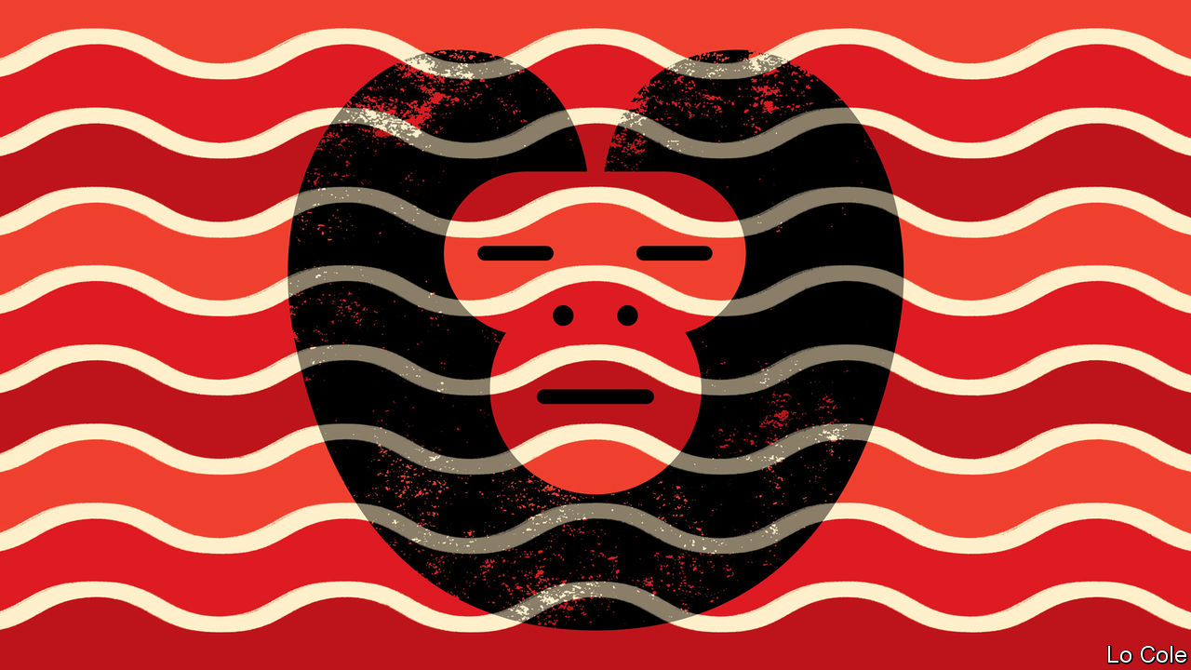

IT IS 1790 in Asunción. Today the capital of Paraguay, it was once an early colonial hub but by the end of the 18th century had become a backwater, the end of the line in a Spanish empire fast approaching the end of its time. Diego de Zama, the legal adviser to the governor, is a man with a brilliant past but, he confesses, now “subjugated by circumstances and without opportunities”. While he waits and waits for a half-promised posting, he is tortured by his desire for illicit love despite his inner promise of fidelity to his wife and children, distant by “half the length of two countries and the width of the second”.

So begins “Zama”, a short novel by Antonio Di Benedetto, published in 1956. Di Benedetto was born and lived for much of his life in Mendoza, an Argentine city in wine country at the foot of the Andes. He shunned the cosmopolitan cultural world of Buenos Aires. He preferred a life on the periphery. Though his work was appreciated in literary circles in Argentina and was translated into several European languages, only in 2016 was “Zama”, his masterwork, published in English (in a fluent translation by Esther Allen). Di Benedetto’s name is unmentioned in many histories of Latin American literature. In future ones it is likely to figure large.

In “Zama” he created a haunting novel about solitude and self-destruction that is both earthly and oneiric. Di Benedetto was influenced by Dostoyevsky and Kafka. But he also had much to say about the Latin American condition. “Zama” is dedicated to las víctimas de la espera, which Ms Allen translates as “the victims of expectation”, though the Spanish also means “the victims of waiting”. That could be said to sum up a region whose people are still waiting expectantly for progress and prosperity, or simply for a necessary piece of paperwork, a hospital appointment or for the bus.

The book starts with a graphic image. In the eddies of the great river “a dead monkey, still whole, still undecomposed, drifted back and forth with a certain precision…there he was, ready to go and not going. And there we were.” They were there in a world of exuberant nature, celebrated in many Latin American novels of the past but, in “Zama”, a looming Freudian threat. Spiders, snakes, bolting horses and savage dogs appear. There is a threat of sudden violence.

They were there, too, in a geographical vastness, but in a social world of cloying smallness, of daily encounters “repeated over many months and long years”. In this world, recognisable still in the provinces in Latin America, money and race count for much but status even more. Indians and mulattos are exploited and subordinate, but also valued for their knowledge (the shaman more so than the surgeon, for example). Zama is an americano, of Spanish parents but born in America and thus barred from the top posts in the Spanish administration. As Ms Allen notes in her preface, it will be the americanos who soon afterwards rise against the metropolis and lead the battle for independence. There is a glimmering of what is to come in the novel’s final section.

The Spanish empire looked stronger than it was. Zama’s salary goes unpaid for many months, as sometimes happens to contemporary civil servants in Latin America. The law had little relevance to local realities. Zama’s structured life gradually disintegrates. Like the borders of the empire, the boundaries of his self seem fluid.

An early admirer said of “Zama” that it is “a deliberate refutation of the very idea of the historical novel”. In place of baroque magic realism, Di Benedetto writes in sharp, modern, deceptively simple prose. Without proposing to be so, he was a bridge between Jorge Luis Borges, with his mental labyrinths, and Roberto Bolaño, a peripatetic Chilean whose work explored both the condition of the writer and chronic violence in Latin America. Bolaño recognised a debt, paying fictional homage to Di Benedetto in a short story. More recognition has come with a film of “Zama” in 2017 directed by Lucrecia Martel, an Argentine.

In an extraordinary twist, Di Benedetto’s own life came to resemble that of Zama’s final years. He was politically moderate. Yet hours after the coup in Argentina in 1976 he was arrested, jailed, tortured and subjected to four mock executions. Released after 18 months, he went into exile in Spain. “I’ll never be sure whether I was jailed for something I published,” he said later. “The uncertainty is the worst of the tortures.” That, too, is a statement that many Latin Americans might identify with.

This article was downloaded by calibre from <https://www.economist.com/the-americas/2020/05/09/antonio-di-benedetto-and-the-latin-american-condition>

|  |  |  |  |
| --- | --- | --- | --- |
| Previous | Articles | Sections | Next |

|  |  |  |
| --- | --- | --- |
| The Americas | Sections | China |

Asia

Developing countries and covid-19: Bargain abatement

.

Politics in Kazakhstan: Bye-bye Nazarbayeva

.

Press freedom in the Philippines: Blank screen

.

Afghanistan and covid-19: Gunmen with thermometers

.

Thailand’s armed forces: In the doghouse

.

Sunbathing in Indonesia: Hot spot

.

Banyan: Lockdown lock-up

.

|  |  |  |
| --- | --- | --- |
| The Americas | Sections | China |

|  |  |  |  |
| --- | --- | --- | --- |
|  | Articles | Sections | Next |

#### Bargain abatement

# Vietnam and the Indian state of Kerala curbed covid-19 on the cheap

Their secret is quick and efficient public-health systems

May 9th 2020 | DELHI

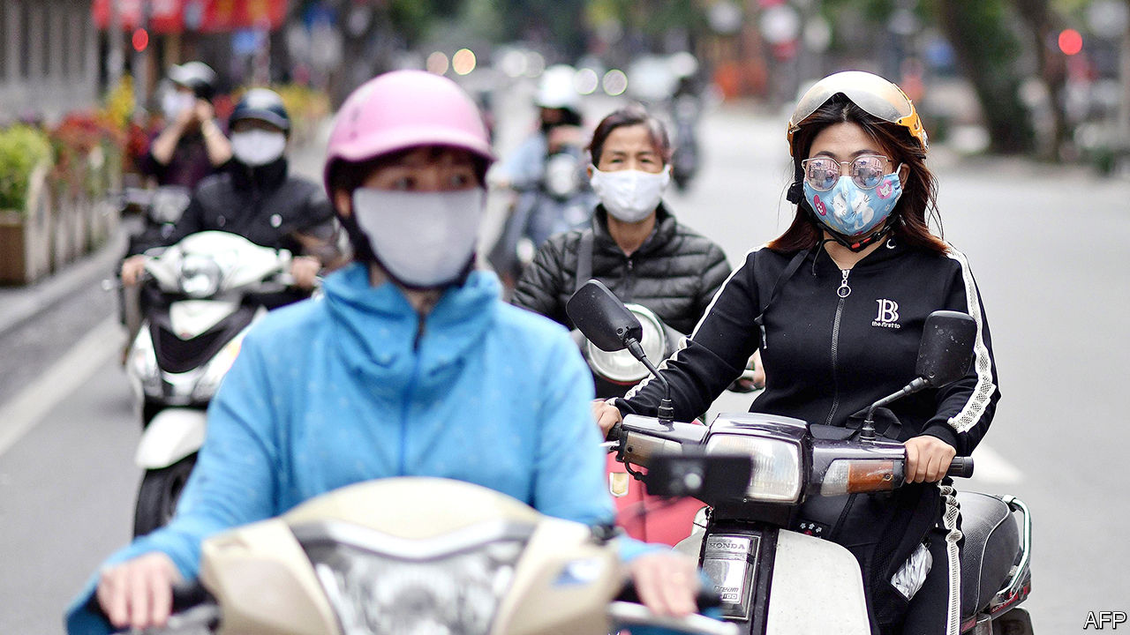

Editor’s note: The Economist is making some of its most important coverage of the covid-19 pandemic freely available to readers of The Economist Today, our daily newsletter. To receive it, register [here](https://www.economist.com/newslettersignup). For our coronavirus tracker and more coverage, see our [hub](https://www.economist.com/coronavirus)

THE PHONE rings and a doctor picks up. “Sir, we’ve run out of ventilators. What do we do when more patients come?” Soon after, a grim medic explains that the disease they are battling kills three in four victims. There is no vaccine or treatment.

Such talk has become commonplace in the time of covid-19. Yet this scene has nothing to do with the current pandemic. It is the opening of “Virus”, a film that won critical acclaim last year in Mollywood, as the Malayalam-language cinema of the Indian state of Kerala is sometimes known. Styled as a thriller, it tells the true story of the struggle to contain an outbreak of the Nipah virus in 2018. The bat-borne pathogen killed 21 out of the 23 people infected. But Kerala tamed Nipah within a month, adopting an all-hands approach that included district-wide curfews, relentless contact-tracing and the quarantine of thousands of potential carriers.

Kerala has used the same simple, cheap tools to fight covid-19, with similarly stellar results. It was the first of India’s 36 states and territories to report a covid-19 case, a medical student who returned in January from Wuhan, the Chinese city where the epidemic started. By March 24th, when Narendra Modi, the prime minister, declared a nationwide lockdown to combat the disease, Kerala accounted for a fifth of India’s cases, more than any other state. Just six weeks later, it ranks 16th. As India’s active caseload has risen by a multiple of 71, Kerala’s has fallen by two-thirds (see chart). It has suffered just four deaths. Many of Kerala’s 35m people work abroad; 20 times more of them have died of the illness in another country than have at home.

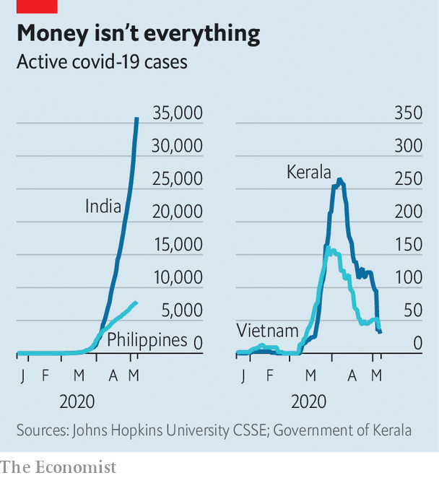

With 95m people, Vietnam is a much bigger place. In dealing with covid-19, however, it has followed a strikingly similar script, with an even more striking outcome. Like Kerala it was exposed to the virus early, and saw a surge of infections in March. Active cases also peaked early, however, and have since tumbled to a mere 39. Uniquely among countries of even remotely similar size, and in contrast to such better known covid success stories as Taiwan and New Zealand, it has not yet suffered a single confirmed fatality. The Philippines, a nearby country of roughly the same population and wealth, has suffered more than 10,000 infections and 650 deaths.

Like Kerala, Vietnam has recently battled deadly epidemics, during the global outbreaks of SARS in 2003 and of swine flu in 2009. Vietnam and Kerala both benefit from a long legacy of investment in public health and particularly in primary care, with strong, centralised management, an institutional reach from city wards to remote villages and an abundance of skilled personnel. Not coincidentally, communism has been a strong influence, as the unchallenged state ideology of Vietnam and as a brand touted by the leftist parties that have dominated Kerala since the 1950s.

Some suggest that having relatively young populations may have lessened the toll of the disease in both places. Others speculate that universal inoculation with BCG, a vaccine against tuberculosis and leprosy, has made locals less susceptible. Todd Pollack, a specialist in infectious diseases based in Vietnam, says the reasons for its success are simpler: “Countries that took early, aggressive action, using proven methods, have severely limited the virus. If you reduce it fast enough, you never reach the point of exponential growth.”

Mr Pollack agrees that cultural factors may have aided Vietnam’s effort, such as a willingness to study and learn from China, social comfort with wearing protective masks, acceptance of being isolated away from home and respect for expert advice. He admits that the age profile of Vietnamese covid-19 carriers has been generally younger than elsewhere, giving more resistance to illness. But that is largely because health workers swiftly and effectively isolated carriers, so protecting older people.

Before the end of January Vietnam had declared a national emergency, formed a top-level steering committee chaired by the deputy prime minister and begun screening passengers and restricting movement. The effort to trace the contacts of infected travellers drew on personnel from the army and civil service as well as health workers. At one large hospital in Hanoi, the capital, investigators tracked and tested some 5,000 people. As early as mid-February, Vietnam had imposed stringent lockdowns on some districts, with communes of as many as 10,000 inhabitants placed under heavy police guard. As in China, potential carriers of the disease were quarantined away from their own families.

The government’s public-awareness campaign was equally aggressive, relying on text-messaging, information-packed websites and downloadable apps as well as a barrage of some 127 articles a day, on average, across 13 of the most popular online news outlets. “The impression they created was that the government was really doing everything it could,” says Mr Pollack.

Kerala’s state government has been similarly energetic, from the chief minister, its top elected official, giving nightly pep talks to village-level committees working to set up public hand-washing stations. Aside from showing logistical efficiency in monitoring cases and equipping its health system, it has also emphasised sympathy and compassion for people affected by the pandemic. The state has mobilised some 16,000 teams to man call centres and to look after as many as 100,000 quarantined people, ensuring they do not lack food, medical care or simply someone to talk to. Free meals have been delivered to thousands of homes, as well as to migrant workers stranded by a national lockdown.

Both Kerala and Vietnam are keenly aware that the danger is far from over. Until there is a vaccine or better treatment, Vietnam will remain on alert, says Mr Pollack. Kerala, for its part, is preparing for a huge influx of expatriate workers returning from the economically battered Arab Gulf countries. More than 300,000 have requested help getting home via a state website. Rajeev Sadanandan, a public-health expert who spearheaded Kerala’s Nipah campaign, admits this is a big risk, as well as an added burden at a time when state revenues are under severe strain. “But”, he says, “there is no doubt in government or in our society that they must be brought back and that we should stand by them whatever the circumstances.” ■

Dig deeper:  
For our latest coverage of the covid-19 pandemic, register for The Economist Today, our daily [newsletter](https://www.economist.com/newslettersignup), or visit our [coronavirus tracker and story hub](https://www.economist.com/coronavirus)

This article was downloaded by calibre from <https://www.economist.com/asia/2020/05/09/vietnam-and-the-indian-state-of-kerala-curbed-covid-19-on-the-cheap>

|  |  |  |  |
| --- | --- | --- | --- |
|  | Articles | Sections | Next |

|  |  |  |  |
| --- | --- | --- | --- |
| Previous | Articles | Sections | Next |

#### Bye-bye Nazarbayeva

# A Kazakh politician with a pedigree unexpectedly loses her job

The former president’s daughter is no longer next in line to the presidency

May 9th 2020 | ALMATY



WHEN HE STEPPED down abruptly as president of Kazakhstan last year after 30 years in power, Nursultan Nazarbayev appeared to take out an insurance policy. As stipulated in the constitution, he was succeeded by the speaker of the Senate, Kassym-Jomart Tokayev, who was later affirmed as president in a rubber-stamp election. To replace Mr Tokayev as speaker, the Senate chose none other than Dariga Nazarbayeva, the outgoing president’s daughter. Should Mr Nazarbayev for some reason feel let down by Mr Tokayev, many speculated, an even more loyal lieutenant was poised to take charge—or perhaps was being groomed to advance a Nazarbayev dynasty in due course. So when Ms Nazarbayeva lost her job this week, Kazakhs were left surprised and confused.

Ms Nazarbayeva was replaced by Maulen Ashimbayev, a technocrat who is thought to be closer to Mr Tokayev than Mr Nazarbayev. That prompted talk that Mr Tokayev, who is widely seen as the puppet to Mr Nazarbayev’s puppeteer, was trying to bolster his authority. But the “Leader of the Nation”, as Mr Nazarbayev is officially known, still chairs the committee that controls the security forces and could certainly have prevented the change had he wanted to. That suggests that Ms Nazarbayeva has fallen foul not of Mr Tokayev, but of her father. If so, her problems probably stem not from events in Nur-Sultan—the capital, renamed after Mr Nazarbayev last year—but from peculiar goings-on in London, where two embarrassing family dramas have recently unfolded, in the courts and around a rehab clinic frequented by the rich and famous.

In April Ms Nazarbayeva and her eldest son, Nurali Aliyev, successfully fought off a British government attempt to seize $80m-worth of property deemed “unexplained wealth”. The British authorities failed to prove that they purchased the property—including a ten-bedroom mansion on a street nicknamed “Billionaires’ Row”—with funds obtained through corruption. She declared herself “vindicated” by the ruling, which would “clear her name”. However, the case shone an unwelcome spotlight on the Nazarbayev family’s fortune (another daughter, Dinara Kulibayeva, and her husband, Timur Kulibayev, are together worth $5.2bn, according to Forbes magazine), just as the coronavirus pandemic and low oil prices were beginning to vitiate the Kazakh economy.

Even more embarrassing has been the furore stirred by Ms Nazarbayeva’s youngest son, who uses the name Aisultan Rakhat and who featured prominently in British tabloids last year after his arrest for biting a police officer summoned to remove him from a stranger’s flat in central London. He was convicted of causing bodily harm and received a suspended sentence and a fine. On a judge’s orders, Mr Rakhat, who has admitted to a history of substance abuse, went into rehab at the Priory clinic, a haunt of celebrities with a habit. In January he suddenly posted a series of startling allegations on Facebook. Most shockingly, he claimed that his real father was not Rakhat Aliyev, the deceased former husband of Ms Nazarbayeva, but Mr Nazarbayev. Kazakh officials dismissed the claim as the fantasy of a drug-addled mind.

Ms Nazarbayeva has fallen from grace before. In 2007 Rakhat Aliyev fell out with Mr Nazarbayev (whom he memorably dubbed his “godfather-in-law”), prompting Ms Nazarbayeva to divorce him and Kazakh courts to convict him in absentia of an outlandish plot to topple Mr Nazarbayev using poisoned isotopes and mercenaries. Ms Nazarbayeva subsequently lost her job as a prominent MP. It was four years before she returned to politics. Whatever their other qualities, Mr Tokayev did not generate many foreign headlines while he ran the Senate, and Mr Ashimbayev seems unlikely to. ■

This article was downloaded by calibre from <https://www.economist.com/asia/2020/05/09/a-kazakh-politician-with-a-pedigree-unexpectedly-loses-her-job>

|  |  |  |  |
| --- | --- | --- | --- |
| Previous | Articles | Sections | Next |

|  |  |  |  |
| --- | --- | --- | --- |
| Previous | Articles | Sections | Next |

#### Blank screen

# A Philippine broadcaster is forced off the air

President Rodrigo Duterte says ABS-CBN’s troubles are nothing to do with him

May 9th 2020 | SINGAPORE

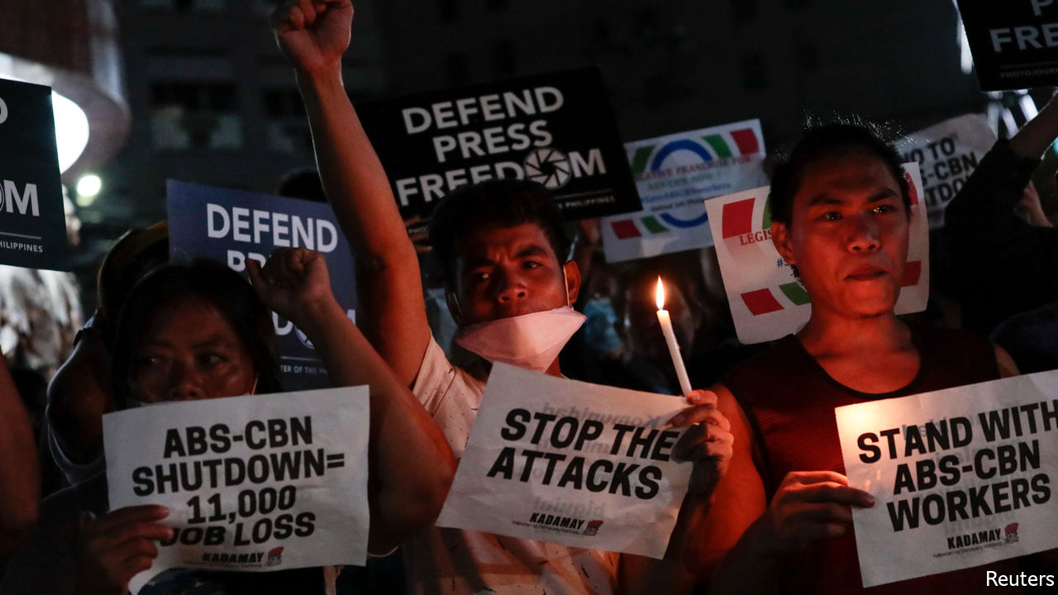

A NEW TELEVISION drama is gripping the Philippines. Its protagonists include ABS-CBN, a giant broadcaster, and President Rodrigo Duterte. The story begins back in 2016, when ABS-CBN did not air some adverts backing Mr Duterte’s campaign for president, noting that others had booked the slots first. He has held a grudge ever since, compounded by the network’s damning reports on his blood-drenched campaign against drugs. Matters came to a head on May 5th. The National Television Commission (NTC), a regulator, ordered the broadcaster to cease operations immediately. It went off-air at 7.52pm that day. (Its cable-news channel and digital offerings are still available.)

The reason given for the NTC’s order was the expiry a day earlier of the media group’s 25-year broadcasting franchise. The solicitor-general, José Calida, took it upon himself on May 3rd to warn the NTC not to grant ABS-CBN any kind of temporary permission to remain on air while Congress, which is packed full of the president’s supporters, considers whether to renew its franchise. (Lawmakers have been sitting on bills to do so since July.) Mr Calida has a big part in the drama. In February he filed a petition with the Supreme Court to revoke the channel’s franchise because of its “highly abusive practices”.

A spokesman for Mr Duterte claims he is “completely neutral” about whether Congress should renew the broadcaster’s franchise. The NTC, he added, came to its decision independently. This contrasts with the president’s own statements regarding ABS-CBN. In December he declared, “I’m sorry. I will see to it that you’re out.”

Press-freedom watchdogs have been howling, but the president cares little. Journalists are “sons of bitches”, he says. Other outlets have also suffered since he came to power. Rappler, a news website, and its boss, Maria Ressa, face charges including tax evasion and cyber-libel which observers say are politically motivated. But ABS-CBN is far bigger quarry: it is the country’s most watched broadcaster and the maker of the most popular news programme in Tagalog, the Philippines’ most widely spoken language. “The move is clearly a case of political harassment against a pillar of Philippine democracy,” says the Foreign Correspondents Association of the Philippines. It does not seem to count the president, sadly as a pillar. ■

This article was downloaded by calibre from <https://www.economist.com/asia/2020/05/09/a-philippine-broadcaster-is-forced-off-the-air>

|  |  |  |  |
| --- | --- | --- | --- |
| Previous | Articles | Sections | Next |

|  |  |  |  |
| --- | --- | --- | --- |
| Previous | Articles | Sections | Next |

#### Gunmen with thermometers

# The Taliban are joining Afghanistan’s fight against covid-19

But they refuse to do the most helpful thing, and stop fighting

May 9th 2020 | ISLAMABAD

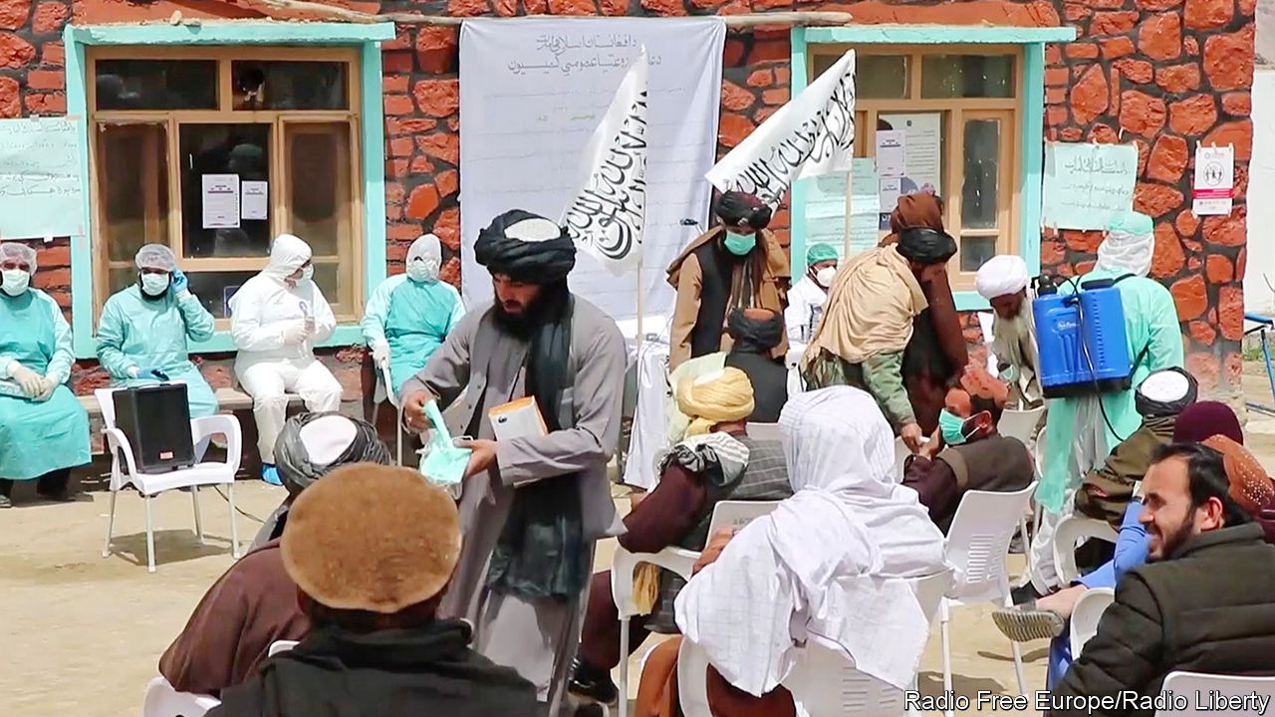

Editor’s note: The Economist is making some of its most important coverage of the covid-19 pandemic freely available to readers of The Economist Today, our daily newsletter. To receive it, register [here](https://www.economist.com/newslettersignup). For our coronavirus tracker and more coverage, see our [hub](https://www.economist.com/coronavirus)

THE OFFICIAL in charge of the Afghan government’s response to covid-19 in a rural district near the city of Herat recently received a dressing-down by phone. The caller berated him for the lack of masks at a particular clinic. Local bureaucrats needed to get their act together quickly, the caller instructed. The man delivering the rebuke was not some big cheese from the ministry of health in Kabul, however, but a member of the Taliban, the rebels who have been trying to overthrow the government since 2001, when they themselves were ousted from power by American-backed forces.

The Taliban’s war with the American-backed regime is waged not just by force of arms, but also by vying to administer the country better. The insurgents pride themselves on their probity, in contrast to widespread corruption within the government. They extract only fixed “tolls” from truck drivers passing through areas under their control, for example, in contrast to the frequent and fluctuating payments demanded by government forces. Many Afghans prefer to seek justice from Taliban judges, who are seen as harsh but swift and clean, than in the slow and crooked government courts. The Taliban also appoint officials to oversee services such as health care and education in the big expanses of the countryside where they have more sway than the government.

When covid-19 reached Afghanistan, the Taliban were quick to trumpet their readiness. Social-media accounts that usually crow about killing government soldiers instead showed the militants handing out masks and advice on public health. One video purported to show Taliban health-workers kitted out in white suits, taking people’s temperatures and squirting disinfectant about. Afghans returning from Iran, an early hotspot for the virus, would be ordered into quarantine, the militants announced.

The government and aid agencies have welcomed the Taliban’s concern about the disease. Both rely on the rebels to allow them to operate in rural areas. For all their talk of good government, the Taliban provide relatively few services—for the most part, they simply co-opt the schools and clinics run by the government or charities. For them to reiterate medical advice about washing hands and social distancing is helpful, aid groups say.

A campaign to tell people how to behave plays to the Taliban’s strengths, says Ashley Jackson, who is researching their response to the coronavirus for the Overseas Development Institute, a British think-tank: “What the Taliban are really good at is discipline. They are not technical experts. What they do is they crack down on things.”

The most helpful thing the Taliban could do, however, is the one idea they have rejected outright. The militants have spurned calls for a ceasefire to allow the government and aid agencies to fight the virus unhindered. Instead, while offering Afghans advice on how to keep themselves safe, they have also been killing lots of them. Taliban attacks rose by more than 70% year-on-year in the six weeks after they signed a peace deal with America in Qatar at the end of February. Some 900 Afghan troops were killed over that period. America has accused the militants of flouting their pledge to reduce violence. The toll not just of pestilence, but also of war, looks set to rise further. ■

Dig deeper:  
For our latest coverage of the covid-19 pandemic, register for The Economist Today, our daily [newsletter](https://www.economist.com/newslettersignup), or visit our [coronavirus tracker and story hub](https://www.economist.com/coronavirus)

This article was downloaded by calibre from <https://www.economist.com/asia/2020/05/09/the-taliban-are-joining-afghanistans-fight-against-covid-19>

|  |  |  |  |
| --- | --- | --- | --- |
| Previous | Articles | Sections | Next |

|  |  |  |  |
| --- | --- | --- | --- |
| Previous | Articles | Sections | Next |

#### In the doghouse

# Thais seem ever less impressed by the army

The army commander recently accused them of ingratitude

May 9th 2020 | SINGAPORE



“EVEN MILITARY dogs are grateful to the army,” said Apirat Kongsompong, its commander, earlier this year. He was implying that if mere animals could muster the appropriate emotion, people should be overflowing with gratitude. After all, the army is a “sacred” institution, he believes. Yet ordinary Thais do not seem to realise how lucky they are. Indeed, they have been showing signs of sacrilege.

Enlistment is one indicator of disenchantment. Every April the government conducts a lottery to select some 100,000 conscripts to serve in the armed forces for two years. Because this year’s draft has been delayed until July, owing to the coronavirus pandemic, a shortfall of soldiers looms: just 5,460 out of 42,000 conscripts scheduled for discharge at the end of April have volunteered to stay on, despite the wilting economy. Often it is poorer boys from rural areas who end up as conscripts; richer Thais seem better at finding ways to dodge the draft. Reports of beatings, abuse and drudgery abound. Occasionally conscripts die from such mistreatment. So unpopular is conscription that a new party which promised to end it and seek other military reforms won the third most seats in last year’s election.

A fuss about military spending is another sign of Thais’ diminishing regard for men in uniform. The government, led by Prayuth Chan-ocha, a former army commander who appointed himself prime minister after a coup, had planned to spend roughly 232bn baht ($7.2bn) on the armed forces this year. When covid-19 blew a hole in its finances, it turned to Thai businesses, cap in hand. Disgruntled netizens pointed out that plenty of savings could be made before the state went begging—a brave thing to do, given how many Thais have been locked up in recent years for expressing the wrong opinions online. The government swiftly trimmed military spending by 8%, diverting the savings to schemes to salvage the economy.

The biggest blow to the army’s standing came in February, when a soldier went on a shooting rampage in the city of Nakhon Ratchasima, killing 29 people. The incident revealed the army’s incompetence (the killer obtained guns and ammunition by raiding a poorly guarded armoury), corruption (he seems to have been enraged after being cheated in a property deal involving relatives of a superior officer) and arrogance (it was criticism of the army’s response to the killings that prompted General Apirat to complain about ingratitude).

Soon after the massacre General Apirat pledged to reform military housing and root out corruption. Mr Prayuth weighed in, too, promising to halve the number of generals—there are about 1,700 of them—and to trim the army overall. Thailand has some 560,000 soldiers and reservists. Britain, with a similar population and pretensions as a global power, has about 230,000.

Many doubt that the promised reforms will come to much. “Nothing is being done,” says Paul Chambers of Naresuan University. Besides, the most urgent reform of all—an end to the army’s involvement in politics—is hardly one that Mr Prayuth is likely to pursue. ■

This article was downloaded by calibre from <https://www.economist.com/asia/2020/05/09/thais-seem-ever-less-impressed-by-the-army>

|  |  |  |  |
| --- | --- | --- | --- |
| Previous | Articles | Sections | Next |

|  |  |  |  |
| --- | --- | --- | --- |
| Previous | Articles | Sections | Next |

#### Hot spot

# Sun-shy Indonesians are suddenly soaking up the rays

The belief that sunlight kills the coronavirus is widespread

May 9th 2020 | SINGAPORE

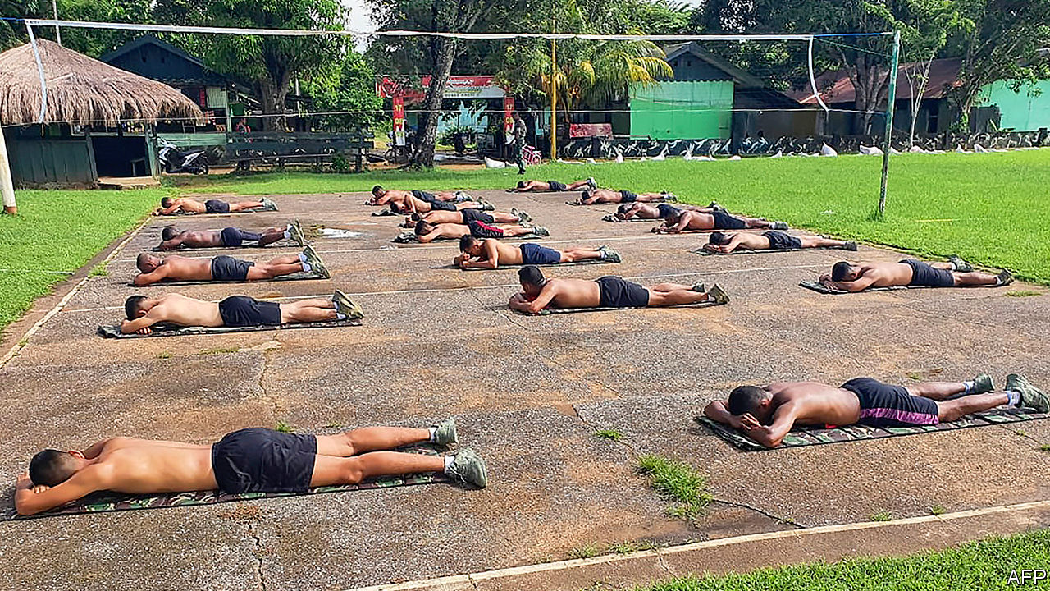

Editor’s note: The Economist is making some of its most important coverage of the covid-19 pandemic freely available to readers of The Economist Today, our daily newsletter. To receive it, register [here](https://www.economist.com/newslettersignup). For our coronavirus tracker and more coverage, see our [hub](https://www.economist.com/coronavirus)

FARAH REYNALDI loathes the sun. Yet for the past month, the 19-year-old law student has been soaking up the rays several mornings a week. At the behest of her father, she takes off her hijab, puts on a T-shirt and shorts, and sweats on the balcony for about half an hour. She is not alone. Over the past month or two, Indonesians have begun sunbathing en masse. Bare-chested soldiers and police officers prostrate themselves before the sun every morning. Residents of a slum abutting a metro line in Jakarta, the capital, drape themselves across the train tracks. So many people have suddenly started basking in the tropical glare that the government has begun extolling sun cream and warning about the risks of skin cancer.

Indonesian culture normally prizes pale skin, which is regarded as beautiful, says L. Ayu Saraswati, the author of “Putih” (White), a book about Indonesian attitudes to skin colour. Many Indonesian women use skin-whitening products. Indonesia is home to the world’s largest population of Muslims; the pious among them do not feel comfortable baring much skin. Most Indonesians would never dream of tanning. Yet they are willing to risk a darker shade now because they believe sunlight helps to fend off covid-19.

There are two reasons for this belief, one more scientific than the other. Sunlight does stimulate the body to produce vitamin D, which in turn boosts the immune system, notes Madarina Julia of Gadjah Mada University. This is why Dr Andi Khomeini Takdir of Cipto Mangunkusomo National General Hospital in Jakarta encourages his patients to sunbathe for 10-15 minutes every day.

But many Indonesians believe that exposure to the sun also kills the virus in itself—an idea for which there is no scientific evidence. A woman spotted by the Jakarta Globe in early April shouted, “Die, you virus! Go away, corona!” as she exercised in the morning light. As Ms Reynaldi puts it, “If you’re not sunbathing, then you’re not preventing covid right.”

The idea that the sun can zap the virus has been endorsed by prominent politicians. Tito Karnavian, the home-affairs minister, said in March that covid-19 cannot spread in a tropical climate like Indonesia’s, and invited the public to snuff out the disease by sunbathing. The number of confirmed cases in the country has since risen to more than 12,000. Perhaps the minister should have read the WHO’s covid-19 myth-busters website, which states, “Exposing yourself to the sun or to temperatures higher than 25°C DOES NOT prevent covid-19.” ■

Dig deeper:  
For our latest coverage of the covid-19 pandemic, register for The Economist Today, our daily [newsletter](https://www.economist.com/newslettersignup), or visit our [coronavirus tracker and story hub](https://www.economist.com/coronavirus)

This article was downloaded by calibre from <https://www.economist.com/asia/2020/05/09/sun-shy-indonesians-are-suddenly-soaking-up-the-rays>

|  |  |  |  |
| --- | --- | --- | --- |
| Previous | Articles | Sections | Next |

|  |  |  |  |
| --- | --- | --- | --- |
| Previous | Articles | Sections | Next |

#### Banyan

# India’s government is better at curbing critics than covid-19

Bureaucrats can be a nuisance, but politicians are often a menace

May 9th 2020 |



Editor’s note: The Economist is making some of its most important coverage of the covid-19 pandemic freely available to readers of The Economist Today, our daily newsletter. To receive it, register [here](https://www.economist.com/newslettersignup). For our coronavirus tracker and more coverage, see our [hub](https://www.economist.com/coronavirus)

MANY INDIANS will remember the coronavirus epidemic less for social distancing, or for watching re-runs of “Ramayan”, a popular 1980s television saga based on Hindu myth, than for the endless queues. Destitute migrant workers hoping for a train home are not the only ones who have been made to line up and wait. Nor are the millions now surviving on charity, or the hope of it. Many in the middle class, too, have been stuck in monstrous tailbacks while trying to make urgent journeys, the victims of arbitrary decisions by babus, as Indians derisively call civil servants.

For example, in the state of Haryana, which almost encircles Delhi, babus have ordered nearly impenetrable roadblocks to seal off the capital. This is akin to Maryland walling off Washington, DC, or the Home Counties blocking access to London. The babus say the blockade is to protect Haryana’s healthier citizens from being infected by sick Delhi-wallahs. The trouble is that severing the city from its suburbs has, among other nuisances, blocked doctors, nurses and patients from travelling to hospitals.

The babus of Delhi, for their part, have generated equally enormous queues. When the central government’s babus decided it was time to lift a nationwide ban on alcohol sales (a measure whose utility in the fight against covid-19 remains mysterious), the government of Delhi decreed that only particular liquor stores could open. This needless constriction created a crush so great as to squash any semblance of social distance. The babus then added insult by slapping a 70% tax on booze.

Not to be outdone as nuisance-makers, the babus of Noida, a suburb of Delhi in the state of Uttar Pradesh, have declared it illegal to carry a smartphone without downloading the government’s contact-tracing app. Many people do not own smartphones and, besides, the software is highly controversial. Yet the wise men of Noida still think it reasonable to threaten citizens with six months in prison for shunning it.

If it were only ill-conceived, ever-shifting rules that magnified the grief of covid-19, Indians would simply shrug and roll their eyes. It is what they have come to expect from the “gomment”. Yet for some citizens things are worse. If you happen to be Muslim, for example, or to have joined the widespread protests earlier this year against government moves to inject religious criteria into citizenship rules, or to have been branded “anti-national” for any other reason, then you may be singled out for special treatment. Despite the spreading epidemic and the hardship caused by the continuing lockdown, the government has not relented from pursuing a range of critics, increasingly invoking draconian laws intended to combat terrorism.

Consider Anand Teltumbde, a 69-year-old management professor who champions the rights of Dalits, at the bottom of the caste system. He has been imprisoned since mid-April, awaiting trial along with ten other leftist intellectuals on credulity-stretching charges of inciting violence, including a purported plot to assassinate Narendra Modi, the prime minister. Or take Safoora Zargar, a 27-year-old graduate student at Delhi’s Jamia Millia Islamia University, arrested a month ago and repeatedly denied bail, despite being four months pregnant. Her membership of a university protest group has been twisted into a leading role in a purported “premeditated conspiracy” by Muslims to stoke the communal violence that engulfed parts of Delhi in February and left more than 50 dead. Among numerous facts that might suggest that this police narrative is pure fantasy, three-quarters of those killed in the riots happened to be Muslim.

Perhaps most disturbing has been the government’s failure to act at all against far more obvious troublemakers. During the covid-19 crisis, it has seemed completely uninterested in staunching a nasty wave of Muslim-baiting on social media, just as it ignored incitement to violence against anti-government protesters before the Delhi riots. The gist of the rumours doing the rounds is that the Muslims are deliberately spreading the epidemic as a “corona jihad” against the Hindu majority. One watchdog group has counted no fewer than 94 fake-news videos circulating in the past month, attracting millions of views, in which Muslims are supposedly shown propagating the disease by spitting in food, dropping infected currency notes and so on. Naturally, any meaningful debate about the government’s handling of the epidemic has been buried under this dangerous rubbish.■

Dig deeper:  
For our latest coverage of the covid-19 pandemic, register for The Economist Today, our daily [newsletter](https://www.economist.com/newslettersignup), or visit our [coronavirus tracker and story hub](https://www.economist.com/coronavirus)

This article was downloaded by calibre from <https://www.economist.com/asia/2020/05/09/indias-government-is-better-at-curbing-critics-than-covid-19>

|  |  |  |  |
| --- | --- | --- | --- |
| Previous | Articles | Sections | Next |

|  |  |  |
| --- | --- | --- |
| Asia | Sections | Middle East & Africa |

China

Social security: Socialism’s precariat

.

Christianity: Heaven’s outposts

.

|  |  |  |
| --- | --- | --- |
| Asia | Sections | Middle East & Africa |

|  |  |  |  |
| --- | --- | --- | --- |
|  | Articles | Sections | Next |

#### Socialism’s precariat

# A slump exposes holes in China’s welfare state

Amid the pandemic, the country’s poor are getting little help

May 9th 2020 | SHANGHAI

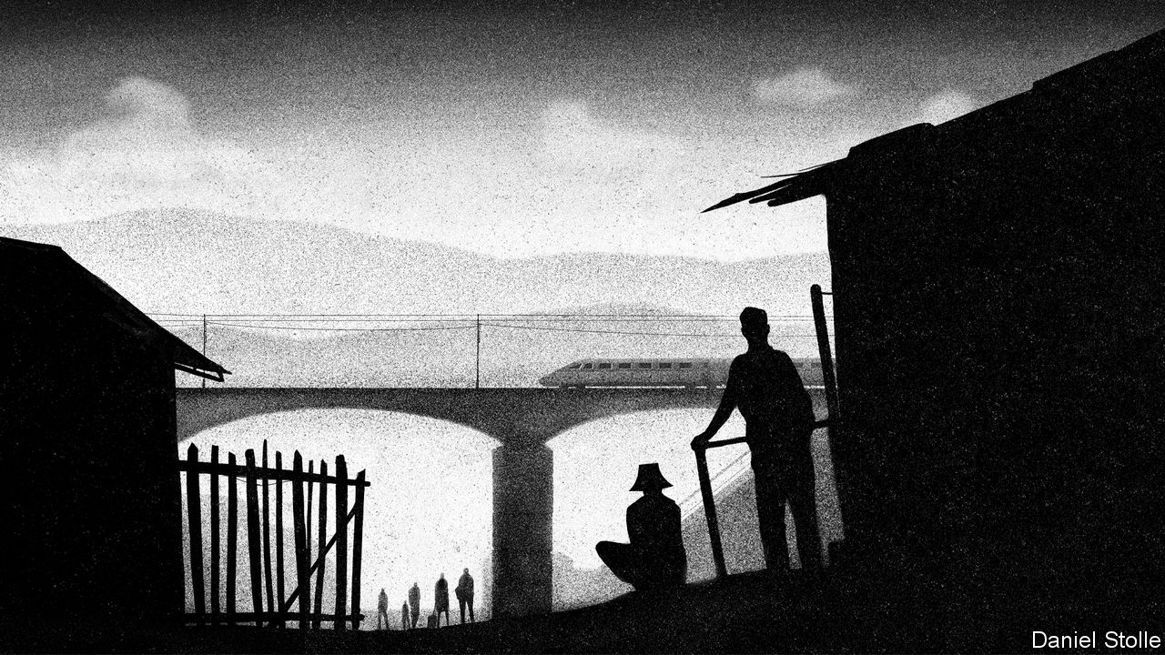

CHINA OR AMERICA: which is the land of rugged self-reliance and which of the government handout? Judging by support for people on low incomes amid the coronavirus crisis, the answer is surprising. America has dramatically scaled up benefits for those out of work. Its federal stimulus has allocated an extra $600 a week to each jobless person—enough, on average, to replace 100% of lost income. The Chinese government, meanwhile, has given an extra 12 yuan ($1.70) a week to its poor. That is enough for a daily bowl of noodles.

Those on the margins in China have no choice but to fend for themselves. Lei Yankun was stuck for three months in Hubei province, where the coronavirus outbreak began. Unable to return to his job at an electronics factory, he topped up his savings by harvesting bamboo shoots in the mountains. Li Quanyou, a grey-haired construction worker, went to Shanghai in search of work, but after three fruitless weeks took a 16-hour train ride home, carrying his clothes in a large plastic bucket, to wait out the downturn. Miao Wenjiang, a driver in Anhui province, eliminated his one luxury—weekly meals for his family at KFC—as his earnings dwindled.

The economic pain that China is suffering as a result of covid-19 is common to many countries. What makes it unusual is the contrast between China’s world-class physical infrastructure—featuring, among other things, the longest high-speed rail network—and its badly lagging soft infrastructure, with a social safety-net akin to those of much poorer countries.

Analysts often point out that China’s official unemployment rate (currently 5.9%, up just slightly from last year) understates the problem, since it only captures full-time urban residents. Economists from UBS and Société Générale think that, by broader measures, as many as 80m might have been out of work in March. That is nearly 20% of the urban workforce. Yet the more salient point is how few of the unemployed receive any help from the government. According to the human-resources ministry, just 2.3m people are on the dole. There are, in other words, upwards of 78m people who are out of a job and are receiving no benefits.

To be eligible for unemployment insurance, applicants must have worked under contract for a company that pays all required fees and taxes. That only describes about a quarter of China’s total workforce of 800m, according to government data. The rest typically work for small, private businesses without any formal contract, or on their family farms. For the lucky few who can get unemployment insurance, the payouts are meagre. Benefits are, by law, set at levels below already-paltry minimum wages. Those with nothing can apply for a guaranteed minimum income known as dibao. But this offers even less—about 600 yuan a month on average.

That Chinese welfare and unemployment benefits are so threadbare might seem odd for a country that prides itself on how well its poor have fared during the past four decades. The reason is partly historical. Before 1986 unemployment did not officially exist in China. Officials, schooled in Marxism, viewed joblessness as a defect of capitalism and were reluctant to accept that China might have such a problem. In more recent years, the government’s main strategy has been to stop unemployment before it occurs, by ensuring that enough jobs are created. Officials have unreservedly primed the pump whenever growth slows. This approach has been helped by the readiness of workers to adapt to changing demands for their labour. Mr Lei, the Hubei resident, has had stints in factories, as a salesman and as a security guard.

But China has refrained from stoking growth in response to the covid slump. It wants people to stay closer to home until the virus is vanquished. So the government is relying on its ultimate safety net, the countryside. Many of China’s nearly 300m migrant workers—those most likely to find themselves unemployed without benefits—have some combination of rural land, savings and family to fall back on. “I suppose the government expects migrants to rescue themselves. They can do so in the short term, but if this goes on much longer, many will fall into poverty,” says Li Shi, an economist at Zhejiang University. In surveys of villagers in seven provinces, researchers from Stanford University found that most had already started to reduce their spending on basic food items.

Calls are growing for more government action. Gan Li of Southwestern University of Finance and Economics, an expert on income inequality, has proposed, as a start, one-off cash transfers of 2,300 yuan to needy households. Mr Li of Zhejiang University would prefer an outright expansion of the dibao income guarantee, to cover more people and provide more cash. Fully replacing wages for the 80m unemployed for three months would amount to less than 1% of GDP—highly affordable. The State Council said last month that it would increase both unemployment and dibao benefits, but it has not given details.

The lack of support for the jobless is just one element of a social-security system that is lacking in nearly every dimension. Public spending on health care is, for instance, only about 2% of GDP, roughly half the average of other countries at China’s income level, according to the World Bank. Government expenditure on education and social assistance is also lower than the average among China’s peers.

One reason to help the needy is moral. But there are also economic arguments for greater social spending. It would deliver an immediate boost to growth. Returns on capital have declined steadily in China over the past decade. So the government is reluctant to stimulate growth by splurging on yet more railways and airports. The IMF reckons that well-designed investments in social security could have a similar effect.

It would also be consistent with what the government itself wants: growth driven more by consumption and less by pouring concrete. The lowest tenth of income earners in most countries often have no savings. In China they put aside roughly 20% of their earnings, an exceptionally high rate. One reason is that Chinese worry about having to provide for themselves in bad times. A stronger social safety-net would free people to spend more.

If the economic arguments are simple, the politics are more complicated—much as they are in the West’s debates about welfare for immigrants. The only difference is that in China, the migrants are not from abroad. Officials in China’s big cities worry that if they were required to deliver the full gamut of social services to all residents, including migrant workers, the fiscal burden would be crippling. Local authorities also fear that the promise of full benefits would attract more people from elsewhere.

For now they have ways to keep them at bay. On a sunny afternoon in late April, a graphic designer whose firm was in trouble visited a social-security office in Shanghai’s Hongkou district to ask about unemployment insurance. He had worked in the city for several years and his company had paid his payroll tax. But an official told him that he would have to go to his birth city in Jiangsu province, a couple of hours away by train, to apply and, if successful, collect his benefits. In Jiangsu, however, the payout would be lower than in Shanghai. “I might not bother,” he said. ■

This article was downloaded by calibre from <https://www.economist.com/china/2020/05/09/a-slump-exposes-holes-in-chinas-welfare-state>

|  |  |  |  |
| --- | --- | --- | --- |
|  | Articles | Sections | Next |

|  |  |  |  |
| --- | --- | --- | --- |
| Previous | Articles | Sections | Next |

#### Heaven’s outposts

# Near China’s border with Russia, the Orthodox Church regains a toehold

China is wary of religions with foreign links, but it likes Russia

May 9th 2020 | ERGUN

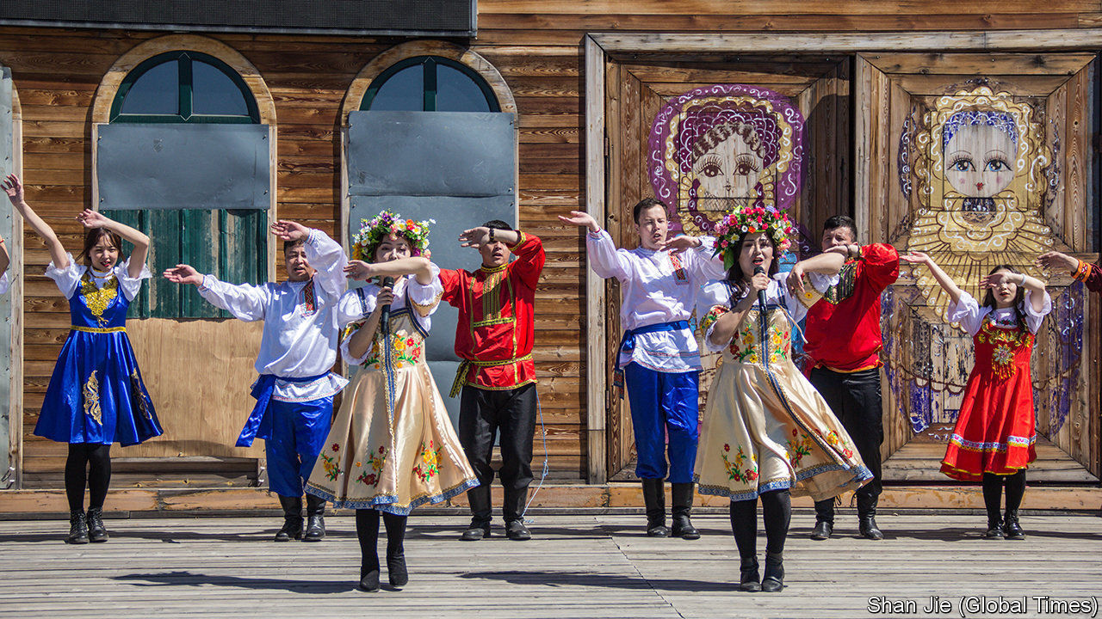

IN THE CITY of Ergun, about 60km from China’s border with Russia, the feast of Pascha last month was one that Father Pavel Sun Ming will long remember. Because of covid-19, he could not open his Eastern Orthodox church for celebrations of Christ’s resurrection. Police wearing surgical masks stood outside, stopping passing cars to check people’s health. But it is last year’s Pascha in Ergun that will go down in history. For the first time in more than six decades, the church’s midnight service was led by a local. Father Pavel had recently returned from his ordination in Russia. At last, Ergun’s flock had a priest again.

Father Pavel is only the second person to be accepted officially in China as an Orthodox priest since Mao Zedong tried to wipe out religion a few years after seizing power in 1949. The first was Alexander Yu Shi, who was ordained in Russia in 2015 and now serves in Harbin, about 800km south-east of Ergun.

Before the Communist takeover, Russian Orthodoxy had a strong foothold among Russians living in China’s borderlands. They married local Chinese, but some of their descendants, such as Father Pavel and Father Alexander, kept up the faith. These days few of the 15,000 Chinese citizens of Russian ancestry speak Russian or even look like their Russian forebears. But the government regards them as members of an ethnic minority group. It calls them Russians.

Few are devout, but many of them cling to symbols of Russian-ness. The church on the edge of Ergun, in Inner Mongolia, is one such. Atop it are golden crossbeams, the lowest hanging at a slant. It has a green-domed roof and maroon walls trimmed in white. It was built in the 1990s on the ruins of St Innocent of Irkutsk, one of at least 18 Orthodox churches that were once in the city. Today, apart from those in Ergun and Harbin, there are only two others in China—both in the western region of Xinjiang.

The revival of these four, after the dark days of Mao, has not been easy. The government recognises five religions. These are Buddhism, Daoism, Islam and two strands of Christianity: Catholicism and Protestantism. Orthodoxy operates in a grey zone, assigned to none of these. But along with the rapid improvement of Sino-Russian relations since the 1990s, China’s government has fostered stronger unofficial contacts with its giant neighbour, including in the religious realm.

It took years for Ergun’s church to get government approval to import Russian religious artefacts. But in 2009 it was finally consecrated. Four years later the head of the Russian Orthodox Church, Patriarch Kirill of Moscow, made his first official visit to China where he met President Xi Jinping. This paved the way for Chinese to train as priests in Russian seminaries.

But the Orthodox church in China is still treated warily by the government. Only registered members of Ergun’s church are permitted to enter it (even visiting Russian citizens are barred). There is a security camera above its door. As Father Pavel matter-of-factly admits, Orthodoxy in China is a “slightly sensitive” affair. ■

This article was downloaded by calibre from <https://www.economist.com/china/2020/05/09/near-chinas-border-with-russia-the-orthodox-church-regains-a-toehold>

|  |  |  |  |
| --- | --- | --- | --- |
| Previous | Articles | Sections | Next |

|  |  |  |
| --- | --- | --- |
| China | Sections | Europe |

Middle East & Africa

Lebanon: From crisis to crisis

.

Solar power: Rays of hope

.

Africa’s data deficit: Start counting

.

Benin: Voodoo v virus

.

Hemp in Africa: Pot of gold

.

|  |  |  |
| --- | --- | --- |
| China | Sections | Europe |

|  |  |  |  |
| --- | --- | --- | --- |
|  | Articles | Sections | Next |

#### From crisis to crisis

# Why protesters firebomb banks in Lebanon

The pandemic turned the Arab street quiet. It will not last

May 9th 2020 | BEIRUT

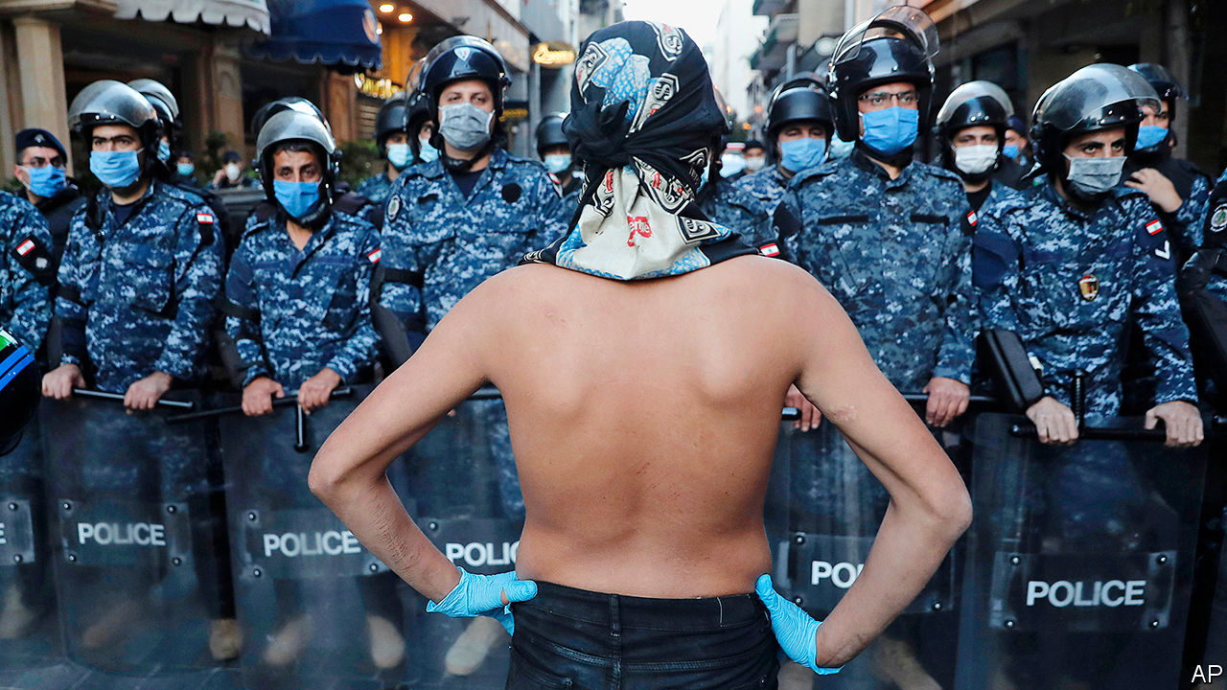

Editor’s note: The Economist is making some of its most important coverage of the covid-19 pandemic freely available to readers of The Economist Today, our daily newsletter. To receive it, register [here](https://www.economist.com/newslettersignup). For our coronavirus tracker and more coverage, see our [hub](https://www.economist.com/coronavirus)

COVID-19, JOKES Chadi Khoury, might have been good for his mental health. For six weeks a nationwide lockdown meant he could not fix a busted refrigerator in his Beirut snack shop. Now he can—but he has spent all morning arguing over prices. Repairmen want to be paid in dollars, which he lacks: gone are the days when customers might buy their falafel with greenbacks. “We’re in Lebanon, not America,” he yells into the phone. “Give me the price in Lebanese.” Down the street, the owner of a salon crunches the numbers for $400-worth of new shavers. Last year that was equal to about 25 haircuts. Today, even after raising prices, he will need to coif 60 customers to cover the bill.

Lebanon is lurching back to life. Most businesses closed in mid-March to halt the spread of the coronavirus. Even Barbar, a much-loved west Beirut takeaway that served shawarma behind sandbags during the civil war, pulled down its shutters. But the government is cautiously declaring victory. It counts fewer than 800 confirmed cases; daily new infections have been in single digits since April 15th. Firass Abiad, the head of Lebanon’s main covid-19 hospital, says the outbreak looks under control.

Little else is, though. Lebanon was in economic crisis before the pandemic, with an illiquid banking sector and a collapsing currency. On March 7th the government decided to default on its debts. The lockdown has pushed the economy into free fall. Thousands of businesses may never reopen. Stories of hardship circulate daily on social media: a pregnant woman and her husband salvaging food from a refuse skip; penniless migrant workers trying to cross the militarised border into Israel. With no other options, Lebanon has asked the IMF for help. But that will require difficult reforms many Lebanese can ill afford.

Since the end of the civil war in 1990, Lebanon has built a service economy based on finance, property and tourism. It ran large fiscal and current-account deficits—11% and 26% of GDP in 2018—and financed them with foreign capital, much of it from a sprawling diaspora. The central bank (Banque du Liban, or BDL) in effect ran a Ponzi scheme to defend its currency peg, borrowing dollars from commercial banks at generous interest rates.

The scheme collapsed last year as bank deposits began to shrink after a decade of growth. The peg, 1,500 pounds to the dollar, is all but meaningless: last month a dollar fetched 4,000 pounds on the black market. Banks have imposed informal capital controls. The state predicts a 53% jump in consumer prices this year. A business federation estimates that one-third of registered companies have gone under.

The middle class has become poor, and the poor destitute: three in four Lebanese may need aid by the end of the year. Despite the lockdown, thousands have taken to the streets in protest. Banks have been firebombed. In Tripoli, one of Lebanon’s poorest cities, a young man was shot dead by soldiers during a protest last month.

On April 30th ministers approved a “recovery plan” meant to win IMF support. It would drop the peg and devalue the pound to 3,500 to the dollar this year. The government would trim its wage bill, phase out electricity subsidies and broaden the tax base. Formal capital controls would keep scarce dollars in the country.

The plan is not perfect. It makes unrealistic assumptions such as strong tourism receipts—wishful thinking in a pandemic. It proposes lifting capital controls after one year. The government itself thinks this would cause an outflow of $9bn in 2021, all but negating any foreign aid. The plan is also too optimistic about the prospect of clawing back billions in stolen assets.

Perhaps most contentious will be how to clean up the balance-sheets of Lebanese banks, which have an estimated 100trn pounds in losses. The plan proposes a bail-in: shareholders would take a bath, and wealthy clients would see their deposits become long-dated, low-interest obligations. Bankers are predictably furious, arguing this would shatter confidence. But their anger is partly a way of ducking responsibility for their role in the crisis. Far from being contrite, banks are still pursuing outlandish schemes to raise capital. One recently offered to double the amount of any fresh dollar deposits. Either the bank has discovered a money tree, or this is a last, desperate stage in Lebanon’s state-sanctioned Ponzi scheme.

If bankers are unapologetic, politicians are oblivious. A quartet of former prime ministers, the men who led Lebanon into the abyss, are fighting against the recovery plan. Appointments at the BDL, which are divvied up by sect, were postponed last month because of partisan squabbling.

Protests that began in October united many Lebanese in disgust at the entire political class. But the country’s crises are giving its factions a new lease on life, as the state struggles to provide help. Hizbullah, the Shia militia and political party, has its own fleet of ambulances and more than a dozen covid-19 clinics. Every party is vaunting its efforts to treat patients and distribute food and cash. Some even hand out surgical masks emblazoned with their logos. The state, meanwhile, has still not distributed a meagre 400,000-pound stipend to needy families.

Other countries should take heed. Before the pandemic protests roiled the region. Iraqis rallied against a useless government. Algerians overthrew their longtime dictator, Abdelaziz Bouteflika, and kept protesting against his army-backed successor. The pandemic cleared the streets, but governments have squandered that respite. Low oil prices will push some states to insolvency. Iraq made just $1.4bn from selling crude in April, down from $7bn in April 2019. Analysts say it may need to borrow $40bn to get through the year. Lebanon will not be the only country where lockdowns give way to protests. ■

Dig deeper:  
For our latest coverage of the covid-19 pandemic, register for The Economist Today, our daily [newsletter](https://www.economist.com/newslettersignup), or visit our [coronavirus tracker and story hub](https://www.economist.com/coronavirus)

This article was downloaded by calibre from <https://www.economist.com/middle-east-and-africa/2020/05/09/why-protesters-firebomb-banks-in-lebanon>

|  |  |  |  |
| --- | --- | --- | --- |
|  | Articles | Sections | Next |

|  |  |  |  |
| --- | --- | --- | --- |
| Previous | Articles | Sections | Next |

#### Rays of hope

# Arab states are embracing solar power

The Middle East cannot rely on oil forever

May 9th 2020 | BENBAN

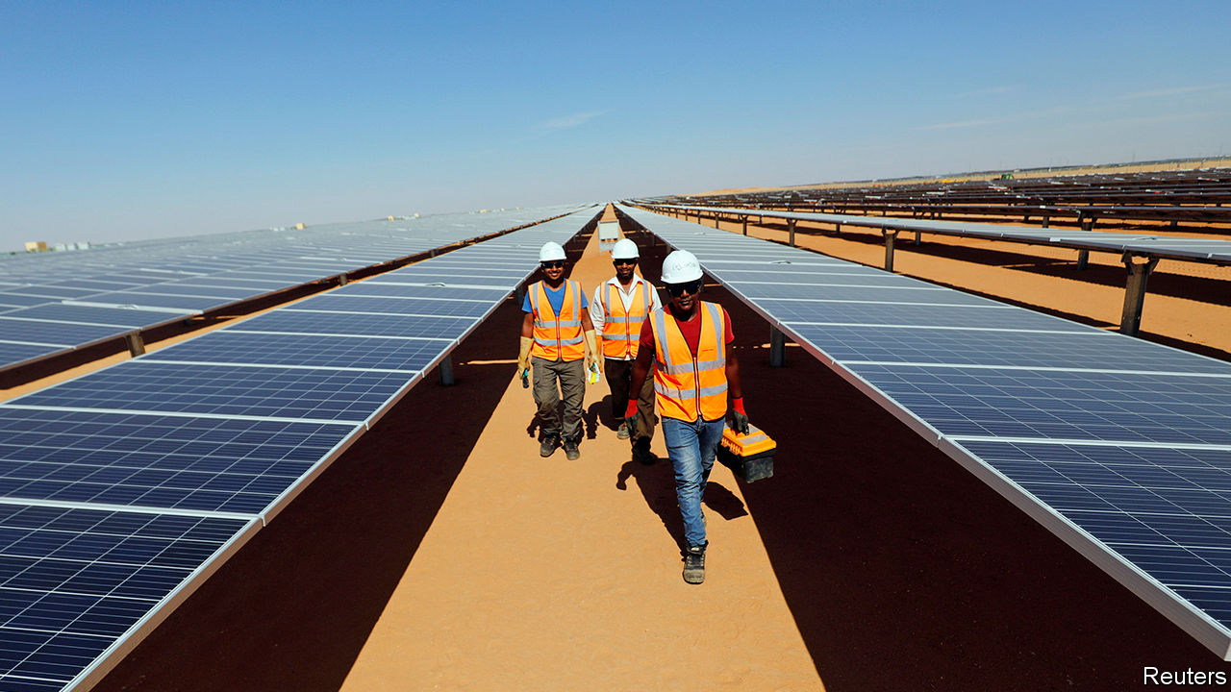

TWO MILLENNIA after the ancient Egyptians dropped their solar deity, Ra, their descendants are rediscovering the power of the sun. In the southern desert, half an hour’s drive from Aswan, Egypt is putting the finishing touches to Benban, one of the world’s largest solar farms (pictured). Its 6m panels produce 1.5 gigawatts (GW) of energy, enough to power over 1m homes. “In a decade we’ll still need oil for plastics and other petrochemicals, but not for energy,” says Rabeaa Fattal, a Dubai-based investor in Rising Sun, one of Benban’s 40 fields.

Much of the modern Middle East and north Africa was built on oil. It exports more of the black stuff than any other region. A quarter of Middle Eastern power comes from it, compared with 3% from renewable sources. But the recent collapse in oil prices is a reminder that it is risky to depend on a single source of revenue. And in the long run the global trend is towards cleaner energy sources. Renewable-energy capacity in the Middle East has doubled to 40 gigawatts (GW) over the past decade and is set to double again by 2024.

With its vast deserts, the Arab world’s most abundant clean-energy source is the sun. Non-oil economies were first to take advantage of it. More than a third of Morocco’s energy now comes from renewables (in the EU the average is 18%). Oil producers are catching up. A big project in Abu Dhabi, the capital of the United Arab Emirates (UAE), recently received the world’s lowest tariff bid for solar power. Oman, Kuwait and Qatar have large projects, too. The Middle East as a whole generates 9GW of solar power, up from a paltry 91 megawatts a decade ago. Between 2008 and 2018 investment in the field increased 12-fold.

The growing competitiveness of renewables makes analysts optimistic that the trend will continue (see chart). Solar farms are cheaper, faster and safer to build and maintain than oil and gas plants. The UAE’s new solar plant will generate electricity at roughly two-thirds the cost of gas and a third that of oil, even at today’s low prices. Several countries in the region speak of becoming renewable-energy exporters.

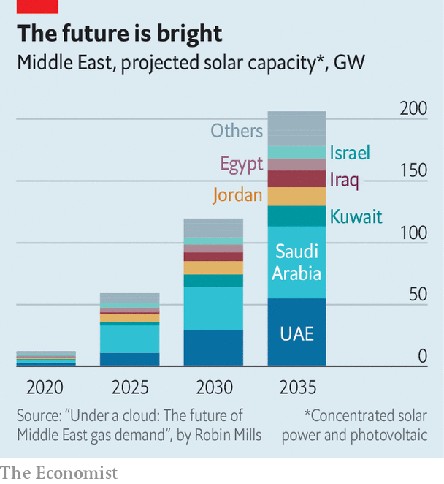

Investors, though, still have cause to hesitate. For a start, Arab autocrats often promise more than they deliver. Take Muhammad bin Salman, the de facto ruler of Saudi Arabia, who has made renewable energy a pillar of his economic-reform plan. In 2018 he and SoftBank, a Japanese conglomerate, announced the world’s biggest solar-power-generation project in the Saudi desert. It was shelved six months later.

Regional turmoil scares investors away, too. Iraq’s electricity minister blames protests for derailing his plans to meet 20% of demand with renewables by 2030. Conflicts in neighbouring countries have damned Jordan’s efforts to export solar power to Lebanon. Turbulent Egypt offered to buy solar power at above-market rates in order to attract investors to Benban.

There is also a risk that, in the short term, cheap oil dims countries’ ardour for solar power. Saudi Arabia, for example, might prefer to burn more oil for energy. Declining revenues could force oil-producing states to suspend new solar projects.

But such projects are largely driven by the private sector, and they continue to compare favourably with fossil fuels. “We have seen an acceleration in tenders during covid-19,” says Paddy Padmanathan of ACWA Power, a Saudi firm that operates renewable-energy projects. “Why spend money taking fuel out of the ground and processing it rather than relying on God-given free sun and wind?” ■

This article was downloaded by calibre from <https://www.economist.com/middle-east-and-africa/2020/05/09/arab-states-are-embracing-solar-power>

|  |  |  |  |
| --- | --- | --- | --- |
| Previous | Articles | Sections | Next |

|  |  |  |  |
| --- | --- | --- | --- |
| Previous | Articles | Sections | Next |

#### Desperate times call for accurate measures

# Lacking data, many African governments make policy in the dark

It is hard to help the poor if you don’t count them

May 9th 2020 |

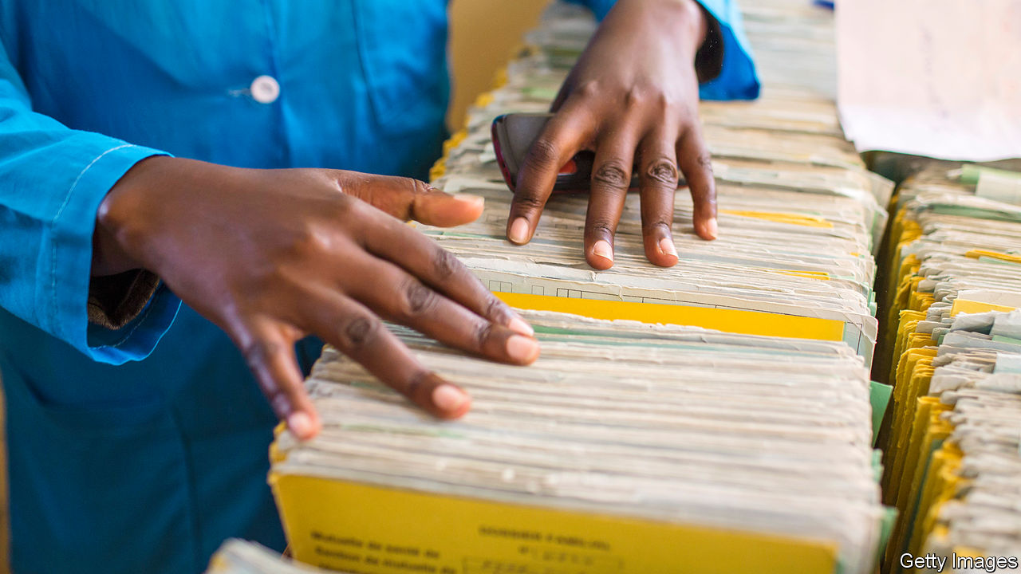

THE GRAVEDIGGERS of Kano know something is up. Death has not come as rapidly to this town in northern Nigeria since a great cholera outbreak 60 years ago, one told the BBC. Local newspapers are running long lists of names of people who have died after showing symptoms of covid-19. Among them were two professors, a newspaper columnist, the former editor of a paper and the mother of a film star. “They all died on Saturday,” read one report. Nobody knows whether they died of the virus, because nobody has checked.

According to official data Nigeria, Africa’s most populous country, has one of the continent’s lowest burdens of covid-19. As of May 7th it had reported 103 deaths and 3,145 confirmed infections from the novel coronavirus. That is almost certainly a vast undercount given that Nigeria has tested fewer than 22,000 people. The government has nonetheless begun easing lockdowns in Lagos, the commercial hub, and Abuja, the capital.

Making policy without reliable facts is hardly unique to Nigeria. In Somalia doctors worry about a surge in deaths, despite official figures showing only a small number of confirmed cases. Nor is it a new problem. A paucity of data across swathes of Africa has left governments guessing about where to build schools and roads. Businesses must take shots in the dark when investing in new markets. “Where do we build clinics, where do we build roads?” asks Gyude Moore, a former minister of public works in Liberia. Without basic data, he laments, we don’t know.

Even the simplest information about life and death is often unavailable. In Tanzania only about one in eight births is registered; in Niger only about 3% of deaths are. Even in relatively prosperous Ghana, just 25% of deaths are officially noted. It is not just the flow of people in and out of the world that is not counted, but also how many are here. Almost half of Africans live in a country where there has been no census since 2009. In the Democratic Republic of Congo the last one was in 1984.

Politics is often to blame. In Nigeria, for instance, money and power are divvied up between states according to their populations, so every region has an incentive to inflate its own count. An accurate tally would also expose gerrymandering of voting districts; urban votes typically count for less than rural ones.

Poverty statistics are little better. The World Bank’s latest count of the world’s poor excluded the region that has most of them—sub-Saharan Africa—because not enough countries had released credible data. The UN’s Sustainable Development Goals cover a broad sweep of objectives, from education and health to the environment. But in Africa there are too few statistics to track progress on 60% of the indicators. Even where data are provided, about half are estimates, not solid counts.

It is often difficult to assess the information that is collected. Patient records in health clinics, for example, are almost always written by hand, and then often gather dust in a corner. Moreover, when governments do publish data online they frequently use formats that make the numbers hard to collate and analyse. Even if one ministry has useful data, other parts of the government often cannot get hold of them. This can lead to big differences in basic numbers within the same government. A few years ago Malawi’s ministry of agriculture estimated there were 3.4m farm households, whereas the National Statistical Office reckoned there were 2.5m.

The problems do not stop at core statistics. Academic research shapes policy in many countries, but Africa generates just 1% of global research. Over a period of 20 years about 15 times more economic papers were published about America than about all of sub-Saharan Africa, according to a review of 20 years of research by Jishnu Das of Georgetown University and Quy-Toan Do of the World Bank. The world’s top five economic journals published just 34 papers in 20 years about sub-Saharan Africa, which, by the by, hosted a tiny 1.5% of the world’s medicine trials.

This is not to say that Africa cannot learn from research on other countries. But “local realities might make things that work elsewhere not work here,” says Charles Wiysonge of Cochrane South Africa, a medical research centre.

## Figure it out

Still, there are reasons for hope. Across Africa, governments have become marginally better at collecting statistics since 2008, according to the World Bank. And others are stepping up. The Africa Evidence Network, a group of researchers and professionals, is promoting the use of evidence in policymaking. In Nigeria BudgIT, a tech-savvy NGO, turns dry budget numbers into understandable graphics for public perusal. It also tracks whether hundreds of budgeted projects for such things as schools and roads actually result in the promised bricks, books and tarmac. Momentum is growing in academia, too. Published studies from African institutions rose by almost 40% between 2012 and 2016.

Outsiders have pitched in as well, most notably with randomised controlled trials. Some have had a big impact. A study which found that a cheap deworming pill could greatly improve school attendance led to 270m children in Africa and Asia being treated in 2019. But other studies by outsiders do not help as much, partly because they focus on narrow interventions or particular aid projects. The influence of many randomised trials on government policy is “very limited”, says Ken Opalo of Georgetown University.

Only 0.33% of all official overseas aid is allocated to statistics, and even that is rarely co-ordinated. “The way to not solve the crisis is to get lots of donors to fund individual surveys,” says Dean Jolliffe of the World Bank. In Malawi five different donors recently funded five separate mobile health applications, with little thought of how they might operate together.

Better data allow governments to make better decisions. James Hollyer of the University of Minnesota and others have found that democracy is more likely to thrive when voters have good information. This boosts foreign direct investment, too.

The fight against covid-19 further highlights the importance of having good data everywhere. In Africa, the word of gravediggers too often seems more reliable than that of governments. ■

This article was downloaded by calibre from <https://www.economist.com/middle-east-and-africa/2020/05/09/lacking-data-many-african-governments-make-policy-in-the-dark>

|  |  |  |  |
| --- | --- | --- | --- |
| Previous | Articles | Sections | Next |

|  |  |  |  |
| --- | --- | --- | --- |
| Previous | Articles | Sections | Next |

#### Alternative medicine

# Voodoo priests recommend voodoo to stop covid-19

The god of wind can blow it away, apparently

May 9th 2020 | OUIDAH

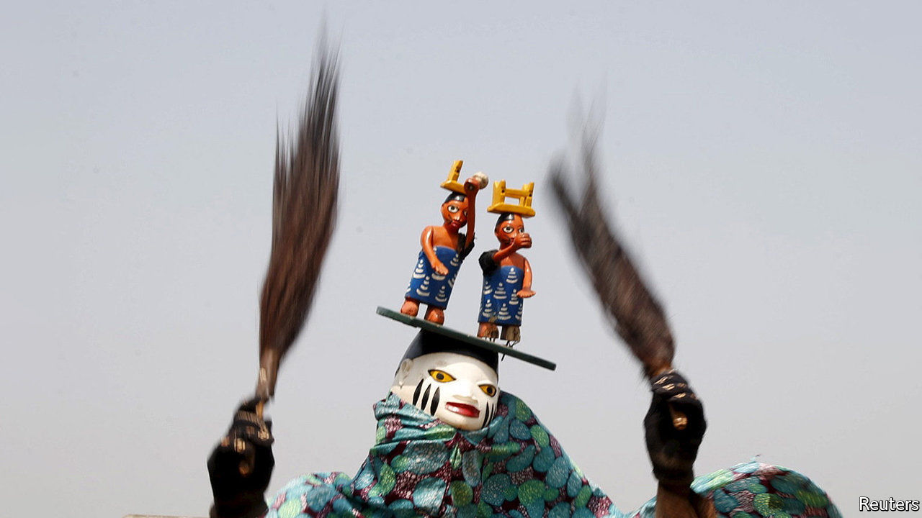

Editor’s note: The Economist is making some of its most important coverage of the covid-19 pandemic freely available to readers of The Economist Today, our daily newsletter. To receive it, register [here](https://www.economist.com/newslettersignup). For our coronavirus tracker and more coverage, see our [hub](https://www.economist.com/coronavirus)

“WE DON’T DO black magic here,” says Zanzan Zinho as he lifts a giant calabash adorned with goat skulls. The shrine of the Vodun (voodoo) priest is in a courtyard in Ouidah, the spiritual home of the religion, in southern Benin. All around are fetishes: dried snakes, twins made of wood and a baby-girl doll into whose mouth the priest inserts a cigarette. “To help her breathe,” explains Mr Zinho. Before your correspondent has a chance to probe, he is given a dram of moonshine from the calabash, of the sort that makes one forget one’s questions.

Roughly 12% of Beninese are adherents of Vodun. Many more, Muslims and Christians alike, incorporate elements of the animist, polytheistic religion in their practice. Suppressed under French rule and then during the Marxist dictatorship of Mathieu Kérékou, Vodun revived after the shift to democracy in the 1990s. In 1996 it was recognised as an official religion. Today tourists from all over visit Ouidah in January for an annual festival. Patrice Talon, the tycoon turned president, has embraced Vodun to bolster his man-of-the-people credentials.

Voodoo can conjure up images of blood and gore. Sacrifices are a core part of ceremonies, providing a way of nourishing the myriad deities. But there is a prosaic aspect to the religion, too. For the Beninese of Ouidah, participating in a ceremony to tap into the Fa (“divination spirit”) is like a Catholic popping into Church to seek wisdom from a priest.

For $10 visitors are allowed to partake in Mr Zinho’s Fa ceremony. After payment the priest grasps a necklace of cowrie shells, manipulating them into patterns to work out which deity is most relevant to the moment. Surprisingly he also inserts twigs between your correspondent’s toes, chain-smokes and offers more moonshine (in lieu of blood sacrifices, apparently). After 15 minutes the priest has reached the relevant spirits. They, via the increasingly inebriated diviner, inform your correspondent that, to live longer, he should eat less papaya and call his father more often.

Despite all this, Ouidah has not been spared the effects of covid-19. Residents are told to stay indoors as much as possible. Gatherings are restricted. Tourism has dwindled. But diviners are busier than ever, as locals seek their help with the pandemic. “There is a greater awareness of human fragility,” says Geoffrey Aidjinou, a guide. He explains that the Vodun god of wind is especially popular at this time. “Only it can speak to the invisible enemy in the air.”■

Dig deeper:  
For our latest coverage of the covid-19 pandemic, register for The Economist Today, our daily [newsletter](https://www.economist.com/newslettersignup), or visit our [coronavirus tracker and story hub](https://www.economist.com/coronavirus)

This article was downloaded by calibre from <https://www.economist.com/middle-east-and-africa/2020/05/09/voodoo-priests-recommend-voodoo-to-stop-covid-19>

|  |  |  |  |
| --- | --- | --- | --- |
| Previous | Articles | Sections | Next |

|  |  |  |  |
| --- | --- | --- | --- |
| Previous | Articles | Sections | Next |

#### Pot of gold

# African cannabis growers are on a high

But their crop is not for smoking

May 9th 2020 | KAMPALA

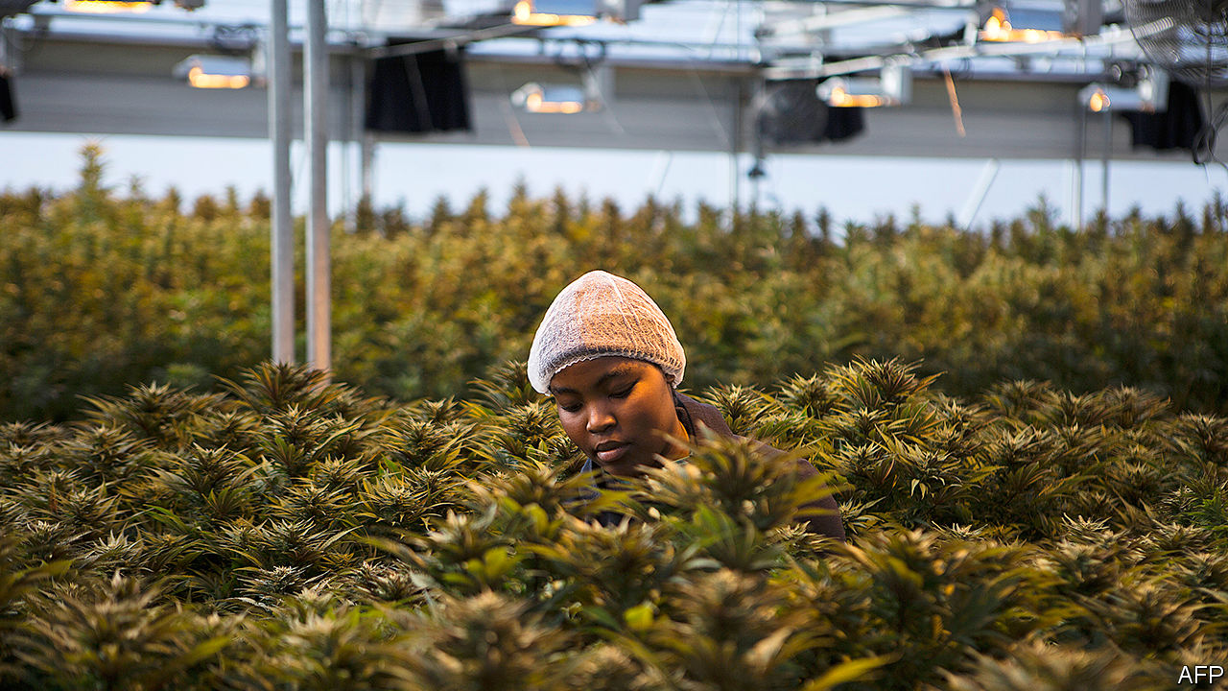

WHEN HE WAS a child, Lauben Kabagambe’s grandparents in western Uganda would boil cannabis leaves to treat sick animals. “I grew up knowing that it is a medicine,” he recalls. Today, as the boss of Industrial Hemp, a Ugandan cannabis company, he is growing weed in computer-controlled greenhouses in partnership with a subsidiary of Together Pharma, an Israeli firm. In April they exported 250kg of medical cannabis to Israel, the first commercial batch ever to leave Uganda.

Africans have been smoking pot for generations: traces have been found on 14th-century pipes in Ethiopia. In colonial times its use was condemned by the church and banned by the state. Now governments sniff an opportunity. Since 2017 five African countries have legalised cannabis farming for medicinal or industrial purposes.

Medicinal plants are typically squat and leafy. The flowers grown in Uganda contain high levels of CBD, a chemical which can be used in therapeutic oils. “It’s cheaper to grow in African countries,” says Nir Sosinsky of Together Pharma, noting that Uganda has low wages and lots of water. This sort of cultivation is high-tech and capital-intensive: firms in Lesotho, a regional pioneer, have attracted multimillion-dollar investments from Canada.

Industrial hemp looks different, growing in tall clusters like bamboo. It contains almost no THC, which gives stoners their highs. The crop can be used for food, rope, textiles and even as concrete. Zorodzai Maroveke, a Zimbabwean dentist, first encountered hemp when she bought a dress in China made from a strange fibre called ma. “I didn’t know what it meant, so I had to go online,” she laughs, “and next thing marijuana pictures were popping up.” Now she is growing Zimbabwe’s first legal hemp crop on a patch of prison land. The site is good for security, she explains, and farming creates work for former inmates.

Reform has been a long battle. Boniface Kadzamira, a Malawian politician, says that “almost the whole house booed me” when he proposed legalisation in parliament. Chiefs and churchmen asked him to explain himself; at the next election he lost his seat. The Hemp Association of Ghana, a campaign group, was told that the word “hemp” in its name was illegal (it registered as the Hempire Association instead). Its president, Nana Kwaku Agyemang, says some politicians hold “archaic” views. Even so, both Ghana and Malawi loosened their laws this year.

The policy shift follows liberalisation in rich countries, which has created a fast-growing market for cannabis products. African firms can be low-cost suppliers to the world, says John Kagia of New Frontier Data, a research firm. In southern Africa cannabis could fill the export gap left by the decline of tobacco. But expensive licences and strict standards shut many local businesses out of the medicinal market. Industrial hemp, by contrast, has lower barriers to entry. Mr Agyemang is registering Ghanaian farmers, some of whom were already growing dope.

Recreational smokers will have to wait. About a quarter of the world’s cannabis users are African (strains such as Malawi Gold are puffed the world over). But only in South Africa, where a court ruled that prohibition violated the right to privacy, is it legal to light up on the continent. Full liberalisation remains a pipe-dream. ■

This article was downloaded by calibre from <https://www.economist.com/middle-east-and-africa/2020/05/09/african-cannabis-growers-are-on-a-high>

|  |  |  |  |
| --- | --- | --- | --- |
| Previous | Articles | Sections | Next |

|  |  |  |
| --- | --- | --- |
| Middle East & Africa | Sections | Britain |

Europe

European law: Seeing red

.

Russia: Journalists are revolting

.

Care-home covid deaths: Getting to the truth

.

Italy: Caffè to go

.

Turkey: Istanbully

.

Charlemagne: All Europe’s a stage

.

|  |  |  |
| --- | --- | --- |
| Middle East & Africa | Sections | Britain |

|  |  |  |  |
| --- | --- | --- | --- |
|  | Articles | Sections | Next |

#### Seeing red

# Germany’s highest court takes issue with the European Central Bank

Its decision imperils the EU’s entire legal order

May 7th 2020 | BERLIN

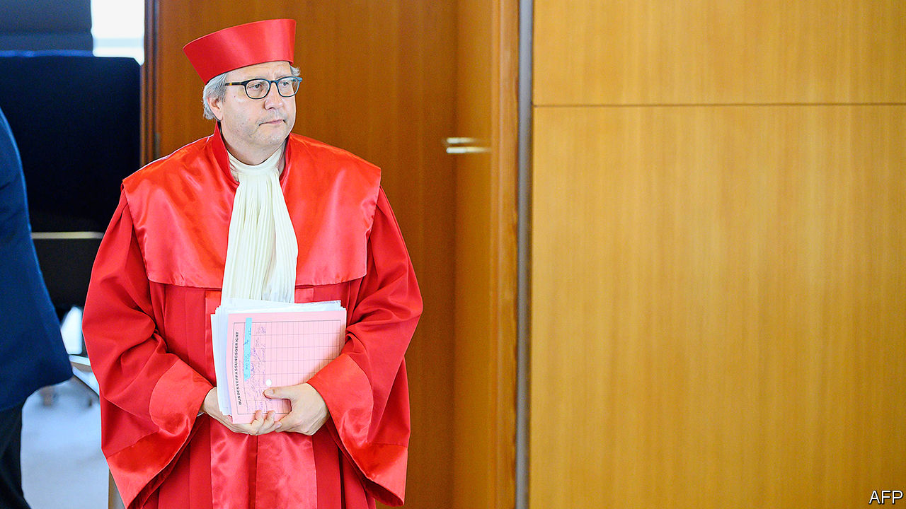

THE MAGNIFICENT scarlet robes that adorn the judges of Germany’s constitutional court trace their origins to a spot of judicial attention-seeking. Soon after the court was established in 1951, its judges decided they needed to distinguish themselves from their peers on the Federal Court of Justice, and recruited a theatrical costumier to update their look. Yet, as the judges showed on May 5th, their rulings can be even more eye-catching than their attire.

This week’s ruling took aim at the Public Sector Purchase Programme (PSPP), a quantitative-easing scheme established by the European Central Bank in 2015. Over the years a gaggle of conservative German academics, lawyers and hangers-on have regularly visited Karlsruhe, where the court sits, to challenge the legality of the ECB’s monetary tools. The court has issued various warnings and red lines in response. But this week it went further, ruling that the bank had not properly applied a “proportionality” test to the PSPP that would have accounted for its economic side-effects, and that German politicians should have challenged it. Worse, the judges said that the European Court of Justice (ECJ), the EU’s top court, which had opined on the case at Karlsruhe’s request, had not checked the ECB’s homework properly.

It will take months for the ruling’s full consequences to unfold. But in the short term little will change. The PSPP looks safe. Karlsruhe rejected the plaintiffs’ claims that it violates the EU ban on monetary financing of governments. Instead, it gave the ECB three months to justify its bond-buying. The bank’s battalion of lawyers can probably pass this test—though the ECB may refuse to be ordered around by a mere national court. The German government may then have to get involved. Ultimately the Bundesbank, which like all euro-zone central banks buys its own government’s debt on behalf of the ECB, could have to sell holdings worth around €550bn ($593bn). But even then the PSPP would probably find a way to muddle on.

More troubling is the cloud the court has cast over all ECB actions. Next in line is its €750bn Pandemic Equity Purchase Programme (PEPP), which aims to inject liquidity and to lower bond spreads in countries like Italy walloped by covid-19. To maximise the bank’s firepower, Christine Lagarde, its president, reserved for the PEPP the right to relax some of the usual rules on which bonds it may buy. But Karlsruhe relied on such rules in its explanation of why PSPP did not amount to monetary financing. This offers an obvious line of attack to the plaintiffs, who seem certain to launch a case against the PEPP. And investors may start to doubt whether the ECB will implement the scheme as decisively as it otherwise might. “At some point the ECB is going to lose credibility with markets,” says Sebastian Grund, a Fulbright scholar at Harvard and former ECB economist.

The larger battle  
Ultimately the ECB is just collateral damage in a long-running tussle between the German and EU courts. Karlsruhe has jabbed at the ECJ for years, in rulings covering EU treaties, extraditions and much besides. The court does recognise the ECJ as the final arbiter of EU law. But the judges also reserved the right to declare that the ECJ acted outside its legal competence by failing properly to assess the proportionality of the PSPP (it dismissed the ECJ’s verdict as “not comprehensible”). Familiar to veteran Karlsruhe-watchers, this argument rests on the contention that because the EU is not a federal state, national courts may step in if they judge the ECJ to be acting outside the competences governments have granted it. But who should take precedence?

This challenge to the EU’s supreme legal authority has not gone unnoticed elsewhere. The deputy justice minister of Poland, which has been locked in rule-of-law wrangles with the EU for years, said (tendentiously) that the Karlsruhe ruling was of “tremendous importance” to his own country’s disputes. Others speculated that a southern European court might one day rule against the ECB for failing to give due weight to employment or growth effects in its decision-making. Fearing a leaching of the EU’s legal authority, the European Commission may in time feel obliged to open an infringement case against Germany.

Some optimists spot opportunity in crisis. For years the ECB has in vain urged the euro zone’s governments to balance its monetary firepower by doing more on the fiscal front. By highlighting the perils of forcing the ECB to shoulder the entire burden, the ruling may jolt politicians—Germans, above all—into action. The EU’s negotiations over a post-covid recovery fund offer a timely chance to conduct that debate. Yet governments have taken every opportunity to duck it in the past.

A related view is that Karlsruhe helps the EU by drawing attention to its creaking legal edifice. The judges have long sought to remove the air of stealth from rows over legal authority in the EU, says Robert Klotz, a Freiburg-based lawyer and research associate. But it is a risky path to tread. “This is about the European legal order,” says Olli Rehn, who sits on the ECB’s governing council as head of Finland’s central bank. “Not national courts, but the European Court of Justice has exclusive jurisdiction over the ECB. This is an existential question for the EU.”

This article was downloaded by calibre from <https://www.economist.com/europe/2020/05/07/germanys-highest-court-takes-issue-with-the-european-central-bank>

|  |  |  |  |
| --- | --- | --- | --- |
|  | Articles | Sections | Next |

|  |  |  |  |
| --- | --- | --- | --- |
| Previous | Articles | Sections | Next |

#### Stop the press

# Russia’s leading business paper is being gagged

Vedomosti wasn’t very political, but it was independent

May 9th 2020 |

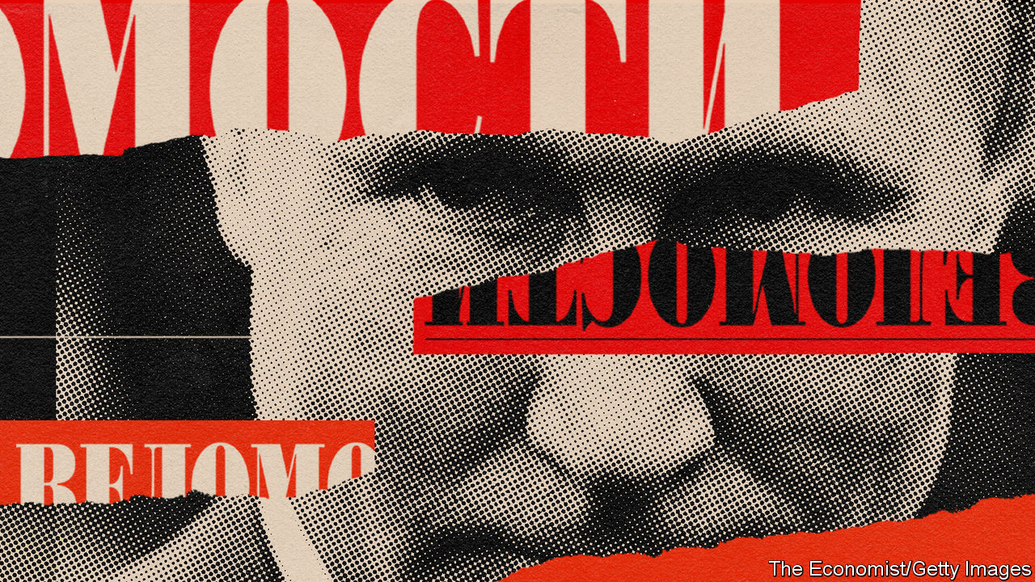

THEY ARRIVED together. The first issue of Vedomosti, Russia’s leading business newspaper, appeared in September 1999, a month after Vladimir Putin was appointed prime minister and anointed as future president. It was half pink and half white, a tribute to its foreign co-founders and shareholders: the Financial Times and the Wall Street Journal.

The timing of the new venture was brave. Russia was reeling from its financial crisis of 1998 and heading into a brutal war in Chechnya. But the economy started to grow, private businesses sprang up and Vedomosti was there to write about them. Its journalists and editors, most of them in their 20s, embodied the aspiration to integrate with the world and prove that business in Russia need not be the exclusive domain of the mafia and oligarchs.

“Our journalists know…that honest competition and honest success are no rarity in Russian business,” Vedomosti said in its first editorial. It took to the principles of its Anglo-Saxon shareholders with the zeal of the convert. Its code of conduct stated that “A journalist must treat all events, firms and people with equal scepticism. Nobody is entitled to special treatment—least of all the shareholders, advertisers and the so-called oligarchs.”

Over the past two decades, the paper has largely stayed true to its code, protected first by its foreign owners and later by its own reputation. But in the past few weeks a revolt by its staff has begun against the new acting editor, Andrei Shmarov, an old-style journalist from the 1990s, who was imposed on the paper by its prospective buyers as part of a murky and yet to be completed takeover. The staff, and many observers, believe that their paper is being distorted to suit the interests of the Kremlin and Rosneft, the state-controlled oil giant.

Vedomosti journalists have warned in the columns of their organ that it could become a controlled outlet, serving the interests of officials and its secret owners. Mr Shmarov began by changing a headline on an already-published story about Rosneft, and removed from its website a column by a prominent economist that scolded Igor Sechin, Rosneft’s boss and one of the most powerful men in Mr Putin’s entourage. A few days later, Mr Shmarov banned his writers from mentioning Levada, Russia’s most reputable pollster, whose latest findings show Mr Putin’s approval rating at 59%, its lowest level since 1999.

Paradoxically, investigative journalism and critical analysis have been thriving in Russia, mostly online. But as Maxim Trudolyubov, a Vedomosti columnist and editor-at-large, argues, what is going on at his paper is an attack on an institution that embodied the values of fair, rules-based market competition and transparency.

Vedomosti was critical, but never an opposition newspaper. It shunned activism because it believed business had to be separate from politics, just as opinion and reporting were on its pages. Vedomosti readers, including most of Russia’s business and political elite, subscribed to the initial contract of Mr Putin’s presidency, where people were free to make and spend money as long as they stayed out of politics.

That deal started to unravel after mass urban protests in 2011-2012. In 2013 Vedomosti splashed with a letter from 35 businessmen who openly supported Alexei Navalny, the leader of the protests, as he ran to be mayor of Moscow. As Tatyana Lysova, its former editor, recalls, this infuriated the Kremlin and solidified its mistrust of private business and the non-state media.

But attacking Vedomosti too openly risked conflict with two of the world’s most influential business newspapers, something that the Kremlin was still wary of in 2013. A year later, following the annexation of Crimea, that inhibition was gone. The Kremlin passed a law barring foreign control of Russian media, and forced the FT and Dow Jones (the Wall Street Journal’s parent company) to sell their stakes. The paper’s new Russian proprietors kept the paper afloat for a few more years, but this year quickly caved in when the Kremlin piled on the pressure, and decided to sell.

The timing of the current attempts to bring the paper to heel is not so much a sign of Vedomosti’s outspokenness (it recently attracted Mr Navalny’s ire for being too conformist), but of the Kremlin’s intolerance of any criticism. Mr Putin great fear is that a consensus may start to emerge among Russia’s political and economic elite that it is time for him to go. The front page of an elite newspaper could provide encouragement for such a consensus—but not if Mr Putin’s friends can censor it.

So just as the birth of Vedomosti coincided with Mr Putin’s arrival, its current afflictions coincide with his refusal to leave. But the journalists’ revolt demonstrates that Vedomosti has bred a generation of writers, and readers, who see Mr Putin as an anachronism and will not quietly accept his experiments in absolutism. ■

This article was downloaded by calibre from <https://www.economist.com/europe/2020/05/09/russias-leading-business-paper-is-being-gagged>

|  |  |  |  |
| --- | --- | --- | --- |
| Previous | Articles | Sections | Next |

|  |  |  |  |
| --- | --- | --- | --- |
| Previous | Articles | Sections | Next |

#### Uncounted, unseen

# Many covid deaths in care homes are unrecorded

Governments are waking up to a hidden calamity

May 9th 2020 | PARIS

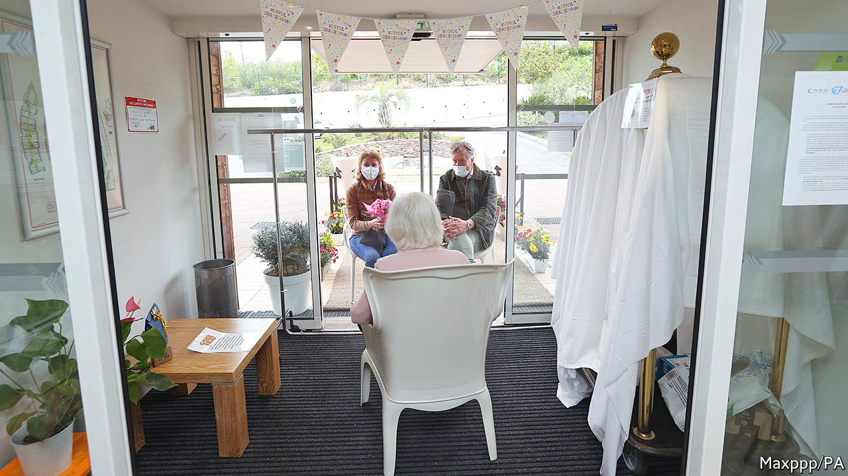

Editor’s note: The Economist is making some of its most important coverage of the covid-19 pandemic freely available to readers of The Economist Today, our daily newsletter. To receive it, register [here](https://www.economist.com/newslettersignup). For our coronavirus tracker and more coverage, see our [hub](https://www.economist.com/coronavirus)

AT A CARE home high in the hills above Cannes, on the French Riviera, the first report at the end of March was of 12 deaths. A week later, the toll had surged to 24. The town’s undertaker was overwhelmed. Families began to panic. By April 30th, 38 of the original 109 residents at the care home were dead, from confirmed or suspected covid-19. In care homes across France 9,471 deaths had been recorded by May 5th—nearly two-fifths of the country’s official covid-19 death toll.

This grim situation became apparent in France when it started publishing statistics for care-home deaths on April 1st. Britain, which began to do this four weeks later, is only now uncovering a similar calamity. When it first added care-home casualties, the official death toll jumped by almost 4,000 in a day. On May 5th the total in Britain, at 29,427, overtook Italy’s tally (which does not yet include them) to become Europe’s highest.

How many sinister, underreported aspects of the covid-19 outbreak might yet emerge in Europe? Due to reporting lags and varying death-certification procedures, all official data tend to undercount covid deaths. The best way to get a more accurate picture is to look at excess mortality, the gap between the number of overall recorded deaths and the historic average for the same period. The Economist has calculated excess mortality for some of Europe’s worst-hit countries, using, where possible, a five-year average (see chart). We also use this to calculate how well different countries are capturing the effect of covid-19 in their official data.

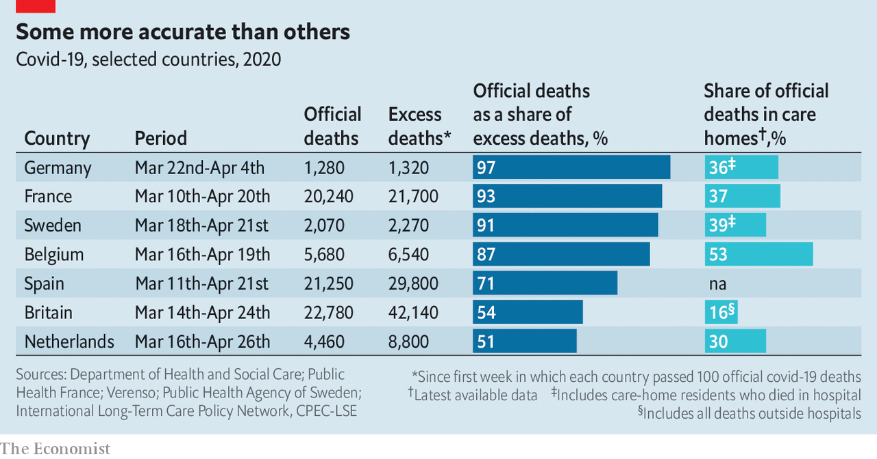

France, Sweden and Belgium seem to do the best job. (German numbers are not recent enough to make valid comparisons, and may be exaggerated by unusually low flu-related deaths earlier this year.) Their official covid-19 death tolls are picking up 87-93% of excess mortality. This partly reflects reporting protocols. Belgium includes suspected as well as confirmed covid-19 deaths. Indeed, three-quarters of covid-19-related deaths in its care homes have not actually been tested, according to Yves Coppieters, an epidemiologist at the Free University of Brussels. This gives tiny Belgium a big total relative to its population. Belgian officials were miffed when Donald Trump recently used a chart showing Belgium as the worst-affected country. A “vile” insinuation, commented Denis Ducarme, a Belgian minister. Even in Belgium, some criticise this approach as too speculative, but it may mean fewer nasty surprises later on.

“France and Belgium have been pretty exemplary in publishing data on suspected or probable deaths from covid-19 in care homes,” says Adelina Comas-Herrera, at the Care Policy and Evaluation Centre of the London School of Economics. From early April the French health ministry began to push testing into care homes, even if the roll-out has been uneven and painfully slow in places. This has helped to uncover a pattern that fairly well matches excess mortality as recorded by INSEE, the statistics body. Thanks to a fall during lockdown in other deaths, notably on the roads, total mortality in France has now dropped back to normal levels.

Contrast such relative transparency with official figures in the Netherlands. Its statistics on covid-19 deaths capture only 51% of estimated excess mortality. This is partly a measure of more restrictive recording. The national public-health institute includes in its tally only those who have tested positive. But Dutch figures also seem to capture poorly what is happening in its care homes. It has no systematic policy of testing there, and unco-ordinated data collection. According to a paper by Florien Kruse, Toine Remers and Patrick Jeurissen of the Radboud University Medical Centre, “deaths are underreported in nursing homes.”

As Europe begins to emerge from lockdown, those countries with a low or unreported share of covid-19 deaths in their care homes could well be in for a shock. Besides the Netherlands, Spain and Britain look particularly exposed. Spain in theory requires regional governments to provide figures. But, say Ms Comas-Herrera and her LSE colleagues, methodological problems mean that the health ministry has not yet released any national data on care-home deaths. As for Britain, the daily death toll in care homes is still rising, even as that in hospitals falls. Angela McLean, deputy chief scientific adviser, this week stated bluntly: “We need to get to grips with what is happening in care homes.” ■

Dig deeper:  
For our latest coverage of the covid-19 pandemic, register for The Economist Today, our daily [newsletter](https://www.economist.com/newslettersignup), or visit our [coronavirus tracker and story hub](https://www.economist.com/coronavirus)

This article was downloaded by calibre from <https://www.economist.com/europe/2020/05/09/many-covid-deaths-in-care-homes-are-unrecorded>

|  |  |  |  |
| --- | --- | --- | --- |
| Previous | Articles | Sections | Next |

|  |  |  |  |
| --- | --- | --- | --- |
| Previous | Articles | Sections | Next |

#### Latte to go

# Italy, the first country in Europe to enter lockdown, starts to emerge

But there is a long way to go

May 9th 2020 | FLORENCE

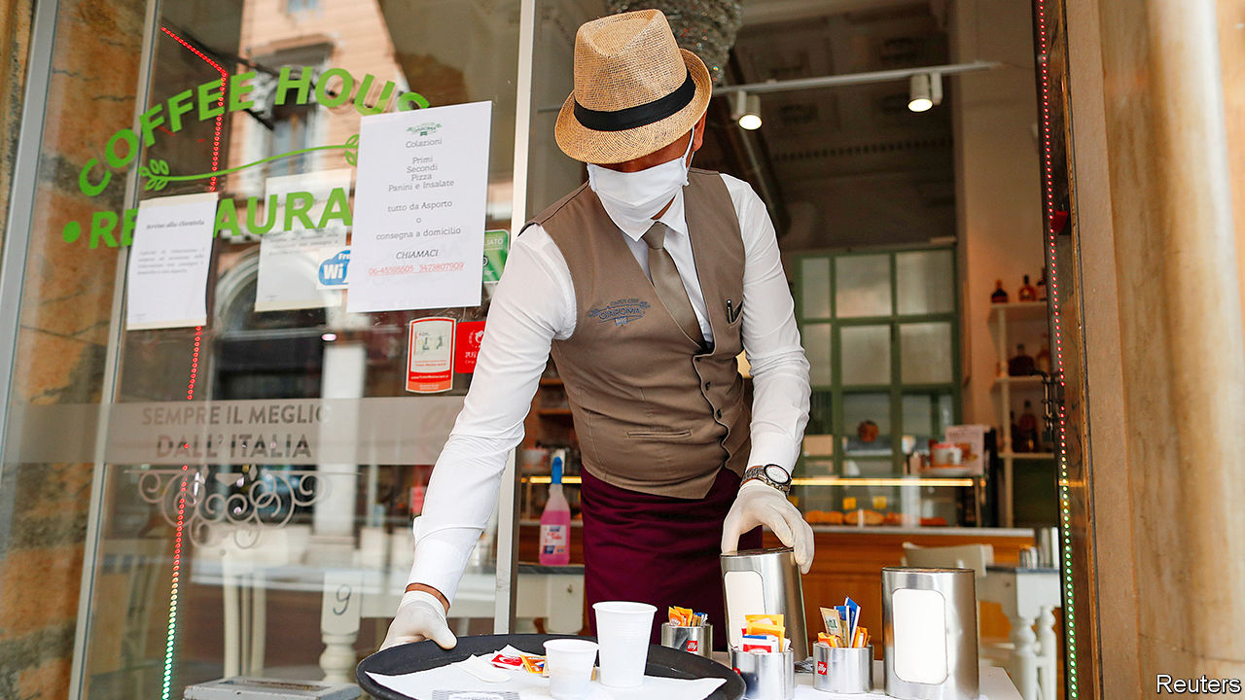

Editor’s note: The Economist is making some of its most important coverage of the covid-19 pandemic freely available to readers of The Economist Today, our daily newsletter. To receive it, register [here](https://www.economist.com/newslettersignup). For our coronavirus tracker and more coverage, see our [hub](https://www.economist.com/coronavirus)

MAGDA VERGARI, co-owner of the Bar La Lastra in the hills above Florence, used to sell 80 to 100 pastries a day. “Now, I’m ordering 20,” she says gloomily. Despite an easing of Italy’s strict covid-19 lockdown on May 4th, her sales of coffee are also running at a quarter of the normal level. The problem is that customers are not allowed to enjoy their breakfast cappuccino and brioche at the counter. The new rules preserve social distancing, and only allow bars and restaurants to offer takeaways. Ms Vergari’s regulars must consume their purchases in the street outside.

Awkward compromises are at the heart of Italy’s emergence from an eight-week lockdown. More industries have been allowed to resume production. But most shops will stay closed until May 18th. Hairdressers will have to wait until June 1st. But parks have reopened. People can now travel between municipalities, but not between regions without good reason. And Italians can only visit their congiunti—a term almost unknown beyond officialdom that has prompted confusion and hilarity. The government initially defined it as relatives and in-laws, but then a court ruling was unearthed that included those bound by a “stable and enduring emotional link”, whatever that means.

At least two reasons help explain the hesitancy of what many Italians call Phase 1.5. The prime minister, Giuseppe Conte, faces contrasting fears of infection on the one hand, and of impoverishment on the other. Italy had recorded more deaths than any other country in Europe except Britain (whose figures include care-home deaths, which Italy’s do not): 29,684 by May 6th. But while its economy suffered less than those of either France or Spain in the first quarter, the IMF forecasts a devastating contraction, of 9.1%, by year’s end. With debts of almost 135% of GDP before the pandemic struck, and still unsure how much help it will get from Italy’s EU partners, the government has been reluctant to throw much money at the problems covid-19 is causing for individuals and companies.

Mr Conte’s other problem is the unevenness with which the virus has struck. As the restrictions were eased, three regions in the centre and south were free of fresh contagion. In Lombardy, the region around Milan, more than 3,500 people had tested positive in the previous five days.

Yet it is from the north, Italy’s economic powerhouse and the stronghold of Matteo Salvini’s hard-right Northern League, that the most strident calls have come for the lifting of restrictions. Mr Salvini’s unrelenting criticism of the government does not seem to be doing him much good, however. His poll ratings have fallen. And that is not his only problem. One League governor, Attilio Fontana in Lombardy, is under fire for mishandling the crisis; another, Luca Zaia in Veneto, has been so successful that he is now being talked of as a possible replacement for Mr Salvini as party boss.

As for the prime minister, his biggest challenge may come from within the governing coalition. Matteo Renzi, whose small Italia Viva party could rob Mr Conte of his majority, has threatened to withdraw his support if more is not swiftly done to revive the ailing economy. ■

Dig deeper:  
For our latest coverage of the covid-19 pandemic, register for The Economist Today, our daily [newsletter](https://www.economist.com/newslettersignup), or visit our [coronavirus tracker and story hub](https://www.economist.com/coronavirus)

This article was downloaded by calibre from <https://www.economist.com/europe/2020/05/09/italy-the-first-country-in-europe-to-enter-lockdown-starts-to-emerge>

|  |  |  |  |
| --- | --- | --- | --- |
| Previous | Articles | Sections | Next |

|  |  |  |  |
| --- | --- | --- | --- |
| Previous | Articles | Sections | Next |

#### Istanbully

# Turkey investigates those who object to homophobia

For Islamophobia, of course

May 9th 2020 | ISTANBUL

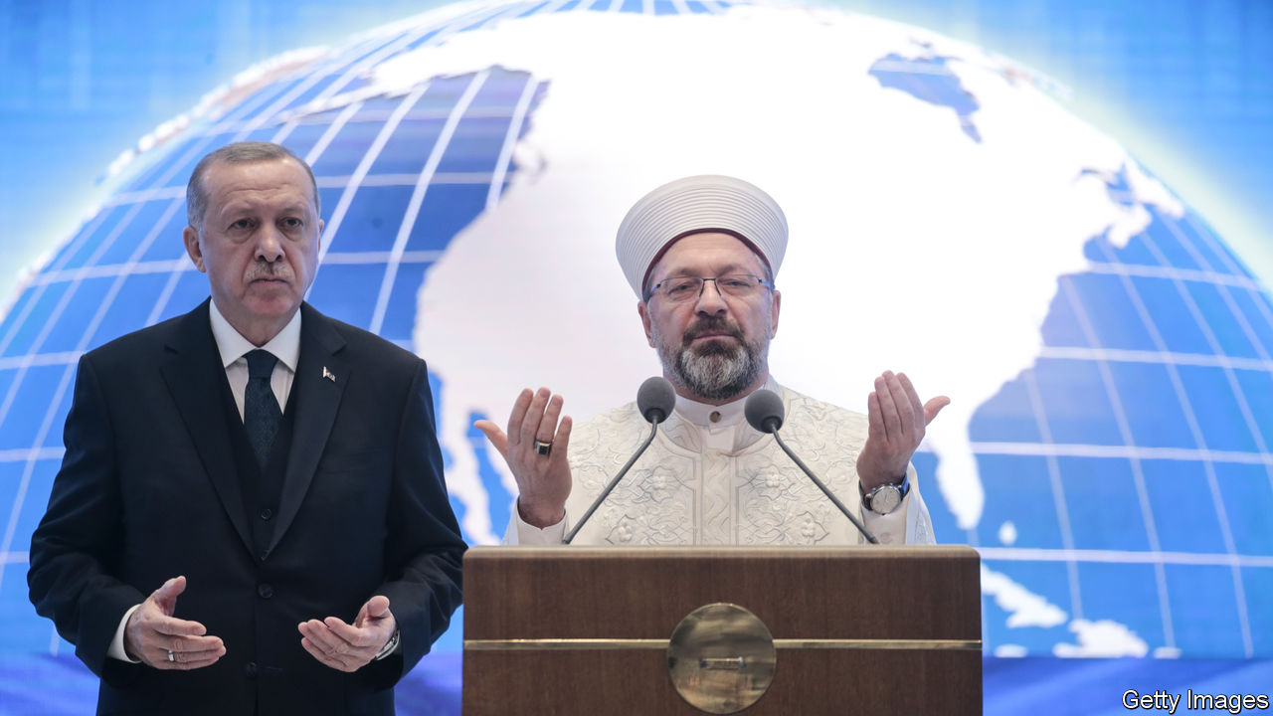

STUCK AT HOME during Ramadan because of covid-19, Turks at least have something new to argue about. In a sermon marking the start of the holy month on April 24th, Ali Erbas, the country’s top religious official, proclaimed that Islam condemned homosexuality “because it brought illnesses and generational decay”.

After human-rights groups, some opposition politicians and the Ankara Bar Association accused Mr Erbas of inciting hatred, Turkey’s President Recep Tayyip Erdogan and his supporters rushed to the cleric’s defence. One of his flacks said Mr Erbas could not be faulted for voicing “divine judgment”. Another accused his critics of Islamophobia. “An attack against the head of the Diyanet is an attack on the state,” Mr Erdogan himself warned, referring to the institution Mr Erbas has headed since 2017. “What he said was completely true.” The same day, state prosecutors launched an investigation—against the Ankara Bar.

Scripturally speaking, Mr Erbas had a point. The Koran takes a dim view of homosexuals (not to mention atheists, drinkers and women who disobey their husbands). But though homosexuality is outlawed in most other Muslim countries and punished by death in a few, it is not a crime in constitutionally secular Turkey. The Diyanet, which runs the country’s 90,000 mosques, provides religious guidance, but has no power to impose its prescriptions.

LGBT groups have never had it easy in Turkey, though prejudice seems to be on the wane. As recently as 2012, a whopping 85% of Turks said they did not want to have a gay neighbour. In a new poll, that had fallen to 47%. But while public attitudes have softened, official ones have hardened.

Only a decade ago, when it still enjoyed good relations with Europe, Mr Erdogan’s government signed a convention banning discrimination on the basis of sexual orientation or gender identity. Tens of thousands marched in the Pride Parade on Istanbul’s main street under police escort. Today, very little of that spirit remains. The pride march has been banned; rubber bullets and tear-gas await those who turn up. The Diyanet, set up nearly a century ago to reconcile Islamic teachings with secular values, has turned into the voice of political Islam and an arm of the government. Nuanced interpretations of the Koran have given way to a more restrictive approach. Gay celebrities are still feted, even in government circles, but only as long as they do not discuss their sexuality in public.

Mr Erdogan’s attempts to raise what he calls “a pious generation” have not had the desired impact, however. Studies show young people are turning away from religion. That may be why the ruling Justice and Development (AK) party and the Diyanet have decided to double down. “They’re increasingly insecure politically and culturally and they don’t want to give an inch to those who take other interpretations of Islam,” says Omer Taspinar of the Brookings Institution, a think-tank. “Now there’s a spirit of defensive jihad against moral laxity and relativism.”

In the row over Mr Erbas, Mr Erdogan and his surrogates are suggesting that there is only one immutable Islam, which should not accommodate changing norms. Turkey’s history suggests that is not true. But anyone who still thinks moderate Islam and AK belong in the same sentence might want to take note. ■

This article was downloaded by calibre from <https://www.economist.com/europe/2020/05/09/turkey-investigates-those-who-object-to-homophobia>

|  |  |  |  |
| --- | --- | --- | --- |
| Previous | Articles | Sections | Next |

|  |  |  |  |
| --- | --- | --- | --- |
| Previous | Articles | Sections | Next |

#### Charlemagne

# European leaders are appealing directly to voters in other countries

A bold attempt to create a pan-European conversation

May 9th 2020 |

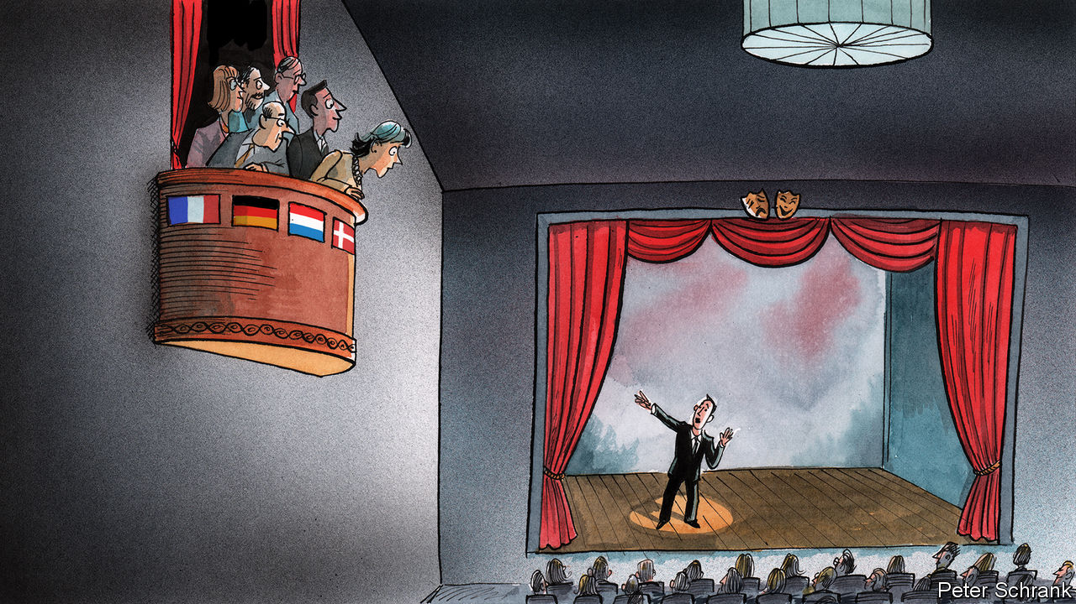

IN THE NASTY, brutish and short life of an Italian prime minister, an interview with a mid-market Dutch newspaper is not usually a high priority. Yet when faced with the worst health crisis in a century and the prospect of economic meltdown, Giuseppe Conte took time to speak to De Telegraaf about the crisis. In it, Mr Conte addressed the Dutch prime minister, Mark Rutte, in front of his voters: “Mark, help us now.”

European leaders are attempting to burst out of the corset of national politics. Increasingly, politicians across the EU are going over the heads of their peers and speaking to each other’s voters directly instead. A group of Italian mayors recently bought an advert in the Frankfurter Allgemeine Zeitung, calling for debt relief, with a punchy reference to Germany benefiting from similar leniency in the wake of the second world war. Pedro Sánchez, Spain’s socialist prime minister, writes op-eds in major European newspapers. Mr Conte also took time to address readers of the Süddeutsche Zeitung, a national newspaper based in Munich. Emmanuel Macron, the French president, deploys rhetorical hand grenades when speaking to the English-language press, in the hope the explosion will be heard beyond Francophone borders.

It is a potential solution to a long-running problem for the EU. The bloc suffers from the conundrum identified by Massimo d’Azeglio, one of the architects of Italian unification: “We have made Italy; now we must make Italians.” Increasingly, the EU is in a similar position. It is a de facto state without a nation. It is a top-down project, taking a bigger role when it comes to protecting borders, defence and foreign policy to go with its common currency and myriad regulations. What it lacks, like 19th-century Italy, is a coherent sense of citizenship. Instead, 27 sets of national politics collide with a half-built European political system.

If European leaders want to alter European public opinion, they must first create some kind of pan-European conversation. This is easier said than done. With 24 official languages, Europe does not speak with one voice. Public opinion, meanwhile, is siloed on a national basis. The decisions that matter most to European voters, whether tax or health or their children’s schooling, are still taken in national capitals. It is understandable that the bulk of attention of voters and journalists alike goes to matters at home. Even European elections to determine the make-up of the European Parliament are domestic politics by other means.

Some of the barriers to a truly European public opinion are falling. Google Translate is the closest mankind has come to a “Babel fish”, a leech-like creature invented by Douglas Adams in “The Hitchhikers’ Guide to the Galaxy” which translates all the universe’s languages if shoved in one’s ear. Even Estonian, the peculiar cousin of Finnish, is relatively well covered. With language barriers crumbling, the hurdle becomes persuading someone to read about European politics in the first place.

A Babel fish comes with downsides in Mr Adams’s telling: “By effectively removing all barriers to communication between different races and cultures, [it] has caused more and bloodier wars than anything else in the history of creation.” If anything, though, European politics could do with more metaphorical bloodshed. Although the critique of Vivien Schmidt, an academic at Boston University, that the EU offers “policies without politics” is unfair, the machinations of national leaders when in Brussels are often a little bloodless. The EU should arouse political passions. Decisions over the make-up of a €1trn ($1.1trn) recovery fund for those hit hardest by the covid crash will determine the fate of southern Europe’s economies. In such circumstances, an honest knife-fight in the press is surely better than a quiet stitch-up in Brussels.

Appealing to an embryonic European point of view is far from foolproof. During the Greek crisis such tactics were at the heart of Syriza’s attempt in 2015 to renegotiate a bail-out with its euro-zone partners. Rather than wooing the grey-suited men who dominated the club of euro-zone finance ministers, the left-wing leadership opted to fight a public-opinion war. Some journalists lapped up the narrative of a rebellion against an unfeeling empire, particularly when one of the main characters, Yanis Varoufakis, was a motorbike-riding skinhead who talked about economics in refreshingly plain English. There was no fairytale ending. Appeals to a sense of European rather than national democracy failed to move public opinion in, for instance, Germany. Syriza capitulated to the empire’s demands. Mr Varoufakis appearing in Paris Match, a celebrity gossip-sheet, was in retrospect not much help.

## Europe is listening (for now)

This time, the strategy has a better chance. Politicians in southern Europe have found a more sympathetic audience in foreign media than previously. A pandemic comes without the moral baggage of the euro crisis. The German press, which once revelled in caricatures of inflation-addicted Italians and siesta-taking Spaniards, has been more open to the ideas for getting out of the economic crisis put forward by their southern cousins. Both Der Spiegel, a centre-left news weekly, and Süddeutsche Zeitung have written in favour of some form of mutualised debt, which is a no-no for much of the German establishment and the holy grail for southern Europe. A genuinely European political debate is emerging.

Whether it will last is another matter. Interest in the life of the EU has peaks and troughs. When the EU appears on the edge, it dominates headlines. (An irony of Brexit was that the actions of the EU dominated British journalism in a way they seldom had before Britain decided to leave.) But when the EU sails through serene waters, journalists look for drama elsewhere. After this crisis passes, the audience may narrow again. Public opinion will keep its national boundaries while true power resides far from Brussels. The discourse may be increasingly European, but the voters who count are still as national as ever. ■

This article was downloaded by calibre from <https://www.economist.com/europe/2020/05/09/european-leaders-are-appealing-directly-to-voters-in-other-countries>

|  |  |  |  |
| --- | --- | --- | --- |
| Previous | Articles | Sections | Next |

|  |  |  |
| --- | --- | --- |
| Europe | Sections | International |

Britain

Offices: The shape of things to come

.

First orders: The return of fun

.

Scientists and politics: Of white coats and grey suits

.

Tracing: App exceptionalism

.

The politics of lockdown: Climbing the walls

.

Vulnerable children: A different danger

.

Newspapers: Stunt men

.

Bagehot: Contra mundum

.

|  |  |  |
| --- | --- | --- |
| Europe | Sections | International |

|  |  |  |  |
| --- | --- | --- | --- |
|  | Articles | Sections | Next |

#### Getting back to work

# What will be the new normal for offices?

Millions of workers are toiling at home because of the pandemic. Many of them may never go back into the office

May 9th 2020 |

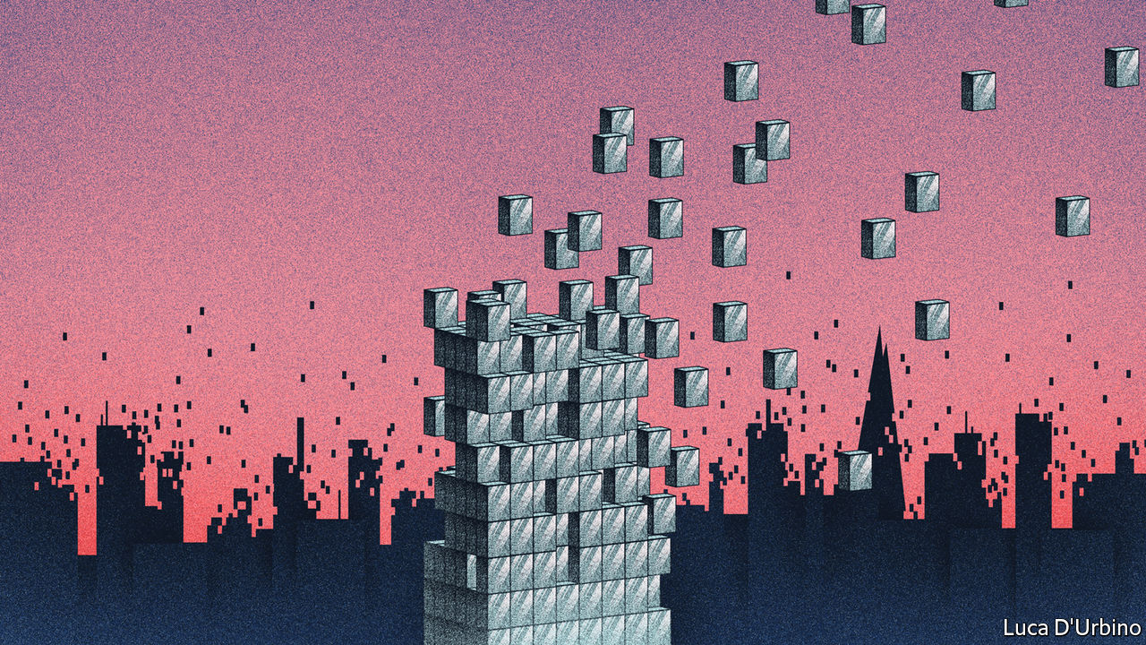

Editor’s note: The Economist is making some of its most important coverage of the covid-19 pandemic freely available to readers of The Economist Today, our daily newsletter. To receive it, register [here](https://www.economist.com/newslettersignup). For our coronavirus tracker and more coverage, see our [hub](https://www.economist.com/coronavirus)

ON MAY 10TH Boris Johnson, the prime minister, is expected to outline the beginning of the end of lockdown. Non-essential shops will start to reopen and factories will gradually get back to work, while maintaining sensible distancing.

For the deskbound, not much will change. Unlike pubs, restaurants and non-essential retailers, offices were not closed by government decree. Instead, since late March, the government has been encouraging those who can work from home to do so. As The Economist went to press, it was due to issue guidance on how to work safely in offices. The main thrust is expected to be, for now, not to.

A few will start to return. Those who need better IT support and faster broadband than they have at home will be back sooner. Banks expect traders to work from either their normal offices or from disaster-recovery sites. Charlie Rudd, chief executive of Leo Burnett, an advertising firm, reckons design and production staff will be among the first back: “when you’re dealing with big files of high-quality material domestic Wi-Fi is not great”. But for now, the numbers are likely to be small. Nicolas Aubert, head of British operations at WillisTowersWatson, an advisory firm, says that “it’s going to be a very small percentage of our population, we believe that is going to be roughly 25% for six to nine months”. And many bosses predict that the pandemic will lead to a step-change in homeworking and the demand for office space.

According to the Office for National Statistics around one in 20 workers did their jobs mainly from home in December 2019. Thanks to faster internet connections, the number is edging up. Chris Grigg, the chief executive of British Land, a property company, notes that the car parks near rail stations in commuter towns are already emptier on a typical Friday than in the rest of the week. Will Gosling from Deloitte, a professional-services company, believes the pandemic has brought about a “five-year acceleration” of a trend that was already under way: it has shown that working from home is feasible and has made it more acceptable. The old view that “you’ve got an easy day” if you work from home has become much less common, he says.

Attitudes have shifted rapidly. A business-continuity planner at a financial-services firm says that before the lockdown, when the company initially pondered moving to split working to enforce more distancing in their offices, “no one wanted to be on the working from home side. But a few weeks later, as we started planning how to get back to the office, everyone wanted to stay at home.” More than half of Britons would like to work from home more often after the crisis and around a third say the ability to work at home will be a factor when they next seek a new job.

Nobody is yet committing to flogging their own headquarters and, in the short term, the need for social distancing within offices may prop up demand. But some bosses are predicting radical changes that will delight chief financial officers eyeing potential savings from dumping expensive city-centre locations. Jes Staley, chief executive of Barclays, has said that large headquarters buildings may become a “thing of the past”. Mr Aubert “would be very surprised if corporations in professional services kept more than 50% of their real estate, and it might be significantly less”. Even a commercial-property manager admits that “there is a serious risk that what was once a prime real-estate asset is now an overpriced half-empty building.”

The pandemic has prompted firms to think hard about what offices are for, and many are concluding that a lot of tasks are better done from home. Lee Elliott of Knight Frank, an estate agent, reckons that “the days of people taking a 74-minute average commute into town to process email, and then 74 minutes back out—they’re gone.” Mr Gosling believes that “the focus of the workplace will be much more around collaboration, much more around the things you can only get the most value from by being together.”

That will be more important to some sectors than others. Mr Rudd of Leo Burnett reckons that “in the advertising world many people thrive off that collaboration and being together, and so they will still need offices where they can do that.” But if social distancing limits the number of people who can work physically together, it will undermine the office’s collaborative function. “I’d happily go back if everyone was going back,” says an executive at a technology firm, “but it makes no sense if only one in four people are there. I might as well be at home.”

More home working will mean new challenges for managers. Home workers are harder to monitor and so trust becomes more important. It will be harder for junior employees than senior ones. Junior employees need mentoring, want to socialise and have worse living conditions. But the decisions on the future of offices will be made by those for whom the alternative is more likely to be a nice house than a bedsit.

Some even predict the decline of office politics. “Normally in the office power structure, there’s always one who’s chatting up the powers that be, being just perched outside the office door when they’re going for lunch or for coffee,” according to Ann Francke, chief executive of the Chartered Management Institute. When people work at home, “that kind of political operator is rendered useless.”

If companies shrink their office space, the impact could be felt well beyond the firms themselves. “Getting rid of those physical barriers between cities will actually make us much more diverse,” says Tanuj Kapilashrami, head of human resources at Standard Chartered, who predicts that the firm will recruit from a wider pool. “I think there will be a significant movement of people out of London,” says Mr Gosling. “If I was in Boris’s shoes, the opportunity for the so-called ‘level-up’ is unbelievable,” says Mr Aubert, referring to the prime minister’s plan to raise incomes outside London and the south-east. There could be consequences for infrastructure, social geography and the subject closest to the British heart—house prices.

The need for workers to cluster together in offices has shaped every aspect of modern life. If the pandemic has weakened the office’s hold on society, the implications will be profound.■

Dig deeper:  
For our latest coverage of the covid-19 pandemic, register for The Economist Today, our daily [newsletter](https://www.economist.com/newslettersignup), or visit our [coronavirus tracker and story hub](https://www.economist.com/coronavirus)

This article was downloaded by calibre from <https://www.economist.com/britain/2020/05/09/what-will-be-the-new-normal-for-offices>

|  |  |  |  |
| --- | --- | --- | --- |
|  | Articles | Sections | Next |

|  |  |  |  |
| --- | --- | --- | --- |
| Previous | Articles | Sections | Next |

#### First orders

# How pubs, cinemas and shops will reopen

Non-essential businesses are making plans to reassure customers

May 9th 2020 |



Editor’s note: The Economist is making some of its most important coverage of the covid-19 pandemic freely available to readers of The Economist Today, our daily newsletter. To receive it, register [here](https://www.economist.com/newslettersignup). For our coronavirus tracker and more coverage, see our [hub](https://www.economist.com/coronavirus)

STREAMING SERVICES have replaced the cinema. Online shopping is standing in for the high street. Restaurant food is being home-delivered. And the ol’ Horse and Groom has become the Horse and Zoom, as people take to video-chatting with friends while sipping from a can of lager. It is, pub-goers have discovered, a poor substitute for the real thing. As Nick Mackenzie of Greene King, which runs 2,700 pubs, puts it: “The point of the pub is to socialise.”

The boozer was among the first casualties of Britain’s lockdown, with pubs ordered to close three days before the rest of the country. Along with other non-essential leisure venues, they will probably be the last to reopen, too. Evidence from countries now opening up suggests that such businesses will have to wait a few weeks longer than everyone else. Those in Britain are using the extra time to plan how to operate when they are allowed to welcome customers once more.

The task is particularly tricky for publicans. The very social distancing measures that save lives also kill the vibe: nobody wants to go to an empty pub. Larger pubs are planning to space out tables, reduce the number of occupants and offer takeaway pints and roasts. Independent pubs can start selling other things, such as groceries. One, the Red Lion in Ealing, is already offering Italian cheese, olives and ham, as well as sourdough breads. Those of all sizes will have to make a show of good hygiene. Expect regular table-wiping and digital ordering to replace germy paper menus.

Consumers are likely to hit the high street before the pub. Primark, a big clothes retailer with no online shop, is installing hand-sanitiser stations and Perspex screens to separate staff from customers at the tills. The layout of its shops is being tweaked to discourage people from lingering at high-traffic spots. “The government can give regulations. I think you go beyond...The thing that we’re looking at is reassurance,” says John Bason of Associated British Foods, which owns Primark. The hand sanitiser, for instance, is not merely plonked onto tables but installed in solid-looking fixtures.

Perhaps the unlikeliest leisure business preparing to reopen is the cinema. Pubs can space tables farther apart and shops can allow in fewer customers. But going to the cinema means spending hours in a small, enclosed space, breathing the same air as others. That does not phase Tim Richards, who runs Vue, a chain of cinemas. Attendance has been dwindling for years, which could turn out to be an advantage: “I think what’s important to recognise is that our occupancy rate tends to be around 20%, so for us to manage our customers coming in is relatively easy to do.”

Mr Richards’s plan is to stagger screening times in a cinema’s different auditoria, with no two films starting at the same time, so as to stop people hanging around together buying popcorn. Ticketing systems will ensure that any booking—whether for a couple or a family of five—is surrounded by empty seats. Vue will open cinemas gradually, once it is allowed to, with the formal reopening on July 17th planned for the release of Christopher Nolan’s “Tenet”, a film in which a secret agent must save the world. At the very least, he might help save the cinema. ■

Dig deeper:  
For our latest coverage of the covid-19 pandemic, register for The Economist Today, our daily [newsletter](https://www.economist.com/newslettersignup), or visit our [coronavirus tracker and story hub](https://www.economist.com/coronavirus)

This article was downloaded by calibre from <https://www.economist.com/britain/2020/05/09/how-pubs-cinemas-and-shops-will-reopen>

|  |  |  |  |
| --- | --- | --- | --- |
| Previous | Articles | Sections | Next |

|  |  |  |  |
| --- | --- | --- | --- |
| Previous | Articles | Sections | Next |

#### Scientist and politics

# Britain’s government says it is “following the science”. Which science?

Scientists deal in uncertainty, politicians prefer not to. Amid the pandemic, the two are not mixing well

May 9th 2020 |

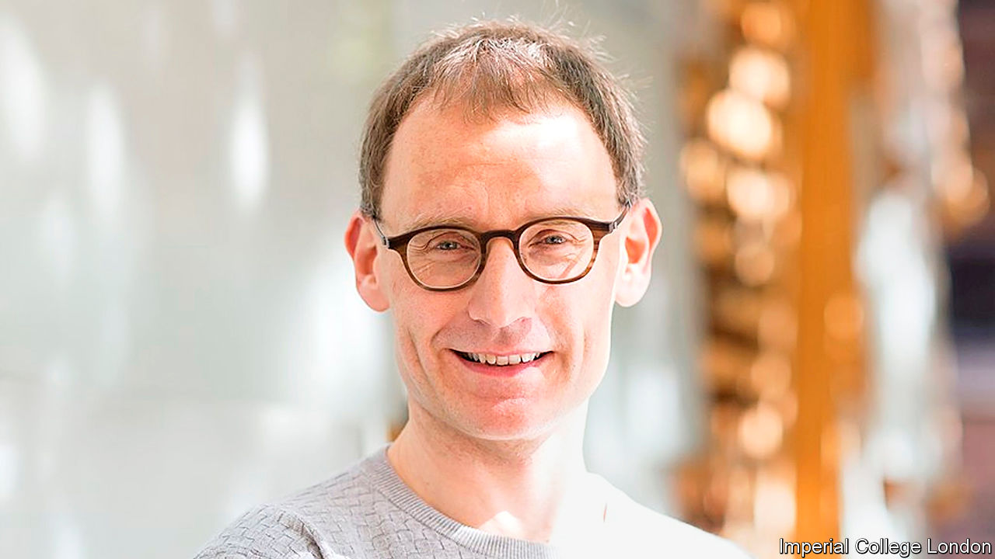

Editor’s note: The Economist is making some of its most important coverage of the covid-19 pandemic freely available to readers of The Economist Today, our daily newsletter. To receive it, register [here](https://www.economist.com/newslettersignup). For our coronavirus tracker and more coverage, see our [hub](https://www.economist.com/coronavirus)

WATCHING THE great and good trip up is a popular British spectator sport, and the lockdown offers a variety of banana skins which may bring eminent people down. First to tumble was Catherine Calderwood, who resigned as Scotland’s chief medical officer after twice breaking restrictions to visit her second home. This week it was the turn of Neil Ferguson (pictured), an epidemiologist whose bleak modelling spurred on Britain’s lockdown. He will no longer advise the government after flouting the rules by having his lover visit. The newspaper headlines were merciless. “Prof Lockdown broke lockdown to get his trousers down,” read the Sun’s splash.

The episode provides a fine example not only of Britain’s immature attitude to sex and scandal but also of the degree to which the covid-19 pandemic has thrust scientists into the spotlight. Eight weeks ago, hardly anybody had heard of the man whose extra-curricular activities graced the newspapers’ front pages; today, whether he likes it or not, “Prof Lockdown” is a public figure.

The roles of the government’s chief scientific officer and chief medical officer are normally “backstage jobs”, says James Wilsdon of Sheffield University, who has had trouble tracking down pictures of former office-holders with prime ministers for his lectures. Yet the incumbents—Sir Patrick Vallance and Chris Whitty, respectively—are now household names. They flank the prime minister at press conferences; Dr Whitty fronts public-information advertisements. The editor of the Lancet, a medical journal, pops up on television panels. And everybody seems to have a view about SAGE, the acronym for the government’s scientific advisory group for emergencies.

The closeness of the new relationship between science and politics has created three problems. First, as Dr Ferguson found to his cost, scientists who get drawn into politics are exposed to new dangers. There’s a good reason why governments should want to put them into the front line: polling by Ipsos MORI finds that more than four in five Britons trust professors and scientists, compared with fewer than one in five who put their faith in government ministers. But some scientists worry that the government’s mantra that it is “following the science” is an attempt to deflect blame. Sir David King, a former chief scientific adviser, has said he is “a little worried the ministers are setting the scientists up to be the fall guys”. If they fall, as Dr Ferguson has, the public interest will be damaged along with theirs.

Second, science and politics operate best under different conditions. While science needs transparency to progress, policymaking requires a certain amount of opacity. SAGE’s membership and processes have been kept secret, though on May 4th the government reluctantly, under pressure, published a list of all but two of its members. Sir David, arguing that science is best done in sunlight, set up his own rival group, the “independent sage”, which streams its meetings on YouTube.

Third, the government’s mantra implies a consensus about “the science” that points towards a single policy choice. Yet covid-19 has spread so fast that none of the important questions about it have been settled. Estimates of the proportion of the population infected range widely. It is hard to be definitive about the rate at which the disease reproduces, even though this number is pivotal to policymaking. There are even competing death tolls. Do you consider all excess deaths or only those strictly attributed to covid-19? Evidence can be found for many different policy responses. “In the absence of sufficient data and scientific consensus, people are going to use their judgment,” says Kieron Flanagan of Manchester University.

Scientists are accustomed to talking about ranges and living with uncertainty. The public might find that harder. As the first meeting of Sir David’s online committee got going, commenters were enthusiastic about “this effort to disseminate the science, rather than the spin”. But, once it became clear that the panellists had differing views and were not about to offer up a ready-packaged solution, the tone changed. “Please Mr Modeller!” went one comment. “Just answer the questions.”■

Dig deeper:  
For our latest coverage of the covid-19 pandemic, register for The Economist Today, our daily [newsletter](https://www.economist.com/newslettersignup), or visit our [coronavirus tracker and story hub](https://www.economist.com/coronavirus)

This article was downloaded by calibre from <https://www.economist.com/britain/2020/05/09/britains-government-says-it-is-following-the-science-which-science>

|  |  |  |  |
| --- | --- | --- | --- |
| Previous | Articles | Sections | Next |

|  |  |  |  |
| --- | --- | --- | --- |
| Previous | Articles | Sections | Next |

#### Tracing

# Why Britain is ignoring the Google-Apple protocol for its tracing app

The decision makes it a global outlier

May 9th 2020 |

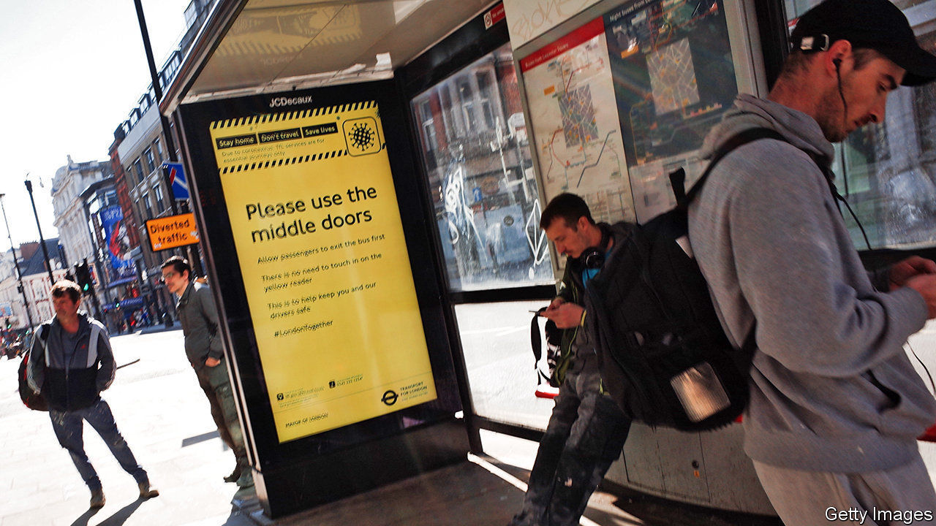

Editor’s note: The Economist is making some of its most important coverage of the covid-19 pandemic freely available to readers of The Economist Today, our daily newsletter. To receive it, register [here](https://www.economist.com/newslettersignup). For our coronavirus tracker and more coverage, see our [hub](https://www.economist.com/coronavirus)

EVER SINCE Apple and Google announced that they would tweak their smartphone operating systems to help digital contact-tracing, governments have been changing their approaches. Germany went along with the tech giants on April 26th, having initially been opposed. Singapore, which built the world’s first nationwide contact-tracing app, is rebuilding atop Google’s and Apple’s technology.

Not Britain. The app which Britain started trialling on the Isle of Wight on May 5th eschews the Apple and Google protocol in favour of a home-grown solution. While the Apple and Google system processes information about people’s contacts on their phones, the British system will store it on a central server controlled by the National Health Service (NHS).

The British approach has problems. There are doubts about whether it will work at all. The point of the Apple and Google protocol update is to allow phones to exchange Bluetooth contact signals in the background. Otherwise, on the latest versions of Android and on Apple’s iOS, the screen must always be on for Bluetooth tracking to take place, with the app in the foreground, killing battery life and making the phone unusable. The NHS says it has found a work-around for this, but it will certainly use more battery power than the tech giants’ own solution; and, given that it is doing something the phone systems are designed to prevent, there is a good chance that it will work poorly. The NHS’s record on tech is not great: in 2011, it pulled the plug on an £11bn IT system that didn’t work.

The Irish border poses a further problem. Ireland, like most European countries, has chosen to use a decentralised system built atop the Google and Apple protocol. The Irish and British apps will therefore be unable to communicate, so the contacts of the 30,000 people who commute across the border with Northern Ireland every day will not be traced on the other side. Scotland is not keen on the NHS app either, and will not push its adoption. The same problem will apply to cross-border tracking of foreign tourists in Britain, or Brits abroad. Apple’s and Google’s protocol allows for national apps built using it to talk to each other. The NHS app does not.

The British approach may also face legal problems. Ravi Naik of AWO, a data-rights agency, says that because centralised systems consolidate individuals’ data in a single location outside their control, they also pose a greater threat to their rights. “To justify that interference, the government will have to provide significant evidence to show that such a system is necessary and proportionate,” says Mr Naik. Matthew Ryder of Matrix Chambers has said that a legal challenge to the app is “almost inevitable”.

The government’s decision to go for a centralised system may in part be the consequence of its tardiness in getting testing off the ground. A system that relies on self-reporting of symptoms requires public-health authorities to make judgments about symptoms; centralisation permits that. The authors of a paper published on April 16th by a group at Oxford University, widely acknowledged to have influenced the government’s decision-making, says that “prolonged test turnaround times and low capacity for testing” limit the use of testing as an indicator.

The decision to go with the centralised version may also have been influenced by the power of the NHS brand. Brits trust it—probably more than they trust Apple and Google. Mr Hancock has called on that brand power in his sloganeering around the app: “Stay at home, install the app, protect the NHS, and save lives.”

Yet getting the app installed on enough phones to be useful requires that it be as energy-efficient and painless to use as possible, something best done with the Apple and Google tools. Many techies expect an about-face on centralisation, despite the potential for bruised egos and the extra work that would need to be done to bring the app in line with Google, Apple and most of the rest of the world. ■

Dig deeper:  
For our latest coverage of the covid-19 pandemic, register for The Economist Today, our daily [newsletter](https://www.economist.com/newslettersignup), or visit our [coronavirus tracker and story hub](https://www.economist.com/coronavirus)

This article was downloaded by calibre from <https://www.economist.com/britain/2020/05/09/why-britain-is-ignoring-the-google-apple-protocol-for-its-tracing-app>

|  |  |  |  |
| --- | --- | --- | --- |
| Previous | Articles | Sections | Next |

|  |  |  |  |
| --- | --- | --- | --- |
| Previous | Articles | Sections | Next |

#### Conservative Party

# Lockdown is making the Tory party restive

MPs are climbing the walls

May 9th 2020 |

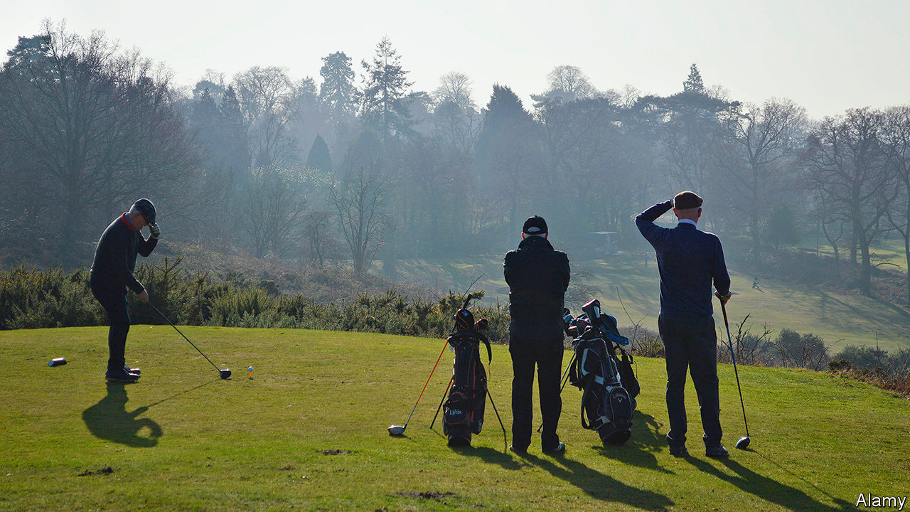

Editor’s note: The Economist is making some of its most important coverage of the covid-19 pandemic freely available to readers of The Economist Today, our daily newsletter. To receive it, register [here](https://www.economist.com/newslettersignup). For our coronavirus tracker and more coverage, see our [hub](https://www.economist.com/coronavirus)

IF A COMMITTEE were to design a policy with the aim of offending the Conservative Party, it might come up with something resembling Britain’s lockdown. In its bones the party believes that law-abiding Britons should be free to go for an evening walk without explaining themselves to a police constable, or downloading a surveillance app on their mobiles. Public health is a matter for citizens’ good judgment, not bossy officials. The state should not, as a rule, negotiate with trade unions to pay wage subsidies, or hand grants to stricken businesses. “All the wrong people are cheering,” says a Tory MP, noting the Labour Party’s support for the lockdown.

The party’s most loyal supporters are feeling the pain. Small businesses’ revenues are collapsing. Healthy over-70s with busy social calendars are classified as “clinically vulnerable”, and may face a longer period of social distancing. Golf courses and garden centres are shut.

On May 4th MPs got the chance to air their grievances in a House of Commons debate called to approve lockdown legislation retrospectively. Marcus Fysh, dialling in on Zoom, a video-conferencing app, argued that the government must not set a precedent that health trumps liberty, which he insisted was “fundamental to our very souls”. Sir Charles Walker warned of mass unemployment that would “unleash a tidal wave of human misery”. Many are concerned about the toll from delaying treatment for other diseases. Iain Duncan Smith, a former party leader, urged Boris Johnson not to delay opening up until a contact-tracing app is ready.

But the prime minister, who is expected to outline plans to end lockdown on May 10th, worries that moving too fast will cause a surge in infections. He is in a powerful position. He has a majority of 80, seeks a Brexit to backbenchers’ liking and is popular with the party. Polls suggest voters approve of his performance in the crisis and think it too early to lift restrictions.

It is not the first time Mr Johnson has found himself at odds with large sections of his party. Since he became leader last summer, he has sought to reinvent the party after a decade in government and infighting over Brexit. He has purged pro-European MPs and adopted a big-spending, communitarian agenda. The scale of his victory in the general election last December suggests that voters approve of the makeover. But internal dissent remains. Mr Johnson’s decision in January to allow Huawei, a Chinese telecoms company, a role in building Britain’s 5G network prompted a small rebellion of MPs who want to ban the company over national-security concerns. In February he approved the High Speed 2 railway, which plenty of Tories think is wasteful and will spoil the countryside.

The longer parties stay in power, the less pliant they become, notes Philip Cowley, a politics professor at Queen Mary, University of London; and a mere change in prime minister does not overcome that tendency. “You have all the resentments and the grumbles, and just the tiredness building up of being in office.” There is some overlap between critics of the lockdown, the veteran Eurosceptics who ousted Mrs May and the Huawei rebels. Some are old foes of Dominic Cummings, Mr Johnson’s combative aide. The backbenches are home to many unconstrained by ambition because they know their time in ministerial office has been and gone, or will never come.

The virtual parliament makes party management still trickier. Tea-room chats allow ministers to counsel dissenters and detect trouble. Some think the government risks losing votes if businesses are still shuttered by June. “It will take longer for a rebellion to come into being, but it will be harder to suppress, if the whip’s not there to grab you by the elbow,” says an MP.■

Dig deeper:  
For our latest coverage of the covid-19 pandemic, register for The Economist Today, our daily [newsletter](https://www.economist.com/newslettersignup), or visit our [coronavirus tracker and story hub](https://www.economist.com/coronavirus)

This article was downloaded by calibre from <https://www.economist.com/britain/2020/05/09/lockdown-is-making-the-tory-party-restive>

|  |  |  |  |
| --- | --- | --- | --- |
| Previous | Articles | Sections | Next |

|  |  |  |  |
| --- | --- | --- | --- |
| Previous | Articles | Sections | Next |

#### Children at risk

# How covid-19 puts vulnerable children in greater danger

The lives of vulnerable children have got harder. So has the job of protecting them

May 9th 2020 |

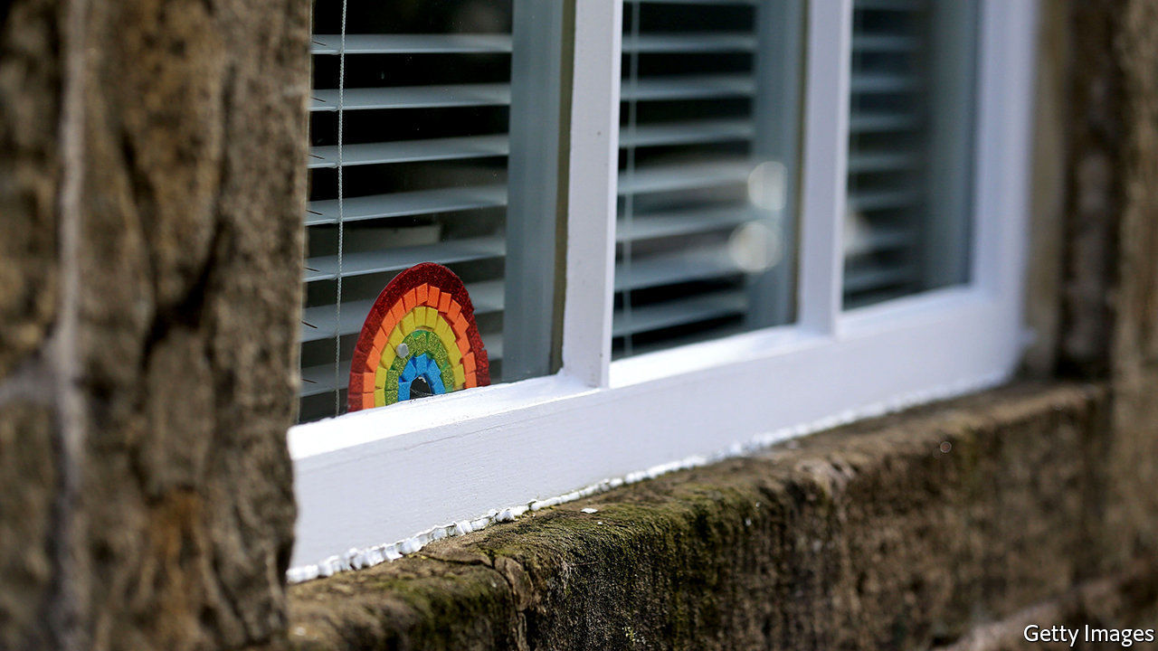

Editor’s note: The Economist is making some of its most important coverage of the covid-19 pandemic freely available to readers of The Economist Today, our daily newsletter. To receive it, register [here](https://www.economist.com/newslettersignup). For our coronavirus tracker and more coverage, see our [hub](https://www.economist.com/coronavirus)

IN NORMAL TIMES Chris, a social worker in a north London borough, visits the homes of vulnerable children, checking the fridge for food, looking for evidence of drugs or excessive drinking and otherwise being the eyes of the state. Now he has to try to gauge the condition of a household over a ropy internet connection. “It’s been an extraordinarily steep learning curve,” he says. “When you’re relying on a video call, things can easily be hidden.” A child who appears to be alone may not be. A violent partner may just step outside. Illicit substances can be locked away.

The number of children in the care of the state has been rising for over a decade, as the government becomes more cautious about leaving vulnerable children exposed to potential harm. Around 400,000 children have an assigned social worker, meaning that the state is worried enough about their welfare to want to check on them frequently. According to the Children’s Commissioner, 723,000 are receiving some sort of protection and 2.3m are “living with risk”.

Lockdown affects nearly everyone, but those least vulnerable to the actual virus—children—may be among the most exposed to the consequences of being shut in, especially if they are poor. With families cooped up, often in overcrowded homes, the likelihood of violence or abuse soars. Calls to the government’s domestic-violence hotline have jumped by half.

The government is trying to mitigate the effect of lockdown on vulnerable children by keeping school places open for them. That has not happened elsewhere in Europe. But the message to stay home has swamped the message that some children should still go to school, says Anne Longfield, the children’s commissioner. At the beginning of this term, just one in 20 eligible to attend actually turned up.

Since the support and vigilance that schools offer vulnerable children has been withdrawn, some big urban councils are not willing to take the risk of leaving them in potentially dangerous situations. Applications for children to be removed from their homes have therefore jumped, according to Ms Longfield.

But lockdown is hampering the process of taking children into local authority care. Court hearings have to take place by telephone. Removing a child with evidence given over the phone was “unimaginable in pre-covid days”, says Aysen Soyer, a solicitor who deals with many child-protection cases. It is happening now.

Yet making such huge decisions remotely is not easy. On April 16th Andrew McFarlane, the president of the family division of the courts, issued a judgment in a complicated case involving a seven-year-old girl where the local authority alleges that the mother has harmed her daughter by fabricating illnesses. Mr McFarlane ruled that while delaying the decision would not be good for the girl, he feared it would be “impossible” to come to a fair decision remotely, with a judge having to decide about the parties’ honesty based on a “postage-stamp image” on a screen. Some lawyers feared that would stop hearings entirely. For now they are continuing, but judges are forced to weigh the fairness of remote proceedings on top of everything else. Covid-19 has made both the lives of vulnerable children and the job of protecting them much harder.■

Dig deeper:  
For our latest coverage of the covid-19 pandemic, register for The Economist Today, our daily [newsletter](https://www.economist.com/newslettersignup), or visit our [coronavirus tracker and story hub](https://www.economist.com/coronavirus)

This article was downloaded by calibre from <https://www.economist.com/britain/2020/05/09/how-covid-19-puts-vulnerable-children-in-greater-danger>

|  |  |  |  |
| --- | --- | --- | --- |
| Previous | Articles | Sections | Next |

|  |  |  |  |
| --- | --- | --- | --- |
| Previous | Articles | Sections | Next |

#### The press

# How the pandemic revived the newspaper stunt

Patriotism is fertile ground for an ancient form of journalism

May 9th 2020 |



AFTER WEEKS of criticism of the government’s failure to organise enough personal protective equipment for health workers, a plane from China touched down at Heathrow Airport on April 28th with 20 tons of the stuff. But these were not government-ordered supplies; the consignment had been arranged by the Daily Mail, a newspaper that ministers have long credited as the authentic voice of Middle England. “Touchdown for Mail Force One,” roared the paper, above pictures of its precious cargo. More supplies will be procured thanks to donations from readers to a charity founded by the newspaper, Salesforce, a software firm, and Marshall Wace, a hedge fund.

The airlift is a classic example of journalism as spectacle. The Rothermere family’s publishing empire, which owns the Mail, started life with a 19th-century newspaper called Answers that promised to give away £1 a week for life to a reader who could guess the exact amount of bullion in the Bank of England’s vaults, points out Adrian Addison, author of “Mail Men”, a history of the paper. (Sapper C.D. Austin of the Ordnance Survey came within £2 and “married on the proceeds”.) Given the proud place of stunts in the firm’s history, it is no surprise that the current Lord Rothermere sits in on the daily video calls to co-ordinate the campaign.

Stunts have grown rarer lately, as circulations and budgets have dwindled, but they sit comfortably with the pandemic’s patriotic atmosphere. The Mail trumpeted the delivery of protective kit to a care home putting on an anniversary party for war veterans: “Mail Force saves VE Day for heroes”. The paper is also marking the 75th anniversary of the end of fighting in Europe, on May 8th, by chartering a Spitfire. Readers nominated a care home for the flypast. But tabloid stunts sometimes stray from patriotism to xenophobia. One such wheeze involved sending “a platoon” of models to Germany to protest at claims that English tourists hogged sun-loungers. “The Sun invades Germany,” ran the headline.

This latest spectacle is also in keeping with the emotive nature of the genre. The Mail orchestrated an airlift of 99 orphans from Vietnam in 1975. Cute animals are regular protagonists. In 2017, the Sun intervened to “rescue” two military dogs that were due to be put down. Perhaps the apex of the genre came in 1987, when the Sun paid a Spanish farmer for his donkey, which had attracted sympathy in Britain after reports that it would be crushed to death during a fiesta. A reporter from the Daily Star, another tabloid, tracked the animal down, paid the farmer again and shipped the donkey back to Britain. Reprising its rival’s most famous headline, the paper’s front-page splash read simply: “Gotcha!”

This article was downloaded by calibre from <https://www.economist.com/britain/2020/05/09/how-the-pandemic-revived-the-newspaper-stunt>

|  |  |  |  |
| --- | --- | --- | --- |
| Previous | Articles | Sections | Next |

|  |  |  |  |
| --- | --- | --- | --- |
| Previous | Articles | Sections | Next |

#### Bagehot

# The rise of isolationism in the Conservative Party

Britain is starting to look like a very lonely little country

May 9th 2020 |



A FEW YEARS ago Britain liked to think of itself as the belle of the globalisation ball. David Cameron invited Xi Jinping, China’s president, for a state visit that involved a trip down the Mall in a gilded carriage and a banquet in Buckingham Palace. He wooed Angela Merkel, Germany’s chancellor, in a bid to breathe new life into Britain’s membership of the European Union. He liked to boast that his friendship with Barack Obama, America’s president, was so close that Mr Obama had once tucked him up in the presidential bed on Air Force One.

Boris Johnson came to power promising, in a very Johnsonian manner, to preserve Britain’s pro-global stance while also delivering Brexit. He routinely referred to the Europeans as “our neighbours and partners”. He got on famously with Donald Trump. Shortly before taking over as prime minister he told a Chinese TV station that his government would be “very pro-China”. He repeatedly insisted that there are two possible versions of Brexit: Nigel Farage represented the inward-looking and xenophobic one while he represented the outward-looking and cosmopolitan one.

Yet Mr Johnson’s party may be turning against his global vision. One piece of evidence is the emergence of the China Research Group (CRG). Founded a couple of weeks ago to “promote debate and fresh thinking” about China, in the words of one of its founders, Tom Tugendhat, it has attracted interest from all sorts: moderates like Damian Green, Eurosceptics like Mark Francois and human-rights advocates like Benedict Rogers. Mr Tugendhat is a moderate Remainer; Neil O’Brien, the co-founder, a moderate Leaver. It has already drawn some blood: on May 5th the foreign-affairs select committee, which Mr Tugendhat chairs, asked some difficult questions about whether, acting through surrogates, the Chinese government took over a British-based firm, Imagination Technologies, in order to get control of security software.

The rise of the CRG is not evidence, in itself, that the Conservative Party is losing its enthusiasm for “global Britain”. There are plenty of good reasons for criticising a country that distorts trade through industrial subsidies, soft loans from state banks and discriminatory standards while conducting industrial espionage and supporting authoritarian regimes around the world. Keeping China at arm’s length may also be a price for maintaining a close alliance with America: some senators are trying to block the deployment of the latest generation of American fighter jets to Britain because it is allowing Huawei into its 5G network. Still, the CRG’s name, a deliberate echo of the European Research Group (ERG) that masterminded Brexit, is ominous. You cannot pick fights with China without China hitting back.

The rise of scepticism towards China that the CRG represents comes at a perilous time for Britain’s international affairs. Relations with Russia have not recovered from the Salisbury poisonings two years ago, and those with both the European Union and the United States are unusually troubled.

A Tory MP characterises Mr Johnson’s attitude to the EU as “the only way is out, out, out”. The prime minister is willing to accept a much harder Brexit than the average member of the ERG would have thought possible a couple of years ago. He has little interest in remaining part of the EU’s foreign policy and security structures that his predecessor, Theresa May, held in high regard. The pandemic is widening the channel even further. Britain is so preoccupied by the virus that it is devoting far too little attention to its Brexit negotiations, increasing the chances that an on-time Brexit will also be a bitter Brexit.

Britain’s relations with the United States are volatile. The Brexiteers’ bet on Donald Trump was always risky, given his exotic personality and determination to put America first. The Anglo-American trade talks, which have just got under way, cover such tricky topics as chlorinated chicken and the National Health Service’s purchasing policy. The chances that Britain will soon be dealing with Joe Biden rather than Mr Trump go up by the day, as Mr Trump flails around in the face of the virus. Mr Biden may well be more interested in cosying up to the EU than to “Britain Trump”, the moniker which the American president bestowed on the British prime minister. Given his long record of pro-Irish sentiments, Mr Biden will not take kindly to a Brexit that damages either the Anglo-Irish agreement or the Republic’s economy.

## Alone again

Domestic pressures to turn inward are also mounting. The election shifted the Tory party’s centre of gravity from regions dominated by the winners of globalisation to those dominated by losers. The pandemic is leading many Tories to question the relevance of free-market orthodoxies to a world in which supply chains are vulnerable and protectionism is spreading. They point to the way that Germany has benefited from its national capacity to carry out tests and make personal protective equipment. “Reshoring”, “domestic resilience” and “strategic industries” are all the rage. Mr Johnson talks about a shift to “national self-sufficiency”, with a step-change in Britain’s capacity to manufacture drugs, vaccines and medical equipment.

The idea of distilling a “global Britain” from the frenzy of Brexit was always problematic. It depended on pulling off two difficult tricks simultaneously: back home, taming the protectionist forces that drove Brexit, and, abroad, cosying up to competing powers without getting too close to any of them. The pandemic has made it harder still. Anti-Chinese sentiment is rising across the West, particularly in America. Nation states are retreating to their core function of protecting their citizens first or consolidating their relations with their closest neighbours. The British are about to discover that the “splendid isolation” the Victorians once celebrated is less glorious when that solitude is not chosen as an instrument of power, but is imposed by the world’s indifference. ■

This article was downloaded by calibre from <https://www.economist.com/britain/2020/05/09/the-rise-of-isolationism-in-the-conservative-party>

|  |  |  |  |
| --- | --- | --- | --- |
| Previous | Articles | Sections | Next |

|  |  |  |
| --- | --- | --- |
| Britain | Sections | Special report |

International

Virtual dating: Fever when you hold me tight

.

Domestic abuse: No safe haven

.

|  |  |  |
| --- | --- | --- |
| Britain | Sections | Special report |

|  |  |  |  |
| --- | --- | --- | --- |
|  | Articles | Sections | Next |

#### Fever when you hold me tight

# Casual sex is out, companionship is in

Lockdowns are forcing singletons to embrace emotional intimacy

May 9th 2020 |

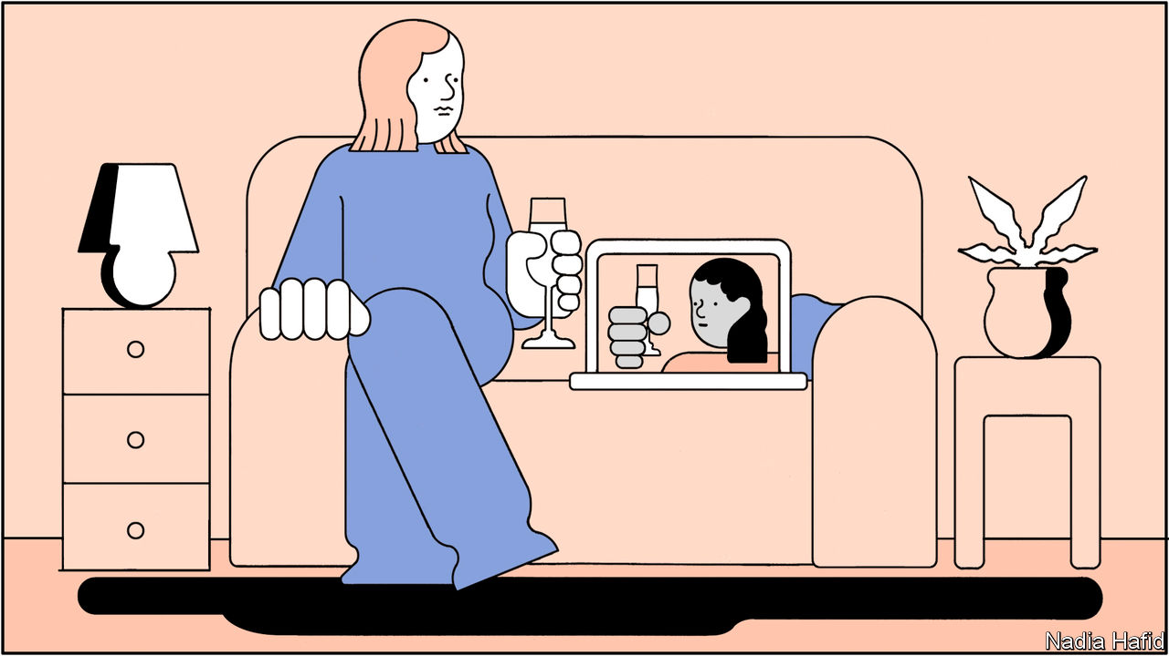

Editor’s note: The Economist is making some of its most important coverage of the covid-19 pandemic freely available to readers of The Economist Today, our daily newsletter. To receive it, register [here](https://www.economist.com/newslettersignup). For our coronavirus tracker and more coverage, see our [hub](https://www.economist.com/coronavirus)

ON A SMARTPHONE screen Rob (not his real name) looked good. Twenty-four years old, classically handsome, with a job on Wall Street, he was an attractive prospect on dating apps. Shepherding women from bar to bedroom was easy. Sex was on tap. Then in March covid-19 struck New York City and shut off the mains.

It is a frustrating time to be single. Social distancing makes meeting in the flesh hard. Some people are still trying. In socially conservative Bangladesh, where cohabitation is rare, couples rushed to get married before lockdown started. In Italy lovers rendezvous in supermarket queues.

But many more are looking for love on the internet. Some people are trying to recreate old formats online. In Lagos professionals host virtual games nights for the unattached. In China people dance the night away at “internet discos”, before peeling off into message boards to chat privately. But others are embracing a new set-up: the virtual date. And the solitude of lockdown is making them reconsider what they want from romantic relationships.

Nearly 240m people use dating apps and websites. Even before the pandemic American couples were more likely to meet each other through online-dating services than through personal contacts, according to a study published in 2019 by sociologists from Stanford University and the University of New Mexico. Such apps are increasingly popular in poor countries, too, especially where dating is frowned upon. In Bangladesh and Egypt singletons have flocked to apps such as Tinder.

Dating apps are designed to push users off their phones and into bars, a less-than-ideal model in the middle of a pandemic. But user numbers for the five most popular online dating services have held steady this year, according to App Annie, a market-research firm. And would-be Romeos and Juliets are using them more intensely than they were before covid-19 struck. In April the average number of messages sent daily across Match products, including OkCupid, PlentyOfFish, Tinder, Hinge and Match.com, was up by 27% compared with the last week of February. During the worst week of China’s epidemic, in late February, the average user of TanTan, a Chinese app, spent 30% longer on the app than normal.

Before the pandemic, online daters complained about the fickleness of their peers. Many failed to initiate conversations with those they were matched with; if they did, the other party soon disappeared, according to Dawoon Kang of Coffee Meets Bagel, an app. The ease with which users could make connections encouraged them to treat matches as if they were “replaceable”, argues Rachel DeAlto, a relationships expert from Match, one of the first dating websites. This stoked frustration; last October 45% of American users told Pew that online dating was a vexing experience.

But covid-19 has rendered users less flighty. Between late February and late March, the average length of a conversation on Tinder, one of the most popular apps, surged by 25%. “People are taking the time to get to know each other more,” says Ms Kang, who has seen a similar shift on Coffee Meets Bagel. In Bangladesh the daily video calls Shenaz has with her boyfriend, whom she met on Tinder five months ago, last for hours. She was worried they would drift apart during lockdown, but knowing that she cannot meet someone new “has made me commit to this relationship” more than she did before. (She is luckier than some. Saeda Bani of BRAC, a Bangladeshi NGO, says men from poor families are commandeering the mobile phones of female relatives, younger ones in particular, to stop them from spending money on phone credit or talking to strange men.)

The pandemic has also made singletons more willing to show their faces. Before it, they rarely turned on the webcam. Video-conferencing was “a business thing”, says Mike, a 28-year-old Bumble user from Perth; using it for dating seemed creepy. Just 6% of American singles said they were likely to have used video to meet people before the pandemic, according to a poll of Match users conducted in mid-April.

But Zoom chats with friends and family have become routine in the age of covid-19. Some 70% of American singles surveyed by Match said they would now use video. Bumble, which introduced video chat last July, reported an 84% increase in the number of video calls between the third and fourth weeks of March. Hinge, the League and Match added video last month. Facebook Dating and Tinder plan to do so, too.

And people are surprisingly willing to bare their souls on video dates. At home there are fewer distractions to nudge along a dull conversation than there would be at a restaurant enlivened by a bickering couple. Mike realised that the only way to avoid the dreaded “awkward pause” during his virtual dates was to “really listen, really react and go deep into what we’re talking about.” The result is that “you end up really investing in each other.” And such dates weed out those unable to make conversation, points out Abigail Arunga, a journalist in Nairobi.

These shifts reveal a desire for companionship, argues Ms DeAlto. They also highlight the unease felt by some with the rush of romance pre-covid. Merav Gur, a psychologist in Manhattan, says that before the pandemic her millennial patients felt pressure to have casual sex. The more anxious shunned dating altogether. More confident millennials like Rob, the banker, threw themselves headlong into hook-up culture but it left them dissatisfied.

Isolation has improved their emotional lives, says Ms Gur. Those who felt hurt by the casualness of dating apps say the people they are meeting now are kinder and more responsive than before the pandemic. App users surveyed in March by the Kinsey Institute at the University of Indiana “were more likely to say that they found other users to be friendlier than usual, more willing to have video chats, and more willing to have deep conversations” than before the pandemic, says Justin Lehmiller, one of the study’s authors.

Where lockdowns lift, the old ways are returning. In Beijing, which is slowly reopening, parks are filling up with strolling couples and restaurants are busy serving tables for two. In Iran, which has allowed cars back on the streets, a teacher says that he has registered as a driver on one of the country’s ride-hailing apps, hoping to meet women. But Ms DeAlto predicts that until people need no longer worry about covid-19, most singletons will be wary of close contact with potential mates. Almost all OkCupid users, polled since March, say they plan to continue using video. The virtual date may outlast the pandemic. ■

Dig deeper:  
For our latest coverage of the covid-19 pandemic, register for The Economist Today, our daily [newsletter](https://www.economist.com/newslettersignup), or visit our [coronavirus tracker and story hub](https://www.economist.com/coronavirus)

This article was downloaded by calibre from <https://www.economist.com/international/2020/05/09/casual-sex-is-out-companionship-is-in>

|  |  |  |  |
| --- | --- | --- | --- |
|  | Articles | Sections | Next |

|  |  |  |  |
| --- | --- | --- | --- |
| Previous | Articles | Sections | Next |

#### No safe haven

# The pandemic may be making domestic abuse worse

It is also forcing people to find new ways to curb it

May 9th 2020 |

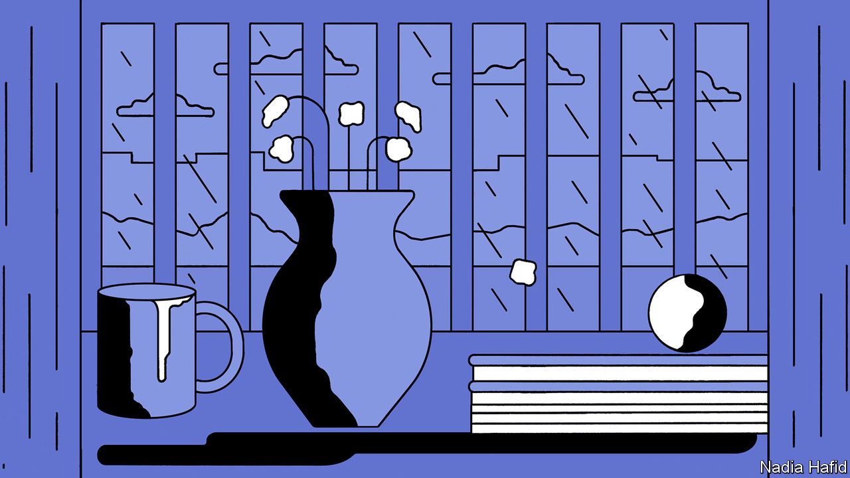

Editor’s note: The Economist is making some of its most important coverage of the covid-19 pandemic freely available to readers of The Economist Today, our daily newsletter. To receive it, register [here](https://www.economist.com/newslettersignup). For our coronavirus tracker and more coverage, see our [hub](https://www.economist.com/coronavirus)

EVEN BEFORE covid-19 began to spread, domestic abusers often tried to isolate their victims so as to exert physical and psychological control over them. Lockdowns have magnified their ability to do that. Those at risk—be they partners, children or parents—can no longer escape, even briefly, to school or work. To help them, policymakers, social workers and campaigners are having to innovate.

The pandemic has probably made domestic violence worse, but proving it is hard. Some rich countries are reporting more calls for help, says Claudia Garcia-Moreno, who leads the World Health Organisation’s (WHO) efforts against violence against women. In France reports to police of domestic violence rose by at least 30% in the first week of the lockdown imposed in mid-March. Other places are noting steep declines. Reports of domestic violence in New York City in April dropped by 35% compared with the same month last year. Overall crime, by comparison, fell by 29% over the same period.

Even in normal times domestic violence is underreported. The UN estimates that less than 40% of women who are physically abused at home seek any kind of help. In lockdown victims may be scared to call the police or a helpline if their tormentor can overhear them. Victims may stay in their homes for fear of infection. Those who have lost their jobs may find it even more difficult to leave. The pandemic is making it harder to get help to the vulnerable—social workers fear infection, too.

Domestic-abuse hotlines say that growing numbers of callers refer to covid-19—and the related economic fallout. Katie Ray-Jones, head of America’s national hotline, says the lockdown is prompting some already abusive men to become more so; some of those who were verbally abusive before are becoming physically violent. Others are lying to their victims about lockdown rules, telling them that they are not allowed to leave the house under any circumstances, for instance.

Lockdowns are forcing those who help to be more innovative. Technology has long been useful. Refuge, a British charity, has an online-chat tool that shows survivors how to set up strict privacy features on their mobile phones. Many shelters and hotlines already have a button on their website that takes those looking for help to Google’s home-page and floods their search history with unremarkable sites in case their abuser walks into the room.

Online tools are especially useful now. A Dutch helpline is seeing increased numbers of children asking for advice on community forums and using their online chat tool to talk to experts. And the pandemic is prompting fresh thinking. Courts in New York state have started issuing orders of protection virtually. If the scheme remains in place after the pandemic, it would remove the obstacle of having to go physically to a court to gain legal protection from an abuser. Staff at the Sexual Assault and Violence Intervention Programme at Mount Sinai Hospital in New York are now doing Zoom therapy sessions.

Where internet access is limited and legal protections are weaker technology may be less help. In Latin America mobile-data charges are unaffordable for many, so the WHO is trying to spread information about the help available through adverts on television and radio. Domestic abuse will outlive the pandemic. With luck, so will new tools to combat it. ■

Dig deeper:  
For our latest coverage of the covid-19 pandemic, register for The Economist Today, our daily [newsletter](https://www.economist.com/newslettersignup), or visit our [coronavirus tracker and story hub](https://www.economist.com/coronavirus)

This article was downloaded by calibre from <https://www.economist.com/international/2020/05/09/the-pandemic-may-be-making-domestic-abuse-worse>

|  |  |  |  |
| --- | --- | --- | --- |
| Previous | Articles | Sections | Next |

|  |  |  |
| --- | --- | --- |
| International | Sections | Business |

Special report

International banking: Parallel universe

.

Global banks: Credit clout

.

International currencies: Redback on track

.

Payment systems: Piping up

.

After covid-19: The dark side

.

|  |  |  |
| --- | --- | --- |
| International | Sections | Business |

|  |  |  |  |
| --- | --- | --- | --- |
|  | Articles | Sections | Next |

#### International banking

# Geopolitics and technology threaten America’s financial dominance

And now the covid-19 pandemic is precipitating a split, says Matthieu Favas

May 7th 2020 |

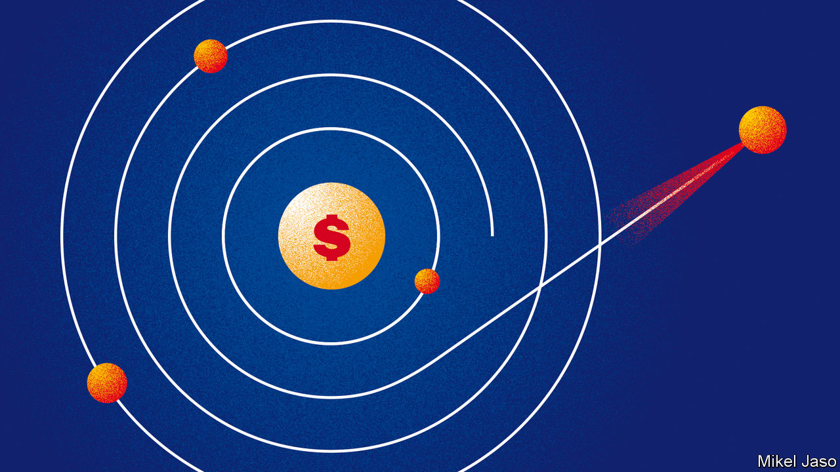

IN ANUARY AN American former general spoke at a gathering of senior global financiers. Used to thinking about strategy and hard power, he warned that America is dealing poorly with its most complex array of threats since the cold war—from Iran and Russia to the novel coronavirus. But he also spoke of a much less visible threat: how, through its aggressive use of economic sanctions, America is misusing its clout as the predominant financial power, thereby pushing allies and foes alike towards building a separate financial architecture. “I’m not sure of the decider-in-chief’s appreciation for how the financial system works,” he said. That a former general would be thinking about the global financial system says much about how significant that danger has become.

The system is made up of the institutions, currencies and payment tools that dictate how the invisible liquidity feeding the real economy flows around the world. America has been its pulsating centre since the second world war. Now, though, repeated missteps, and China’s growing pull, have begun to tear at the seams. Many assume the status quo is too entrenched to be challenged, but that is no longer the case. A separate financial realm is forming in the emerging world, with different pillars and a new master.

The hegemon-in-waiting financially, as geopolitically, is China, whose rapid rise is tugging away at the system. The country today accounts for 15.5% of global GDP, up from 3.6% in 2000. Its economy, the world’s second-largest, is deeply woven within the fabric of global trade. Yet it weighs little in the financial system. China sees correcting this asymmetry as crucial to gaining great-power status. “The dollar dominance is being hollowed out from underneath,” says Tom Keatinge of RUSI, a think-tank. The covid-19 crisis threatens to give centrifugal forces a decisive boost.

The system’s first pillar was laid in 1944 with the founding of the World Bank, the IMF and the global monetary order at Bretton Woods, New Hampshire. Having supplied weapons to allies throughout the war, America owned most of the planet’s gold, in which it priced its wares. Much of Europe and Asia lay in ruins. The interwar system of floating exchange rates had proved dysfunctional. It was thus decided that all currencies would be linked to the dollar, and the dollar tied to gold. That made the greenback the world’s new reserve currency. Two decades later the rising economic heft of Japan and Germany, coupled with vast money-printing by America during the Vietnam war, made the pegs untenable. The system disintegrated, but the “dollar standard” survived.

In the 1970s America also gained sway over the plumbing system that underpins global payments. American banks, then barred from operating outside state borders, teamed up to develop interbank messaging systems and nationwide ATM networks. Lenders also clubbed together to form credit-card “schemes”—associations setting the rules and systems through which members settle payments in plastic. Those worlds merged when two major card networks (soon rechristened Visa and MasterCard) bought the two largest ATM firms to expand overseas. By allowing individuals to shop anywhere, cards and cash machines became the dominant infrastructure for moving small sums of money across the world.

A revolution soon ensued in large-value transfers. In the old “telex” system, a cross-border payment between banks required the exchange of a dozen messages in free text, a process prone to human error. In 1973 a group of banks joined to create SWIFT, an automated messaging service assigning a unique code to every bank branch. It became the lingua franca for wholesale payments.

New technology boosted America’s banks, which became better equipped to follow clients overseas, and its capital markets, helped by the digitalisation of paper assets. Having rebuilt, savings-rich Japan and Germany parked their dollars in treasury bonds. A housing boom spawned asset-backed securities. Between 1980 and 2003, America’s stock of securities grew from 105% to three times GDP, forming the international springboard for its investment banks. After a regulatory big bang in the 1990s, they merged with commercial banks. By 2008, 35 firms had become the big four—Citigroup, Wells Fargo, JPMorgan Chase and Bank of America—the last prong of America’s financial dominance.

America’s pull within the system remains huge. When disasters strike, the dollar surges. It is still the world’s safest store of value and its chief means of exchange. That makes the institution that mints it the metronome of global markets. In 2008 America’s Federal Reserve avoided a general cash crunch worldwide by offering “swap lines” to rich-world central banks, allowing them to borrow dollars against their own currencies. When panic gripped markets again this March, the Fed expanded the offer to some emerging countries. In April it widened it further, allowing most central banks and international institutions to exchange their American debt securities against greenbacks, thus stalling the stampede.

The world’s financial plumbing remains under America’s thumb, too. SWIFT’s 11,000 members across the world ping each other 30m times daily. Most international transactions they make are ultimately routed through New York by American “correspondent” banks to CHIPS, a clearing house that settles $1.5trn of payments a day. Visa and Mastercard process two-thirds of card payments globally, according to Nilson Report, a data firm. American banks capture 52% of the world’s investment-banking fees.

## All change

Three things are driving change. First, the “push” factor of geopolitics. America’s centrality allows it to cripple rivals by denying them access to the world’s liquidity supply. Yet until recently it refrained from doing so. The financial system was seen as neutral infrastructure for promoting trade and prosperity. The first cracks appeared after 2001, when America started using it to choke funding for terrorism. Organised crime and nuclear proliferators soon joined the list. It persuaded allies by presenting such groups as threats to international security and the integrity of the financial system, says Juan Zarate, a former adviser to George W. Bush who designed the original programme.

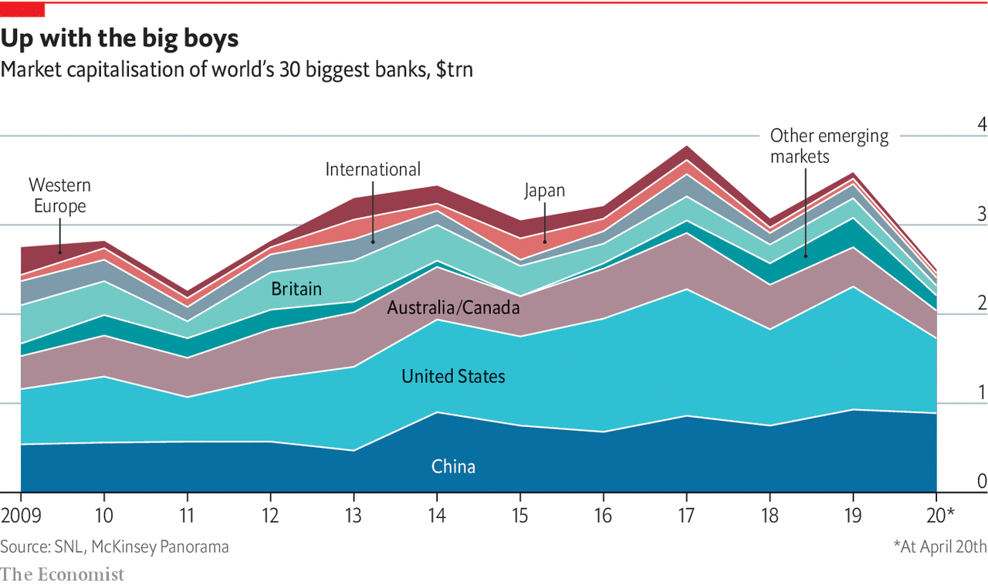

The arsenal gained potency under Barack Obama. After Russia’s invasion of Crimea in 2014, America punished oligarchs, companies and entire sectors of an economy twice the size of previous targets. “Secondary” sanctions were imposed on other countries’ companies that traded with blacklisted entities. President Donald Trump has since elevated the system for use as a weapon and used it against allies. In December it targeted firms building a pipeline bringing Russian gas into Europe. In March it toughened sanctions against Iran even as others channelled aid to the country. The arsenal hardly feels impartial: since 2008 America has fined European banks $22bn, out of $29bn in total. In 2019 it designated new sanction targets 82 times, says Adam Smith of Gibson Dunn, a law firm.

Sanctions are now increasingly used in conjunction with other restrictions to throttle China. The Department of Commerce maintains a jumble of lists of entities with which other firms cannot deal. One of them, the “unverified” list, bans exports to companies about which the ministry has questions. It has grown from 51 names in 2016 to 159 in March. Chinese entities make up two-thirds of additions. Other departments are also racing to be seen as the toughest on China.

In the short run the opaque nature of the whole system maximises the impact of sanctions. But it also creates a strong incentive for others to seek workarounds, and technology is increasingly providing the tools needed to build them.

It helps that many emerging markets, not just China, are keen on a rebalancing

Such advances result from the second driver of the new trends: the “pull” factor of attempts to meet the needs in emerging economies. Tech firms have sights on the world’s 2.3bn people with little access to financial services. Helped by plentiful capital and permissive rules, they have created cheap-to-run systems they are starting to export. Some also aim to enable commerce in regions where credit cards are rare but mobile phones common. Propped up by their huge home market, China’s “superapps” run ecosystems in which users spend their way without using actual money.

It helps that many emerging markets, not just China, are keen on a rebalancing. Most borrow abroad, and price their exports, in dollars. America was once the biggest buyer. Whenever the dollar rose, demand would follow, making up for costlier debt. But a stronger dollar now means China, their chief trading partner, can afford less stuff. So demand falls just when repaying loans gets dearer. And the stakes have risen: emerging markets’ stock of dollar debt has doubled since 2010, to $3.8trn.

The third factor helping insurgents is covid-19, which could lead to a tipping-point. Already hobbled by rising tariffs, global trade is likely to fragment further. As disruption far away causes local shortages, governments want to shorten supply chains. That will give regional powers like China more room to write their own rules. The economic fallout in America—not least the fiscal impact of its $2.7trn stimulus measures—could dent confidence in its ability to repay debt, which underpins its bonds and currency.

Most important, the crisis harms other countries’ trust in America’s fitness to lead. It ignored early warnings and botched its initial response. China is guilty of worse—its own missteps helped export covid-19 in the first place. Yet it managed to curb cases fast and is now broadcasting a narrative of domestic competence. America’s ability to guarantee global prosperity is the glue that holds the financial order together. With its legitimacy badly hit, renewed assaults on the system seem inevitable. On the front line are the dollar-system’s foot soldiers, the banks. ■

This article was downloaded by calibre from <https://www.economist.com/special-report/2020/05/07/geopolitics-and-technology-threaten-americas-financial-dominance>

|  |  |  |  |
| --- | --- | --- | --- |
|  | Articles | Sections | Next |

|  |  |  |  |
| --- | --- | --- | --- |
| Previous | Articles | Sections | Next |

#### Global banks

# As China goes global, its banks are coming out, too

European banks are losing their influence

May 7th 2020 |

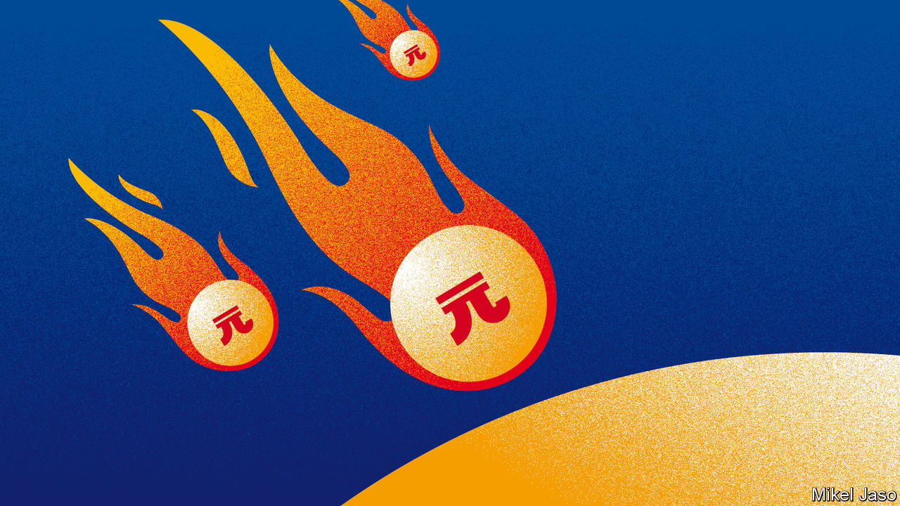

AMERICAN BANKERS make for bold bosses. From his roomy office in Manhattan, in early February, the boss of one of the country’s biggest suggested he has few serious rivals—and all are just a few blocks away. “US banks continue to gain share from European banks.” Asia barely gets a mention. “Chinese institutions have generally proven incapable of expanding globally. When they buy sports cars and flashy hotels, it just doesn’t feel solid.” Days later Morgan Stanley, America’s sixth-largest bank, announced its $13bn acquisition of E-Trade, a broker—the biggest by a Wall Street bank since 2008.

Within weeks China had exported a different threat. As coronavirus-induced investor fever took hold, the Dow Jones index of top American lenders, which had soared by a third over 2019, crashed by 50%. The market rout did not wipe them out. But it is the sort of event that could lead incumbents to self-isolate—accelerating the discreet spread of Chinese banks in emerging markets. And the country is opening up its own market, hoping to learn tips from new entrants along the way.

Chinese banks are already huge. Their total assets now surpass those of American and European banks. They are also providing more cross-border credit, the bread and butter of international banks. The sum they lend overseas has grown by 11% a year since 2016. More surprising to outsiders, they are gaining clout in the sophisticated universe of capital markets, too. Last year Chinese banks earned three times more investment-banking fees than all Asian rivals combined (excluding Japan). Their share of the total has jumped from 1% in 2000 to 14%.

## Balance-sheet of power

On the eve of the collapse of Lehman Brothers in 2008, European banks were the kings of cross-border lending. They accounted for 71% of total flows, which had grown from $10trn in 2000 to $35trn in 2008. But the subprime meltdown, followed by the eurozone crisis, forced them to retreat. As regulators required global banks to hold more rainy-day equity, other lenders chose to issue capital or to retain earnings. But conditions in Europe meant its banks had little choice but to trim their balance-sheets. Banks shed assets overseas. Far-flung subsidiaries were sold or shut. Today Europe (including Britain and Switzerland) provides 47% of the world’s $31trn in cross-border flows.

Cyclical events are likely to stymie them further. It is hard for banks to grow faster than their home economy. Europe has had anaemic growth throughout the 2010s. The virus crisis is turning 2020 into an even sicklier year. Interest rates, negative across the region for many quarters, are plumbing new depths. European banks’ return on tangible equity (ROTE) sank to 6.6% last year (investors reckon 10% is par). America’s top banks, buoyed by positive rates and a sprightly economy, posted double-digit ROTEs in 2019.

Europe will be hindered by structural factors, too. American lenders draw strength from their vast and unified home market. They can also reduce risk by repackaging loans and flogging them onto the country’s deep capital markets. The EU lacks both those things. Squabbles among members are hampering plans to complete a banking union. Cross-border mergers would give its top banks more scale, but are politically tricky, says Irene Finel-Honigman of Columbia University. And efforts to fuse capital markets remain unfinished (and diminished by Brexit, which separates the EU from its main financial centre).

The biggest issue lies with where European banks sit within the financial system. For all their cross-border heft, they are mostly middlemen, ferrying greenbacks from New York to other corners of the planet. Outside Europe much of their lending is done in dollars. Some is locked in long-term loans that cannot be called back. Yet they have no natural source of dollars, so many fund themselves by borrowing from short-term money-market funds. That makes them hostage to unsympathetic parties. Many reeled in 2012 when American funds, spooked that some European countries might default on their debt, struck European clients off their registers, says a top executive at a Swiss lender.

Asian rivals are filling part of the gap. With Japan stagnant, the country’s “megabanks” have been hunting for yield. They now extend 16% of global cross-border lending, twice their pre-2008 share. But their onslaught looks brash: they have piled into risky American securities. The rise of South-East Asia’s “super-regionals” seems more robust. They avoided follies during the 2000s, so suffered no hangover, says Edmund Lin of Bain, a consultancy. They have upgraded their tech. Perky economies give them oomph. Their total assets in the region have grown fivefold since 2002, when those of international banks doubled.

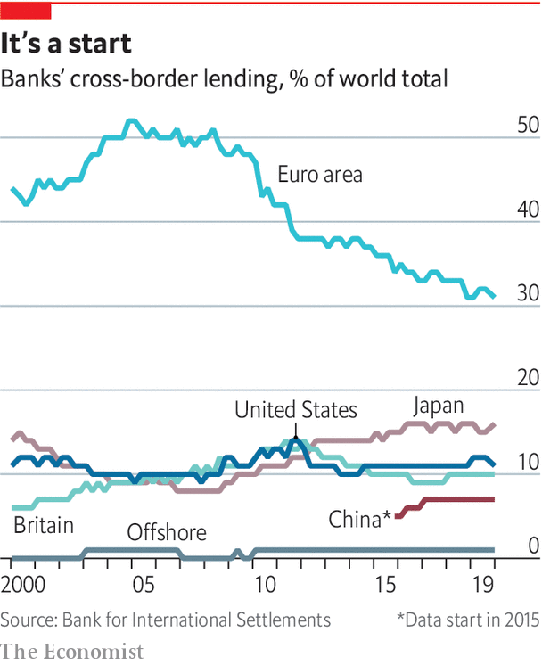

Many think China is missing out. A distant third in 2008, its banking system, at $40trn in assets, now surpasses both the euro area’s and America’s. A list of 30 “global systemically important banks” by the Financial Stability Board, a grouping of watchdogs, now includes all China’s “Big Four”—Bank of China, Industrial and Commercial Bank of China (ICBC), China Construction Bank and Agricultural Bank of China. Only one featured in 2012. But sceptics say they sit on dud loans at home and are being reined in by the state, which owns them. Their management is deemed “paternalistic”; their systems “unsophisticated”.

Chinese banks have indeed long been absorbed by their home market, where they have a 98% share. And their first attempts at internationalising did fail. Many hoped to garner tips on how to climb global leagues in the 2000s after luring American stars, like Goldman Sachs and Bank of America, as “strategic shareholders” through IPOs in Hong Kong. But those stakes were quickly liquidated after the subprime crisis. Chinese banks also realised they could earn higher profits at home. So plans were scaled back.

President Xi Jinping’s Belt and Road Initiative is a big catalyst

In recent years, however, they have been on a stealthy prowl. Banks have followed their corporate clients, themselves inclined to grow beyond their saturated home market. They finance trade, take local deposits from local subsidiaries and serve their mundane needs, like cash management or foreign exchange. They also fund Chinese-built infrastructure in emerging markets. Thanks to huge balance-sheets and inside knowledge of contractors’ history, they often outcompete foreign peers, says John Ott of Bain.

## The Chinese octopus

Their tentacles are spreading. The Big Four now have a total of 618 branches outside the mainland—a conservative proxy, since commercial banks need few shops. Since 2015 their share of global cross-border lending has risen from 5% to 7%. Foreign assets account for 9% of their book. Their footprint differs from that of Western peers: Chinese banks supply two-thirds of all cross-border lending within emerging markets. Hasnen Varawalla of Absa, a South African bank, says their presence in Africa keeps growing.

President Xi Jinping’s Belt and Road Initiative (BRI) is a big catalyst. Chinese banks have lent nearly $600bn to 820 official BRI projects since 2013, reckons RWR, a consultancy. Unofficial sums are probably bigger. Bank of China alone says it lent more than $140bn to 600 projects between 2013 and mid-2019 (others do not disclose figures). Chinese lenders are expanding along the trail: they now have 76 branches in BRI countries, many created since 2018. Commercial banks share the labour with “policy” banks, like China Development Bank or the Export-Import Bank. Those tend to fund low-yielding projects like ports and railways, while the Big Four often back the “bankable” amenities around them, such as shopping centres or property development. Significant lending also appears to be done by non-bank subsidiaries of Chinese banks (no one knows how much). Many state agencies also disburse “hidden” credit. A paper in 2019 by German economists argues international bodies miss as much as 50% of China’s “public” lending.

The medium-term fallout from covid-19 may draw China’s Big Four further out. China’s global firms—which make up 24% of the Fortune 500 ranking, second only to America’s—may focus on Asia, where they have a natural edge. The banks will also want to diversify away from their domestic market, where non-performing loans are increasing. And unlike Japanese banks in the 1980s, which bought expensive property, they “have a strategic reason to win,” says Jamie Dimon of JPMorgan Chase.

They may be fighting the wrong fight. Since the financial crisis a growing share of people and firms are financing themselves by issuing securities on capital markets, shunning traditional lenders for “shadow” banks like pension funds and insurance firms. These have been amassing assets twice as fast as banks since 2008. They now account for nearly half the world’s financial system—about $184trn. Issuers of securities still rely on banks, but the shift favours those earning a living through fees (advising on issuances or underwriting them) rather than interest on loans from their balance-sheets.

American banks have a huge advantage, says James Gorman, Morgan Stanley’s boss. They make 60% of their revenue at home, which hosts the world’s biggest and most profitable capital market (it now represents 45% of global investment-banking revenue, up from 36% in 2009). The world’s top-five earning banks are all American. Some European banks, notably BNP Paribas, have snapped up clients and businesses from ailing peers, says Jean Lemierre, its chairman. Yet even in their backyard the top slots belong to transatlantic rivals.

Gaining an edge in investment banking requires a global network of investors and companies Chinese banks do not yet have. Many also lack independence. In 2015 the state leaned on securities firms to rescue the stockmarket. Last year it told them to lend to struggling small firms. Attempts at tie-ups with foreigners have foundered, too. The rigid hierarchy of China’s state-owned firms does not mix well with Wall Street’s freewheeling ethos, bankers say. Many staff have left CSLA, a respected Hong Kong outfit, since CITIC, a Chinese broker, bought it in 2013.

But Chinese banks are making unnoticed leaps. Eager to diversify funding and amass firepower for acquisitions overseas, home-grown companies have been rapidly raising dollar debt. Issuance reached $310bn last year, from $71bn in 2016. Chinese banks are underwriting these as lead or even sole arrangers, allowing tighter links with domestic titans while building contacts with foreign investors. Some also outsource services they do not yet master, like sales or electronic trading, to Western banks, which they then resell under their own brand. That enables them to grab a growing slice of clients’ “banking wallet”.

They are also progressing in the prestigious equity business. In 2019 CITIC beat Goldman Sachs to become the first local bank to top league tables in Asia. Chinese firms are propelled by their home market: local companies raised half a trillion dollars through IPOs in the past decade, says Refinitiv, a data firm. They are climbing the ranks in Hong Kong, which became the world’s largest listing hub in 2019. Chinese venues may not replace New York peers soon, says Ivy Wong of Baker McKenzie, a law firm. But they do provide leverage. Chinese issuers facing resistance in America can court global investors from Hong Kong, with no political fracas. Stock Connect, a scheme launched in June 2019 allowing Shanghai-listed firms to raise equity in London, may help.

Elsewhere in Asia China’s progress has been muted. But that need not matter much. Last year protests in Hong Kong prompted talk of a drain to Singapore, the rival regional centre. Yet, loth to anger Chinese officials, few firms dared move staff, says an executive at an American bank in Hong Kong. The Middle Kingdom is cementing its status as the centre of gravity for the region: investment-banking revenue in China has grown to $12bn, up from $550m in 2000.

Those juicy prospects are attracting outsiders—and Beijing is opening the door. Last year regulators cleared the way for full foreign takeovers of local banks. They then allowed outsiders to control wealth-management firms, pension-fund managers and brokers. In April foreign-ownership caps were also removed on securities firms. The world’s A-team of money managers is teaming up with locals or seeding subsidiaries in the hope of grabbing a slice of China’s $45trn financial-services market. “Every week we get a knock on the door by one of these top 15 players,” says Greg Gibb of Lufax, a Chinese wealth manager.

Breaking ground will be hard. Incumbents have a 25-year head start at building networks of branches and contacts throughout China’s huge landmass. Often they use investment banking to cross-sell other services to local companies, so can undercut outsiders on fees. Past episodes of liberalisation are not encouraging: in 2007, when Beijing first allowed foreign banks in, it hindered competition by forcing them to operate in bizarre locations. Today they have a 1.5% market share.

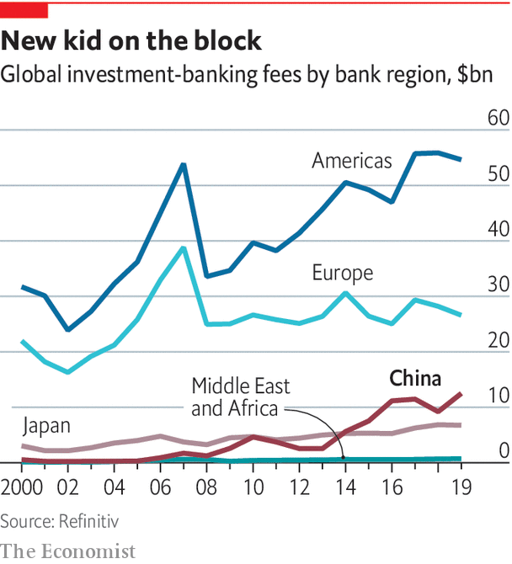

New entrants say it would be mad not to try. But many fear they will be crushed before they get big enough to make money. “We do not have expectations of short-term commercial success,” says the man in charge at an American firm. Another money manager in a tie-up with a local company says the flow of information seems to be going only in one direction.

Incumbents can hope for more efficient markets and some knowledge transfers. Many have started joint ventures with several foreign firms to cover all bases. “China is opening up because it is confident,” says a former Bank of China executive. He compares the country’s financial industry to its automotive sector, on which China also lifted ownership caps last year. One such tie-up suggests possible dangers ahead for foreign companies. In 2007 Geely, an obscure Chinese firm, partnered with LTI, the maker of London’s black cabs. By 2013 it had bought the business. It is now filling Britain with e-taxis that can out-green Uber. ■

This article was downloaded by calibre from <https://www.economist.com/special-report/2020/05/07/as-china-goes-global-its-banks-are-coming-out-too>

|  |  |  |  |
| --- | --- | --- | --- |
| Previous | Articles | Sections | Next |

|  |  |  |  |
| --- | --- | --- | --- |
| Previous | Articles | Sections | Next |

#### International currencies

# China wants to make the yuan a central-bank favourite

And it is playing a trump card in order to achieve it

May 9th 2020 |



BETWEEN 2004 AND 2012 BNP Paribas helped funnel $30bn into Sudan, Cuba and Iran, all then under American sanctions. It hid its tracks using a network of “satellite” banks and by stripping payment messages of incriminating references. Whistleblowers tipped off American prosecutors. The bank pleaded guilty, expecting to pay €1.1bn ($1.2bn). It was fined $8.9bn by American authorities in 2014, and the case escalated to a diplomatic row.

BNP immediately fell into line. It moved the division overseeing the security of its dollar transactions from Europe to America, the first foreign bank to do so. A dozen staff lost their jobs and its compliance team was revamped. There was relief at the bank. It had avoided being permanently banned from clearing dollars, the closest thing to commercial death for international lenders. “Banks create money, and money is a sovereign good,” says Jean Lemierre, BNP’s chairman. “States decide what we can do with it.”

America wields more clout than other states because its money is so central to the system. On international currencies’ three roles—unit of account, medium of exchange and store of value—the greenback ranks high. Most commodity contracts are denominated in it. The dollar represents half of cross-border interbank claims, a proxy for international payments, and 62% of central-bank reserves. No amount of American goofing seems able to blunt its appeal. Everyone rushed to buy dollars during the subprime crash, even though Wall Street caused it. They did it again in March despite America’s bungled response to covid-19.

## Minting it

Yet the flattering snapshot masks an ominous process. Aware of the power that issuing an international currency confers, China is on a charm offensive. Cautious to avoid past mistakes, it is advancing methodically. And it is playing a big trump card: opening up its $13trn bond market, which accounts for 51% of all bonds issued by emerging economies. So far, all is going according to plan.

There are three types of benefits to the issuers of a reserve currency. One is reduced transaction costs. Banks can access central-bank liquidity at will. Firms can borrow cheaply overseas and suffer less foreign-exchange risk.

A second, bigger prize is macroeconomic flexibility. To outsiders, dollars are an attractive asset they use for cross-border purposes. Yet, for America, foreign ownership of its notes is like a loan from abroad. Hunger for dollars allows it to finance deficits with its own money instead of forcing its residents to spend less. That reduces the elemental need to balance the money that comes in with what goes out, freeing America to pursue the monetary and fiscal policy it wants. When the country suffered its first-ever credit-rating downgrade in 2011, investors rushed to buy dollar assets, making it even cheaper for it to borrow.

That autonomy, as well as the world’s dependence on greenbacks, gives it leverage—its third big advantage. America can extract concessions by rewarding allies with vital liquidity while denying it to foes. Last year three Chinese banks pledged swift compliance when suspected of flouting sanctions against North Korea. Monetary clout grants influence on international regulation: European bankers complain that global capital-adequacy ratios are harsher on them than on Americans.

Being the world’s money master incurs costs, too. Robust demand for the dollar boosts its value relative to others, hurting exporters. The Fed must contend with a growing overhang of liquid debt overseas, which leaves the domestic economy hostage to sudden movements of capital, says Benjamin Cohen of the University of California, Santa Barbara. And there is the duty to bail out the system when necessary.

Such trade-offs explain why rising economies, like Japan and Germany in the 1980s, shied away from turning their fiat into global favourites. Until recently Europe was in that camp. It saw the euro as a tool to build the union but did not care if others adopted it. Yet that calculus has changed. With America more isolationist, the EU attaches fresh value to monetary autonomy. In 2018 the European Commission started pushing for a stronger international role for the euro.

In that world minting a reserve currency is the ultimate aim. This is because the currency mix of central-bank holdings tends to be highly concentrated—more so than private investors’ portfolios. Becoming an investor darling, however, is a necessary first step. That requires having large, liquid capital markets and government bonds that are deemed safe assets (these make up the bulk of foreign-exchange reserves). Another requisite is to be widely used in trade, as central banks like to stock up on the cash their country needs to buy imports. There it helps to have a big economy that is integrated into global markets.

With four oil majors, a convertible currency and a vast cross-border banking system, the EU would seem to be “ready for prime time”, says Karthik Sankaran, a fund manager and currency strategist. Without fiscal union, however, it lacks a supranational, liquid eurobond. And bonds issued by single members display uneven safeness, because Europe’s weak banks and sovereigns are tightly connected (banks typically hold 15-30% of their home country’s debt). A banking union would help break that “doom loop”, but Brusselites admit the project is “a bit stuck”. The euro’s share of global reserves fell to 20% last year, from 28% in 2009.

So Europe tinkers around the edges. It sends questionnaires to G20 countries to understand why they do not use euros more often. In March it held a workshop with its eastern neighbours on how to issue euro bonds. The EU scolds its policy banks for not issuing more debt in euros. But top-down efforts are gaining little traction. “I look around me and everyone uses the dollar. It’s not me, it’s my clients,” says a European bank boss.

Russia has been brasher. Since 2013 its central bank has cut the dollar share of its reserves from 40% to 24%. Today Moscow mostly issues debt in roubles and euros. ING, a bank, reckons 62% of its exports were settled in dollars last year, down from 80% in 2013. But the push aims to insulate it from American wrath, not make it a currency power. Rosneft, a blacklisted firm that extracts 40% of Russia’s oil, now denominates its contracts in euros.

## Going global

China makes no secret of its yearning for a global yuan. Eager to control how much money comes in and out of the country, however, it has long had capital controls in place, which limit how much of the currency outsiders can access. So its progress has been gradual. In the 2000s it started allowing Hong Kong residents to open deposit accounts in redbacks, creating pools of liquidity outside the Great Wall. It used the former British colony to test other policies, such as persuading foreign states and firms to issue “dim sum” bonds. Its efforts stalled in 2015, when a loosening of controls, and worries about China’s economy, forced the central bank to dump $1trn in reserves to combat outflows. Controls were tightened. Foreign trade settled in yuan collapsed. Offshore deposits cratered.

Sceptics say China is dreaming when it talks about internationalisation. But they have not woken up to fresh facts on the ground. Deposits did take a hit in 2015, but they are rising fast again and are now back to over 1trn yuan ($144bn), 20 times their total in 2009. Liquidity has spread: Taiwan has nearly half as much in deposits as Hong Kong. Singapore and London have grown.

A boom in foreign-exchange transactions also suggests growing usage. The daily turnover of FX instruments traded in Hong Kong has more than doubled since 2013, to $107bn. Other hubs have risen: Britain accounts for 37% of all trades; France and America are nearing double-digit shares. A growing list of offshore investment products are denominated in yuan, which helps raise its profile among investors. Hong Kong now lists exchange-traded funds, equities, gold futures and property investment trusts, says Craig Chan of Nomura, a bank.

But China’s mightiest advances are in the real world, where it uses its vast trade and investment network to fan out its fiat. The Belt and Road helps. Direct investment by Chinese firms into related projects was worth $15bn last year, a quarter of which was in yuan. China now settles 15% of its foreign trade in the currency, up from 11% in 2015. It has made it easier for its national champions to use the yuan in their transfers to foreign outposts, such as financing flows, capital injections or day-to-day cash management.

China wields particular clout in emerging markets. The number of banks processing yuan payments globally has grown by half since 2017, to 2,214. Most additions have come from Asia, the Middle East and Africa. Some European countries are also keen, notably France, the region’s dollar-basher in chief. A fifth of its trade with China is settled in yuan, as is 55% of payments between both countries. Paris actively encourages its banks and businesses to use the redback. A former IMF official says several multinationals have begun pricing deals in yuan to bypass American sanctions.

Beijing is mulling a wider offensive. It has appointed yuan-clearing banks in 25 countries to accompany exporters. It also wants to procure more of its vital imports in redbacks. In 2018 it launched yuan-denominated oil futures in Shanghai. This helps importers hedge risk while paying in domestic currency, says Stephen Innes of Axicorp, a foreign-exchange provider. They became the third-most widely traded such futures globally in just six months. Last year HSBC became the first foreign bank to hold margin deposits for foreign traders of iron-ore futures in Dalian, China’s commodities exchange. Vina Cheung, its yuan expert, says the country is “preparing the infrastructure to include overseas investors and traders”. Multinationals are starting to respond: Rio Tinto sold its first yuan iron-ore contract in October.

Crucially for China’s end goal, central banks are also warming up to the yuan. Since its inclusion in the IMF’s special drawing rights, a basket of elite currencies, in 2016, its share of global reserves has risen every quarter, to 2.1% in September. Natalie Dempster of the World Gold Council, an industry body, reckons some central banks are using gold as a halfway house to buy yuan once capital controls are lifted (they bought a record amount of gold in 2018). China has signed currency swap agreements with over 60 countries, amounting to half a trillion dollars. Some have pledged to allocate 10% of their stash to the yuan, which would bring its share of reserves to $800bn (from $220bn today).

Two factors could tip them into action. First, the yuan appears to be influencing exchange-rate fluctuations around the world. Recent research by IMF scholars finds the “yuan bloc” to account for 30% of global GDP—second only to the dollar, at 40%. Central banks pick reserve currencies closely tied with their own.

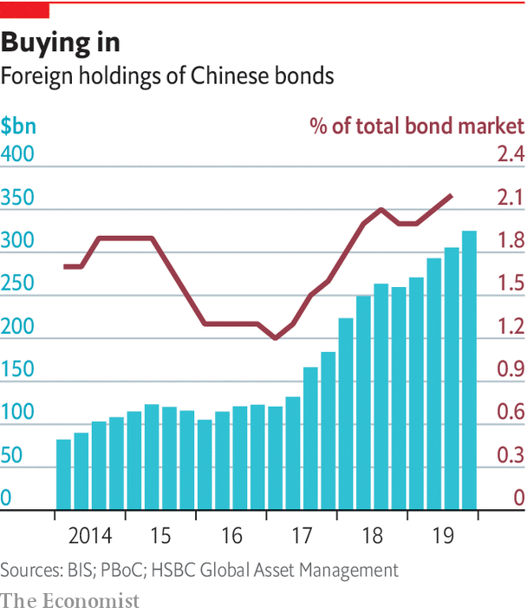

Second, China has opened a fresh breach in its capital controls, and money is streaming in (see chart). In 2017 the country launched Bond Connect, which allows foreigners to invest in onshore bonds through Hong Kong, and scrapped investment quotas. Last year it also authorised international credit-rating agencies. That, plus rising domestic demand for listed securities, has convinced the world’s most popular index providers to phase Chinese bonds into their benchmarks. This helped draw $60bn of foreign money into government bonds in 2019, a flow that covid-19 has not stopped. Some 1,900 overseas investors are registered to Bond Connect, up from 700 a year ago.

Foreigners now own 3% of China’s bond market, the world’s second-largest, and 8.8% of its government bonds (up from 2.8% in 2015). Their appetite will only rise. Chinese bonds offer good yields and diversification benefits. Yet they remain on the “very periphery of institutional investors’ portfolios”, says Mark Wiedman of BlackRock, the world’s largest money manager. It is creating a programme to guide clients on how to invest in China. ■

This article was downloaded by calibre from <https://www.economist.com/special-report/2020/05/09/china-wants-to-make-the-yuan-a-central-bank-favourite>

|  |  |  |  |
| --- | --- | --- | --- |
| Previous | Articles | Sections | Next |

|  |  |  |  |
| --- | --- | --- | --- |
| Previous | Articles | Sections | Next |

#### Payment systems

# The financial world’s nervous system is being rewired

And it is not America that is doing it

May 9th 2020 |

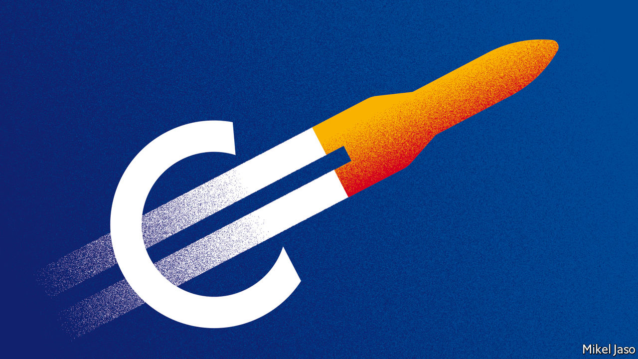

TWO WEEKS before Christmas, executives from OneConnect, a Chinese technology firm, boarded a plane to New York. They landed in a chilly atmosphere: American legislators were about to bar Huawei, a telecoms giant suspected of spying for Beijing, from supplying American agencies. But OneConnect did the job. On December 13th it listed on the New York Stock Exchange, raising $312m, which valued it at $3.7bn. Analysts expect the loss-making firm’s share price to climb by more than 70% in the next 12 months.

OneConnect supplies the artificial brain and nervous system of financial firms that go digital, says Dai Ke, its strategy chief. It serves all China’s top lenders and 99% of the next tier down. It is expanding in Asia and recruits in America, where it runs a research lab, yet few people have ever heard of it. It belongs to a new breed of Chinese firms that are rewelding the pipes channelling money in the developing world. They are waging a “proxy battle” against American giants, says Huw van Steenis of UBS, a bank.

With America readier than ever to close the liquidity taps on rivals, China is investing time and money in building a private track. It has rolled out its own messaging system to complement SWIFT, which may one day supersede it. Meanwhile Alibaba and Tencent, two giant tech firms, have already built what Paco Ybarra of Citigroup, an American bank, calls “parallel banking systems”. Their digital wallets have over 1bn users each and account for half of in-store payments and nearly three-quarters of web sales in China.

## Plumbing new depths

Payment systems are more about moving information than money. The process usually involves banks at both ends, which exchange messages about such things as the sender’s identity or funds available. Within a single country banks talk the same language, and transfers can be settled by updating the central bank’s ledger. But cross-border payments cause headaches. Rules and standards differ. And the world lacks a common central bank, so there is no global ledger on which to record the transfer.

For large-value payments, finance’s usual fix is the “correspondent” banking system. Under often reciprocal arrangements, one bank in one country holds deposits owned by another bank in another. When a customer of the second wants to pay someone at the first, that bank instructs its correspondent to use the deposits. Many banks, however, do not have a direct link. To get to its final destination, the money must make stopovers. That requires an ID for each bank, a messaging system and a common language.

SWIFT provides all of these. Built over decades, its network is hard to replicate. But most of the world has two incentives to give it a go. The first is political. Although the organisation is not American, Uncle Sam leans on it to pressure friends and isolate foes. In 2018, when America threatened action if it did not exclude Iranian banks, SWIFT quickly complied.

The network’s complexity also makes cross-border transfers slow and costly. Many tasks, like checking customers are not known criminals, are duplicated. Banks must keep idle funds in foreign currency (some $10trn globally) to meet forecasted demand. And the system is not fully hack-proof. In 2016, North Korean hackers used stolen SWIFT identifiers to siphon off $81m from an account Bangladesh’s central bank held in New York.

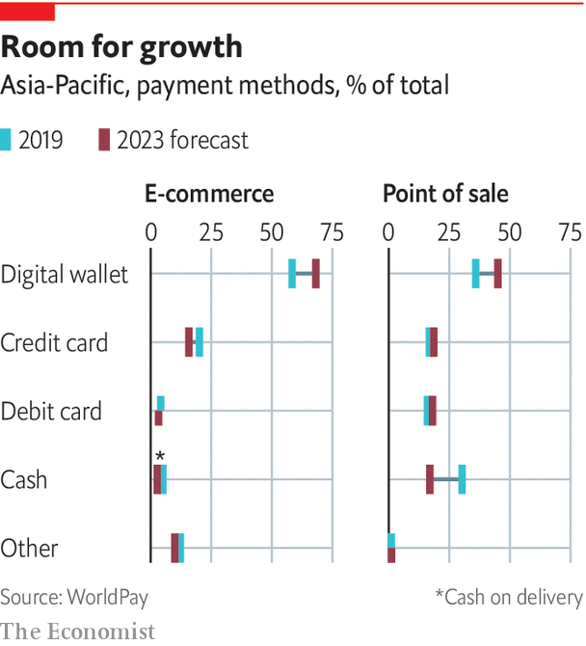

Startups try to alleviate the pain by reducing the number of interactions banks and companies have with SWIFT. Some work with “hub” firms in recipient countries that break up big sums, like payroll, into tiny payments. Others aggregate transfers to absorb fixed costs. Lucy Liu of Airwallex, a fintech company, says it relocated from Australia to Hong Kong to serve rising demand from Chinese exporters. Some fintechs fully bypass SWIFT. Ripple, an American firm, has created a cryptocurrency it uses as an intermediary for payments between countries with different currencies.

Governments are also exploring crypto-money. China is leading a solo effort. It has already filed more than 120 patent applications for a sovereign digital currency, more than any other country. Hawks fear it may impose its use on BRI countries. “Our values are at stake,” says Tim Morrison, a former adviser to President Trump. But China seems to favour goals closer to home. With much of its economy now cashless, it sees a digital coin it controls as a crucial fail-safe for its domestic payment systems. It also wants to pre-empt Libra, a cryptocurrency Facebook intends to launch, from infiltrating people’s pockets.

Others have looked at international applications. Singapore and Canada, as well as Hong Kong and Thailand, have led joint experiments to test if digital coins minted by central banks could be used by commercial banks to transact across borders. Those proved successful, but engineers who took part doubt the system could ever deal with a large volume of transfers.

## Crypto and petro

Pariah states already use digital monies to trade unnoticed. North Korea has hacked crypto-exchanges to fund weapons imports. Russia used bitcoins to pay for the infrastructure that hacked into the servers of America’s Democratic Party in 2016. But that underground economy is tiny. Jonathan Levin of Chainalysis, a data outfit, says transactions involving the petro, a currency Venezuela created, hit its peak in the last quarter of 2019—at just $8m.

Europe has instead tried to barter. Last year Britain, Germany and France launched Instex, a system meant to match the payments of firms buying oil or foodstuffs from Iran with the receipts of companies selling to the country. In principle, goods could flow with no need of moving money. Yet it took 14 months for Instex to do its first deal. European firms, many of whom do more business with America than Iran, fear being blacklisted.

China has gone furthest. In 2015 it launched CIPS, an interbank messaging system to ease international payments in yuan. It uses the same language as SWIFT, allowing it to talk to other countries’ payment systems. For now just 950 institutions use it—less than 10% of SWIFT’s membership. But “what matters is it’s there,” says Eswar Prasad of Cornell University.

The real revolution is happening in low-value transfers. Like SWIFT, the network of American card schemes is tricky to displace. Member banks and merchants trust each other because they adhere to tested rules. They also like the convenience of the schemes’ settlement platforms, which compute “net” positions between all banks that they square up at the end of the day. So rival schemes struggle to make a dent. In 2014, fearing sanctions could block it from using American schemes, Russia created its own, which now accounts for 17% of domestic cards. But its 70m tally is dwarfed by Visa and Mastercard’s 5bn. Size is not a problem for UnionPay, China’s own club. Just 130m of its 7.6bn cards were issued outside the mainland, however, where it is mostly used by Chinese tourists.

A mightier threat comes from a state-led revamp of domestic payment systems. Eager to reassert control over key infrastructure, some 70 countries have rebuilt their local plumbing to enable near-instant bank transfers at the tap of a screen. Europe is the most advanced, having fused local networks into a bloc of 35 countries and more than 500m people. South-East Asia is also trying to stitch its systems together. On March 5th India and Singapore connected theirs for the first time.

Last year Chinese customers paid $49trn in purchases via mobile, 35 times the total in 2013

China lags behind its neighbours in beefing up its kit. But that need not matter. As the region’s trade hegemon, it can free ride on others. “Once Malaysia gets its system going, it will figure out a way to work with China,” says Phil Heasley, a former chairman of Visa USA. China is also hedging its bets by building a private track.

Just five years ago, shopping in second-tier cities was tedious. Few shops accepted cards. They did not like the fees and lacked a connection to plug in terminals. Settling anything other than daily supplies in cash required wads of it. The mass adoption of smartphones, however, meant most customers were starting to carry mini-terminals around. And the invention of QR codes suddenly allowed customers to pay even when the merchant was offline.

The combination of both has swept all before it. Last year Chinese customers paid 347trn yuan ($49trn) in purchases via mobile, 35 times the total in 2013. Two giants eat up 92% of the market. WeChat Pay, owned by Tencent, a tech group, dominates peer-to-peer transfers. Alipay, which belongs to Ant Financial, the finance arm of Alibaba, an e-commerce group, rules payments to firms. After loading digital “wallets” from their bank account, users can pay for almost anything, from cabs and bills to doctor appointments. Wallets charge no fee to users but tax them when they move money out, so everybody is incentivised to stay in their universe.

Their market now cornered, the “super-apps” are going global. Alipay is accepted by shops in 56 countries and regions, where it targets Chinese travellers. It has also bought minority stakes in wallets in nine Asian jurisdictions, allowing it to influence the industry without applying for local licences.

Douglas Feagin, Ant Financial’s internationalisation chief, says connecting the wallets in which it has invested is not a priority. But others suspect the firm is waiting for local wallets to reach critical mass. “It may not be branded Ant Financial,” says Zennon Kapron of Kapronasia, a consultancy, “but one of their goals is to eventually build an international cross-border wallet platform.” Its expertise is also luring firms from farther away. Six European mobile wallets have adopted Alipay’s QR format.

China’s fintechs will not always succeed. In some markets credit cards, or interbank systems, are too popular. But the battle over payment methods masks a bigger war over the hardware and software that power them all. It is one that China is winning.

Squeezed by low interest rates and the high fixed costs of going digital, banks across Asia are seeking to borrow scale by “moving to the cloud”. They store their data on large servers owned by specialist providers. Dave Bartoletti of Forrester, a research firm, sees the region as the “most important battleground” for cloud in finance (along with Europe). On hardware Alibaba is top dog. The firm provides a fifth of cloud infrastructure in Asia Pacific, more than its next two rivals (Amazon and Microsoft) combined.

China’s tech firms also rule the software bit. The need to execute huge amounts of transactions fast—last year Alibaba netted its first billion dollars in sales for Singles’ Day, China’s annual shopping festival, in 68 seconds—has endowed Ant Financial and Tencent with a knack at automation, machine-learning genius and troves of data. Both have used them to build nimble digital banks. These lead the race to define identification and security standards, crucial as banks and payments move online. Henry Ma of WeBank, Tencent’s offspring, says its facial-recognition tool has an error rate of less than one in a million (the human eye averages 1%).

Both banks are growing fast. MYbank (Ant Financial’s offering) already serves 20m of the country’s 100m SMEs. It also rents its kit to 200 other banks, and hopes to use Hong Kong and Singapore as a testing ground for those skills abroad. Investors think internationalisation has promise: Ant Financial, which is private, was valued at $150bn in its latest funding round. WeBank is taking a different tack. It is making the infrastructure it created available on an open-source basis, so foreign banks can build upon it.

Tencent and Alibaba’s greatest impact, however, may have been to awaken another giant. Ping An, a Chinese insurer with $1trn in assets, decided to become a cloud company after seeing their meteoric rise in finance, says Jonathan Larsen, its innovation chief. The company, which invests 1% of its revenue—worth $164bn last year—in research and development, has spawned 32 stand-alone businesses to help export the tech it hones at home.

The most strategic of its offspring is probably OneConnect, the startup that listed in New York in December. The firm offers cloud-based services that cover everything, from back-office to client-facing tasks. Its first foreign outpost, opened in 2018 in Singapore, has grown to 200 staff. It now serves 47 clients in 16 overseas markets. Those include Thailand, where it is poised to power the credit-card processing of a top-three bank, and Europe.

Covid-19 could help. With staff stuck at home, banks across the world are looking to move data-hungry processes like risk management online. OneConnect has launched a charm offensive to capture the business—this time without boarding a plane. ■

This article was downloaded by calibre from <https://www.economist.com/special-report/2020/05/09/the-financial-worlds-nervous-system-is-being-rewired>

|  |  |  |  |
| --- | --- | --- | --- |
| Previous | Articles | Sections | Next |

|  |  |  |  |
| --- | --- | --- | --- |
| Previous | Articles | Sections | Next |

#### After covid-19

# Can China be trusted to be a responsible financial power?

There are still a lot of questions that it must answer

May 9th 2020 |



CAUSEWAY BAY is back in business. Even as the world shuts down, the retail heart of Hong Kong, which enforced an early lockdown, is beating again. Yet normality is not complete. The local branch of ICBC, a symbol of Beijing’s sway, remains barricaded. Its managers fear that pro-democracy protesters, free after weeks of quarantine, might target it again. This points to a tension within China’s global ambitions. Its political system can suppress problems fast by mobilising everything in the pursuit of one goal. But it also creates crises—and lets them fester.

Trust is what binds the financial system together. Economic agents need to be convinced, not coerced. But like many China watchers in other spheres, they remain both awed by its formidable rise and doubtful it cares about the common good. “People think it is like the Death Star from “Star Wars”. It is this massive, inscrutable thing sitting up in the sky that has the potential to destroy us all,” says Jan Dehn of Ashmore Group, a fund manager. Can they trust the regime whose attempted cover-up let the virus escape in the first place?

A partial schism in the world’s financial system will be hard to arrest. Economic weapons are cheap and require few permissions, so American presidents will continue to like them. The longer they last, the more workarounds get entrenched. Until recently these were too haphazard to really matter, but China, whose economy could soon surpass America’s, has the muscle to create the markets and norms that bring alternative worlds to life. And it is concentrating its charms on the emerging world, whose lesser sense of loyalty to Western structures could make it easier to peel off.

Sceptics doubt a country with both a current-account surplus and strict capital controls can provide the world with a reserve currency. But China’s surplus has shrunk vastly since its peak in 2007. A deficit is likely to become the norm. Its ageing population is saving less. Beijing wants more domestic consumption, which will boost imports. And stagnant Western economies will mean sluggish exports. Morgan Stanley reckons China will require $210bn a year in net foreign inflows between now and 2030 to plug the gap.

That, in turn, should push it to further liberalise its financial markets. Blanket deregulation is unlikely, but steps to boost liquidity, like better market infrastructure and fairer pricing, will help. And China’s capital controls are already easing. Domestic savers are still caged in, but foreign investors say they have no trouble getting money out, even during market routs. Reserve managers see value in the currency stability that limited controls afford. So full convertibility may not be needed for the yuan to gain fans. In time party leaders in Beijing may well decide for it, especially if it has attracted enough sticky money to feel comfortable.

A more diverse financial system has benefits. Relying on a single dominant currency threatens the world with cash crunches in times of crisis. More efficient cross-border payments drive down costs. Duplication makes the overall infrastructure more resilient.

## Decoupling or deglobalisation?

There are also encouraging shifts in how China connects with the system. It has become the world’s third-largest creditor, up from 16th in 2005. And though foreign-exchange reserves were its largest type of investment overseas until 2016, its private foreign investment assets—worth $4.2trn—now beat its central bank’s stash of FX. This is a more productive use of money. The opening of its financial industry will allow its troves of savings to be better allocated. The growth of its financial markets provides more choice to international investors. Short of over-reaction in Washington, a decoupling of finance need not mean full deglobalisation.

Nevertheless it brings three dangers. The first is that it accelerates the balkanisation of financial markets initiated a decade ago. Most countries reacted to the financial crisis by enacting new regulations. Many have made the system safer. Yet watchdogs have sometimes seemed more motivated by a will to restore local control than foster global resilience. “Ring-fencing” forces global banks to establish subsidiaries, which are under the watch of local regulators, rather than just branches. Extraterritoriality imposes layers of obligations on foreign banks.

More divided markets may help stem contagion during crises. But they also prevent financial institutions from diversifying portfolios, which can concentrate risks. And they trap excess savings, blocking the money from being invested where there is a shortage of it, says Jose Viñals of Standard Chartered, a British bank.

Geopolitical tensions have supported that drift. Covid-19, which focuses minds and money closer to home, could give it another push. That will not come cheap. A survey in 2018 found that fragmentation already shaves nearly 1% off global GDP. Policies that compel firms to relocate their data within a country’s borders, which already exist in China, India and others, could reduce future gains from digitalisation and fragment markets further.

“Localisation” rules also prevent data-sharing for risk-management purposes, pointing to the second danger: that a broken-up system will be less secure. Multiple links between banks and fintech firms offer more points of entry for cyber-crooks. Dependencies are building upon nodes that are not regulated and are poorly understood, creating room for systemic breakdowns.

The third, and biggest, risk lies in relying on an apparatus with two heads but without a benevolent leader. Notwithstanding crises, the dollar system enabled decades of sustained growth. Yet America sometimes appears less interested in the common good than the rent it can extract from its dominance of the system. Last August several lawmakers sponsored a bipartisan bill proposing that the Fed taxes foreign capital inflows to help weaken the dollar. Such actions hint at the fraying consensus in Washington about the trade-offs that come with being a financial hegemon.

In contrast China says it is ready to embrace leadership. It responds to Washington’s attacks with offers of collaboration. Despite huge balance-sheets, its banks have shied away from trying to buy European rivals. Yet as in business, diplomacy and most terrains where China’s footprint looms large, questions linger. It is opening up its markets, but new entrants are unsure if unwritten rules might block them. Regimes allowing foreign investors to recoup collateral if companies default are untested. China lacks a free press, common law and a judiciary that might protect the public interest and restrain land grabs by the state.

Left unaddressed, those doubts could limit Beijing’s sphere of financial influence to being a satellite system, as many market participants choose to stick with the devil they know. That world would be suboptimal in many ways. Porosity between that Chinese sphere and the dollar system would be limited, obstructing capital flows. Feeling more anxious about China, America may try to tilt the current structure even further in its favour.

There is a different path. China can choose to reassure the financial community that it will not seek to hide truth when there are problems in the system, and that it will act promptly—but within commonly accepted rules—to solve them. It must show that it is ready to respect the rights of those who choose to trust it, even when they run contrary to its interests. Western-led institutions can help, by recognising the status it is owed. So will time, as finance folks exposed to Chinese assets and systems find out not just that profits are good, but also that promises are met.

By many measures, America is becoming an ever smaller part of the global economy. The laws of gravity dictate that its ability to be the world’s sole central banker, sooner or later, will ebb, and that China will fill part of the vacuum. Much better for both powers to peacefully coexist and collaborate than barricade themselves in their own incomplete universes. ■

This article was downloaded by calibre from <https://www.economist.com/special-report/2020/05/09/can-china-be-trusted-to-be-a-responsible-financial-power>

|  |  |  |  |
| --- | --- | --- | --- |
| Previous | Articles | Sections | Next |

|  |  |  |
| --- | --- | --- |
| Special report | Sections | Finance & economics |

Business

The business of health: Prognosis: mixed

.

Drugmakers: Convalescent

.

Big business in France: Reargardère action

.

Disney: Cruising for a bruising

.

Office culture: The presenteeism premium

.

Bartleby: Don’t stand so close to me

.

Schumpeter: The mavericks of oil

.

Airlines: Eyeing the sky

.

|  |  |  |
| --- | --- | --- |
| Special report | Sections | Finance & economics |

|  |  |  |  |
| --- | --- | --- | --- |
|  | Articles | Sections | Next |

#### Prognosis: mixed

# The pandemic will recast America’s health-care industrial complex

Our guide to winners and losers

May 9th 2020 | NEW YORK

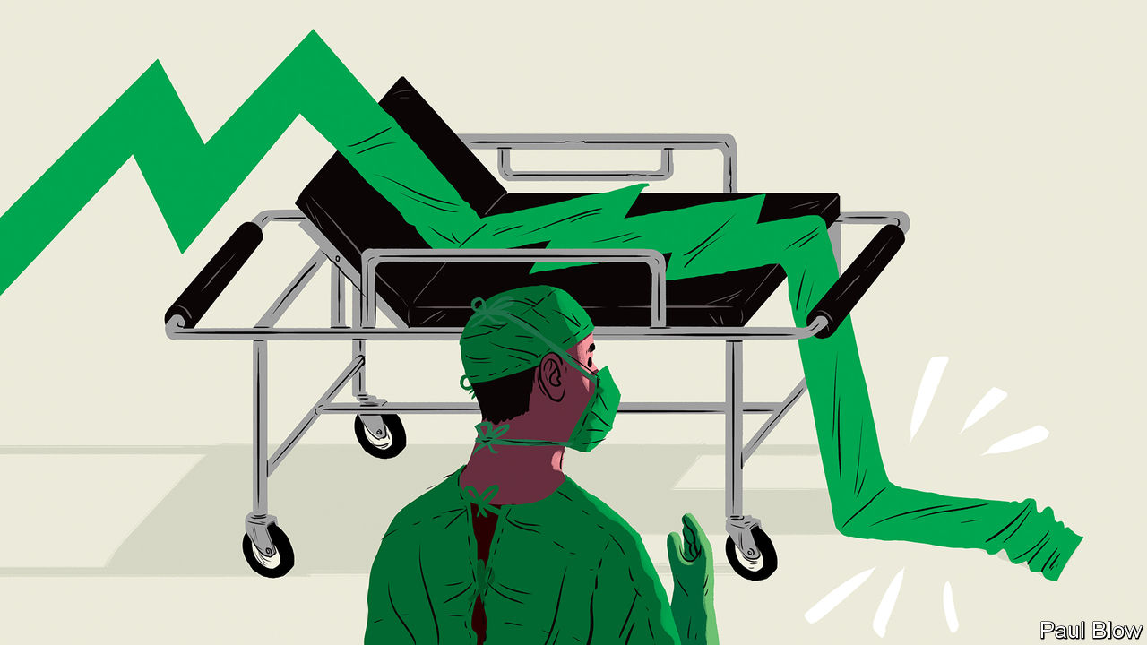

Editor’s note: The Economist is making some of its most important coverage of the covid-19 pandemic freely available to readers of The Economist Today, our daily newsletter. To receive it, register [here](https://www.economist.com/newslettersignup). For our coronavirus tracker and more coverage, see our [hub](https://www.economist.com/coronavirus)

DOCTORS AND nurses at Northwell Health have treated nearly 40,000 covid-19 cases, more than any other American provider. But Michael Dowling, who runs New York state’s largest hospital firm, is not triumphant. “This crisis has humbled us,” he sighs. The same goes for much of America’s $4trn health-care sector.

You might think that if anyone stood to benefit from the world’s biggest pandemic in a century it would be providers of health care. Markets certainly give that impression. Health-related firms in the S&P 500 have outperformed the broader index since March, when covid-19 first hit America hard (see chart 1). On May 5th Regeneron, a biotech firm with a promising antibody cocktail, reported first-quarter sales of $1.8bn, a third more than last year. Gilead has received emergency approval to use remdesivir, an antiviral agent it is developing, in coronavirus patients; its share price is up by 19% this year.

For most of the industry, America’s biggest, covid-19 may prove less rewarding as the pandemic unfolds. Reduced spending on health care accounted for nearly half of the 1.2% quarter-on-quarter drop in GDP in the first three months of the year. Things could get worse. Even Regeneron and Gilead are not all they are trumped up to be.

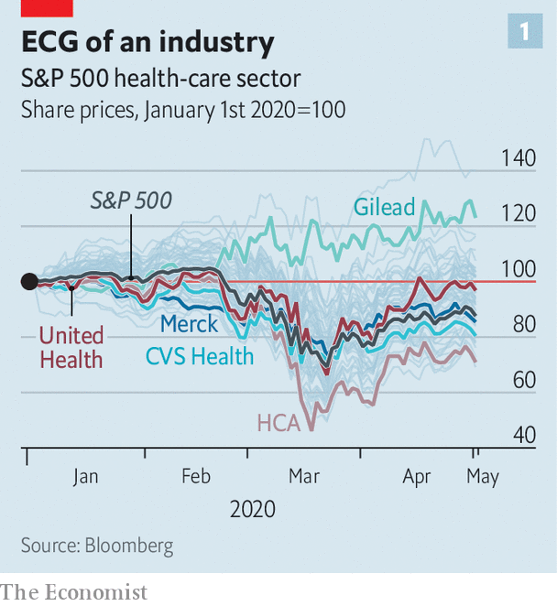

The American Hospital Association, a trade body, estimates that its members will lose more than $50bn a month between March and June. Tim van Biesen of Bain, a consultancy, notes that procedures like hip replacements or heart and brain surgery, which make the most money for hospitals, are down by 65-80%. Strata Decision Technology, which makes software for hospitals, estimates that hospital revenues have dropped by $90bn a month. Mr Dowling says Northwell, with annual revenues of $14bn, made a loss of $350m-400m in the past month. HCA, the biggest listed hospital chain, scrapped its annual guidance, citing uncertainty.

The pain extends beyond clinics. Medtronic, a medical-devices giant, admitted its weekly revenues in America fell by 60%, year on year, in April. Even big pharma, usually resilient to downturns, is not immune. On April 28th Merck, a large drugmaker, said it expected a $2.1bn (around 4%) hit to sales this year because patients sheltering at home are not consuming physician-administered drugs.

America’s health businesses face two questions. How quickly can hospitals return to normal-ish—and with them spending on ailments other than the coronavirus? And will the crisis reshape the industry, which is bigger and more Byzantine than in other rich countries?

The answer to the first question is: not as fast as markets seem to assume. Robert Fields of Mt Sinai Health Partners, which has 4,000 doctors, expects normal services to resume slowly, with “built-in inefficiencies” arising from continued social distancing; other administrators concur. Sam Glick of Oliver Wyman, a consultancy, says that with new safety protocols, extended hours, virtual appointments and the like, non-covid therapies, and so income, could be nearly back to pre-covid levels within two months of the outbreak’s peak in a given region. Without such measures, he says, income might be 35% lower by then.

This would have knock-on effects for the rest of the sector. Take drugmakers. Bain reckons that “injectables”—mostly administered by professionals and so hurt by fewer non-covid hospital visits—make up a quarter of sales at Johnson & Johnson (J&J) and Pfizer, and up to half at Merck. With clinical trials interrupted by lack of patients, potential blockbuster drugs face delays, notes Ben Isgur of PwC, a consultancy. J&J, the world’s biggest pharmaceutical firm, has cut its full-year revenue forecast for 2020 from $86bn to $79bn-82bn.

Even inventing a covid cure does not guarantee riches. A successful firm will face public pressure to make such a drug available cheaply. The Institute for Clinical and Economic Review, an independent drug-evaluator, reckons remdesivir could earn Gilead more than $1bn if reimbursement were based on cost-effectiveness—but only a few million if sold at cost. Bernstein, a research firm, predicts the drug will make no “material” contribution to Gilead’s profits in the next two years. Evan Seigerman of Credit Suisse, a bank, says that it is in big pharma’s interest to help end the pandemic even more or less at cost—so it can return to lucrative business-as-usual.

Pharmacy middlemen and retail chains are in a similar bind. A spike in sales as buyers rushed to fill prescriptions helped CVS Health, a big pharmacy group which reported results on May 6th, beat analyst estimates. But the pandemic may merely have brought purchases forward. New prescriptions fell by 15% year on year in the week to April 17th, according to IQVIA, a data firm. Mr van Biesen observes that pharmacy chains were already squeezed because of a decline in “front of store” profits (from beauty products and over-the-counter drugs) caused by online competition and a shift to low-margin generics.

Health insurers look least vulnerable in the near term. Most have big enough buffers to withstand even a severe scenario for covid-19, in which 130m Americans are infected and 4m-5m need intensive care, reckon credit-raters at Moody’s. The collapse in claims for non-covid procedures has reduced insurers’ overall costs. Ricky Goldwasser of Morgan Stanley, an investment bank, thinks that big ones like Humana and Anthem could see profits rise by 4% and 15%, respectively, in 2020. Another, Centene, has just hired 1,000 new workers.

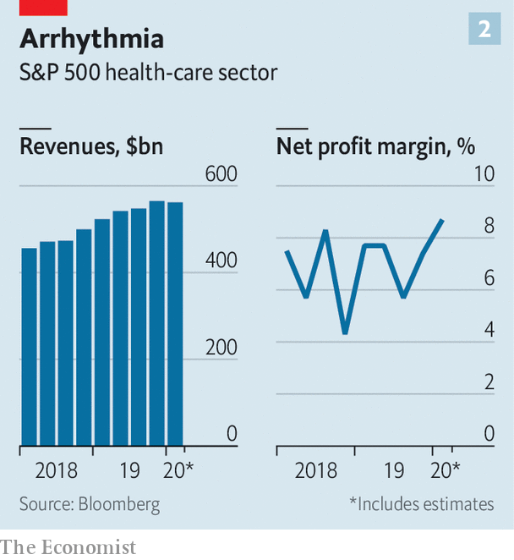

Next year may be tougher for insurers. Oliver Wyman estimates that six months after an outbreak starts in a region, they will see a “large and sustained rebound in costs”, as patients seek elective treatments. Meanwhile, Gregg Bloche of Georgetown University and Daniel Wikler of Harvard find that insurers (and self-insured firms) could face a bill next year of over $650bn for covid-related expenses.

Where does all this leave the industry? It is likely to emerge a touch more administratively efficient; Chris Coburn of Mass General Brigham, a big hospital network, says things which have been talked about for years, from more telemedicine to less insurance paperwork, have been achieved in six weeks. It will also become a bit more concentrated: a few weaklings will perish; the strong, be they hospitals, drugmakers, pharmacies or middlemen, will get stronger. Covid-19 may push pharmacy chains to shut some bricks-and-mortar stores, of which CVS alone has nearly 10,000.

But the industry was already headed in that direction. The past few years saw a slew of mega-mergers, including CVS’s $69bn purchase of Aetna, a big insurer, and the $67bn tie-up of another big insurance firm, Cigna, with Express Scripts, a middleman which manages prescriptions for health plans. Those on America’s left who see the crisis as a chance to reform what they see as an unjust system, which charges more than other rich countries for worse health outcomes, may be disappointed. Investors who hold their nerve for the next year or two might not be. ■

Dig deeper:  
For our latest coverage of the covid-19 pandemic, register for The Economist Today, our daily [newsletter](https://www.economist.com/newslettersignup), or visit our [coronavirus tracker and story hub](https://www.economist.com/coronavirus)

This article was downloaded by calibre from <https://www.economist.com/business/2020/05/09/the-pandemic-will-recast-americas-health-care-industrial-complex>

|  |  |  |  |
| --- | --- | --- | --- |
|  | Articles | Sections | Next |

|  |  |  |  |
| --- | --- | --- | --- |
| Previous | Articles | Sections | Next |

#### Convalescent

# The pandemic is a chance to revamp India’s pharmaceutical industry

Companies could switch from primarily making generics to producing higher-margin licensed drugs

May 9th 2020 | DELHI

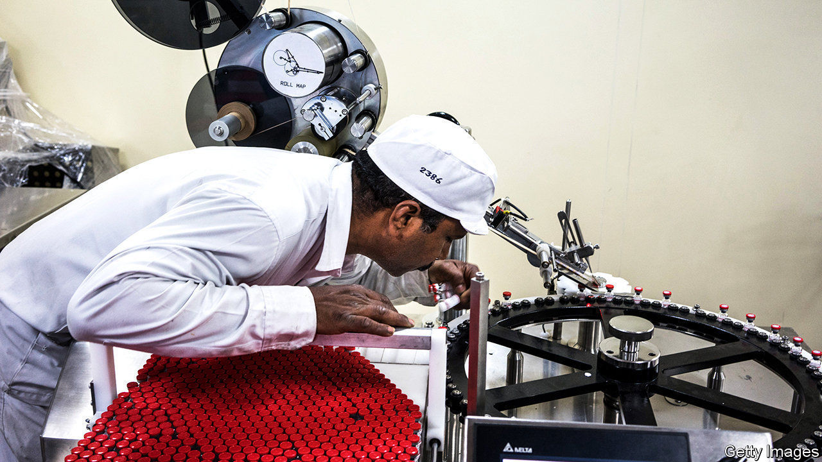

Editor’s note: The Economist is making some of its most important coverage of the covid-19 pandemic freely available to readers of The Economist Today, our daily newsletter. To receive it, register [here](https://www.economist.com/newslettersignup). For our coronavirus tracker and more coverage, see our [hub](https://www.economist.com/coronavirus)

NOTHING IN YUSUF HAMIED’S 60 years at Cipla, an Indian drugmaker where he is chairman, prepared him for covid-19. Production at its 30 plants fell by 70% nearly overnight in March as India’s government ordered a lockdown that made it hard for its 23,000 employees to work. Critical inputs, from packaging to active ingredients, became scarce. The price of some sourced from China shot up five-fold.

A month on things are looking up. Cipla’s output is still half its pre-crisis levels; operations in hard-hit Mumbai remain curtailed. But a factory in the north-eastern state of Sikkim is fully staffed. The firm ferries employees to work in sanitised (and uncrowded) buses. Basic supplies are available again, and the premium charged by Chinese sellers has narrowed to 10-20%.

That is good news—and not just for Mr Hamied’s firm, or indeed his country, which has largely avoided drug shortages thanks to Cipla and its fellow pharma firms. The world relies on their health. Their revenues amounted to $40bn in 2019, half of it from exports. They produce one-tenth of all pharmaceuticals by volume, including 50% of the world’s vaccines, 40% of generics sold in America and a quarter of all medicine bought in Britain. Visitors from Africa leave India with suitcases stuffed with cheap pills.

Indian pharma was not in great shape going into the pandemic. Revenue at big firms is expected to grow by 5% this year, down from 18% in 2016, shortly after their share prices peaked as Western countries swallowed their cheap me-too pills by the millions. Since then fierce competition has eroded the already-slim margins firms could earn on generics. Prices of drugs sold by Indian firms declined by 8% in 2018 and 5% in 2019, estimates McKinsey, a consultancy. Quality concerns led America’s Food and Drug Administration to issue “import alerts”, which block products’ distribution, for 15 Indian firms in 2019 and 2020.

Fears of rising costs and depressed sales, as patients and hospitals everywhere limited non-covid treatments, have added to the existing concerns. Yet the coronavirus may be an inflection point for the industry, if it shows it can rapidly produce huge volumes of coronavirus drugs.

There is evidence that it can. Indian firms, including Cipla, have begun making favipiravir, an antiviral drug developed by the drugs arm of Japan’s Fujifilm, which has shown promise in treating covid-19. Last month Serum Institute of India, the world’s biggest vaccine-maker, broke with standard practice and announced it was producing 40m-50m doses of a vaccine developed by researchers at Oxford University before human trials have even started. On May 5th the Indian press reported that Gilead, an American firm whose drug called remdesivir has received emergency approval in America for treating coronavirus infections, was in advanced talks with four domestic firms—Cipla, Dr Reddy’s Laboratories, Jubilant Life Sciences and Strides Pharmaceuticals—to produce it.

Mr Hamied expects more tie-ups as the merits of co-operation become evident. So, it seems, do investors—who also predict collaboration might prove lucrative. Indian drugmakers’ share prices have gone on a tear. An index of big ones is up by 43% since the lockdown began in mid-March amid a stockmarket meltdown in India.■

Dig deeper:  
For our latest coverage of the covid-19 pandemic, register for The Economist Today, our daily [newsletter](https://www.economist.com/newslettersignup), or visit our [coronavirus tracker and story hub](https://www.economist.com/coronavirus)

This article was downloaded by calibre from <https://www.economist.com/business/2020/05/09/the-pandemic-is-a-chance-to-revamp-indias-pharmaceutical-industry>

|  |  |  |  |
| --- | --- | --- | --- |
| Previous | Articles | Sections | Next |

|  |  |  |  |
| --- | --- | --- | --- |
| Previous | Articles | Sections | Next |

#### Reargardère action

# The French establishment closes ranks to help Lagardère

A fallen star of corporate France survives an Anglo-Saxon assault—for now

May 9th 2020 |

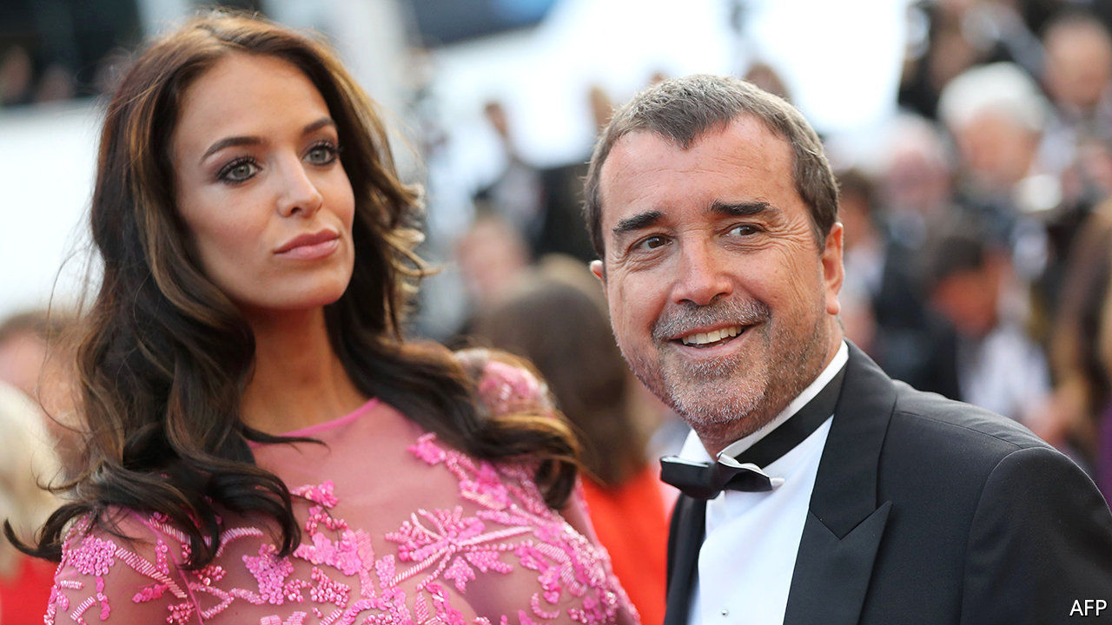

SHAREHOLDER BATTLES pit managers against investors at crowded annual meetings. Amid covid-19 the one between the bosses of Lagardère, an ailing conglomerate, and a few irate owners happened largely behind closed doors. On May 5th an activist hedge fund’s bid to topple the scion running the erstwhile blue chip was foiled by l’establishment. The reprieve may prove short-lived.

Not even hardened habitués of Parisian society galas can defend the track record of Arnaud Lagardère. His father, Jean-Luc, an industrialist of the old school, deftly navigated the couloirs of power to build an empire spanning media, publishing and defence. His death in 2003 left the group in the hands of his only son. Now 59, and having married a Belgian model, Arnaud is more frequently seen in gossip pages than the business ones.

Lagardère fils lacks his father’s touch. Some units, like the Hachette publishing arm, have fared decently. But his big idea was to sell the group’s 15% stake in what is now Airbus (created in part with Lagardère assets) in 2006 and 2013, and reinvest the proceeds in glamorous ventures like sports. The Airbus stake alone would now be worth over €6bn ($6.8bn), three times Lagardère’s market value. The group crashed out of the CAC 40 index of leading French firms a decade ago.

A London hedge fund argued fresh leadership could boost returns. Amber Capital built an 18% stake, bigger than the 7% owned by Mr Lagardère, whose grip is aided by an antiquated corporate structure that blends a partnership with limited liability. The besieged heir called on some powerful pals, even co-opting Nicolas Sarkozy, a former French president, to the board. A state-run fund with a 3% holding also backed him.

Mr Lagardère’s position may not be safe for long. A firm controlled by Vincent Bolloré, a French tycoon, last month took an 11% stake in the group. Mr Bolloré has a knack for coming in as a white knight before turning hostile. Mr Lagardère has won his battle against Amber. He may lose the war for control.

This article was downloaded by calibre from <https://www.economist.com/business/2020/05/09/the-french-establishment-closes-ranks-to-help-lagardere>

|  |  |  |  |
| --- | --- | --- | --- |
| Previous | Articles | Sections | Next |

|  |  |  |  |
| --- | --- | --- | --- |
| Previous | Articles | Sections | Next |

#### Cruising for a bruising

# Parks and resorts powered Disney’s growth. Then came covid-19

Disney has diversified into exactly the wrong businesses for a pandemic

May 9th 2020 |

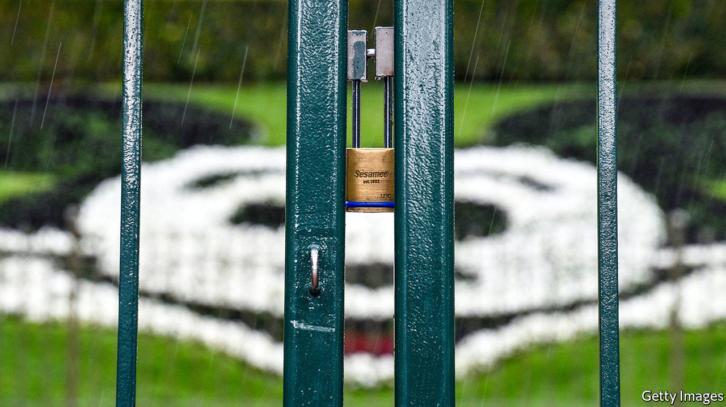

A LONG TIME ago in a galaxy far, far away—February, to be precise—Bob Iger quit as head of a wildly successful company. Disney ruled the box office, with seven of the ten biggest hits of 2019. It had just launched a streaming service, Disney+, to take on Netflix. And it had completed a $69bn debt-fuelled acquisition of 21st Century Fox. In Mr Iger’s 14 years in charge, the firm’s share price quintupled. On May 5th he was back, like a Jedi summoned from semi-retirement, to introduce a first-quarter earnings call where Disney suspended its dividend and said covid-19 had caused net profit to fall by 91% from a year ago.

Covid-19 has infected all big media groups. Cinemas are shut; advertising is down; shooting is disrupted and there are no live sports to televise. But few have suffered as badly as Disney (see chart). Netflix is thriving as locked-down consumers sign up. AT&T and Comcast are stabilised by their dull yet dependable cable and mobile businesses. Disney has been whacked for the same reason that for years it thrived: under Mr Iger, the world’s best-known media company grew into far more than a media company. Alas, it diversified into exactly the wrong businesses for a pandemic.

A decade ago Disney’s media networks, which include the Disney Channel, ESPN sports and ABC broadcasting, raked in two-thirds of Disney’s operating profits from its various businesses. Last year they made up half. With pay-TV in decline, Disney has invested elsewhere. One area is its film studios, where profits have been lifted by the acquisition of companies like Lucasfilm (which owns Star Wars) and Fox. That has boosted its consumer-products business, as fans snap up plastic lightsabres and Iron Man toys. But last quarter, with cinemas closed, Disney studios’ profits fell by 8%, year on year. With new releases postponed until July, the next quarter looks worse.

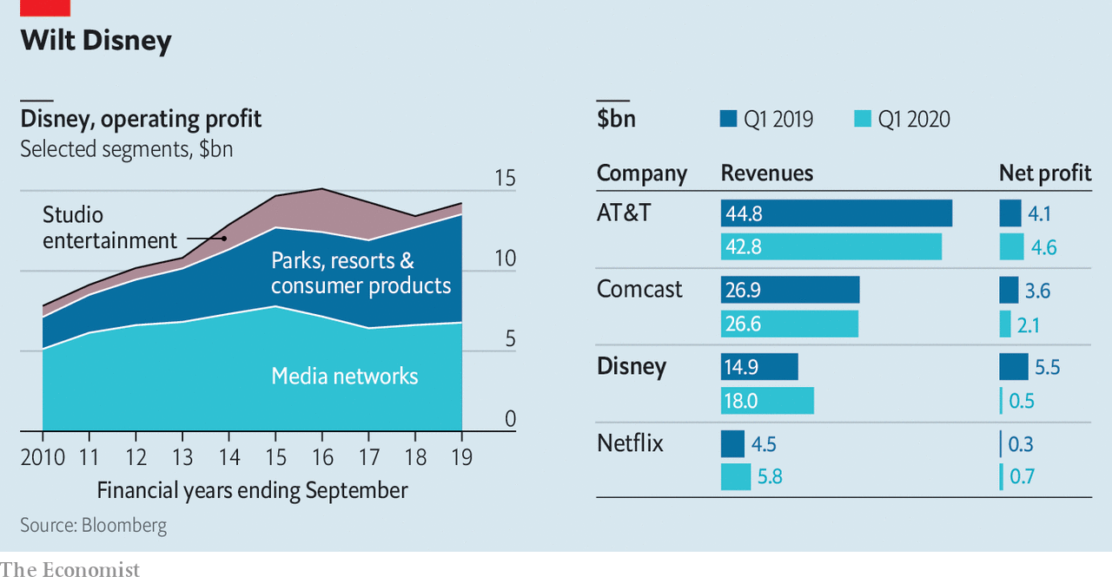

The Fox deal apart, Disney’s biggest expansion under Mr Iger was in theme parks and resorts. Capital spending on these was $4.1bn last year—more than Disney paid for Lucasfilm in 2012. Six parks and four cruise ships (plus a private island in the Bahamas) helped generate a third of Disney’s operating profit in 2019, nearly double the share a decade ago. Bob Chapek, who replaced Mr Iger as CEO in February, ran the division. Yet this business is especially vulnerable to social distancing. With parks closed and ships docked, quarterly profits in this segment swooned by 58%.

Disney’s Shanghai park, at least, will re-open on May 11th, at below 30% capacity. Visitors are banned from hugging Mickey Mouse and must wear face-masks. The Disney shop sells those in packs of four, featuring Mickey or R2-D2, for $19.99. ■

This article was downloaded by calibre from <https://www.economist.com/business/2020/05/09/parks-and-resorts-powered-disneys-growth-then-came-covid-19>

|  |  |  |  |
| --- | --- | --- | --- |
| Previous | Articles | Sections | Next |

|  |  |  |  |
| --- | --- | --- | --- |
| Previous | Articles | Sections | Next |

#### The presenteeism premium

# Japanese offices struggle to adapt to social distancing

Many companies still put a strong emphasis on physical presence

May 9th 2020 | TOKYO

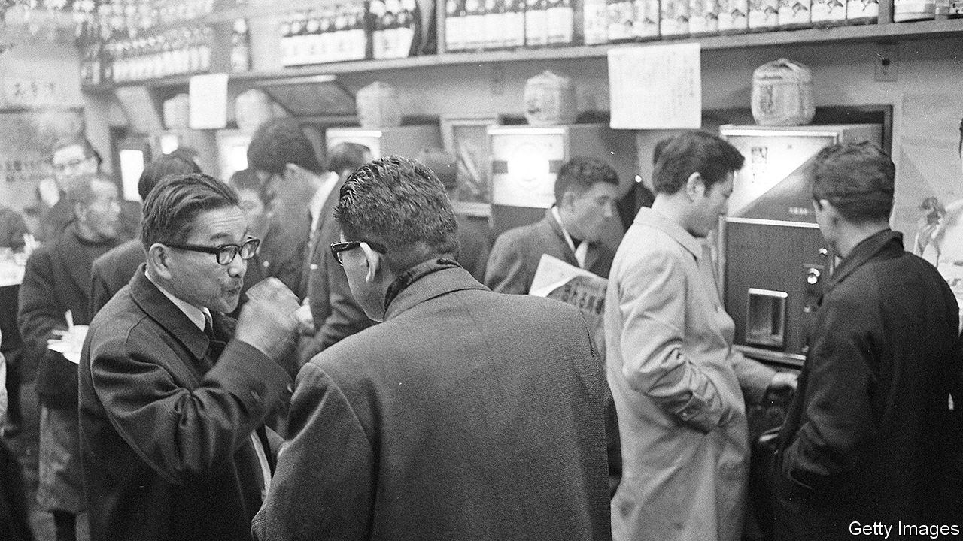

Editor’s note: The Economist is making some of its most important coverage of the covid-19 pandemic freely available to readers of The Economist Today, our daily newsletter. To receive it, register [here](https://www.economist.com/newslettersignup). For our coronavirus tracker and more coverage, see our [hub](https://www.economist.com/coronavirus)

IN 57AD a Chinese emperor, Guangwu, gave an envoy from the kingdom of Wa, as Japan was then known, a solid gold seal, with a handle in the form of a coiled serpent. Such seals, or hanko, are still commonly used in Japan in place of signatures on official documents and contracts. During the covid-19 pandemic, with many workers forced to defy social-distancing guidelines and trudge to their offices to put ink to paper, the hanko captures corporate Japan’s struggle to modernise its anachronistic workplace culture.

Despite its reputation for hi-tech wizardry, Japan can be stubbornly analogue. When the pandemic hit, only 40% of Japanese firms had used digitised contracts at all and just 30% had systems in place to enable remote working. Faxes remain ubiquitous; in many prefectures, doctors have been faxing coronavirus test results to public-health officials.

The pandemic has also exposed Japan Inc’s unusually heavy reliance on face-to-face communication. Meeting clients or business partners in person is de rigueur. The Japanese style of collective decision-making depends on people huddling in a room together. Salarymen and women put in long days in the office to demonstrate their dedication to their company and colleagues—and then late nights of sake-fuelled carousing to build camaraderie.

In Japan gaiatsu, or external pressure, often provokes deep changes. It took the arrival of America’s Black Ships in 1853 to end more than 200 years of Japanese isolation. A collision between Japanese and Chinese vessels near disputed islands in 2010 prompted a revamp of the armed forces. The pandemic, argues Miyake Kunihiko of the Canon Institute for Global Studies, a think-tank in Tokyo, is gaiatsu for corporate Japan.

Some firms are responding. Covid-19 is a headwind for revenues, but a tailwind “in terms of culture”, says Hagiwara Shinichi, boss of Mitsui Foods, a big wholesaler. He has instructed staff to hold regular Zoom meetings. Many firms are shifting to digital contracts. Virtual drinking parties, or Zoom-nomi, are all the rage; as Honda Masakazu, a columnist, recently put it on Toyo Keizai, a business-news site, “You don’t have to worry about catching the last train.”

So far the changes have been halting and uneven. Large Japanese companies are shifting to flexible work regimes more rapidly; they were more likely to have computer systems in place, as well as cash on hand to make up for lost revenues and pay for investment in hardware and software. Small and medium-sized firms “don’t have that luxury”, admits Mr Hagiwara.

And the evolution may not endure. Once restrictions are relaxed, managers may demand to see their subordinates back at their desks. Perhaps, though, without their hanko. On April 27th the prime minister, Abe Shinzo, called for a rapid review of the practice. Even his minister of technology policy, who also heads a parliamentary group for the protection of hanko culture, conceded that the seals present an obstacle to teleworking.■

Dig deeper:  
For our latest coverage of the covid-19 pandemic, register for The Economist Today, our daily [newsletter](https://www.economist.com/newslettersignup), or visit our [coronavirus tracker and story hub](https://www.economist.com/coronavirus)

This article was downloaded by calibre from <https://www.economist.com/business/2020/05/09/japanese-offices-struggle-to-adapt-to-social-distancing>

|  |  |  |  |
| --- | --- | --- | --- |
| Previous | Articles | Sections | Next |

|  |  |  |  |
| --- | --- | --- | --- |
| Previous | Articles | Sections | Next |

#### Bartleby

# Don’t stand so close to me

Office design may need to change

May 9th 2020 |

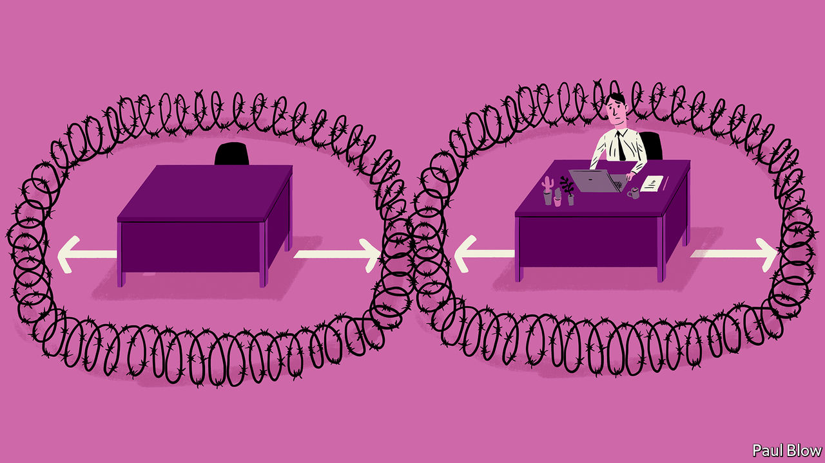

Editor’s note: The Economist is making some of its most important coverage of the covid-19 pandemic freely available to readers of The Economist Today, our daily newsletter. To receive it, register [here](https://www.economist.com/newslettersignup). For our coronavirus tracker and more coverage, see our [hub](https://www.economist.com/coronavirus)

OFFICE WORKING and social distancing really do not mix. The reason why offices exist is to bring colleagues together so they can collaborate. So when employees start to return as pandemic-related restrictions are lifted, they will face a host of challenges.

Start with the basics: getting into the building. In most offices a lot of people tend to leave and arrive at the same time. Keeping them six feet (two metres) apart as they enter may require a queue in the street. Many workers will want to avoid public transport until the pandemic fades from memory, so may cycle to work. But even where offices have changing rooms, they tend to be fairly cramped; hard to keep employees apart.

Lifts are an even bigger choke-point. In normal circumstances people who work in high-rises are accustomed to a long wait to reach the top floors. If lifts can only carry two or three people at a time, that wait would lengthen. And imagine the hassle if a group of visitors arrives at once.

When workers make it to their desks, there is another problem. In recent years offices have been increasing density. The space per workstation in Britain decreased by around a quarter in the decade to 2018, according to Jon Neale of JLL, a property consultancy. But social-distancing rules may drastically reduce the number of people offices can accommodate. Nick Jackson of Arup, an engineering and architectural group, says a two-metre space between desks in a central London office building may reduce the number of staff it can host to 30-35% of the pre-pandemic total.

In the short term, these problems have an obvious answer: let people work from home, or bring them into the office in shifts (maybe two days a week). This will limit serendipity but is better than nothing. The trickier question is whether office design will change in the longer run.

Some high-tech solutions floated before the pandemic appear newly relevant. Zaha Hadid Architects, a big British firm, has designed an eco-friendly building in Sharjah, a city in the United Arab Emirates, with “contactless pathways”, where employees rarely need to touch the building with their hands. Doors open automatically using motion sensors and facial recognition; lifts (and even a cuppa) can be ordered from a smartphone.

Other ideas emerged in response to covid-19. Besides hand sanitiser at the entrance and touch-free doors, an office in Amsterdam designed by Cushman & Wakefield, a property-services group, has desks surrounded by a zone of colour-coded carpet to let people know when they are getting too close. At the start of the day workers pick up a paper deskpad on which to rest their laptop, and which is discarded when they leave. Arrows on the floor guide them to move around clockwise.

All very clever. You could even imagine it working—for a few weeks. But after a while the rules would surely be broken. Bert wants to talk to Ernie who is within sight and just a dozen feet away in an anticlockwise direction. Will he really take the long route around? And physical distance from colleagues is one thing. The potential for germs to be spread via communal items and surfaces is another. Think about the handle on the kettle or the controls of the photocopier. The much-loved snack cupboard at The Economist is probably doomed.

The new emphasis will be on cleanliness. Facilities managers will take a leaf from “The Restaurant at the End of the Universe”, a science-fiction novel by Douglas Adams, where the Golgafrinchans exiled telephone sanitisers and other useless people (such as insurance salesmen and management consultants) on a spaceship, only for their planet’s population to be wiped out by a virus contracted from a dirty handset.

Better air filtration to limit the spread of disease may bring other benefits. One study found that the extra costs of improving air quality could be paid back in less than two years, in terms of higher productivity and reduced ill health.

But not all improvements will be as cost-effective. The reason employees are crammed together is to cut rental expenses. One wonders whether, if a vaccine is found and social distancing no longer required, firms will consider office redesign is worth the candle.

Some elements, like more cleanliness, may stick. The pandemic will speed up the trend towards virtual meetings and home-working. Companies may try to lure highly skilled workers with more personal space, like first-class seats on an aeroplane. But the masses will still be crammed in economy.■

Dig deeper:  
For our latest coverage of the covid-19 pandemic, register for The Economist Today, our daily [newsletter](https://www.economist.com/newslettersignup), or visit our [coronavirus tracker and story hub](https://www.economist.com/coronavirus)

This article was downloaded by calibre from <https://www.economist.com/business/2020/05/09/dont-stand-so-close-to-me>

|  |  |  |  |
| --- | --- | --- | --- |
| Previous | Articles | Sections | Next |

|  |  |  |  |
| --- | --- | --- | --- |
| Previous | Articles | Sections | Next |

#### Schumpeter

# The buoyant oil traders

Not everyone in the oil industry is licking their wounds

May 7th 2020 |

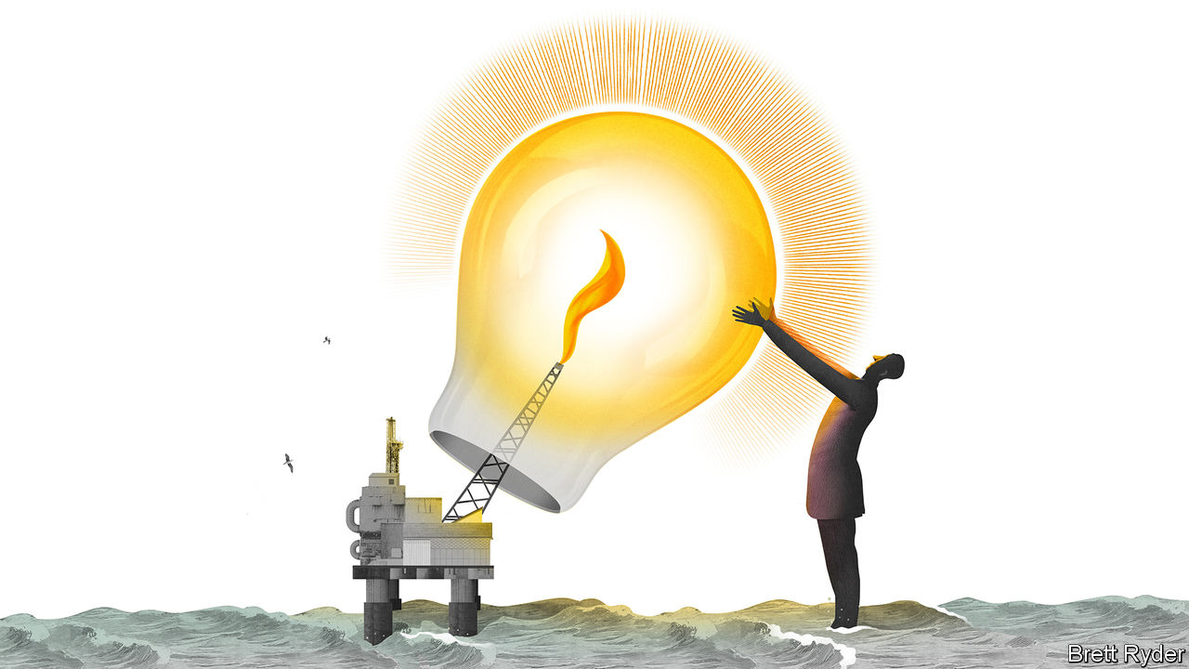

TIMING IS EVERYTHING. When the late Marc Rich, an infamous commodities trader, set out to prise open the Fort Knox world of oil trading in the early 1970s, he had little more to help him than family money, the proceeds from the sale of a colleague’s car, and an address book full of contacts. But something momentous was happening. In the Middle East oil nationalism was stirring. Members of the Organisation of the Petroleum Exporting Countries were tearing up a post-war system in which Western oil companies, the so-called Seven Sisters, fixed the price of crude. An Arab oil embargo had pushed prices up to record levels. It was an ideal time for a renegade trader to go behind the backs of blue-chip producers, ship oil around the world on behalf of despots and sell it at market prices. With the motto “To make money out of other people’s money”, Rich created a business that was reliant on bank loans, secretive and controversial (he was indicted in 1983 for tax evasion and trading with Iran). It was also fabulously profitable.

Almost 50 years later, circumstances could not be more different. After a lousy year for oil producers in 2019, demand for petroleum has collapsed as a result of covid-19 lockdowns. Prices hit record lows. Oil is overflowing from storage tanks and sitting uselessly in supertankers. To constrain supply, producers are shutting down wells and cutting investment. Royal Dutch Shell, an Anglo-Dutch supermajor, has made a 66% cut to a dividend that was once as reliable as the tide on the Thames, onto which its London-based employees look out.

Yet away from the spotlight, the oil-trading operations of Glencore, a listed company founded by Rich, and private ones such as Vitol, Trafigura, Mercuria and Gunvor, are going strong. Last year they shipped more than 24m barrels a day, almost a quarter of world demand, generating turnover (including other commodities) of more than $700bn, as well as bumper profits. This year their winning streak is likely to continue. What makes these mavericks so resilient in an industry prone to boom and bust?

Again, it comes down to timing. As well as ferrying oil around the world, traders store it, taking advantage of differences between the “spot” price of the stuff now and the “futures” price days, weeks or months ahead. Unlike big oil producers, which plough fortunes underground in the hope of big pay-offs in years or decades from today, they hold oil—be it in transit or in storage—for short periods, earning tiny margins on each barrel and magnifying profits by shipping and blending huge volumes. Because the private ones are mostly owned by employees, they face no pressure to pay dividends if times are lean. And even when spot prices are low, they can make fortunes. According to Oliver Wyman, a consultancy, their most recent boom years coincided with the financial crisis of 2007-09 and the oil-price crash of 2014-15.

That is because they benefit from price volatility, rather than absolute price levels. In the turmoil of recent months, haywire markets have experienced an unusually steep “contango”, a state of the market when the spot price is lower than the futures price (its opposite is “backwardation”). For those with storage, contango is a godsend. It enables you to buy oil cheaply, hold it and release it to the market when prices are higher. “It is like sailing with the wind in your back,” says Jean-François Lambert, a trading consultant. Storage has been desperately scarce in recent months. In the heat of the crisis, shipowners took advantage to raise the price of tankers tenfold and demand ultra-long contracts. But thanks to good relations with the shipping industry and supportive banks, the traders were probably swift to get in ahead of the pack.

For all their similarities, they have intriguing differences. The most open of them is Trafigura, which alone publishes detailed annual accounts (as a measure of the wealth generated, its shareholders’ equity last year was $6.5bn, split between management and 700 senior employees). It can count on $60bn in credit lines from 135 banks, and has introduced sophisticated data-crunching tools. It was quick to warn the markets of the lack of storage at the end of March, which suggests it was already well supplied with storage capacity by then. It is now bullish about a pickup in demand, and says low prices are working to force producers to reduce output. Hence the market is starting to rebalance. “Oil is coming back off the boats,” says Ben Luckock, its co-head of oil trading.

Vitol, an even bigger trader, keeps a low profile and appears more cautious. It likes to think of itself as financially conservative and plays down talk of “bumper years”. Its chief executive, Russell Hardy, sees a fragile recovery as lockdowns ease. “The worst is over,” he told Reuters. But his mood is hardly bullish.

There is good reason for caution. The crisis has brought home the danger of collapse among indebted counterparties. Even before American oil prices plunged below zero on April 20th, Hin Leong, Singapore’s largest home-grown oil-trading company, declared insolvency. In the aftermath the big traders quickly reassured banks that they were in no danger. Trafigura, with “adjusted” debt of about $5.3bn, sent a letter to banks explaining the market moves and saying that it had been able to minimise risks before April 20th.

## Less renegade, less Rich?

Bigger challenges lie ahead. Large European producers, such as BP, Shell and Total, have become more aggressive traders in their own right, increasingly clawing back the ground they once surrendered. Middle Eastern oil titans, such as Saudi Aramco, are also trying to muscle in. This could squeeze traders’ margins in the long run. They also face heightened scrutiny over transparency, governance and climate change. Energy has always been a murky business; the pressure is mounting to make it less so. One day Trafigura and the others may be forced to move away from the black stuff. When precisely that will be is anyone’s guess. Timing, yet again, will be everything.■

This article was downloaded by calibre from <https://www.economist.com/business/2020/05/07/the-buoyant-oil-traders>

|  |  |  |  |
| --- | --- | --- | --- |
| Previous | Articles | Sections | Next |

|  |  |  |  |
| --- | --- | --- | --- |
| Previous | Articles | Sections | Next |

#### Eyeing the sky

# Chinese carriers restart their engines

If they recover at home, they could threaten the world’s sickly legacy carriers on international routes

May 7th 2020 |

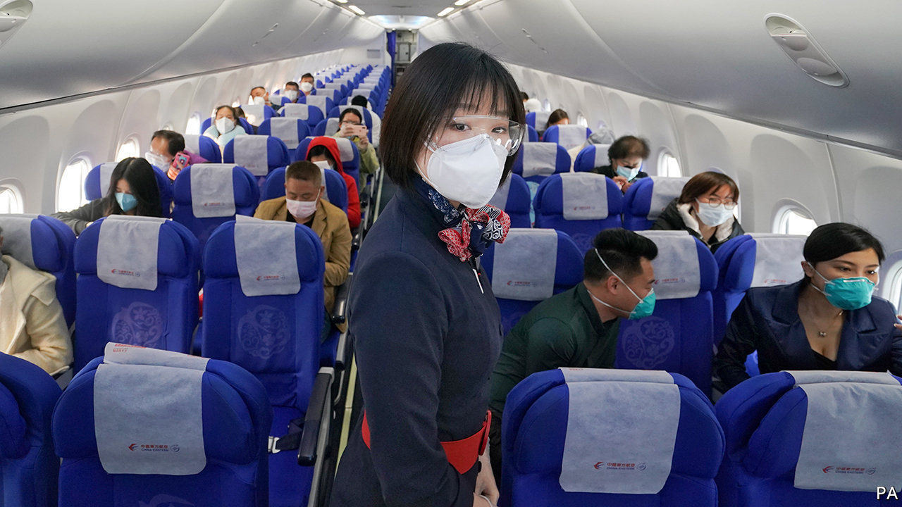

Editor’s note: The Economist is making some of its most important coverage of the covid-19 pandemic freely available to readers of The Economist Today, our daily newsletter. To receive it, register [here](https://www.economist.com/newslettersignup). For our coronavirus tracker and more coverage, see our [hub](https://www.economist.com/coronavirus)

NEWS FOR the world’s airlines goes from bad to worse. In April the International Air Transport Association, their trade body, forecast the industry’s global revenues would fall by $314bn in 2020, down by 55% from last year, owing to pandemic-related travel disruptions. Carriers are laying off thousands of workers. In a vote of no-confidence on their future, on May 2nd Warren Buffett said Berkshire Hathaway, the venerated investor’s conglomerate, had dumped all the shares it owned in American airline firms. Skies in one part of the world, though, look a bit less bleak. The aviation industry in China, where covid-19 was first detected, may have the worst behind it.

The pandemic curve began to flatten in China weeks before the rest of the world entered lockdown. As curbs on internal travel ease and offices reopen, domestic flights are regaining lost ground (see chart). In the first week of May, a holiday in China, capacity was scheduled to be only 10% lower than in the same period a year ago, estimates the CAPA Centre for Aviation, a consultancy. In America, meanwhile, it was 73% lower. As Western rivals slash flights, China Eastern this month claimed the title of the world’s biggest airline by current seat capacity, according to OAG, an aviation-data firm.

Doubters allege that Chinese firms are flying empty planes to boost stated capacity artificially. Yet (self-reported) data from China’s three biggest firms—Air China, China Southern and China Eastern—indicate that the “passenger load factor”, a measure of efficiency, averaged 68% in the first quarter, down from 80-85% in 2019 but still respectable. Spring Airlines, a private low-cost carrier from Shanghai, reported a load factor of 73% in the first three months of 2020. In a sign of bullishness Spring added or restored 47 domestic routes on May 3rd.

To be sure, Chinese carriers have taken a big hit. Revenues at the big three plunged by 46% in the first quarter, year on year, to 54bn yuan ($7.7bn). They suffered a combined net loss of 14bn yuan. Their share prices remain 25% or so below the level in January, when covid-19 began to spread fast in the city of Wuhan. But that is positively perky next to rivals elsewhere. The Bloomberg world airlines index, which tracks two dozen global airlines, has fallen by half in the same period.

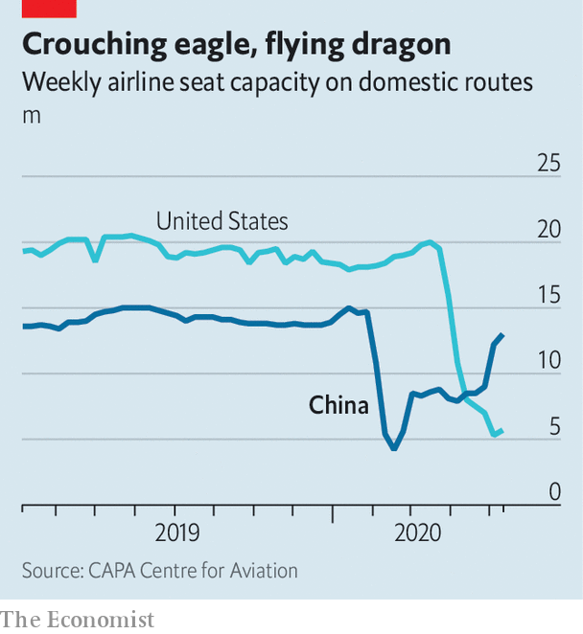

Kelvin Lau of Daiwa Capital Markets, a broker, reckons that travel bans and lockdowns will cut the big three’s revenues by less than a third this year, to 286bn yuan. None has resorted to mass lay-offs. The trio serve the world’s second-biggest domestic market after America and, being state-controlled, can tap government support with fewer strings attached than American firms (whose $58bn bail-out is conditional on suspending payouts to shareholders).

How quickly Chinese air travel returns to pre-pandemic health remains up in the air. A second wave of infections could ground them again. But one thing seems assured: the big three, which accounted for 41% of domestic capacity in 2019, down from 59% in 2010, according to Cirium, a data provider, will reassert their dominance. As firms rush to boost capacity to protect market share, load factors may stay depressed, putting pressure on weaker ones such as Hainan Airlines, China’s fourth-biggest (which last month sought to delay payment on 750m yuan in maturing bonds). And if, as seems likely, a strong recovery at home coincides with continued deterioration of the world’s legacy carriers, the Chinese state-run giants could grab a bigger slice of international routes, too. ■

Dig deeper:

For our latest coverage of the covid-19 pandemic, register for The Economist Today, our daily [newsletter](https://www.economist.com/newslettersignup), or visit our [coronavirus tracker and story hub](https://www.economist.com/coronavirus)

This article was downloaded by calibre from <https://www.economist.com/business/2020/05/07/chinese-carriers-restart-their-engines>

|  |  |  |  |
| --- | --- | --- | --- |
| Previous | Articles | Sections | Next |

|  |  |  |
| --- | --- | --- |
| Business | Sections | Schools brief |

Finance & economics

Credit-rating agencies: Markers marked

.

Commodities: Custom of the country

.

The stockmarket rally: Uppers and downers

.

Emerging markets: QE too

.

Finance in India: Bright spot

.

Gig workers unite: All worked up

.

Free exchange: Unprofitable arguments

.

|  |  |  |
| --- | --- | --- |
| Business | Sections | Schools brief |

|  |  |  |  |
| --- | --- | --- | --- |
|  | Articles | Sections | Next |

#### Markers marked

# Credit-rating agencies are back under the spotlight

This time is different from the financial crisis—sort of

May 9th 2020 |

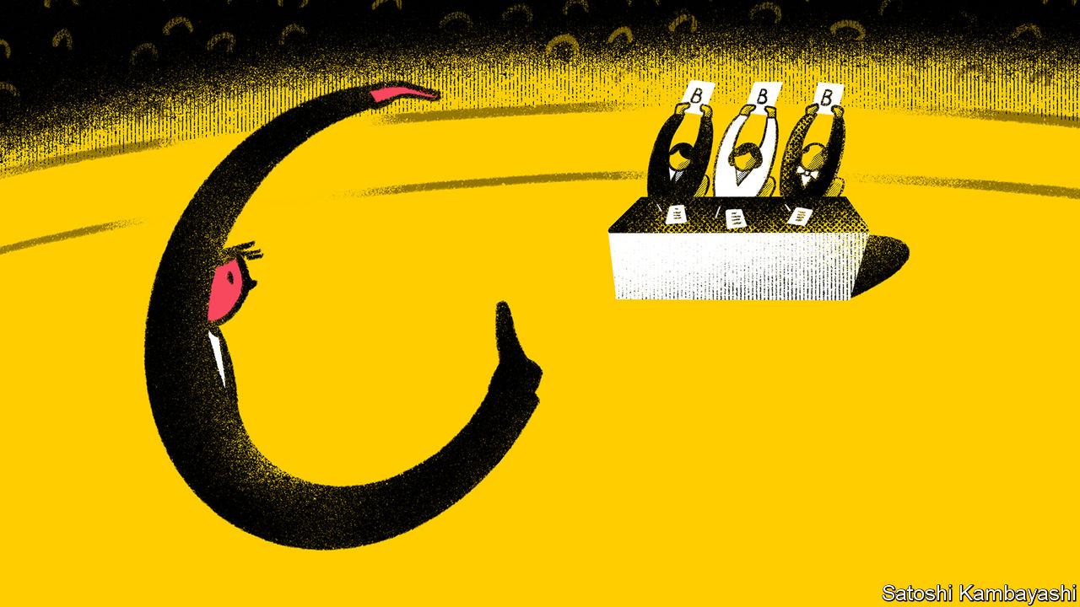

IN TIMES OF financial plenty credit ratings go largely unnoticed. In downturns, though, they attract more scrutiny—and are often found wanting. The dotcom crash of 2000-01 exposed ratings of some erstwhile corporate stars, including Enron, as nonsense. Worse was to come in the financial crisis of 2007-09, which the three big rating agencies—Moody’s, S&P and Fitch—helped cause by trading reputation for profit and giving implausibly high marks to securitised mortgages. An official report on the crisis branded the agencies “essential cogs in the wheel of financial destruction”.

It is, then, no surprise that the ratings oligopoly faces another potential backlash, now that an even bigger pile of debt threatens to go sour, thanks to covid-19. Eyebrows have been raised as the agencies have rushed to mark down bonds and loans of all types. The pace of downgrading in March was the fastest recorded. As of May 5th, S&P had downgraded or put on negative watch a fifth of the corporate and sovereign issuers that it rates, in response to the virus and a tumbling oil price—and over three-fifths in the worst-hit industries, such as cars and entertainment. This burst of activity is stoking a familiar suspicion: that the rating firms let their standards slip in the go-go years, only to scramble belatedly to make amends once markets turned.

The accuracy of ratings matters, because the licensed firms that issue them wield great power over capital markets. A downgrade can cause a company’s funding costs to rocket, or a run on a bank. It can also force a corporate or sovereign borrower out of an index, draining the pool of investors willing or permitted to lend to it.

Far from having their wings clipped after messing up prior to 2007, the rating agencies cashed in on the past decade’s debt bonanza (see chart 1). At the end of 2019 global corporate-bond debt was $13.5trn, double the level of 2008 in real terms. With central banks using ratings to sift potential fodder for their asset-buying programmes, these grades have become even more crucial determinants of who can hold what.

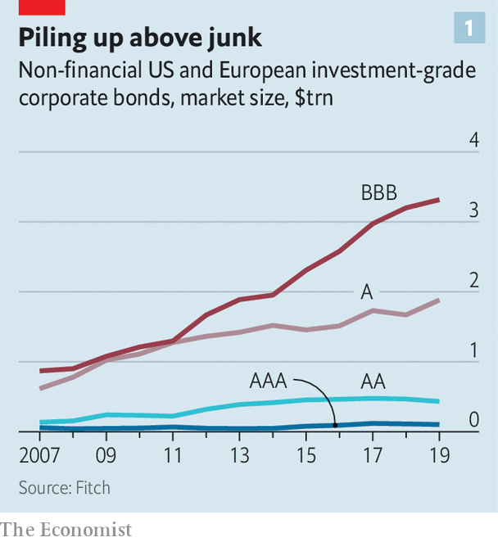

The agencies argue that their ratings hold up well when viewed “through the cycle”, rather than over short periods of time. They also point to changes, imposed on them after the financial crisis, that have strengthened the walls between their analysts and sales teams. Ratings are paid for by the issuer; in the run-up to the financial crisis it was largely the fear that big clients, often banks, would take their business elsewhere that led the agencies to award overly generous marks to toxic loan pools.

It is also true that much of the lower-quality debt raised in recent years has received poor marks from the start. At the end of 2019 almost two-thirds of American leveraged loans rated by S&P were single-B (the mid-band of high-yield, or “junk”) or lower; at the end of 2007 just over a third were. The rating firms point to a plethora of reports they issued as debt built up, warning that things could get messy when sentiment soured. And for years they have highlighted the evisceration of “covenants”, or legal protections for creditors in the event that a borrower’s finances spin out of control.

James Grant, editor of Grant’s Interest Rate Observer, a newsletter, and a longstanding watcher of credit markets, is no great fan of the rating agencies, which he has described as “not customarily the market’s thought leaders”. Even so, in a recent note he acknowledges that they “noticed termites in the house of credit” well before the pandemic. Central banks deserve more of the blame this time, he reckons, for “corrupting” credit with price-distorting ultra-loose monetary policy.

There is, though, still plenty for critics to chew on. A study in 2013 found an inverse relationship between ratings quality and the state of markets: agencies are more likely to issue less-accurate ratings when fee income is high, hiring top-quality analysts is pricier and default probabilities low. In 2019 a Wall Street Journal investigation found that the six largest agencies had in the previous seven years all made changes to ratings criteria that led, at least briefly, to a rise in market share—particularly in the securitised-loan market.

Two more recent studies have found evidence of post-financial-crisis ratings inflation. A report by the OECD in February found that agencies gave borrowers more leeway on leverage, relative to earnings, in 2017 than a decade earlier (see chart 2). The agencies say that factors such as lower interest rates and increased corporate diversification, rather than sloppy ratings, explain the gap. “There’s no doubt some companies are over-levered for their rating,” says Colin Reedie of Legal & General Investment Management. “We’ve seen it before at the same stage of the cycle, when [rating agencies] give managements too much benefit of the doubt on promises to get back on an even keel.”

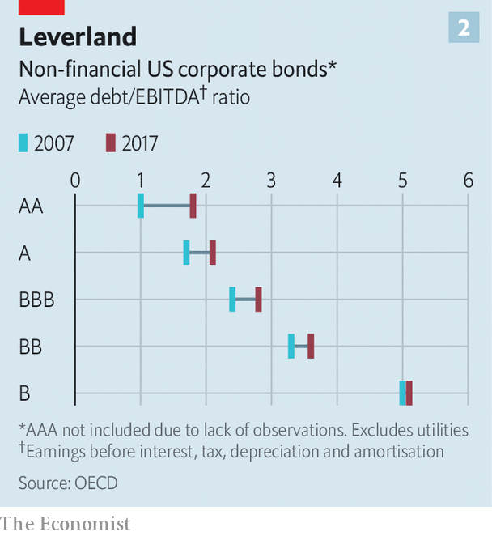

In a working paper, Edward Altman of New York University finds what he calls “an over-rating problem” just above junk. Based on analysis of a batch of metrics including leverage, liquidity and sales, he concludes that over one-third of corporate debt that was on the bottom investment-grade rung going into the pandemic should have been at least one grade lower. In other words, it was junk in all but name.

This bears on the most pressing question facing rating agencies today: what to do about the more than $3trn of corporate debt rated triple-B, on the precipice above junk. In 2010, 45% of all investment-grade debt was in this bottom tier; now it is just shy of 60%.

The OECD study found that downgrades from triple-B to junk are rarer than those elsewhere on the ratings spectrum, suggesting that agencies may be reluctant to force borrowers across that Rubicon. An alternative explanation is that firms make particularly strenuous efforts to avoid such a demotion, to so-called “fallen angel” status, aware that it can mean a sudden spike in borrowing costs.

In March and April, some $193bn of triple-B bonds fell to earth. Rating firms’ credibility rests on dealing rigorously with the rest in that band if there is no quick recovery. But that requires clear information, and fog abounds: 114 firms in the S&P 500 index have suspended earnings guidance.

Another test will be their handling of collateralised loan obligations (CLOs), packages of loans to junk-rated firms. The CLO market has more than doubled since 2010 to $600bn. Analysts at UBS, a bank, foresee default rates of up to 22%, with as much as half of the loan pools slipping to triple-C, the lowest tier. The big risk for rating agencies is the top, triple-A, band. Were that to suffer losses—as happened to mortgage securities known as CDOs in 2008—their reputation would take a hammering.

A third challenge will be to get sovereign ratings right as public finances come under heavy strain. What, for instance, to make of America’s Treasury borrowing a record $3trn this quarter? And what would justify cutting Italy’s rating to junk? (Moody’s and Fitch have it one notch above; S&P, two.) That would send the country’s bonds out of key indices, forcing many investors to sell them. A decade ago the rating agencies were accused of accelerating the euro-zone sovereign-debt crisis by downgrading some of the bloc’s big economies, including France.

How the agencies handle these tests will determine whether the crisis brings more calls for root-and-branch reform of the ratings market. The financial crisis produced just such a clamour, but regulators merely tinkered. The issuer-pays model has proved resilient, despite the potential for conflicts of interest, because the alternatives are flawed, too. Were investors to pay for ratings, for instance, access to them would be restricted to those who could afford to subscribe instead of being available to all, as they are now.

A more fertile area for reform concerns over-reliance on ratings. They are hard-wired into all manner of regulations and investment mandates, often in a mechanistic way that discourages investors from doing their own homework. They help determine everything from banks’ capital requirements to what mutual funds are allowed to buy. Here too, though, change has proved elusive. A study in 2018 found that references to ratings in American bond funds’ investment mandates had actually increased since 2010.

As for competition, several upstarts are hustling for business. Kroll Bond Rating Agency, founded in 2010, chalked up $140m in revenue last year. But Moody’s, S&P and the smaller Fitch still have a combined global market share of almost 95%.

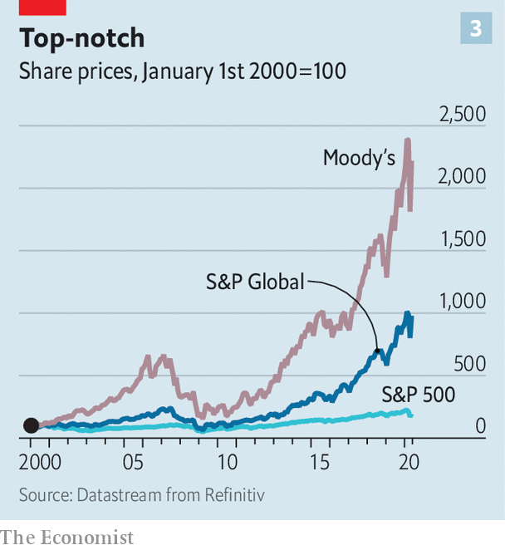

The reluctance of many bond issuers to stray from the big rating firms has helped put “moats” around them and allowed them to raise prices by 3-4% a year, says Craig Huber of Huber Research Partners. Moody’s and S&P have operating margins of an eye-watering 50%. Both stocks have been a shrewd long-term investment, propelled by both the ratings boom and a broader push into data analytics (see chart 3); their combined market capitalisation is $117bn. One happy long-term shareholder is Warren Buffett, whose Berkshire Hathaway owns 13% of Moody’s.

Even the coronavirus may fail to knock them far off course. Moody’s and S&P both posted record first-quarter revenue—$1.3bn and $1.8bn respectively—in part thanks to a fresh burst of bond issuance as companies dashed for cash. Their latest guidance, issued in late April, foresees earnings for 2020 around, or possibly exceeding, last year’s record haul. A triple-A from shareholders seems likely, then, if not from almost everyone else.■

This article was downloaded by calibre from <https://www.economist.com/finance-and-economics/2020/05/09/credit-rating-agencies-are-back-under-the-spotlight>

|  |  |  |  |
| --- | --- | --- | --- |
|  | Articles | Sections | Next |

|  |  |  |  |
| --- | --- | --- | --- |
| Previous | Articles | Sections | Next |

#### Custom of the country

# With oil prices depressed, China presides over a buyer’s market

Oil and gas suppliers are toiling to secure Chinese demand

May 9th 2020 | NEW YORK

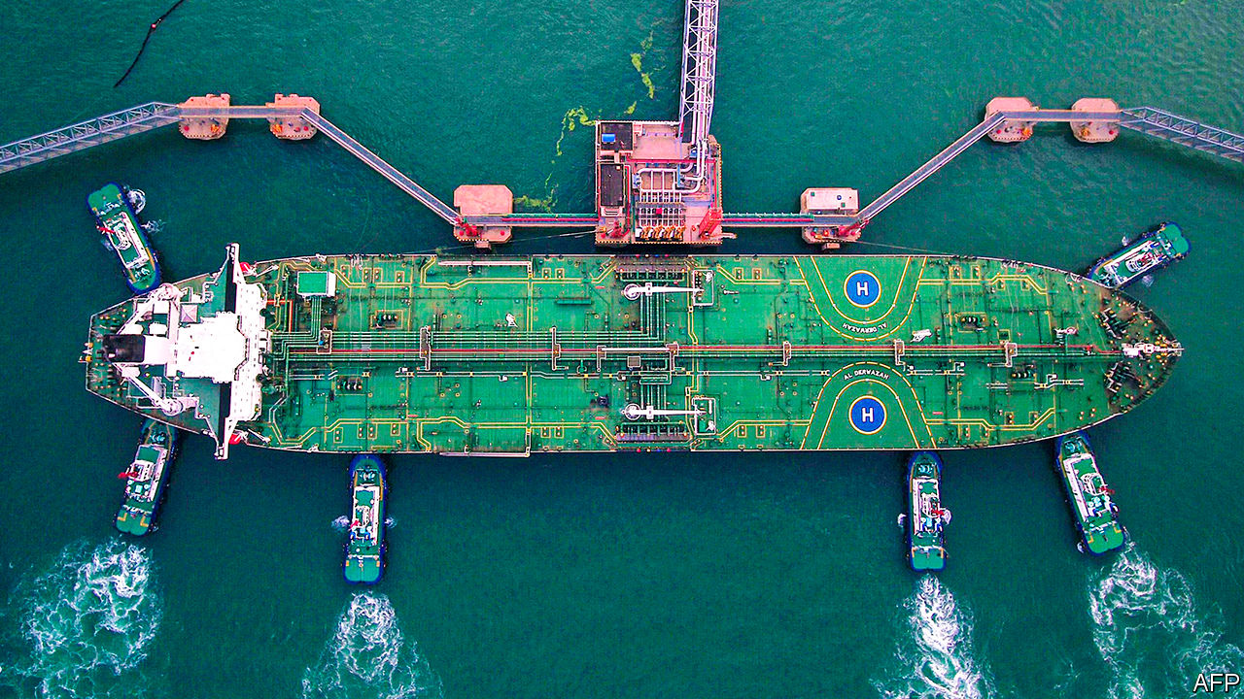

WHEN OIL supply threatened to overwhelm storage tanks in Cushing, Oklahoma, in April, the pain was felt as far as Chongqing. Retail investors in the Bank of China’s oil bao, or “treasure”, a speculative vehicle linked to crude futures, took a hit as the May contract for West Texas Intermediate settled at an astonishing -$37.63 a barrel on April 20th. The market’s gyrations have led to consternation in China—regulators have reportedly called for an investigation—and revealed unexpected victims. In general, though, plunging prices have served Chinese buyers rather well.

In 2017 China became the world’s biggest importer of crude, surpassing America, and the second-largest importer of liquefied natural gas (LNG), behind Japan. Dependence on foreign fuels has long been deemed a strategic vulnerability. But now oil and gas suppliers are toiling to secure Chinese buyers, not the other way round.

China’s heft was set to grow even before covid-19 kept cars parked and planes grounded. In the long term the growth of China’s population and economy make it a likely source of rising demand, even if climate change clouds prospects for oil and gas elsewhere. Companies and petrostates have worked to secure their share of China’s market: Russia’s Power of Siberia gas pipeline opened in December; ExxonMobil’s efforts include a 20-year deal to supply LNG to Zhejiang Provincial Energy Group.

As the pandemic obliterates energy demand, China is revelling in a buyer’s market. It has not been shy about squeezing suppliers. In March Kazakhstan’s energy minister said the country had reduced gas exports to China by 20-25%, at China’s request. China National Offshore Oil Corp reportedly invoked force majeure to halt LNG shipments from BP, Royal Dutch Shell and Total, three European supermajors.

Chinese buyers have also been opportunistic. Although car, freight and plane travel dropped in the first quarter, crude imports rose by 5%. Neil Beveridge of Bernstein, a research firm, estimates that about 200m barrels of oil went into storage in China in the first three months of the year, as the government, refiners and other buyers stocked up on inexpensive oil. Refineries lifted run rates in March, benefiting from the gap between cheap imported crude and the state-mandated domestic-price floor of $40 a barrel, which in turn ensured a higher margin for refined products.

Oil suppliers continue to look to China, which has eased its lockdown before other markets. “China is leading demand at the moment, so everyone is trying to sell into that market,” says Ben Luckock of Trafigura, a trading group. Even as covid-19 depressed global energy demand, seaborne oil exports to China in April reached a record level, according to Kpler, a market-data firm, and were 25% higher than last year’s average. On May 1st independent refineries, known as “teapots”, were processing more crude oil than in December. In April the Shanghai International Energy Exchange approved new storage capacity for Sinopec and PetroChina, national energy giants.

It is unclear if China will remain a bright spot. Despite analysts’ best efforts—by, say, using satellite images to track outlines on storage tanks—no one knows precisely when China’s oil stocks may near its capacity to store it, says Mr Beveridge. The International Energy Agency expects Chinese demand to be tepid in the second half of the year, as the global economy remains weak. “Crude imports are going to have to slow down a bit to run down some of the stocks,” argues Chris Midgley of S&P Platts Analytics, a price-reporting firm.

Meanwhile competition to sell to China continues. Saudi Arabia posted steep discounts for crude heading to Asia in May; rivals are nervously awaiting Saudi prices posted for June. Complicating the outlook for gas exporters to China, the government is keen to support domestic gas and the cost of Chinese wells has dropped. The American Petroleum Institute (API), a lobby group, is urging officials to lean on China to import more American oil and gas, as agreed in a recent trade deal. “China has a growing demand for energy,” says Frank Macchiarola of the API, “and we have a growing need for markets.” Join the club. ■

This article was downloaded by calibre from <https://www.economist.com/finance-and-economics/2020/05/09/with-oil-prices-depressed-china-presides-over-a-buyers-market>

|  |  |  |  |
| --- | --- | --- | --- |
| Previous | Articles | Sections | Next |

|  |  |  |  |
| --- | --- | --- | --- |
| Previous | Articles | Sections | Next |

#### Uppers and downers

# A perky stockmarket v a glum economy

Explaining the stockmarket rally

May 7th 2020 |

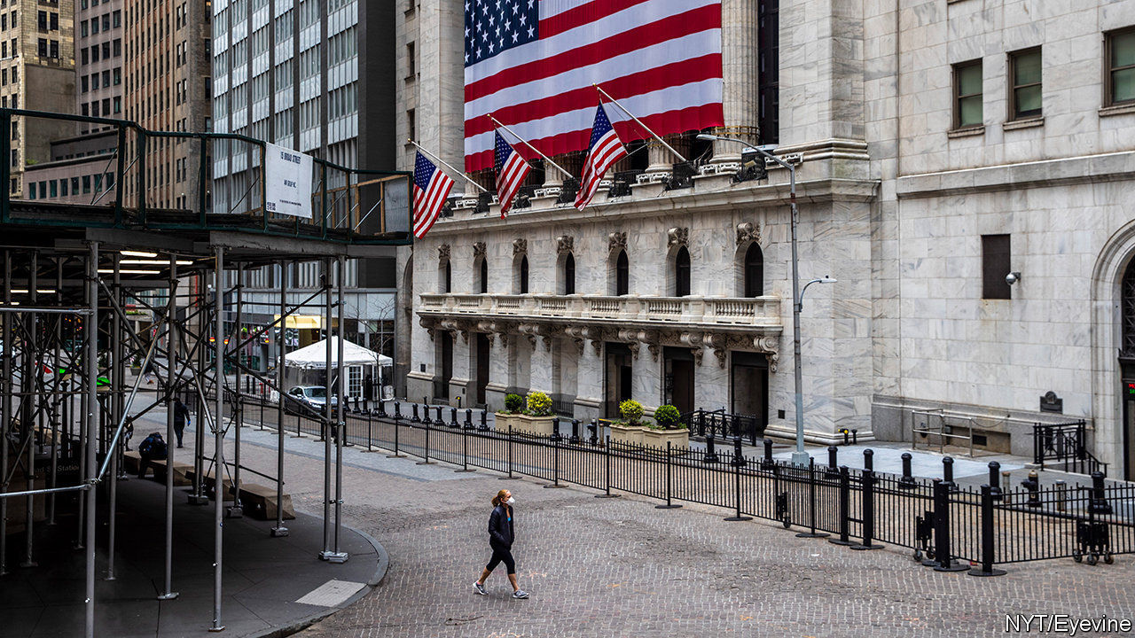

Editor’s note: The Economist is making some of its most important coverage of the covid-19 pandemic freely available to readers of The Economist Today, our daily newsletter. To receive it, register [here](https://www.economist.com/newslettersignup). For our coronavirus tracker and more coverage, see our [hub](https://www.economist.com/coronavirus)

FINANCIAL MARKETS look forward. Yesterday’s news is stale. What matters is the future, in particular the returns that today’s buyer of securities can expect. So there is some reason to think the S&P 500 share index might trace the near future of America’s economy.

Share prices in America have followed a dramatic V-shape recently. A brutal sell off has given way to a lively recovery (chart 1). Yet a V-shaped path for the economy—a brief recession, followed by a swift recovery—seems unlikely. The scale of job losses suggests the economy is in a hole too deep to climb out of quickly. Claims for unemployment insurance have dwarfed peaks in previous recessions (chart 2).

So why has the stockmarket rallied so hard? In part this reflects the Federal Reserve’s efforts to backstop the economy. It has bought bonds on an unprecedented scale, swelling its balance-sheet (chart 3). Bond yields have also become even paltrier (chart 4). Equities are appealing, if only by comparison.

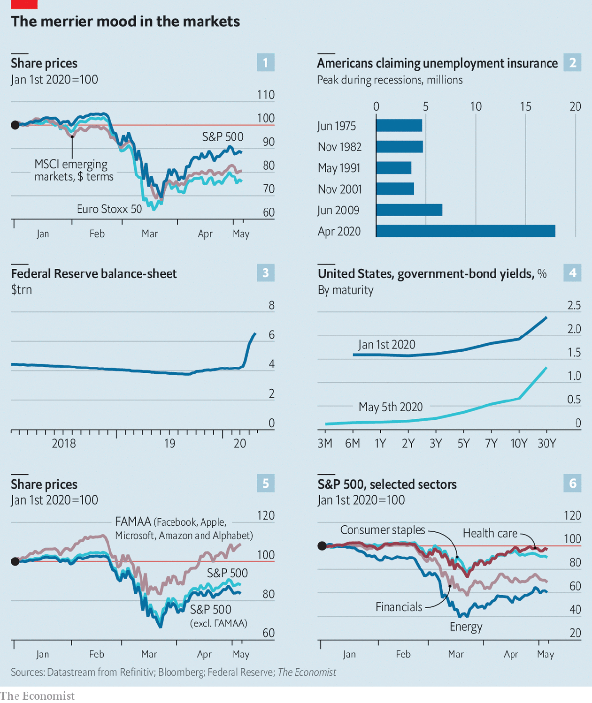

The pattern of share-price changes is revealing. America’s have risen faster than Europe’s. The industry make-up of each market explains much of this. Europe’s bourses are weighed down by cyclical industries—banks, carmakers and energy companies. America’s has a bigger tilt toward technology companies, the relative winners of the covid-19 crash. The five largest tech stocks continue to be market darlings (chart 5). Healthcare stocks and consumer staples have also proved resilient (chart 6). Investors are not looking much beyond stocks they judge to be recession-proof. The market’s recent “V” is not for victory.■

Dig deeper:  
For our latest coverage of the covid-19 pandemic, register for The Economist Today, our daily [newsletter](https://www.economist.com/newslettersignup), or visit our [coronavirus tracker and story hub](https://www.economist.com/coronavirus)

This article was downloaded by calibre from <https://www.economist.com/finance-and-economics/2020/05/07/a-perky-stockmarket-v-a-glum-economy>

|  |  |  |  |
| --- | --- | --- | --- |
| Previous | Articles | Sections | Next |

|  |  |  |  |
| --- | --- | --- | --- |
| Previous | Articles | Sections | Next |

#### Getting on board

# Emerging markets launch QE, too

Unconventional monetary policy is not just for the rich world

May 9th 2020 | HONG KONG

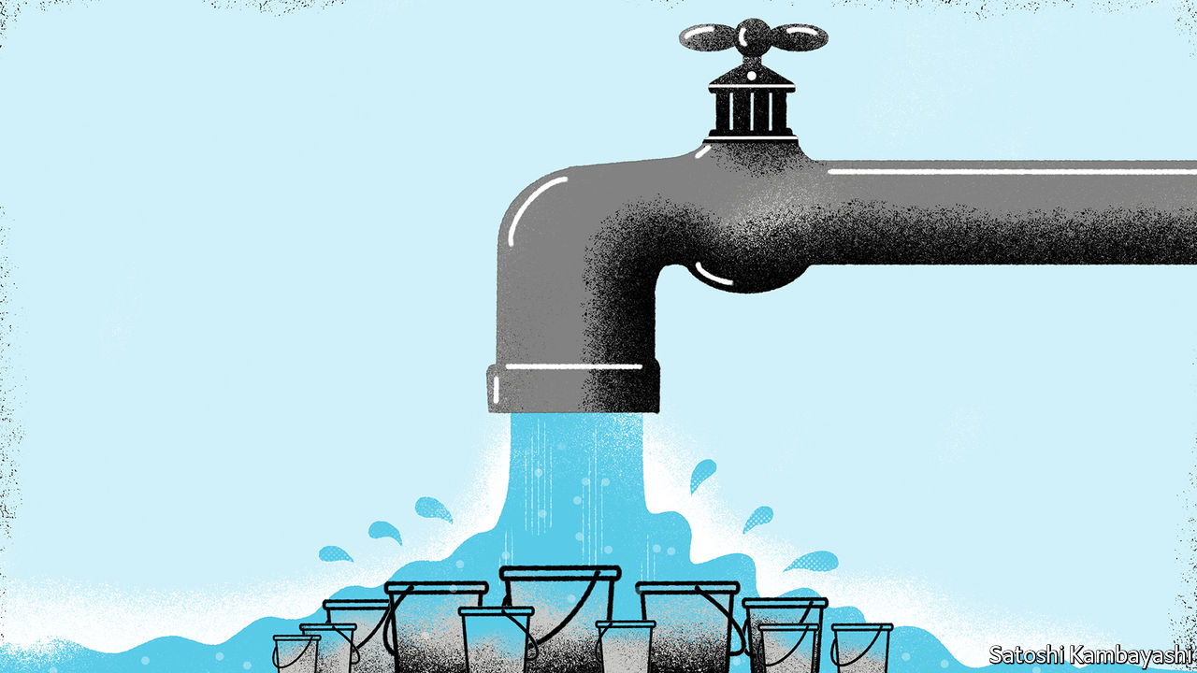

EMERGING MARKETS have long resented quantitative easing (QE). When America’s Federal Reserve began its third round of asset purchases in 2012, Guido Mantega, then Brazil’s finance minister, accused it of starting a “currency war”. In 2013 Raghuram Rajan, then the chief economic adviser to India’s government, expressed his displeasure in the manner of Winston Churchill: “Never in the field of economic policy has so much been spent, with so little evidence, by so few.”

In response to the covid-19 pandemic, much is being spent again. But not by so few. The central banks of America, the euro area, Britain and Japan are set to buy $6trn-worth of assets between them this year, according to Fitch, a rating agency, three times what they bought in 2013, the previous peak. And emerging markets are no longer grumbling on the sidelines. Monetary authorities in Chile, Colombia, Costa Rica, Croatia, Hungary, Indonesia, Poland, Romania, South Africa and Turkey have prepared or begun purchases of bonds of various kinds. Still more are contemplating it. Even in Brazil, congress has passed what it calls the “war budget” law, amending the constitution to give the central bank more freedom to buy government bonds and other assets during this crisis.

The scale of emerging-market purchases is small so far in comparison with the Churchillian appetites of central banks in the rich world. Bank Indonesia, which already owns about 15% of tradable government bonds, may end up adding significantly to its holdings. The National Bank of Poland could end up owning bonds worth about 8.7% of GDP, according to UBS, a bank, if it buys all of the additional debt required to finance the country’s stimulus plan. But no other central bank is poised to buy bonds worth more than 5% of GDP, UBS calculates. By comparison, the Federal Reserve already held Treasuries equivalent to about 10% of GDP at the start of 2020, and is expected to roughly double that percentage over the course of the year.

Critics nonetheless worry that QE is both more dangerous and less necessary in emerging markets than it is elsewhere. It imperils the hard-won independence of monetary authorities that have struggled in the past to keep their distance from big-spending politicians. Brazil’s constitutional limits on the central bank, for example, reflect its history of hyperinflation, when governments resorted to the printing press to finance their populism. And although inflation is now firmly under control in most big emerging markets (exceptions include Argentina, Nigeria and Turkey), many of these countries still worry that monetary indiscipline can lead to destabilising runs on their currency.

QE is also, surely, less needed in the emerging world. In Chile and Peru benchmark interest rates are already about as low as they can go. But in most of their peers, central banks still have room to ease monetary policy by conventional means. In Indonesia and South Africa, for instance, the policy interest rate is still over 4%.

Why then are central banks pressing ahead? They believe their bond purchases serve a distinct purpose. They are neither an unconventional way to lower borrowing costs nor an illicit one to finance the government. The aim instead is to stabilise financial markets. In Brazil the president of the central bank says its bond purchases will resemble foreign-exchange intervention. It will not try to peg bond yields any more than it pegs the real. But it will try to smooth out jumps. The South African Reserve Bank says that its purchases are not meant “to stimulate demand”, but to ensure a “smoothly functioning market”.

In some quarters QE is still a tainted term, associated either with mercantilism, as a weapon in a currency war, or monetary adventurism. But the stigma is fading. Indeed some central banks now say they are doing QE even when they aren’t. The Bank of Korea, for example, has resolved to buy unlimited amounts of bonds from financial institutions that promise to repurchase them after three months. These “repo” operations amount to collateralised loans, not outright purchases. Few economists would describe them as QE. But far from resisting the term, the Bank of Korea has embraced it (“It wouldn’t be wrong to say we began quantitative easing,” noted one official). Never in the field of central banking have so many worried so little about buying so much. ■

This article was downloaded by calibre from <https://www.economist.com/finance-and-economics/2020/05/09/emerging-markets-launch-qe-too>

|  |  |  |  |
| --- | --- | --- | --- |
| Previous | Articles | Sections | Next |

|  |  |  |  |
| --- | --- | --- | --- |
| Previous | Articles | Sections | Next |

#### Bright spot

# In bleak times for banks, India's digital-payments system wins praise

Digital loans could be next

May 9th 2020 |

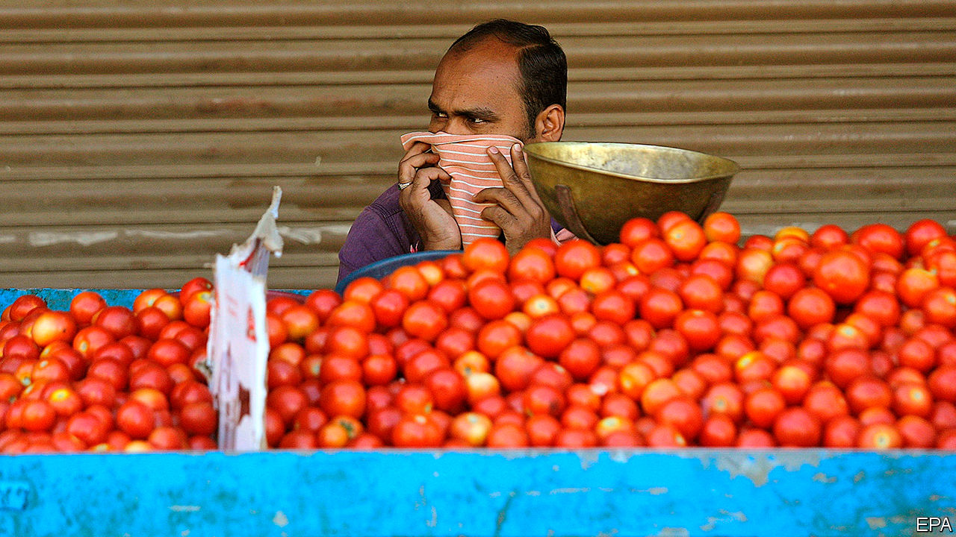

WHEN INDIA was hit both by the failure of a big bank and a nationwide lockdown in March, bankers, fearing runs from rattled depositors, rushed to stuff cash machines with notes. In fact the demand for cash was relatively subdued. Activity hummed along the Unified Payment Interface (UPI), an electronic-payments network that is on its way to becoming the country’s financial lifeline.

In the past two years three big banks or shadow banks have imploded. The severe economic disruption caused by covid-19 will only make lenders’ burden of bad loans heavier. Against this grim backdrop, UPI has shone. In November Google wrote to the Federal Reserve urging it to endorse a similar model for America. The Bank for International Settlements concluded in December that India’s digital financial infrastructure has the “potential to transform emerging markets and advanced economies alike”.

Before UPI was set up in 2016, cash reigned supreme. A large share of the population had no bank accounts, limiting card payments. Now hungry passers-by can pay for snacks like dosas and vada pav from street vendors using apps on their phones. At the start of 2020 nearly 1.3bn electronic payments were made each month, more than those using plastic. They accounted for 19% of banking transactions in the year to March 2019. Saurabh Tripathi of the Boston Consulting Group predicts that they will account for 59% of transactions within two years—three times the share of ATM withdrawals.

UPI usage dipped for the first time in March; that was followed by a fall of 20% in April. The collapse reflects the enormous drop in activity as the country shut down. Data for March suggest that the number of credit-card transactions fell further than that of digital payments, suggesting that UPI still gained market share.

The government has also used UPI to make emergency transfers to street vendors. A new programme is expected to be rolled out in June. This will enable companies to give workers vouchers that can be redeemed by labs testing for covid-19.

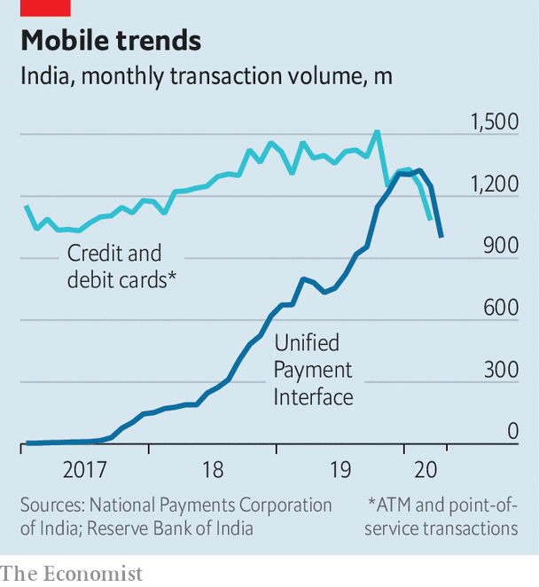

The payment system rests on the Aadhaar card, an identification system with which the fingerprints and irises of more than a billion Indians are registered. Take your card to a bank, as hundreds of millions of Indians have, and you can set up an account; you also become a “known customer”, clearing a regulatory hurdle. You can then, either through your bank or using various apps, send and receive funds instantly from anywhere in India.

Both the identity and the payment layers are controlled by the government, but open to others. As a result, using the system is cheap. Outside India payments tend to be handled mainly by private firms such as Visa, Mastercard, American Express or, in China, Ant Financial and Tencent. These own the pipes through which funds flow, and can charge heavily for their use. Their close relationships with users create high barriers to entry, putting new entrants at a disadvantage. By contrast, UPI is forbidden to charge merchants fees.

India’s set-up enables competition. The heavily regulated banking system still holds all the funds. However, layered on top are a number of lightly regulated private companies, with which customers interact directly. These apps initiate transactions and have access to account information but do not control money or networks. Paytm, a home-grown firm, and PhonePe, owned by Walmart, are big players. So too is Google, perhaps explaining its enthusiasm for the system. But the costs of switching are negligible, requiring just a tap on a phone.

UPI will next step into the realm of lending. Seven “account aggregators’’ are preparing to launch (although covid-19 has delayed their roll-out). Once granted a customer’s permission, these will compile a history of funds received and paid, which can be shared with lenders.

The benefits of such a system are clear. It would break the links between credit and collateral or personal relationships, and allow even small lenders to get loans based on their transaction histories and their income. When combined with cheap transfer costs, the cost of lending to even the tiniest business could fall. These now pay as much as 4% for a one-day loan.

But this is also where the drawbacks of UPI could become most apparent. Only a handful of transactions fail, but glitches have been known to occur. Aadhaar numbers have leaked before. Security matters more when access to credit is at stake. Another concern is the extent of the government’s control over parts of the infrastructure. In related areas it has not been above misusing its clout. In 2019, for instance, it shut down the internet in the troubled territory of Kashmir. Clever as India’s digital financial system is, such risks could mean that, for some, cash retains the edge. ■

This article was downloaded by calibre from <https://www.economist.com/finance-and-economics/2020/05/09/in-bleak-times-for-banks-indias-digital-payments-system-wins-praise>

|  |  |  |  |
| --- | --- | --- | --- |
| Previous | Articles | Sections | Next |

|  |  |  |  |
| --- | --- | --- | --- |
| Previous | Articles | Sections | Next |

#### All worked up

# Could the pandemic give America’s labour movement a boost?

Gig workers are organising, in tech-savvy ways

May 9th 2020 | RICHMOND, CALIFORNIA

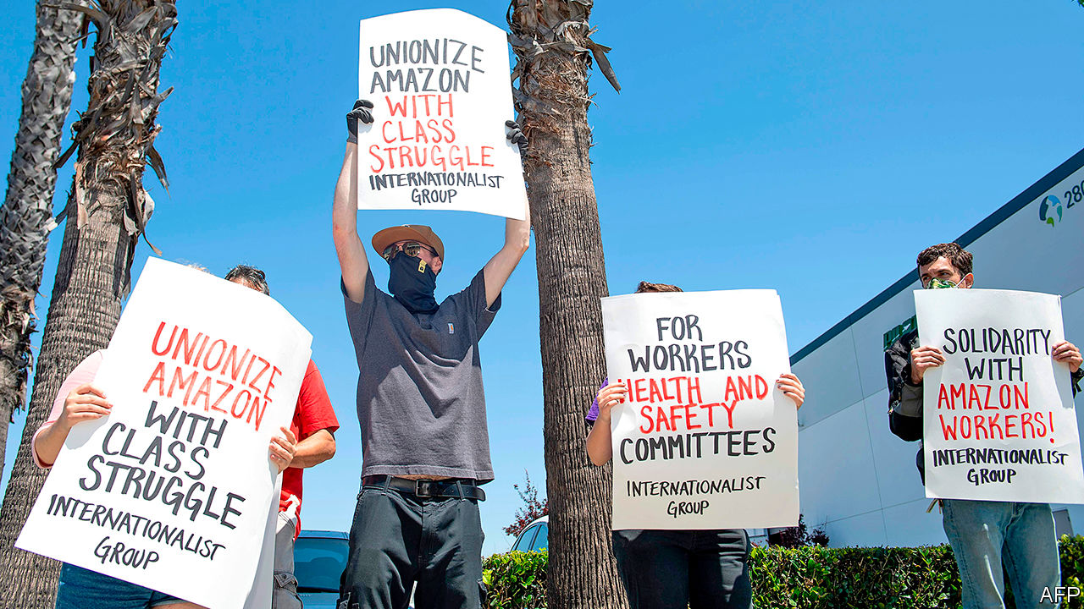

Editor’s note: The Economist is making some of its most important coverage of the covid-19 pandemic freely available to readers of The Economist Today, our daily newsletter. To receive it, register [here](https://www.economist.com/newslettersignup). For our coronavirus tracker and more coverage, see our [hub](https://www.economist.com/coronavirus)

“MAY DAY, ho, ho, billionaires have got to go.” Protesters with slogans and placards, security hovering in the back: the gathering outside an Amazon warehouse in Richmond, California, on May 1st had all the trappings of a proper picket line. One thing was different, though—instead of massing together, participants kept a safe distance. The organisers had even chalked “Stand here” on the pavement at intervals of six feet.

Like much else, collective action is not the same in a time of covid-19. It is also increasingly widespread. The protest in Richmond, which included demands for higher pay, is part of a wave of petitions, walkouts, no-shows and strikes organised by gig workers, factory employees and fast-food servers across America. Coworker.org, a website that helps workers launch campaigns, has seen their number explode to more than 100 new initiatives a week. Mike Elk of Payday Report, a website, counts 45 coronavirus-related strikes in March and 108 in April. Comparing these data with official statistics is not easy, but the rise in strike action that began in 2018 looks likely to accelerate (see chart).

A pandemic would seem an inopportune moment for a revival in organised labour. Figures due to be released on May 8th, after The Economist went to press, were expected to show that America’s unemployment rate exceeded 15% in April, up from 3.5% in February. Many people are grateful simply to have jobs, and do not want to rock the boat. Yet history complicates the picture. Research by Orley Ashenfelter and John Pencavel, labour economists, points to rapid growth in trade-union membership after the Great Depression, when unemployment was about as high as it is today. Other factors, they argue, from “the prevailing attitudes within society” to legislative changes, also help explain the ups and downs of organised labour.

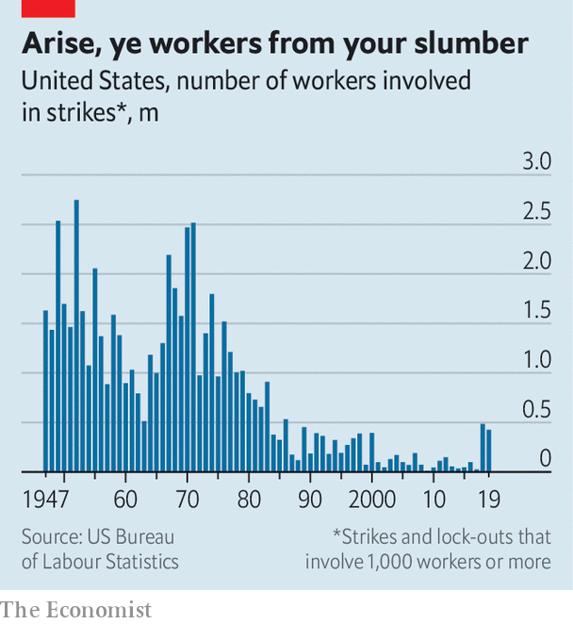

Perceptions of unfairness are likely to aid the worker’s cause. The better educated and richer you are, the easier it is to work from home. But many less-skilled workers must venture outdoors, risking their health, even as they realise that the economy would grind to a halt without them.

Demands for higher pay or paid sick leave also seem to be carrying weight with better-off workers and consumers. It emerged on May 4th that Tim Bray, a senior engineer at Amazon, had quit “in dismay” over the firings of workers who had organised protests, and called on the firm to expand sick leave and hazard pay. “The warehouse workers are weak and getting weaker,” he wrote in a blog post. “Any plausible solution has to start with increasing their collective strength.”

One survey suggests that a majority of Americans’ purchasing decisions will be swayed by how firms treat their workers during the pandemic. Investors may agree: a recent working paper for the National Bureau of Economic Research concludes that companies scoring well on indices of social issues, such as employee welfare and human rights, have fared better on the stockmarket since covid-19 struck.

Gig workers had started to organise even before the virus. Having burned through billions of dollars in venture capital, online platforms such as Instacart and Uber are chasing profits. That has often meant less money and tougher conditions for workers, leading them to form such groups as Gig Workers Collective (GWC) and Rideshare Drivers United (RDU). Activists have developed new forms of collective action, such as turning off their apps at a specified time or refusing to accept gigs, the digital equivalent of a work stoppage.

Technology has made organising easier, too. The GWC, explains Vanessa Bain, one of its founders, uses Facebook to get the word out, Telegram for communication and Slack to organise. The RDU’s app, called Solidarity, aims to overcome the difficulties of organising a fragmented workforce, says Ivan Pardo, its developer. It allows activists to schedule calls with disgruntled drivers, organise protests and ask members what their demands should be.

The latest wave of collective action will allow workers’ groups to grow and form new connections, predicts Veena Dubal of the University of California’s Hastings College of the Law. The strikes on May Day were the first to be organised jointly by several of them. Yet a revolution in American industrial relations, as happened after the Great Depression, is not quite on the cards. Gig workers are still far from matching the might of big platforms, whose business models often rely on fragmented labour. Thomas Kochan of the MIT Sloan School of Management argues that, to increase their leverage, labour groups need to redouble their efforts to make sure they are heard by customers, who can then push firms to change their ways. Protesting outside warehouses, however creatively organised, will probably not do the job. ■

Dig deeper:  
For our latest coverage of the covid-19 pandemic, register for The Economist Today, our daily [newsletter](https://www.economist.com/newslettersignup), or visit our [coronavirus tracker and story hub](https://www.economist.com/coronavirus)

This article was downloaded by calibre from <https://www.economist.com/finance-and-economics/2020/05/09/could-the-pandemic-give-americas-labour-movement-a-boost>

|  |  |  |  |
| --- | --- | --- | --- |
| Previous | Articles | Sections | Next |

|  |  |  |  |
| --- | --- | --- | --- |
| Previous | Articles | Sections | Next |

#### Free exchange

# Losses by central banks are nothing to fear

They do not reflect financial doom. But they expose the fragility of independence

May 9th 2020 |

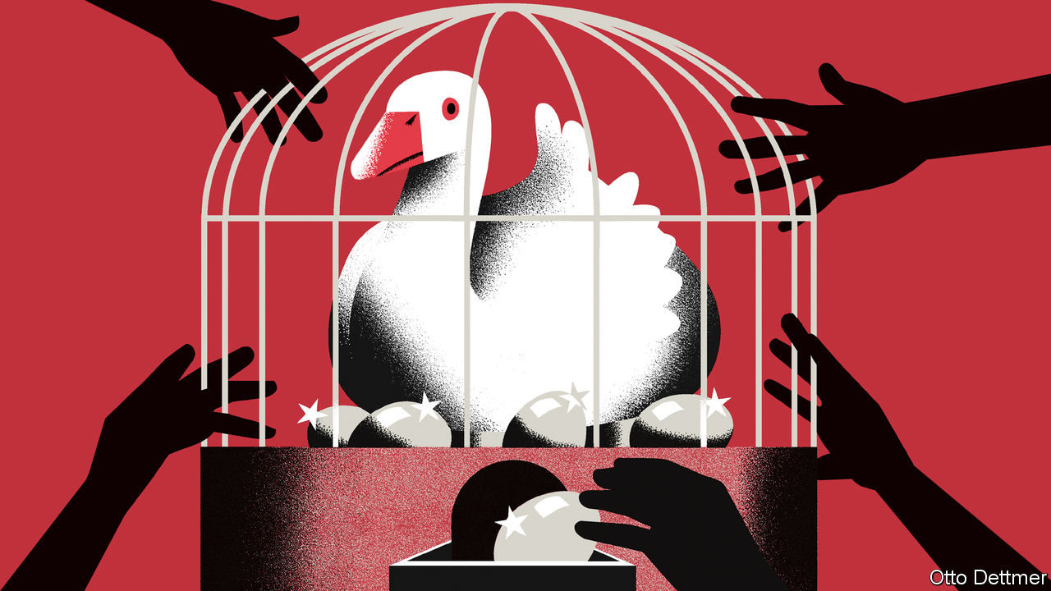

IF MONEY-LOSING banks are a source of concern, then surely losses by central banks—the bankers for banks—must be especially disconcerting. The tumbling value of assets held by the Bank of Japan and the Swiss National Bank seems a sure sign that central bankers have behaved recklessly and put their economies at risk. Anxiety about bond-buying in Germany, where on May 5th the constitutional court suggested that it might block the Bundesbank from participating in the European Central Bank’s asset-purchase programmes (see article), partly reflects such concerns. Central banks are not like private banks, though. Rather than reflecting financial weakness, their losses are a reminder of their odd institutional position.

How does a central bank incur a loss? Like private banks, they have balance-sheets. These consist of assets—such as government bonds—and liabilities, which include the interest-bearing reserve balances of private financial institutions, analogous to current accounts at high-street banks. A central bank makes a loss if the income it earns on its assets falls below the interest it pays out on its liabilities. A decline in the value of its assets can also place it in a hole, and in need of funds to repair its balance-sheet. (Profits tend to be distributed to the government; in 2019, for instance, the Federal Reserve’s net income of $55bn flowed into public coffers.)

The scope for losses has grown considerably. As the global financial crisis took hold in 2007, many central banks cut their main policy rates to zero in order to revive collapsing economies. To inject further stimulus, most then turned to quantitative easing (QE): using newly created money to buy riskier assets like long-term government bonds, mortgage-backed securities and, in some cases, equities. Asset purchases in response to the covid-19 pandemic mean that balance-sheets have ballooned further. Since late February, for instance, the Fed’s assets have swollen by about 60%. Both central-bank action and a broader appetite for relatively safe assets have inflated government-bond prices across the rich world. If bond prices fall as economies heal, for instance, then central banks might make a loss when they come to shrink their balance-sheets by selling bonds. New forms of emergency lending increase the outright credit risk to which central banks are exposed as well. The ECB is hoovering up large quantities of public- and private-sector bonds. The Fed is gobbling up corporate bonds, municipal paper and bank loans to firms of all sizes. A recently enacted economic-rescue bill in America protects it against losses of up to $454bn. Indeed, losses have already materialised elsewhere. The Bank of Japan suffered a large hit to its ¥30trn ($270bn) portfolio of equity funds when stocks plunged earlier in the year. The large holdings of foreign exchange and equity accumulated by the Swiss National Bank, as part of its efforts to limit appreciation of the Swiss franc, have likewise slumped in value.

Losses at central banks, though, are very different from those at private ones. A commercial bank that is in the red might lose the confidence of its creditors, including its depositors, which could place it at risk of bankruptcy. Central-bank depositors, by contrast, have nowhere to go: they have little choice but to park their reserves with central banks. Nor, in most cases, can central banks run out of cash to pay what they owe, since they are able to create new money at will. (There are exceptions: in Lebanon, the central bank has accumulated large foreign-currency liabilities that cannot be met through the operation of the printing press.)

Generally speaking, central banks cannot go bust, and economists largely agree that negative net worth is no impediment to setting monetary policy. In practice, however, a central bank with negative capital would invite much scrutiny. A central bank is ultimately part of the government, and in some respects its liabilities resemble government debt. Paying the bills by printing money is not a good look—especially as newly created reserves themselves incur interest. A solvent central bank could be necessary for the monetary and fiscal regime to look credible. If so, taxpayers must eventually cover the central bank’s losses by, in effect, allowing it to extinguish some of the government’s reserves, undoing some of the expansionary effect of QE on the money supply. Britain’s Treasury has already promised to compensate the Bank of England for any losses that result from today’s bond-buying.

## Tag team, don’t get back again

Losses therefore expose the fragility of central-bank independence. After the inflationary years of the 1970s and 1980s, economists began to view central banks’ freedom from political influence as crucial—it allowed them to establish their credibility with the public and so to hit their policy goals. But monetary policies bleed into fiscal ones when the government’s interest bills are determined by how much bond-buying takes place. Were recapitalisation seen as necessary, the central bank would be at the mercy of politicians. Central bankers appear to take this political risk seriously. Research by Igor Goncharov and Vasso Ioannidou of Lancaster University and Martin Schmalz, now of the University of Oxford, suggests that central banks are more likely to report small profits than small losses. This tendency increases when central bankers are better able to control their reported income, and when they face greater political scrutiny (because, say, they can be reappointed to their positions). Central banks face a dilemma: make policy independently and invite government interference, or pre-empt political meddling by minimising losses.

Perhaps the solution is to acknowledge that central banks now work more closely with governments. Years of financial tumult and falling interest rates have forced them to do more, and to co-operate with fiscal authorities. Rather than fret that losses erode their independence and enable reckless fiscal policy, it may be time to recognise that governments have a role to play in stabilising the economy too—and to demand that they do it properly. ■

This article was downloaded by calibre from <https://www.economist.com/finance-and-economics/2020/05/09/losses-by-central-banks-are-nothing-to-fear>

|  |  |  |  |
| --- | --- | --- | --- |
| Previous | Articles | Sections | Next |

|  |  |  |
| --- | --- | --- |
| Finance & economics | Sections | Science & ... |

Schools brief

Humans and the carbon cycle: Where nature ends

.

|  |  |  |
| --- | --- | --- |
| Finance & economics | Sections | Science & ... |

|  |  |  |  |
| --- | --- | --- | --- |
|  | Articles | Sections | Next |

#### Where nature ends

# Humanity’s immense impact on Earth’s climate and carbon cycle

Much needs to be done for the damage to be reversed

May 9th 2020 |

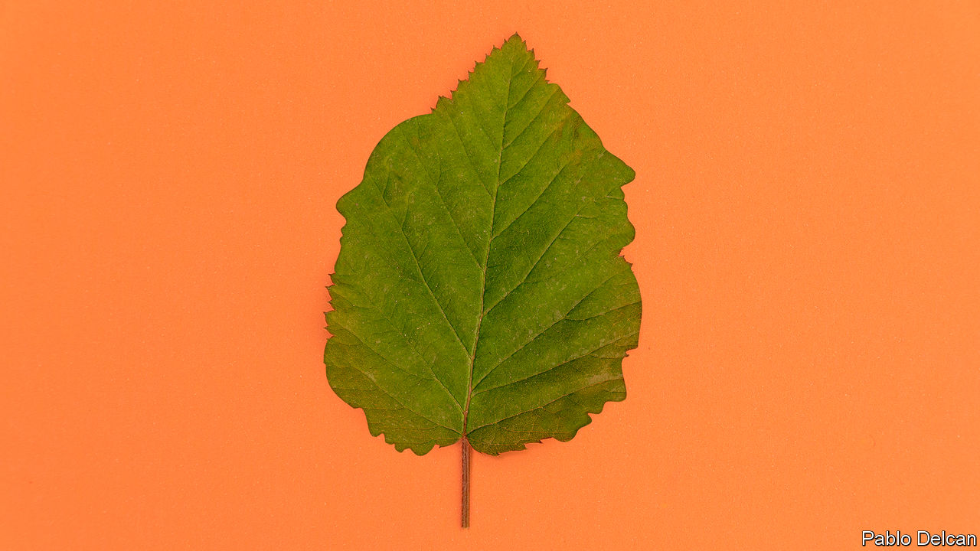

Editor’s note: This is the third in a series of climate briefs. To read the others, and more of our climate coverage, visit our hub at [economist.com/climatechange](https://www.economist.com/news/2020/04/24/the-economists-coverage-of-climate-change)

IT IS ALL, in the end, a matter of chemistry. Carbon dioxide is a form of what chemists call inorganic carbon—a simple molecule that is pretty inert. Fossil fuels are made of carbon in its organic form—often complex molecules that are far from inert. Combustion turns these organic complexities into inorganic simplicities: carbon dioxide, water vapour and heat.

Of the energy that people pay for (as opposed to the energy that comes from burning firewood) 34% comes from burning oil, 27% from coal and 24% from gas. Nuclear power, hydroelectric power and all other renewables combined provide just 15%. The result of all this fossil fuel use is a modern industrial economy and an annual flow of 9.5bn tonnes of carbon out of the ground and into the atmosphere.

Through its effects on the plants, animals and microbes which make up the biosphere, on the climate and on the oceans, this industrial flow of carbon links the Earth’s distant geological past to its future over millennia to come. It is the single clearest piece of evidence for the idea that humans now have a power over the Earth as great as the forces of nature, and that their use of this power has opened up a new geological epoch that some scientists call the Anthropocene.

To appreciate the importance of this industrial carbon flow, you have to understand the carbon cycle in which it sits. At first, this context seems reassuring. Almost all microbes, and all animals, get the energy that they need for life from breaking up food made of organic molecules. The flame-free, internalised form of combustion by which they do so, which biologists call respiration, produces much more carbon dioxide than industry does.

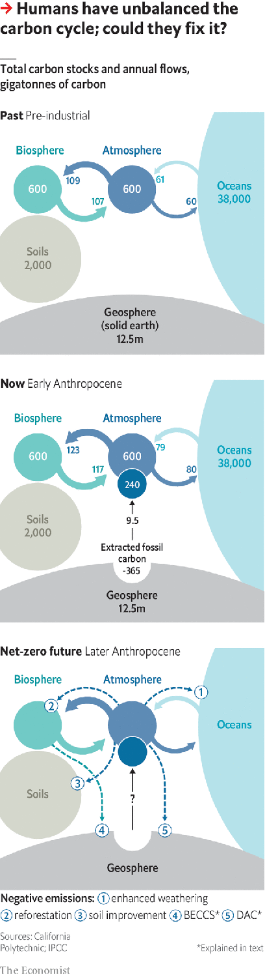

But respiration has a counterpart: photosynthesis, through which plants, algae and some bacteria use sunlight to turn inorganic carbon back into organic molecules. These new molecules are the raw material from which almost all living things on Earth are made; the sunlight stored within them is the source of all the energy that is released through respiration when those living things are eaten.

The other great flow of carbon dioxide into the atmosphere is similarly balanced. Carbon dioxide dissolved in seawater naturally diffuses into the air above. Carbon dioxide in the atmosphere dissolves into seawater. Left to themselves, the two flows balance (see diagram).

These flows create a system in what is called dynamic equilibrium; if you push it away from current conditions, it pulls itself back. If atmospheric carbon-dioxide levels go up, the rate at which carbon dioxide dissolves into the “sinks” provided by the oceans and plants will also, all things being equal, go up. This reduces the surplus, restoring the status quo. Until the 19th century this dynamic equilibrium had kept atmospheric carbon-dioxide levels pretty stable for most of the 10,000 years since the end of the most recent ice age.

The plants-and-food branch of the carbon cycle, though, is not quite perfect. Like the little bit left in the corner of the sardine can that you can’t get out, not all the organic matter made through photosynthesis gets used by creatures that respire. Some ends up buried in sediments instead.

The amount of carbon which leaks out of the biosphere this way is tiny compared with the flow returned to the atmosphere. But the leak has gone unstopped for a very long time, and that has allowed the Earth’s crust to build up a significant store of organic matter. Now human industry’s use of the most concentrated and readily available deposits of these fossil fuels has returned to the carbon cycle in a couple of centuries a fair fraction of what was stashed away over hundreds of millions of years. It is the addition of this new source with no new sink that has knocked the cycle out of whack.

The world’s seas and plants have tried their best to keep things in equilibrium, responding to rising levels of carbon dioxide by stashing more away in the biosphere and oceans. They suck up roughly half of all the extra carbon dioxide that industry puts into the atmosphere. But that is as much as they can do. And so the amount in the atmosphere grows.

This intensification of the carbon cycle has side-effects. Plants fed with extra carbon dioxide tend to grow more, if circumstances allow. Current estimates suggest the global rate of photosynthesis is 3-7% higher than it was 30 years ago; satellite images show the Earth is getting greener. Such “carbon-dioxide fertilisation” has improved the yields of some crops, and the growth of some forests and other ecosystems. This is not enough to compensate for the damage climate change does to agriculture by higher temperatures and altered rainfall. But, on balance, it is hard to see it as much of a problem.

The same cannot be said of the increased flow into the ocean sink. More dissolved carbon dioxide makes seawater more acidic. How bad this acidification will prove is open to debate. But the process will probably be very damaging to some ecosystems, including reefs already stressed by rising temperatures. Even if fossil-fuel use were not warming the climate, this acidification would in itself count as a frightening global change.

The growth of the two carbon sinks is also, left to itself, unsustainable. Warm water absorbs less carbon dioxide than cold water. So as the oceans warm their ability to offset emissions weakens. As to the land sink, higher temperatures speed up microbial respiration, especially in soils, more reliably than higher carbon-dioxide levels speed up photosynthesis.

The Paris agreement of 2015 calls for increases to the atmosphere’s carbon-dioxide level caused by fossil fuels to end by the second half of this century. Even if that deadline is not met, some mixture of policy, catastrophe and/or resource depletion will eventually bring the rise to an end. The flows of carbon between the atmosphere, oceans and biosphere will then come back into balance.

But the equilibrium thus restored will not be the pre-industrial one. The carbon-dioxide level will settle down not far short of whatever the 21st century’s peak level turns out to be. Which means that temperatures will stay high, too—with all that entails for crops, ice caps and the like.

This plateau will eventually subside. The erosion of the Earth’s crust exposes silicate minerals that react with carbon dioxide, eventually producing solid carbonate minerals from which the carbon cannot readily escape. But this “chemical weathering” works on a much longer timescale than the sinks. Geochemists think it would take 1,000 years for a post-fossil-fuel carbon-dioxide level of around 550 parts per million to be brought back below today’s 415ppm towards a mid-20th century level of 315ppm.

## Going backwards

What, though, if the Anthropocene transitioned from a past dominated by anthropogenic carbon sources to a future characterised by anthropogenic sinks? There are two reasons why this might be appealing. One is that some fossil-fuel emissions may be very hard to eliminate from the economy. If they could be counterbalanced by “negative emissions” that take carbon dioxide out of the atmosphere at a similar rate, the Paris goal of stopping any further increase to the carbon-dioxide level would be far easier to meet.

The second attraction of the idea stems from the other Paris goal, that of keeping the global temperature increase, compared to pre-industrial times, well below 2°C. Doing this simply by reducing emissions would require much steeper cuts than any seen to date, and they would have to continue for decades. If the world developed negative-emission technologies, more gentle emissions cuts in the near future could be made up for by negative emissions later on, which would bring the carbon-dioxide level back down from its excessive peak.

Some forms of negative emission look fairly benign: farming in ways that make the soil richer in organic carbon; restoring degraded forests and planting new ones. More ambitious is the idea of harnessing photosynthesis to industry; growing plantation crops, burning them to generate electricity and sequestering the carbon dioxide given off underground, rather than letting it out into the atmosphere, an approach called bioenergy with carbon capture and storage, or BECCS.

Then there is the idea of stripping carbon dioxide out of the atmosphere with renewably powered open-air chemical engineering: “direct air capture”, or DAC. And there is also the possibility of helping along the chemical weathering process by grinding up silicate rocks into fine dusts, thus speeding up the reactions that store carbon dioxide away in stable minerals.

There are two big problems with these ideas. One is the scale at which they need to operate to make a difference. Imagine that in 2060 the world had, through a vast effort, renounced 90% of its fossil-fuel use. To offset the remaining recalcitrant 10% would still require a sink capable of soaking up about 1bn tonnes of carbon a year. The industrial systems for taking carbon dioxide from the air currently on the drawing board operate at barely a thousandth of that scale. Creating such a flow through photosynthesis would require a plantation about the size of Mexico.

This leads to the second problem. Imaginary backstops are dangerous. If countries build negative emissions into their thinking, they will cut emissions more slowly on the basis that any overshoot can be mopped up later. But they will not necessarily undertake the huge efforts required to make those negative emissions a reality. The Anthropocene fact that humans are now integral to the processes of the planet does not mean that they can change those processes without great effort—let alone just through wishful thinking. ■

Sign up to our fortnightly climate-change newsletter [here](https://www.economist.com/theclimateissue/)

Dig deeper:Climate brief 1: [Why tackling global warming is a challenge without precedent](https://www.economist.com/schools-brief/2020/04/23/why-tackling-global-warming-is-a-challenge-without-precedent)Climate brief 2: [How modelling articulates the science of climate change](https://www.economist.com/schools-brief/2020/05/02/how-modelling-articulates-the-science-of-climate-change)The Economist’s climate-change hub

This article was downloaded by calibre from <https://www.economist.com/schools-brief/2020/05/09/humanitys-immense-impact-on-earths-climate-and-carbon-cycle>

|  |  |  |  |
| --- | --- | --- | --- |
|  | Articles | Sections | Next |

|  |  |  |
| --- | --- | --- |
| Schools brief | Sections | Books & arts |

Science & technology

How covid-19 is changing science: Reaping from the whirlwind

.

Covid-19’s many faces: The body snatcher

.

Treating covid-19: Hope rears its head

.

Road safety: Touchy drivers

.

Crewed space flight: A new Moon race

.

|  |  |  |
| --- | --- | --- |
| Schools brief | Sections | Books & arts |

|  |  |  |  |
| --- | --- | --- | --- |
|  | Articles | Sections | Next |

#### Covid-19

# Scientific research on the coronavirus is being released in a torrent

Will that change how science is published?

May 7th 2020 |

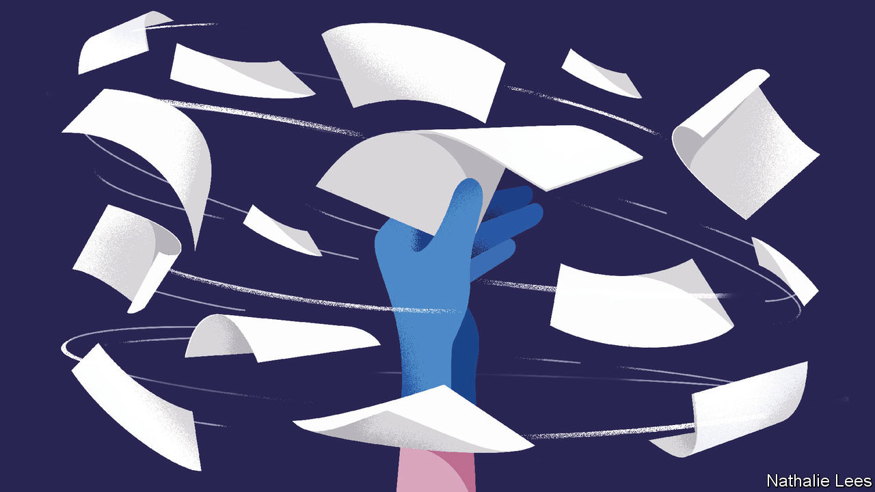

Editor’s note: The Economist is making some of its most important coverage of the covid-19 pandemic freely available to readers of The Economist Today, our daily newsletter. To receive it, register [here](https://www.economist.com/newslettersignup). For our coronavirus tracker and more coverage, see our [hub](https://www.economist.com/coronavirus)

EXPONENTIAL INCREASES are a hallmark of pandemics. The spread of SARS-CoV-2 around the world has followed such a curve inexorably. But so, too, has the research effort to understand and control the virus. More than 7,000 papers on the pandemic—covering everything from virology to epidemiology—have appeared in the past three months (see chart). A fifth of them have come out in the past week alone.

This is astonishingly fast. Researchers usually take years to design experiments, collect data and check results. Scientific journals, the self-appointed keepers of the gate between those researchers and the rest of the world, can easily take six months, often a year, to grind through the various steps of their procedure, including editing and the process of checking by anonymous outside experts, known as peer review.

The current public-health emergency has, however, turbocharged all this. With physicians, policymakers and prime ministers all needing the latest science in order to make immediate life-and-death decisions, speed has become paramount. Journals have responded to sharp rises in submissions by working overtime. In so doing they have squeezed their normal processes down to days or weeks.

## Getting a move on

In the view of many, though, this is not enough. These people support a different way of disseminating scientific information—one that dethrones the journals by making journal publication an optional extra rather than a researcher’s primary goal. This model of scientific publishing relies on online repositories called preprint servers, on which papers can be posted swiftly and with only minimal formalities. Mathematicians and physicists already use them widely. Biologists increasingly do so too. Covid-19, however, has seen a step-change. Around half of the available scientific work on the pandemic has been released through preprint servers. The hope of preprinting’s supporters is that this will make the shift to using them irreversible.

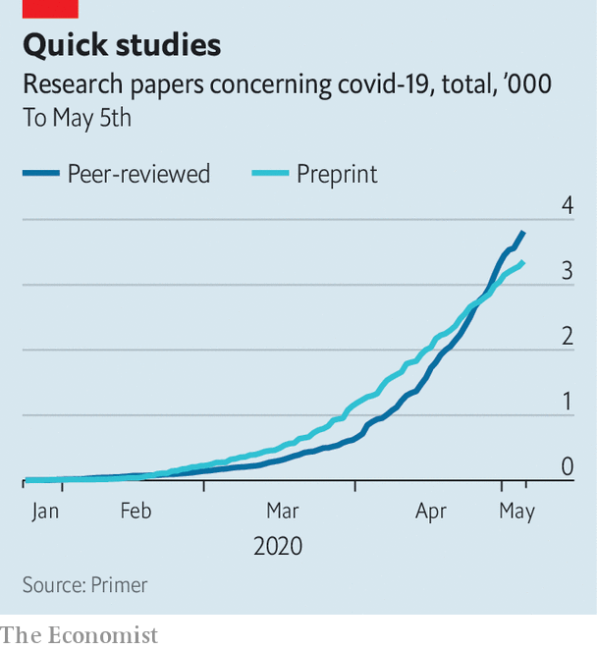

Speed is good during a public-health emergency. The genome of SARS-CoV-2 was published by Chinese scientists on a public genome-data repository, a beast similar to a preprint server, just days after the virus was isolated. This permitted the rapid creation of tests to detect infections in people with suspicious symptoms. And the seriousness with which many parts of the world treated the new virus was aided by early reports which suggested that the fatality rates of the cases they looked at were much higher than those seen in influenza.

This increased speed shows that scientists have learned from their sluggish responses to previous outbreaks. In an analysis of research carried out during and after the Ebola outbreak of 2014-16 and the Zika outbreak of 2015-16, Marc Lipsitch, an epidemiologist at Harvard now working on covid-19, looked at just how sluggish those responses were. He found that, where preprints had been available, they appeared around 100 days before journal articles that had eventually been published on the same work. Unfortunately, less than 5% of all the journal articles published about the two outbreaks had been preprinted.

Dr Lipsitch recommended that preprints form a bigger part of a faster information “ecosystem” during future emergencies. And his wish, it appears, has been granted. The two biggest relevant preprint servers for covid-19 are bioRxiv, set up in 2013, and medRxiv, launched in 2019, both of which are run by Cold Spring Harbor Laboratory in New York state. (The “x” in the names represents the Greek letter “chi”, making them pronounceable as “bioarchive” and “medarchive”.)

BioRXiv is for general biological and related sciences. MedRxiv is focused on health and medicine. As The Economist went to press the two servers featured, between them, 2,853 articles about SARS-CoV-2 or covid-19. Another 789 had been posted on arXiv—at 29 years of age, the granddaddy of preprint servers—which belongs to Cornell University and specialises in maths and physical sciences.

Anyone can submit a manuscript to one of these servers and see it made available to the world within hours. Submissions are given a cursory check, to weed out opinion pieces and to ensure that they have the parts expected of a scientific paper—an abstract and sections describing methods and results. If the topic is controversial, the checkers may flag up outlandish claims. But beyond this they do not attempt to review the scientific contents of the paper. Once a preprint is online, anyone with access to the internet can read it and, if they so wish, leave detailed comments.

## Fast and loose?

This process—essentially a free-for-all version of peer review—can be brutal. But it often works. Conspiracy theories about SARS-CoV-2 being an artificial, laboratory creation were fuelled by a preprint posted to bioRXiv in January, by Indian scientists. This claimed “uncanny” similarities between the genetic sequences of SARS-CoV-2 and HIV, the cause of AIDS. The study was torn apart as soon as it appeared, though, by other researchers who weighed in and pointed out serious methodological flaws. As a consequence, the manuscript has now been withdrawn.

This incident does, however, highlight a repeated criticism of preprint posting, which is that dodgy material may be misused, either accidentally or deliberately, by overzealous patients, politicians, journalists or just plain troublemakers. It is certainly a risk. But in the opinion of many, that risk does not outweigh the advantage of the free and fast flow of information between researchers that preprints provide.

For those who question the quality of science contained in preprints, there is reassurance in a recent study by researchers in Brazil (itself posted as a preprint), in which the authors used a questionnaire to score the quality of preprints on bioRxiv, and also the subsequent peer-reviewed-journal versions of these papers. They found that the journal papers were indeed of higher quality. But the difference was, on average, only 5%.

In any case, peer review as organised by journals is not perfect. It will neither pick up all errors nor weed out all bad research. The distracting focus on hydroxychloroquine as a potential covid-19 treatment was, for example, partly stimulated by a peer-reviewed paper in the International Journal of Antimicrobial Agents that was published on March 20th by French scientists. That paper now has question-marks over its rigour and reliability.

Moreover, even when a peer-reviewed paper is withdrawn, the damage may already have been done. On March 9th the South China Morning Post, an English-language newspaper in Hong Kong, published an article about research reported in Practical Preventive Medicine, a peer-reviewed journal, with a headline that read “coronavirus can travel twice as far as official safe distance”. This article has been shared more than 53,000 times on social media. Unfortunately, the study in question was retracted the day after the newspaper article was published. The Post reported the retraction immediately, but that report was shared less than 1,000 times.

The current pandemic highlights further limitations of the way peer review is typically organised. It works well when confined within a narrow group of specialists, but runs into problems when different fields rub up against each other. As Ivan Oransky, a founder of Retraction Watch, which catalogues bad practice in scientific research, observes, “if you were to do a study of the impact of social distancing, for example, and you only asked public health researchers to review that, there’s a reasonable chance that you would almost exclude or at least certainly not emphasise the economic disruption. Whereas if you only ask economists to look at it, you would almost certainly de-emphasise the health risks.”

Conventional journals might struggle to analyse the wide range of trade-offs from different angles in a situation like this. Preprints, says Dr Oransky, permit experts of different stripes to contribute, publicly and in parallel, to a wide-ranging criticism of a piece of research.

As Stuart Taylor, publishing director of the Royal Society, Britain’s top scientific academy, observes, moves towards more open science, preprints and faster dissemination of results were under way before the covid-19 pandemic. But these events will heighten those changes and probably make them permanent. Scholarly communication seems to be at an inflection point. Like many other things until recently taken for granted, it may never return to the way it was before SARS-CoV-2 came along.■

Dig deeper:  
For our latest coverage of the covid-19 pandemic, register for The Economist Today, our daily [newsletter](https://www.economist.com/newslettersignup), or visit our [coronavirus tracker and story hub](https://www.economist.com/coronavirus)

This article was downloaded by calibre from <https://www.economist.com/science-and-technology/2020/05/07/scientific-research-on-the-coronavirus-is-being-released-in-a-torrent>

|  |  |  |  |
| --- | --- | --- | --- |
|  | Articles | Sections | Next |

|  |  |  |  |
| --- | --- | --- | --- |
| Previous | Articles | Sections | Next |

#### Virology

# Covid-19 has many faces

Why does the virus have such varied manifestations?

May 9th 2020 |

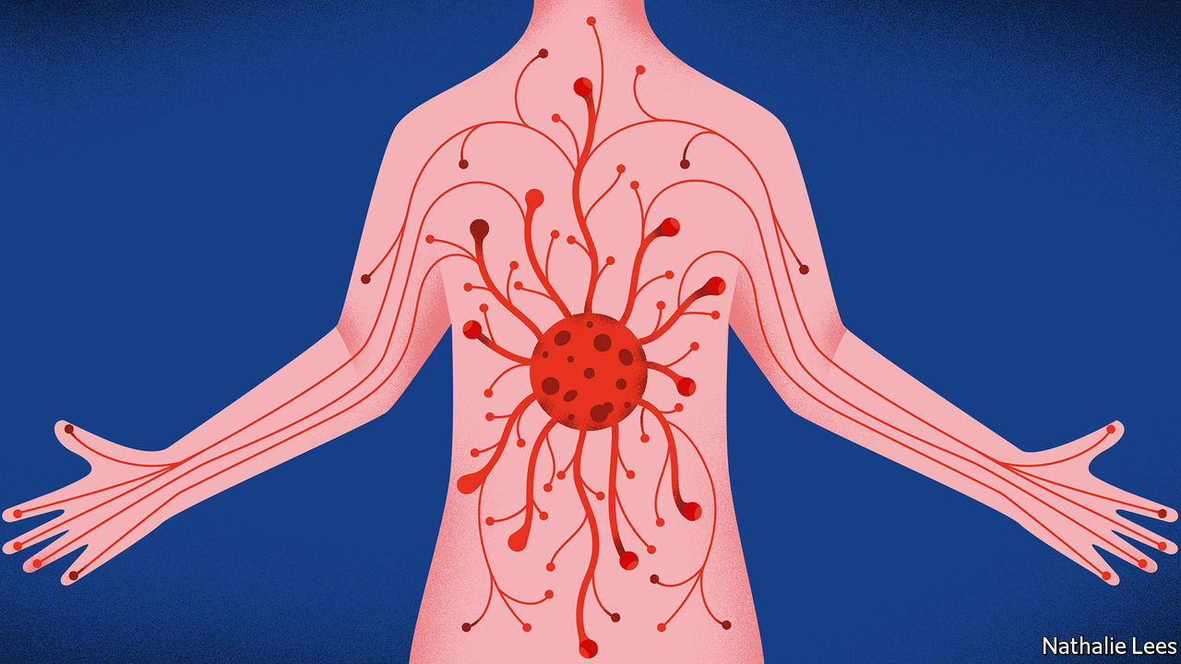

Editor’s note: The Economist is making some of its most important coverage of the covid-19 pandemic freely available to readers of The Economist Today, our daily newsletter. To receive it, register [here](https://www.economist.com/newslettersignup). For our coronavirus tracker and more coverage, see our [hub](https://www.economist.com/coronavirus)

ACCORDING TO England’s National Health Service the signs that someone has contracted the novel coronavirus SARS-CoV-2 are a high temperature or a new, continuous cough. This is certainly true for a majority of patients, but it is not so for a sizeable minority. Papers published in recent weeks present the new virus as having many faces. This is in stark contrast to the way in which influenza, another primarily respiratory disease, behaves—and it makes SARS-CoV-2 all the more dangerous. It also raises the question of why this virus’s symptoms are so protean.

For decades, influenza has been referred to as “an unvarying disease caused by a varying virus” because of its tendency to mutate every year and yet still cause the same symptoms of rapid-onset fever, malaise, headaches and coughing. Indeed, a review of influenza papers published in 2018 by John Paget of the Netherlands Institute for Health Services Research, showed that even when all of the different influenza types (A or B) and subtypes (H1N1, H3N2, etc) were analysed, there were few differences in the ways they presented clinically. Literature on SARS-CoV-2 suggests, by contrast, that this virus is a master of disguise.

For example, Anthony DeBenedet, a doctor at St Joseph Mercy Health System in Michigan, reports in the American Journal of Gastroenterology that in early March, following a trip down the Nile, a 71-year-old woman arrived at his emergency department with bloody diarrhoea. She suffered with this condition for five days, while also experiencing abdominal pains and nausea. But her temperature was normal and her breathing good, so covid-19 was not suspected. Yet when he and his colleagues examined samples of her stools for signs of the sorts of bacterial infections that are likely to be picked up in Egypt, they found none. They also saw no beneficial effects from the antibiotics they were administering. They therefore started to wonder whether something else might be going on. It was only on the fourth day of the woman’s stay at the hospital, her ninth day of illness, when she developed a cough, that they tested her for SARS-CoV-2 and confirmed the virus’s presence in both her nasal tissues and her stools.

Dr DeBenedet’s findings are far from unique. Patients brought into hospital with all the symptoms of a heart attack have later been found to be suffering from cardiac inflammation caused by the virus. It has also demonstrated that it can begin as a kidney infection, or even as meningitis, before sometimes going on to cause its characteristic respiratory problems.

## Variations on a theme

Precisely why SARS-CoV-2 manifests itself in so many ways while all of the various strands of influenza present the same symptoms is not clear. But there are several theories. One proposed by Stanley Perlman, an immunologist at the University of Iowa, is that in actual fact, nothing odd is really going on. The novel virus’s many faces are being noticed merely because it is a new disease and dangerous, and so is being studied intensely. He postulates that if influenza were looked at with equal intensity, it might also be shown to manifest in other ways—as a mild winter stomach infection, for example.

An idea suggested by William James, a virologist at the University of Oxford, is that the two-phase activity of SARS-CoV-2, whereby it starts in the upper respiratory tract and then migrates deep into the lungs, is the critical factor that allows it to travel around the body. “Influenza rarely gets deep into the lungs,” he says. “This new virus gets down there all the time.” Since the lungs are designed to move gases in and out of the bloodstream (their highly vascularised airs sacs have a collective surface area of about 50 square metres), viruses find it easy to make a similar journey.

Dr Perlman agrees that this notion may be correct, but points out that the only way to be sure is to take samples from places other than the respiratory tract, in people suffering from early stages of the infection, to see if virus migration depends on getting to the lungs first. As for why the disease sometimes makes its initial appearance in the digestive system, as it did in Dr DeBenedet’s patient, this is probably because ACE2, the cell-surface protein that SARS-CoV-2 binds to, is abundant in the gut as well as the lungs. How the virus gets through the highly acidic stomach unharmed is unknown. But clearly it can, and does.

ACE2 is also found in the kidneys and the heart, which may help explain why symptoms manifest there, as well. By contrast, the entry molecules preferred by influenza viruses are almost exclusive to the upper respiratory tract. Knowing all this may make identification of the early stages of covid-19 easier, and thus help to ease the plight of future cases like that of Dr DeBenedet’s patient.■

Dig deeper:  
For our latest coverage of the covid-19 pandemic, register for The Economist Today, our daily [newsletter](https://www.economist.com/newslettersignup), or visit our [coronavirus tracker and story hub](https://www.economist.com/coronavirus)

This article was downloaded by calibre from <https://www.economist.com/science-and-technology/2020/05/09/covid-19-has-many-faces>

|  |  |  |  |
| --- | --- | --- | --- |
| Previous | Articles | Sections | Next |

|  |  |  |  |
| --- | --- | --- | --- |
| Previous | Articles | Sections | Next |

#### Treating covid-19

# Two potential therapies for covid-19 have some effect

Hope rears its head, but more information is needed

May 9th 2020 |

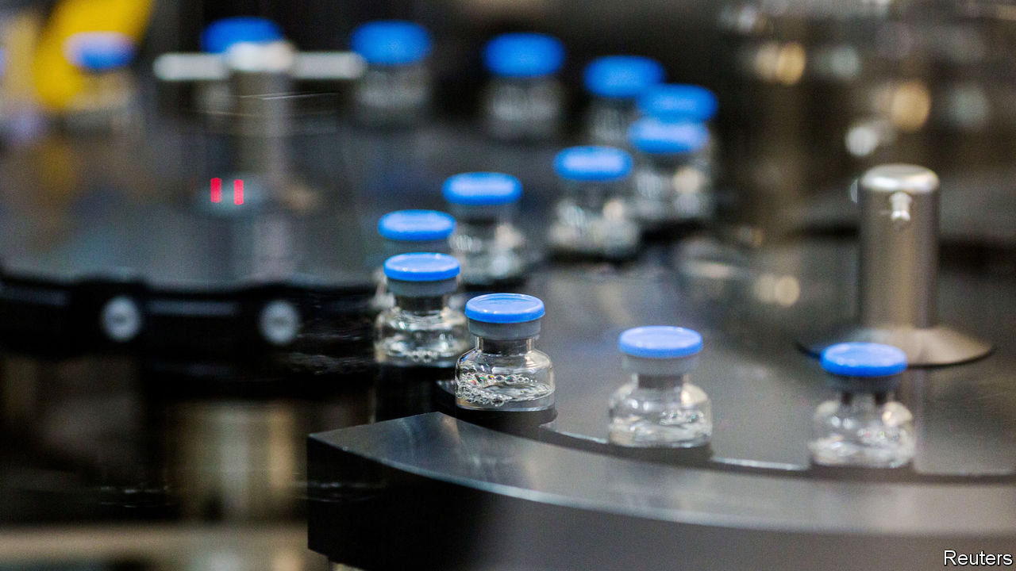

Editor’s note: The Economist is making some of its most important coverage of the covid-19 pandemic freely available to readers of The Economist Today, our daily newsletter. To receive it, register [here](https://www.economist.com/newslettersignup). For our coronavirus tracker and more coverage, see our [hub](https://www.economist.com/coronavirus)

WHEN COVID-19 began its march across the world, so did a desperate hunt for a treatment. Not only would finding one save lives, knowing it was available would also allow countries to relax the lockdowns that are strangling economies everywhere. Attention has focused especially on whether existing drugs—the safety of which is already known from human trials—might be repurposed for the job.

Particular attention has been paid to remdesivir. This is an antiviral agent developed by Gilead, a Californian firm. It was originally intended to treat Ebola, but was sidelined when found to be less effective than alternatives. On April 29th America’s National Institute of Allergy and Infectious Diseases, which has been running trials of it, said preliminary data showed that it worked. On May 1st the country’s Food and Drug Administration permitted its emergency use.

Remdesivir is a nucleotide analogue. In other words, its structure mimics one of the chemical letters of the virus’s genetic code. The ill-fitting chemical letter gums up the virus’s replication mechanism. Remdesivir’s effect was not dramatic—it improved patients’ recovery time from 15 days to 11, and there was no statistically significant difference in death rates between treated and untreated patients—but it was real. A four-day reduction in stay-length will reduce the burden the disease imposes on hospitals.

Full data from the trial have not yet been published, something which makes those not involved in it nervous. Some doctors think that the drug will need to be given early, when a patient’s viral load is rising, to have the greatest effect. Also, outsiders cannot currently analyse the different groups of patients involved, to make sure that those who did not receive treatment were well matched with those that did. If, for example, those in the treatment group were healthier than those who were left untreated as a control, that would make the drug look more effective than it actually is.

Remdesivir is a beginning. Its eventual value, though, is likely to be as an arm of a combination therapy. Other drugs which might form part of such a therapy include further antivirals, and also anti-inflammatory medicines.

One possible anti-inflammatory treatment is tocilizumab, sold by Roche as Actemra and currently prescribed for arthritis. Many of those most seriously affected by covid-19 are killed by an overreaction of their immune system, called a cytokine storm, that leads to massive inflammation of the lungs and consequent respiratory failure. Cytokines are signalling molecules. Several varieties of them are secreted by the immune system in order to regulate itself. A storm occurs when uncontrolled levels of cytokines are released. Actemra blocks the cellular receptors for a cytokine called interleukin-6.

A recent trial of Actemra on 129 covid-19 patients who had developed pneumonia showed that it reduced deaths in the worst-affected. The big challenge with anti-inflammatory treatments is knowing when to give them. Applied too soon, they will reduce the immune response that is needed to tame the virus. For that, doctors will need to look carefully at the data from the Actemra trial. These, though, have not yet been published either. ■

Dig deeper:  
For our latest coverage of the covid-19 pandemic, register for The Economist Today, our daily [newsletter](https://www.economist.com/newslettersignup), or visit our [coronavirus tracker and story hub](https://www.economist.com/coronavirus)

This article was downloaded by calibre from <https://www.economist.com/science-and-technology/2020/05/09/two-potential-therapies-for-covid-19-have-some-effect>

|  |  |  |  |
| --- | --- | --- | --- |
| Previous | Articles | Sections | Next |

|  |  |  |  |
| --- | --- | --- | --- |
| Previous | Articles | Sections | Next |

#### Road safety

# Motorists using touchscreens in cars are being distracted

Voice recognition is much safer

May 9th 2020 |

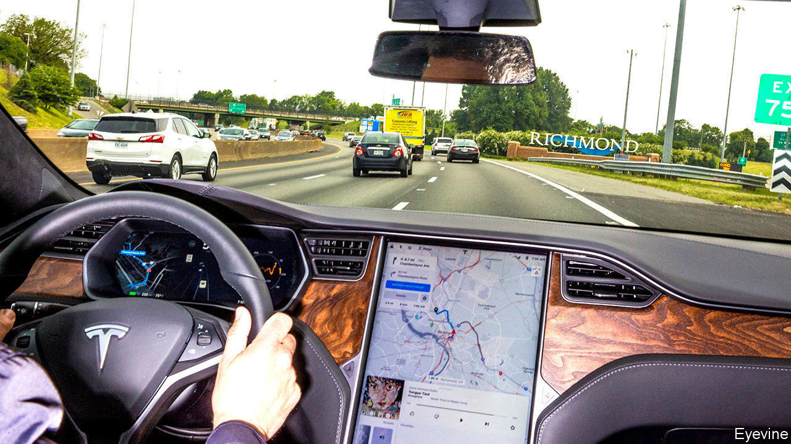

STEP INSIDE most modern cars and instead of all the dials and switches that used to clutter the dashboard you are likely to find it dominated by a touchscreen. Often there is more than one screen, and some are bigger than those on a laptop. But, though touchscreens provide a convenient way to operate a multitude of controls and settings, the latest research shows they can also be dangerous distractions.

To discover how badly touchscreens distract drivers, Neale Kinnear and his colleagues at the Transport Research Laboratory, a former British-government agency now run as an independent test facility, arranged a series of experiments. They recruited two groups of 20 drivers. One consisted of regular users of Google’s Android Auto, a popular “infotainment” app which lets drivers interact with their phone through a car’s touchscreen. The others were partisans of Android Auto’s main rival, Apple CarPlay.

Each participant completed three 15 minute journeys along a set virtual route using the laboratory’s sophisticated driving simulator. On one of these trips they had to carry out tasks using only the touchscreen. These tasks included navigating to a restaurant, playing a particular song on Spotify (a music service), changing radio channels, getting the system to read out a text message, and making a “hands-free” telephone call. On the second trip they had to do the same, but using only the car’s voice-activated controls instead. The third journey was a control, with no assigned tasks.

Whenever a red bar flashed on the windscreen the researchers measured how long it took a driver to react by pulling the indicator stalk to flash the car’s lights. As they expected, drivers using touch controls on the screen took longer to respond to the flashing bar than did those using voice controls. Though the difference might be less than a second, at motorway speeds this would result in an increased stopping distance of up to 25 metres.

Dr Kinnear was, however, surprised by the amount of time drivers’ attention was diverted by the series of glances needed to operate the screen. Among the worst outcomes were a mean of 20 seconds of cumulative glances using Android Auto to play a song on Spotify, and of 16 seconds to set up the route to a restaurant with CarPlay. For voice commands those means fell to four and three seconds respectively.

The researchers calculated that reaction times to the red bar when the touchscreen was being employed were more than 50% longer than standard for some tasks. This was worse than the 46% impairment found in a previous simulator study looking at the effects of using a hand-held mobile phone while driving, which is banned in many countries.

Dr Kinnear and his colleagues have urged vehicle-safety bodies to impose standards that limit the use of overly distracting tasks on a car’s touchscreen. At present there are only voluntary guidelines. America’s National Highway Traffic Safety Administration, for instance, says touchscreen tasks should be completed in glances of two seconds or less, with a cumulative time of no more than 12 seconds.

The researchers believe voice-activation is a safer alternative that should be encouraged, though the software needs to be improved. Andy Peart of Artificial Solutions, a Swedish firm developing AI-assisted voice recognition, agrees. One problem is that spoken commands often have multiple intent. “Ask to turn the temperature up and play Ed Sheeran, and the system can’t cope,” he adds.

The migration of vehicle controls to touchscreens has also led to complaints about the machines’ rather than the drivers’ reaction times being too slow, and requiring a confusing number of steps, to boot. In April, after examining the touchscreens in new vehicles, What Car?, a British motoring magazine, reported that adjusting the heater fan can take twice as long when using a touchscreen rather than a physical button, and that selecting a new radio station takes eight times longer.

Carmakers are developing screens that are easier to operate and positioning them more in line with a driver’s view of the road. Haptic feedback, which adds physical, tactile responses, is also coming. This might, for example, detect a moving finger and produce a clicking sound and a slight vibration when a virtual button on the screen is felt and pressed. Old-school motorists may, however, still prefer their cars to come with real knobs on.■

This article was downloaded by calibre from <https://www.economist.com/science-and-technology/2020/05/09/motorists-using-touchscreens-in-cars-are-being-distracted>

|  |  |  |  |
| --- | --- | --- | --- |
| Previous | Articles | Sections | Next |

|  |  |  |  |
| --- | --- | --- | --- |
| Previous | Articles | Sections | Next |

#### Crewed space flight

# Another step towards returning people to Earth’s satellite

A new Moon race has begun

May 9th 2020 |

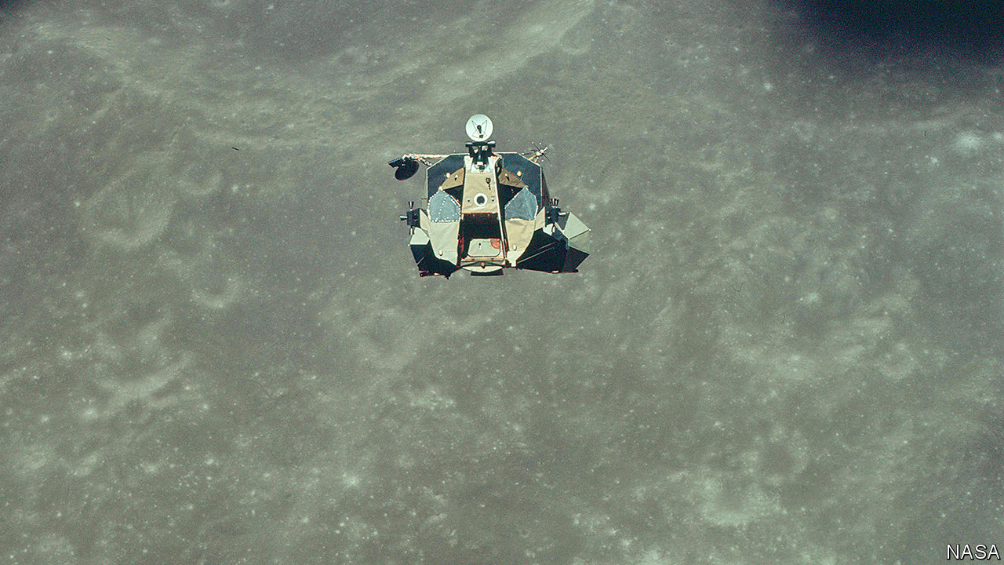

THE NEXT ten months will see a new race to the Moon played out on Earth, as three groups vie to construct a successor to the Lunar Excursion Module (LEM) which took the astronauts of the Apollo project there half a century ago.

The contestants, announced by NASA on April 30th, are SpaceX, run by Elon Musk, a high-profile billionaire, and two consortia. One is led by Blue Origin, run by Jeff Bezos, similarly profiled to Mr Musk and laden with even more billions, and the other by a not-at-all-high-profile outfit called Dynetics, a subsidiary of Leidos, an American technology firm.

The LEM’s landings were hit-and-run affairs. The longest spent three days on the lunar regolith. The LEM itself had a descent stage, with four spindly legs, that also acted as a platform for the ascent stage (pictured), which took its crew of two back to the mother ship.

This time around the plan is for larger crews and longer stays. The candidates are thus bigger than the LEM. The most LEM-like in concept, though, is Blue Origin’s. It has separate descent and ascent stages. But it has two of the latter—one to low lunar orbit, the other thence to a rendezvous with the craft that will take the astronauts home. It would be carried to the Moon either by Blue Origin’s proposed New Glenn launch rocket, or on Vulcan, a launcher planned by a consortium, the United Launch Alliance, of Lockheed Martin and Boeing.

SpaceX and Dynetics each have designs that land and take off intact. But they differ in how they will get to the Moon. Dynetics’ will launch on Vulcan. SpaceX’s lander is a version of its proposed Starship design that will do so on the firm’s planned Super Heavy rocket.

Conspicuous by its absence from the list is Boeing. Its offer of a LEM-like system of descent and ascent stages did not make the cut. The others have until next February to firm up their designs.

This article was downloaded by calibre from <https://www.economist.com/science-and-technology/2020/05/09/another-step-towards-returning-people-to-earths-satellite>

|  |  |  |  |
| --- | --- | --- | --- |
| Previous | Articles | Sections | Next |

|  |  |  |
| --- | --- | --- |
| Science & ... | Sections | Economic & ... |

Books & arts

Cinema in America: After the intermission

.

John Maynard Keynes: Alive in the long run

.

Historical fiction: A kind of freedom

.

The Troubles: Ghost town

.

The hereafter: A place on Earth

.

Home Entertainment: The comforts of suburbia

.

Home Entertainment: Bake your way through the lockdown

.

|  |  |  |
| --- | --- | --- |
| Science & ... | Sections | Economic & ... |

|  |  |  |  |
| --- | --- | --- | --- |
|  | Articles | Sections | Next |

#### After the intermission

# When cinemas reopen they will not be the same

Covid-19’s legacy will be fewer theatres, showing bigger blockbusters

May 9th 2020 |



THE LIGHTS are off in many Florida businesses. But after dark, the glow of the Ocala Drive-In’s 90-foot screen can be seen from a quarter of a mile down the highway. With half the parking spaces in its seven-acre plot fenced off to allow for social distancing, the Ocala has room for 240 vehicles—and it is full every night. “We’re the only thing going right now,” says John Watzke, the owner. Families sit out in deckchairs or perch beneath open tailgates to see a double-bill of “Trolls World Tour” and “Back to the Future” for $6 per adult (under-fives and pets go free). Mr Watzke decided to stay open because of his experience of Hurricane Katrina in 2005, when “anything that brought a few minutes of normal lifestyle to us was appreciated.”

For most of America’s nearly 6,000 cinemas, life is far from normal. All but a handful have been shut since March. And although some states have begun to ease the lockdown, it will be months before theatres raise their curtains. A quarter of Americans say they won’t go back to the movies until at least the autumn, so studios are holding their films. No releases are planned for the July 4th weekend, normally a coveted slot. The next big-budget premiere, “Tenet”, an action flick from Warner Bros, is tentatively down for July 17th.

That may be longer than some cinemas can wait. Already indebted after years of investing in reclining seats and the like, they face four months without revenue, followed by only a slow return to business as usual. The world’s largest chain, AMC, which has around 1,000 theatres, the bulk of them in America, last month borrowed an emergency $500m, which ought to tide it over until November. But this will bring its total debt to nearly ten times gross operating profit, according to Moody’s, a rating agency. Restructuring looks likely. Cineworld, the second-largest chain, said in March that it would be at risk of bankruptcy if forced to close for more than three months. The stock prices of both firms have plunged since the start of the year.

## Show-stopper

America already has 1,600 fewer cinemas than at the turn of the century. Back then the average American went to the movies five times a year; last year it was three and a half. As more theatres close or cut costs and the virus lingers, the couch will become more tempting still.

So Hollywood studios are exploring alternatives. Although it hit screens on April 10th, amid the pandemic, “Trolls World Tour” has been seen well beyond the Ocala, since Universal Pictures decided to put the animation online on the same day. At $20 for a 48-hour download, it took $95m in America in its first three weeks, the Wall Street Journal reported. That is less than the $125m the previous “Trolls” movie made at the box office in the same period. But Universal could keep about 80% of download revenues rather than giving almost half to theatres. The studio hailed the experiment as a success and said it would do more simultaneous releases in future.

Cinema bosses are naturally horrified by this breaking of the 90-day window in which films are normally shown exclusively on the big screen; AMC says it will no longer show any Universal films, adding with a suitably theatrical flourish that this is “not some hollow or ill-considered threat”. Cineworld says it too will boycott films that break the window. But Universal is not the only studio going online. Warner has arranged a digital-only release for “Scoob!”, which was due in theatres on May 15th. Paramount has sold “The Lovebirds” to Netflix. Even Disney, which does better at the box office than any other studio, has decided to put “Artemis Fowl” on its Disney+ streaming service, skipping the cinema.

These decisions were all provoked by the pandemic. But studios were already under pressure to provide content for the streaming services launched by their parent companies. When Netflix is commissioning hits and putting them online immediately, Disney cannot serve up a diet of months-old films. Hence features like its remake of “Robin Hood”, which in the past might have got an outing at the cinema, are going straight to Disney+. This year’s Oscars will admit streaming-only films, in what the Academy insists is a covid-induced one-off. But last year’s best-picture nominations included two Netflix films—“The Irishman” and “Marriage Story”—that had minimal theatre runs.

It isn’t yet time for the credits to roll for the cinema. This year’s biggest titles, from James Bond to Wonder Woman, have been postponed rather than put online. Universal itself has delayed the latest in its “Fast and Furious” series until next April. Given that previous “Furious” films have taken as much as $1.2bn at the worldwide box office, it cannot afford to miss a theatre run.

But increasingly, cinematic releases make sense only for the biggest blockbusters. Studios have realised that betting heavily on a few expensive “tentpoles” brings in more money than placing lots of smaller stakes. Blockbusters’ marketing costs are proportionally lower than those of middling movies, and shelling out for globally famous stars makes it easier to sell a film internationally. With cinema attendance in decline in America, titles must sparkle to be one of the few that people bother going to see. And so ever-greater rewards are accruing to the biggest hits. Last year the five highest-grossing films took a quarter of the domestic box-office, nearly double the top five’s share in 2000.

Critics complain that the emphasis on “event movies” is making studios tediously conservative about what they green-light. All of America’s ten most successful films last year were part of a series, like “Avengers: Endgame”, or remakes, like “The Lion King”. That was the case for only two of the top ten in 2000. And what Hollywood produces, the rest of the world watches: last year’s global top ten was almost identical to America’s. In truth, studios won’t stop making lower-budget features; apart from anything else, they need to try out new actors and new ideas (it wasn’t always obvious that comic-book adaptations would be money-spinners). But increasingly, the tiddlers will go straight to streaming.

All this is only a continuation of television’s century-long siphoning of content away from the cinema. Movie theatres were once the home of all types of video. From the 1950s TV nabbed news, cartoons and serials, leaving cinemas with only feature films. Now streaming is sucking up many of those too, so that the theatre is a place to visit just for event movies. Something is being lost: an evening at home with Netflix isn’t quite the same as a night at the Ocala, reflects Mr Watzke. People may enjoy a film just as much on TV. But “if they see it at the drive-in, it’s a memory.” ■

This article was downloaded by calibre from <https://www.economist.com/books-and-arts/2020/05/09/when-cinemas-reopen-they-will-not-be-the-same>

|  |  |  |  |
| --- | --- | --- | --- |
|  | Articles | Sections | Next |

|  |  |  |  |
| --- | --- | --- | --- |
| Previous | Articles | Sections | Next |

#### Alive in the long run

# The enduring legacy of John Maynard Keynes

It is easy to forget how often his advice was ignored during his lifetime

May 9th 2020 |

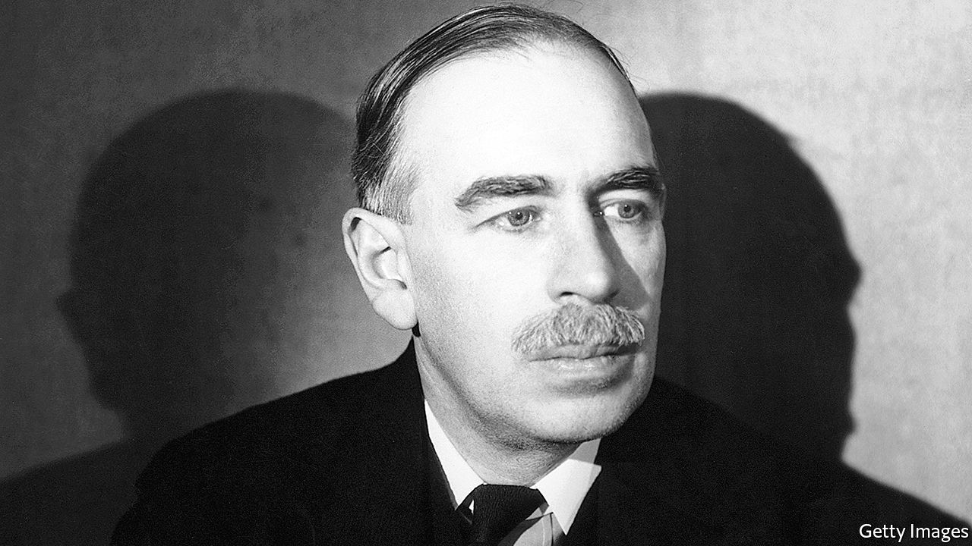

The Price of Peace. By Zachary Carter.Random House; 656 pages; $35 and £25.

ANY BIOGRAPHER of John Maynard Keynes must labour in the shadow of Robert Skidelsky’s magisterial three volumes about the great economist. Zachary Carter, a journalist at the Huffington Post, has tackled the problem in an ingenious way, by focusing on the development of Keynes’s ideas and how they fared after his death in 1946. The result is an entertaining summary of 20th-century economic history that will appeal to the general reader.

The key to Keynes, Mr Carter shows, is to place him in his time and class—a well-heeled British intellectual who moved effortlessly between the worlds of academia, government and the arts. Born in 1883, he grew up at a time when the British Empire was at its peak, which, for people like Keynes, was an age of peace and prosperity.

The idyll was destroyed by the first world war and, in part, Keynes’s life was a bid to restore the better parts of that lost world. He first made his name by raging against the terms of the Versailles peace treaty; his economic views were shaped by the experience of Britain in the 1920s, which was marked by deflation and high unemployment. Then came the Great Depression, which seemed to show the folly of the classical view of an economy as a machine which, if left to its own devices, would return to equilibrium.

For Keynes, this was a call to action. He perceived “the real struggle” to be between liberalism, in which the primary objectives of government were peace, freedom of trade and economic wealth, and a militarist school “which thinks in terms of power, prestige, national or personal glory, the imposition of a culture and hereditary or racial prejudice”. In a sense, he wanted to save capitalism from itself. Mr Carter sees Keynes’s career as an attempt “to make the practical risk-averse anti-revolutionary conservatism of Burke fit the radical democratic ideals advanced by Rousseau”.

Given Keynes’s standing today, it is easy to forget how often his advice was ignored during his lifetime. In spite of his opposition, Britain’s Conservatives restored the gold standard in 1925. He backed Lloyd George’s Liberals in the election of 1929, just as the party was descending into irrelevance. While some elements of Franklin Roosevelt’s new deal were Keynesian, the president regarded the economist as an indecipherable mystic. And at the Bretton Woods conference of 1944 many of Keynes’s plans for the post-war economic order were overruled by the Americans.

His greatest influence was exerted after his death, as the economics profession overwhelmingly adopted his ideas in the three decades after the war. As Mr Carter says: “Keynesianism took on a life of its own Keynes himself could scarcely have predicted.” His legacy was affected by the style of his intellect and writing, which had been honed in Cambridge common rooms and Bloomsbury salons; he expressed his ideas more in arresting bons mots than in mathematical equations. Partly as a consequence, his magnum opus, “The General Theory of Employment, Interest and Money”, is a confusing read. Keynes recommended that governments should manage aggregate demand or purchasing power, but did not say precisely how they should do so. He enshrined full employment as the main measure of success but did not define the term.

Instead, Keynesianism was defined by his colleagues, such as Joan Robinson and John Hicks, and intellectuals like J.K. Galbraith. That philosophy was in turn attacked in the 1960s and 1970s by Milton Friedman, Friedrich Hayek and others, who argued that Keynesianism had resulted in government playing too big a role in the economy and a chronic tendency towards inflation. Ronald Reagan and Margaret Thatcher presided over a big shift away from the use of fiscal policy to manage the economic cycle, with monetary policy taking the strain.

Mr Carter is dismissive of these anti-Keynesian reactions. Still, you have to wonder whether Keynes, who relied on his investment income to fund his lifestyle, would have been enthusiastic about the economic policies of the mid-1970s, which in Britain yielded a top rate of income tax of 83% and inflation of over 25%.

For a while, as the profession moved away from his ideas, it looked as if Keynes might become one of the “defunct economists” he once quipped about. But the 21st century has restored his reputation. In 2009, in response to the financial crisis, G20 governments agreed on the kind of co-ordinated fiscal stimulus that Keynes would surely have recommended. The pandemic has led to yet another round of government action to stave off depression. Meanwhile, increasing use of automation has revived interest in Keynes’s thoughts about a shortened working week, which he expounded in “Economic Possibilities For Our Grandchildren”. The world will be debating, and learning from, the work of Keynes for many decades to come. ■

This article was downloaded by calibre from <https://www.economist.com/books-and-arts/2020/05/09/the-enduring-legacy-of-john-maynard-keynes>

|  |  |  |  |
| --- | --- | --- | --- |
| Previous | Articles | Sections | Next |

|  |  |  |  |
| --- | --- | --- | --- |
| Previous | Articles | Sections | Next |

#### A kind of freedom

# “Conjure Women” is a tale of slavery and its aftermath

Afia Atakora’s debut novel evokes a haunting period in American history

May 9th 2020 |

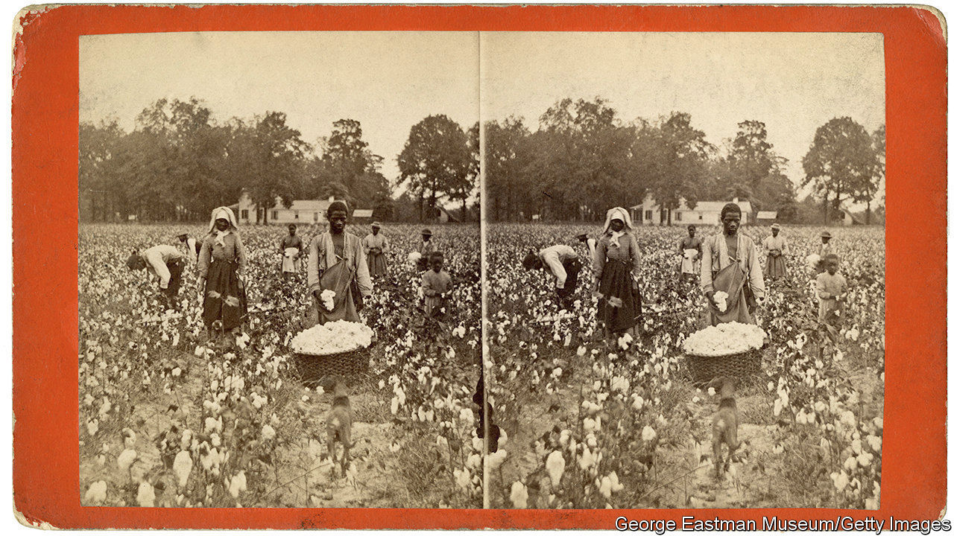

Conjure Women. By Afia Atakora. Random House; 416 pages; $27. Fourth Estate; £14.99.

RUE KNEW she was a liar. When she was enslaved, and then during her first years of freedom, she often said, falsely, “I know.” As a child, she only pretended to understand why her mother’s love felt so fierce and unforgiving. Years later, as her plantation’s resident healer, she was not sure why so many babies fell ill, or why women felt certain pains in childbirth, but she assured people otherwise. Rue saw that healing demanded faith and that she had to seem confident to get others to believe in her power. Her magic “ought to be absolute…or it wasn’t magic at all”.

“Conjure Women”, Afia Atakora’s atmospheric debut novel, is largely Rue’s story. Born into slavery in America’s South, she tends to the plantation’s pregnant and sick in the years after the civil war. Her mother, May Belle, made her name and living crafting curses for fellow slaves. “Hoodoo”, May Belle would say, “is black folks’ currency.” From her, Rue learned to heal, but she is wary of witchcraft—and troubled by a shameful secret. When an illness claims the lives of local children, grieving parents accuse her of devilry. Meanwhile, Bruh Abel, a handsome itinerant minister with “a too-wide grin on his face”, arrives peddling salvation to a community too nervous about reprisals to feel truly free.

The book opens in the 1860s (“Freedomtime”), when Rue is around 20, but it skips back and forth before and after the war. By juxtaposing the brutality of slavery with the uncertainty of freedom, Ms Atakora captures the disorientation of the era. After Rue’s first whipping, her father reassures her that her cuts will “harden so’s the next time and the next time they beat you it won’t hurt quite so bad.” A few years later, he will be lynched by a white mob, “his dangling toes making circles in the dirt as his body spun on the rope”. Naturally, Rue and her fellow former slaves remain wary of breaking “the white man’s nonsense rules”. She “had never seen that thing the Yankees were promising—freedom—and she did not trust in what she could not see.”

Ms Atakora poetically evokes the anxious, cloistered life of newly emancipated slaves. She notes “the aroma the earth made when it sighed”, and the stale air in the bedroom of the master’s daughter, which “smelled of rosehip and burning hair and sweat”. Repetitious as it sometimes feels, her novel is a vivid portrait of a time in American history that remains both haunting and unresolved. ■

This article was downloaded by calibre from <https://www.economist.com/books-and-arts/2020/05/09/conjure-women-is-a-tale-of-slavery-and-its-aftermath>

|  |  |  |  |
| --- | --- | --- | --- |
| Previous | Articles | Sections | Next |

|  |  |  |  |
| --- | --- | --- | --- |
| Previous | Articles | Sections | Next |

#### Ghost town

# Darran Anderson’s granular memoir of the Troubles

“We are only sheltered from tragedy”, he writes in “Inventory”, “by the thin ice that we call time.”

May 9th 2020 |

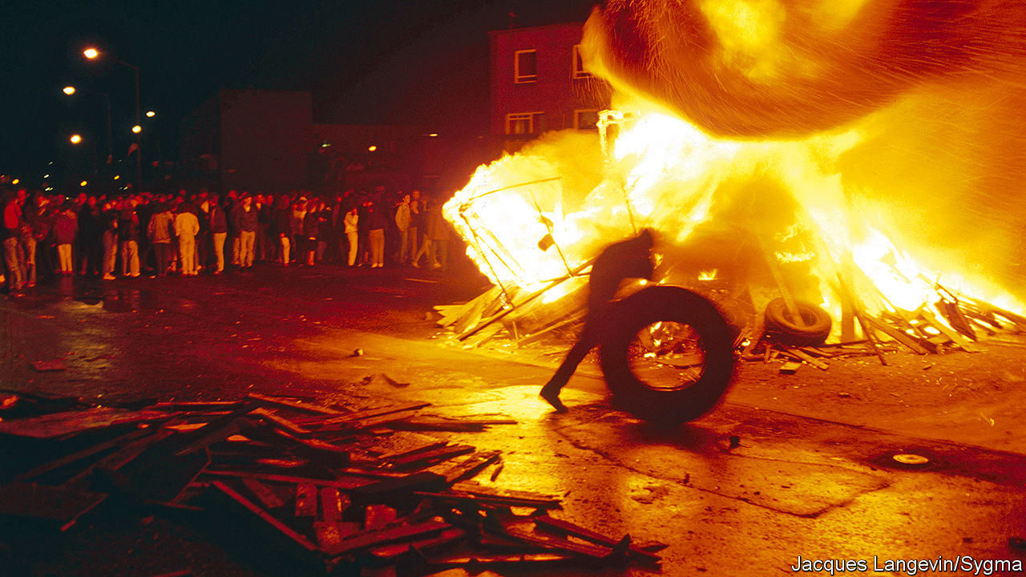

Inventory. By Darran Anderson.Chatto & Windus; 416 pages; £16.99. To be published in America by Farrar, Straus and Giroux in August; $27.

THE TITLE of Darran Anderson’s new book comes from Georges Perec, an experimental French writer of the mid-20th century. Perec urged other authors to describe—to inventorise—the streets and objects around them. Mr Anderson follows this advice rigorously, rendering a finely textured account of his upbringing in a city that Catholics called Derry and many Protestants knew as Londonderry. In the 1980s and 1990s, amid the fear and violence of the Troubles, every detail was telling.

The telephone, for example, was more than an everyday communication device. It was used by paramilitaries to issue warnings of bombings or to claim responsibility for attacks and murders. As Mr Anderson puts it, it was a means to “give ideological justification for why a child might no longer have a parent or a parent might no longer have a child”.

His own (Catholic) family were stalwarts of the city. His grandfather was a smuggler who knew every sandbank and cove of the Foyle, a river that runs through Derry-Londonderry and along the Irish border. His father was a gravedigger and gardener, who in his youth had been caught up in the Troubles and imprisoned, though he never spoke of the experience with his son. But the sectarian strife, and the bigotry that fed it, stretched into the author’s childhood, and scarred it.

The daily news was a roster of violent death. The residents of the city, mostly innocent civilians, were killed frequently and in diverse ways. Some murders were banal: you could be shot carrying your supper from the fish-and-chip shop. Others were fiendish: victims were kidnapped, then beaten and killed in pubs to entertain mobs. The presence of the army and paramilitary outfits made adolescence hazardous. Prowling around derelict buildings in a teenage posse was risky, given the proximity of trigger-happy adults. The paramilitaries’ assumption of policing duties meant Mr Anderson and his friends risked death or disability for standard youthful excesses such as throwing noisy parties.

None of this was very long ago, but—two decades after the Good Friday Agreement ended the violence—it now feels remote in history. Here are lives lived under extreme stress in a divided community, where everyone was marked by poverty, superstition and bloodshed. The book is an admirable feat of recreation that yanks the past back into clear focus—and, as Brexit calls into question the border arrangements that are part of the peace deal, a timely warning. As Mr Anderson says, “we are only sheltered from tragedy and brutality by the thin ice that we call time.”

This article was downloaded by calibre from <https://www.economist.com/books-and-arts/2020/05/09/darran-andersons-granular-memoir-of-the-troubles>

|  |  |  |  |
| --- | --- | --- | --- |
| Previous | Articles | Sections | Next |

|  |  |  |  |
| --- | --- | --- | --- |
| Previous | Articles | Sections | Next |

#### A place on Earth

# The ideas of celestial bliss and fiery damnation are powerful ones

But Jesus himself never spoke of heaven and hell, explains Bart Ehrman

May 9th 2020 |

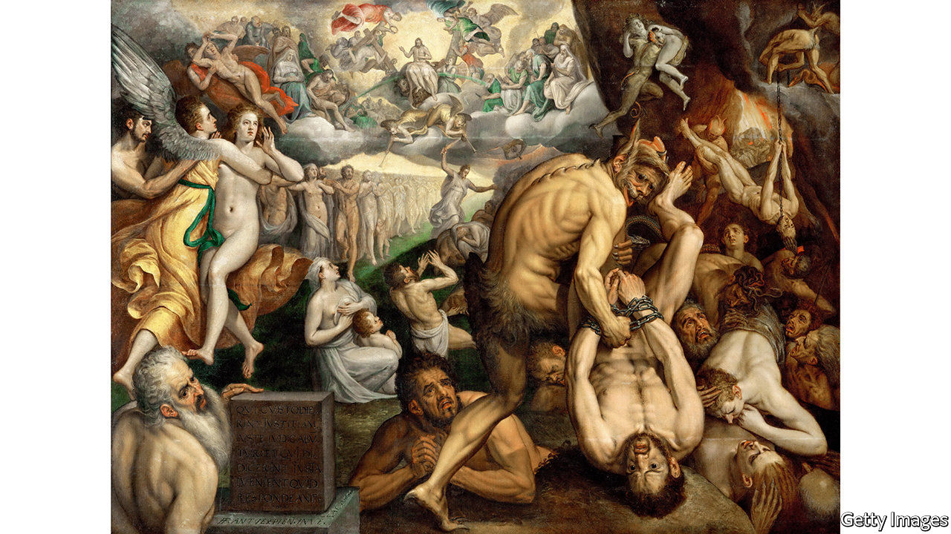

Heaven and Hell: A History of the Afterlife. By Bart Ehrman.Simon & Schuster; 352 pages; $28. Oneworld; £20.

WHERE WOULD Christianity be without heaven and hell? Where, for that matter, would art and culture be, without Dante’s “Divine Comedy”, Milton’s “Paradise Lost”, Michelangelo’s “Last Judgment” or Verdi’s “Dies Irae”? For centuries the moral suasion of death, judgment, heaven and hell has underpinned much of Western civilisation. And hard as modern theologians may argue that heaven and hell are just states of mind, experienced here on Earth as much as anywhere else, even now furious devils and shining angels lurk stubbornly in people’s brains. Some 72% of Americans believe in an actual heaven, and 58% in an actual hell.

Hell has always had the more exciting press: fornicators hung by their hair or their genitals, simoniacs buried in sink-holes upside down, despairing gluttons shrieking for a single drop of water, continuous rains of hot coals. Heaven, by contrast, can seem dull and over-decorated with beryl and crystal, with round after round of feasting broken only by sessions of praise. But Bart Ehrman of the University of North Carolina, Chapel Hill, is not concerned with how these imagined places developed their visitor offerings over time. In this unexpectedly entertaining book he sets out to explore how they took hold in Christianity at all.

The fact is that the Old Testament does not mention them, and Jesus himself never spoke of them. Countless priests and bishops have taught that he did; but, says Mr Ehrman, they have all got it wrong. The outer darkness where there is weeping and gnashing of teeth, or the fire into which the tares are cast, are not hell but Gehenna (the word Jesus used), a desecrated ravine and tip outside Jerusalem where rubbish smouldered until it was entirely consumed. Gehenna was simply the grave or the pit, like the Hebrew Sheol; it was death itself, annihilation.

And its opposite was not heaven, as far as Jesus taught: it was the coming of the Kingdom of God on Earth, in which those who did good, and believed in him, would be saved to live and flourish. Resurrection, in so far as he mentioned it, was not individual but general, just as God had promised to raise up the whole nation of Israel after its wanderings; and it was not to be in the same old bodies but in glorified ones, as spirits or angels might appear.

In Mark, the earliest canonical gospel, these teachings are quite clear. Gradually, especially in Luke and John (both written several decades after Jesus’s crucifixion), other ideas crept in. Luke’s story of the good thief, who is told by Jesus on the cross that “This day you will be with me in paradise”, introduces the idea of instant individual resurrection. The incident in Luke 24, where Jesus appears to his disciples after the resurrection and eats broiled fish with them, suggests that he has been raised bodily and hungrily from the dead. Luke’s tale of Dives and Lazarus, rich man and poor, and their different posthumous fates—Dives desperate with thirst, Lazarus cosy in the bosom of Abraham—puts heaven firmly above and hell below, a topography for the ages, when all Jesus had taught was the triumph of a glorious future over the sins of the past.

## Above us only sky

Luke, however, was not writing in a vacuum. Ideas about the nature of the afterlife had been evolving and intermingling for centuries, perhaps millennia; for nothing is more comforting to humans than to think that death is not the end, and that their individually conscious existence will somehow carry on. The dead in many cultures were buried with grave-goods—food and weapons, harps and drinking cups—in case they needed them in the next world. But the details and description of this next world were often vague. The most famous of them, the Greco-Roman Hades, was a dim place of flitting, fretful shades, still recognisable (as Virgil’s Aeneas recognised his father), but fugitive as sand. And this was their condition for eternity; there was no coming back.

Yet a perception of unfairness was creeping in. Surely, after death, not all should be treated alike. Indeed, already some were not. In Hades those who had offended the gods were given special treatment: Tantalus eternally tormented by delicious food he could not reach, Sisyphus doomed to push a boulder eternally uphill. Meanwhile, the great and good were somewhere else entirely, the restful Elysian Fields, where Socrates in Plato’s “Phaedo” imagined he might meet old friends for delightful conversation.

Jesus’s teachings of the wheat and the tares, the sheep and the goats, even God and Satan, could be taken to imply something similar: a sorting out and judgment that would lead to distinctly separate eternities in distinctly separate realms. (Since the Kingdom had not after all appeared on Earth, it was probably confined to heaven.) And this distortion of Jesus’s teaching was evidently useful. The thought of heaven encouraged listeners across the Roman Empire to convert, spread the faith and become martyrs in the firm trust of joyful reward; and for centuries afterwards the thought of hell instilled sufficient fear in ordinary folk to make them behave better, more or less.

Many redoubtable volumes have been written about all this, but Mr Ehrman, who already has more than two dozen books on early Christianity under his belt, merrily blows the dust off the subject. A paragraph on hell breezily concludes “You don’t want to go there,” and one on heaven “Let the good times roll.” One quibble is that he omits the influence of ancient Egyptian beliefs about the afterlife, which also involved judgment, expiation and redemption, and which influenced Greece through Orphic and Eleusinian teachings. Another is that he repeats and recapitulates much more than seems necessary—perhaps anticipating readers who believe in the literal truth of the Bible, and may need gentle but insistent persuading.

They should take comfort in the knowledge that the coming of the Kingdom on Earth is something, at least, that Jesus did teach. As for Mr Ehrman, he is looking forward to the alternative afterlife that Socrates also imagined: after a full life happily lived, a good long unbroken sleep. ■

This article was downloaded by calibre from <https://www.economist.com/books-and-arts/2020/05/09/the-ideas-of-celestial-bliss-and-fiery-damnation-are-powerful-ones>

|  |  |  |  |
| --- | --- | --- | --- |
| Previous | Articles | Sections | Next |

|  |  |  |  |
| --- | --- | --- | --- |
| Previous | Articles | Sections | Next |

#### God and the grid

# “Holy Land” and the comforts of suburbia

A classic account makes clear that many people are happy to lead constrained lives

May 9th 2020 |

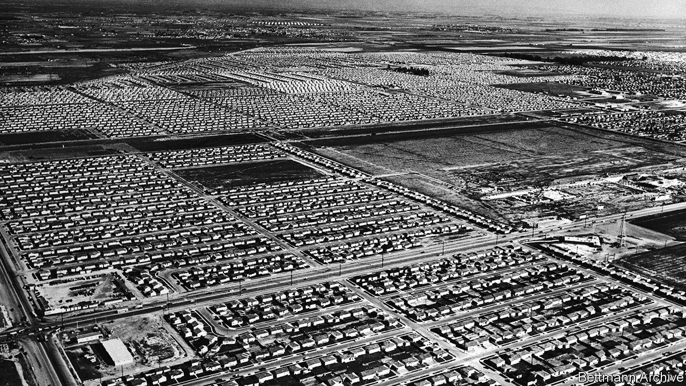

HE LIVES WHERE most Americans live—in suburbia. His house sits on a plot that is 50 feet wide and 100 feet deep. In front is a pavement, four feet wide, then a strip of green containing a tree, seven feet, then a road, 40 feet. His neighbours’ houses look much the same. At six per acre, homes are close enough for arguments to be overheard, but only if you pay attention. They are close enough for comfort.

The suburb is Lakewood, south of Los Angeles. It was built during and after the second world war and was at first occupied mostly by white manual workers. Although the developers were Jewish, Jews were initially barred from living there, as were blacks. Among the early settlers were the parents of D.J. Waldie. He became a city official, and in 1996 published “Holy Land”, a short, delightful book about the place. It is a reminder that many people are happy to lead constrained lives, even if they are free to move.

Earlier defences of America’s suburbs, such as Herbert Gans’s “The Levittowners”, argued that they were more diverse and sociable than their critics alleged. Mr Waldie does not quite agree. His childhood, with its packed swimming pools and freewheeling Monopoly games, was sociable. Adulthood is less so. Few people walk the streets; each house is an island, visited occasionally by friends and family, who come and go in cars. “The critics of suburbs say that you and I live narrow lives,” he writes. “I agree.”

The form of the suburb encourages conformity and repetition. Most streets adhere to a grid, running north-south and east-west, which is linked to a grid that extends across southern California and indeed much of America. Navigation is straightforward. The ambulance that carries Mr Waldie and his dead father to the hospital turns left out of his road, then left onto a boulevard, then right. Those who live there do not find this stifling. “The grid limited our choices, exactly as urban planners said it would. But the limits weren’t paralysing.”

Yet, as in many locked-down homes, the impression of quiet and order is surface deep. The community relies on deep aquifers, but the rocks could also transmit terrible seismic shocks to the surface. During the second world war the nearby aircraft factory was disguised to look like a suburb: had the enemy bombers come, Lakewood could have been accidentally wiped out. The buyer of one house discovers that the previous owner had excavated a large air-raid shelter underneath his garage.

Above all, residents feel the presence of God. The developers boasted of Lakewood’s many churches, and funded a synagogue after the ban on Jews was lifted. Mr Waldie’s father, who had briefly joined a religious order, knows the Catholic liturgy so well that he teaches newly ordained priests. As a boy, Mr Waldie carried the crucifix in his church on Good Friday, wiping lipstick off Jesus’s feet. In the book of Revelation, the city of God is perfectly square. ■

This article was downloaded by calibre from <https://www.economist.com/books-and-arts/2020/05/09/holy-land-and-the-comforts-of-suburbia>

|  |  |  |  |
| --- | --- | --- | --- |
| Previous | Articles | Sections | Next |

|  |  |  |  |
| --- | --- | --- | --- |
| Previous | Articles | Sections | Next |

#### Home Entertainment

# Why and how to bake your way through the lockdown

Sourdough starters are today’s pockets full of posies: charms against the surrounding pestilence

May 5th 2020 |

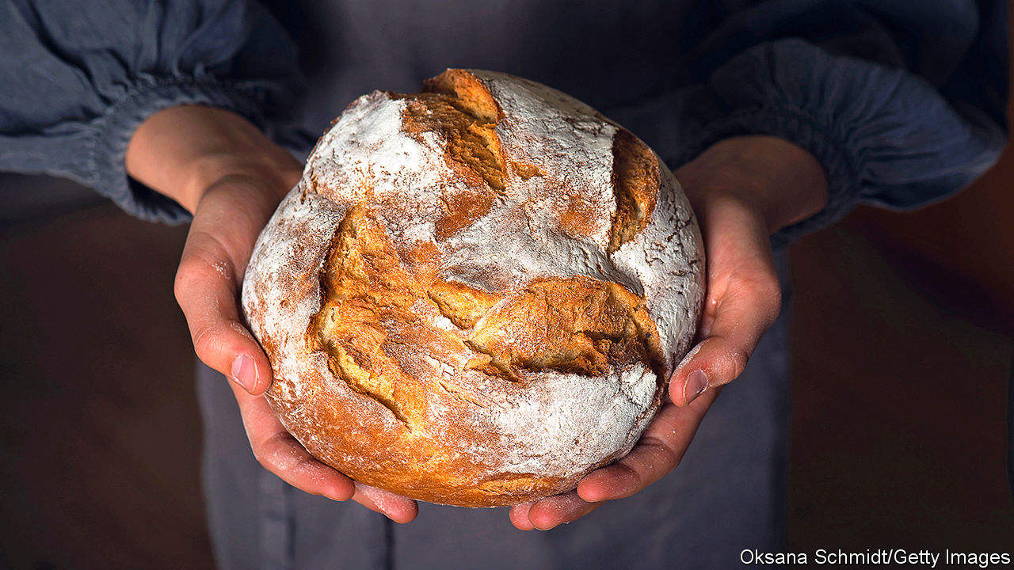

Editor’s note: The Economist is making some of its most important coverage of the covid-19 pandemic freely available to readers of The Economist Today, our daily newsletter. To receive it, register [here](https://www.economist.com/newslettersignup). For our coronavirus tracker and more coverage, see our [hub](https://www.economist.com/coronavirus)

DISSERTATIONS WILL doubtless soon be written on supermarket shortages during the pandemic. First disinfectant disappeared, then loo roll, frozen foods, pasta and rice. And then people came for the flour and yeast. There are no atheists in foxholes; there are, apparently, no carb-phobes in a lockdown.

Unable to publicise their ski slopes and cruises, show-offs have instead posted snaps of burnished brioche, perfectly whorled pain de campagne and glistening pastries. Pride in seeing a loaf nurtured from a handful of grist emerge from the oven is understandable—and eating one is a soul-filling pleasure, the culinary equivalent of a grandmother’s hug. But just as holiday pictures fail to capture the real highlights of time off (noodling around without a deadline), the true joy of baking lies as much in the process and experimentation as in the finished article.

Be warned: novices are unlikely to produce anything to rival a high-street bakery. But that is not the point. Weekend runners do not hang up their trainers because they will never compete with Mo Farah. Home-brewers may never outdo the pints pulled at their local pub, but rumour has it that some find the effort enjoyable. And you will not fail entirely, or not for long.

More than other culinary arts, baking has an element of magic. A glistening croquembouche suspended in its golden cage, a tiered wedding cake gilded with fondant flowers, ethereal multicoloured macarons—all can seem as if they have sprung from a fairy tale. Yet with trial, error and time, anyone can make them. And the wonder and grace of baking, as in so much else, often lie in the simple things. A Poilâne-style miche, made from high-extraction winter-wheat flour and two days’ labour, is a work of art and craft; but, when made with love, so is chapati (flour, water and salt, rolled thin and blasted on a stovetop).

Take, for example, sourdough—bread with a malty, complex, acidic flavour—the baking craze of the pandemic. Flour and water stirred and fed for a few days with more flour and water will produce a teeming, bubbling, leavening slurry. This is the starter, a prosaic name for a galaxy of wild yeast and attendant bacteria which, when combined with more of the same ingredients, left to rise and baked, results in sourdough. Starters are today’s pockets full of posies: charms against the surrounding pestilence.

Sourdough starter is an expression of place and individuality. The precise combination of yeast and bacteria varies with location, so sourdough bread made in one city will taste different from another’s. So too will loaves made by two people chatting in the same kitchen, because those bakers will have different microbiotic flora on their hands and in their mouths.

With proper care and feeding, starters can last indefinitely, subtly changing over time as the bakers themselves must. To create a starter, then, is to encourage and nurture life—a noble mission, especially in a virus-stricken age. ■

Dig deeper:  
For our latest coverage of the covid-19 pandemic, register for The Economist Today, our daily [newsletter](https://www.economist.com/newslettersignup), or visit our [coronavirus tracker and story hub](https://www.economist.com/coronavirus)

This article was downloaded by calibre from <https://www.economist.com/books-and-arts/2020/05/05/why-and-how-to-bake-your-way-through-the-lockdown>

|  |  |  |  |
| --- | --- | --- | --- |
| Previous | Articles | Sections | Next |

|  |  |  |
| --- | --- | --- |
| Books & arts | Sections | Graphic detail |

Economic & financial indicators

Economic data, commodities and markets

.

|  |  |  |
| --- | --- | --- |
| Books & arts | Sections | Graphic detail |

|  |  |  |  |
| --- | --- | --- | --- |
|  | Articles | Sections | Next |

# Economic data, commodities and markets

May 9th 2020 |

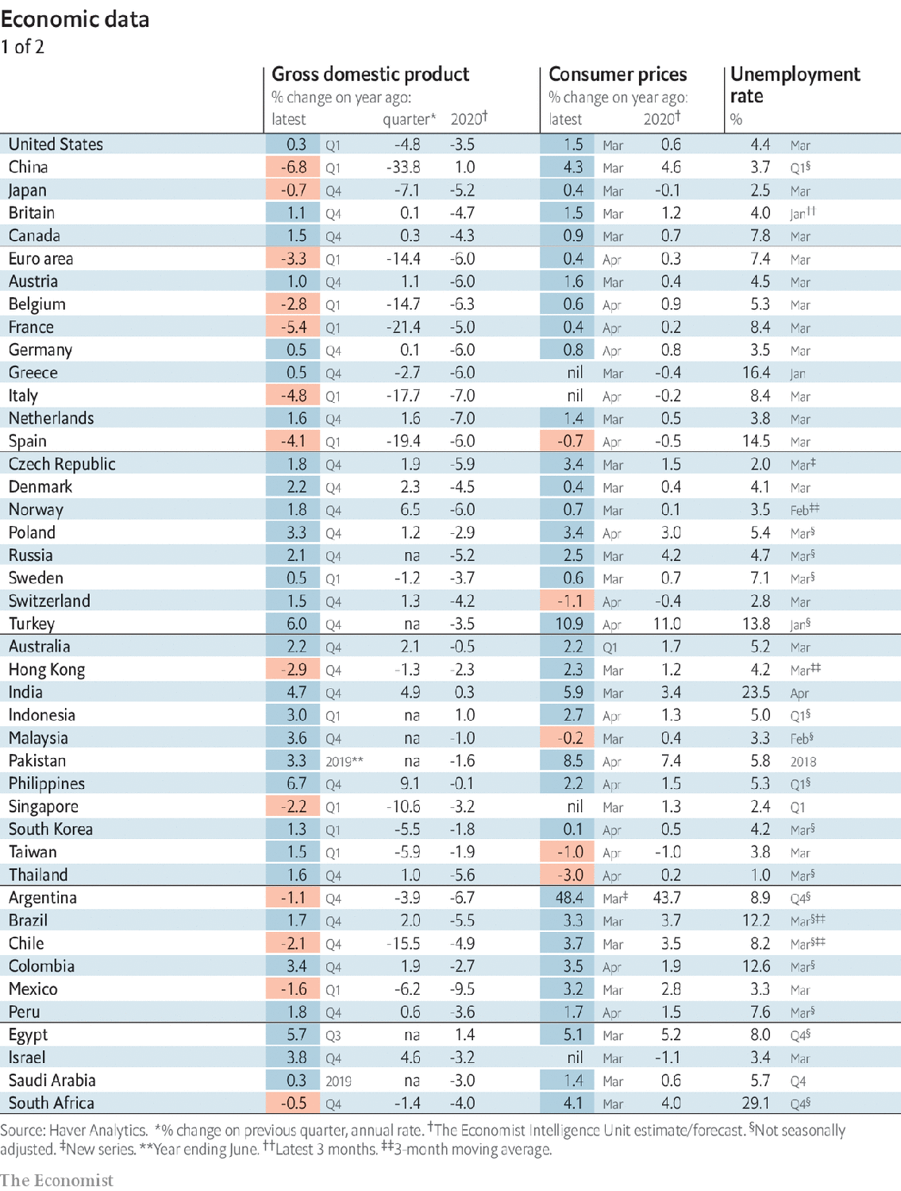

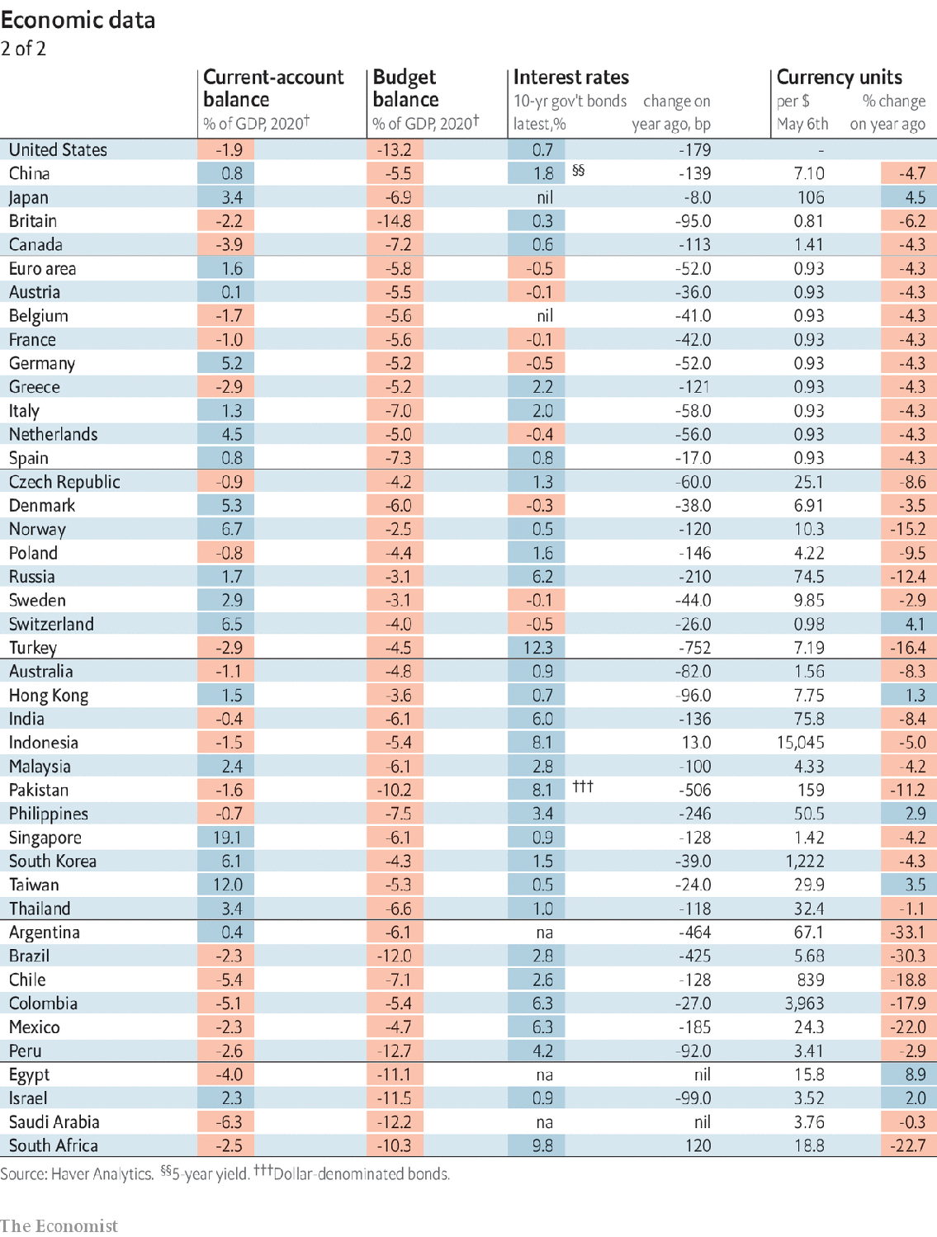

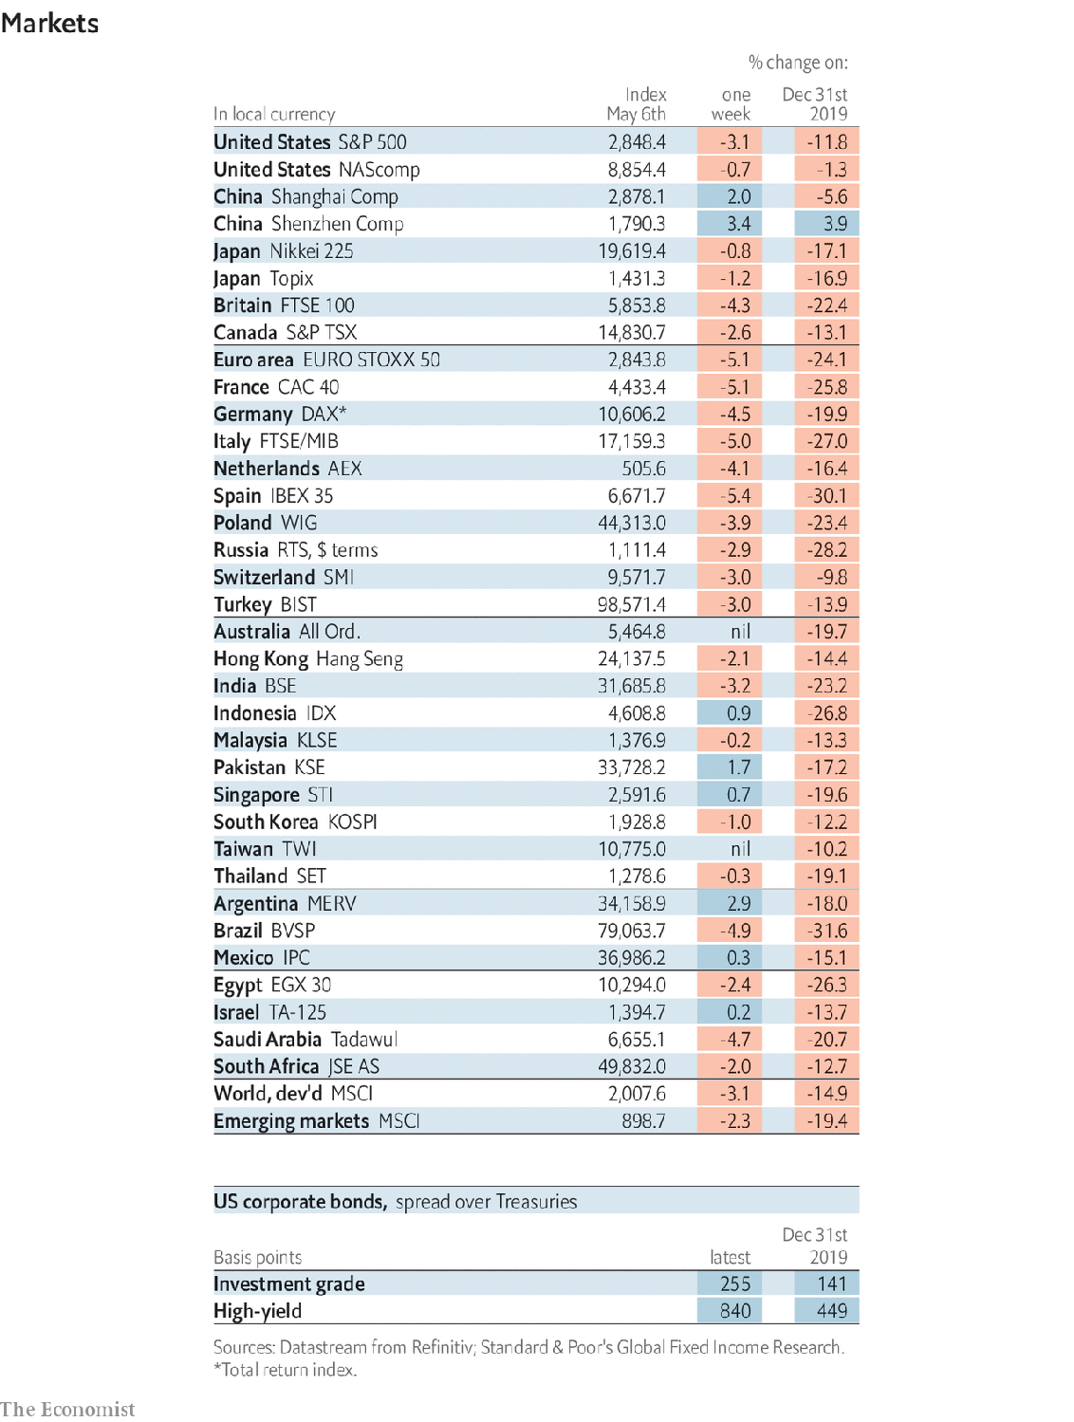

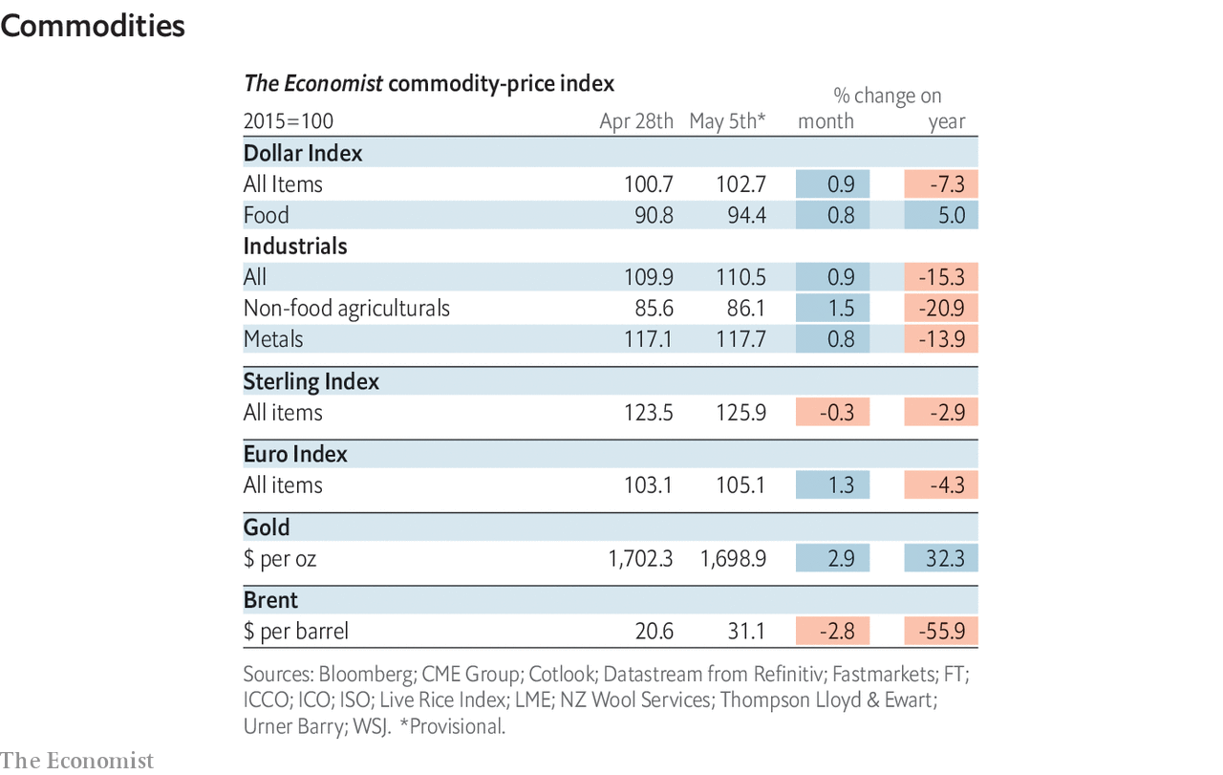

This article was downloaded by calibre from <https://www.economist.com/economic-and-financial-indicators/2020/05/09/economic-data-commodities-and-markets>

|  |  |  |  |
| --- | --- | --- | --- |
|  | Articles | Sections | Next |

|  |  |  |
| --- | --- | --- |
| Economic & ... | Sections | Obituary |

Graphic detail

Covid-19 and politics: Following the leader

.

|  |  |  |
| --- | --- | --- |
| Economic & ... | Sections | Obituary |

|  |  |  |  |
| --- | --- | --- | --- |
|  | Articles | Sections | Next |

#### Rallying round the flag

# Covid-19 has given most world leaders a temporary rise in popularity

Politicians who took the disease seriously have generally seen a boost in approval ratings

May 9th 2020 |

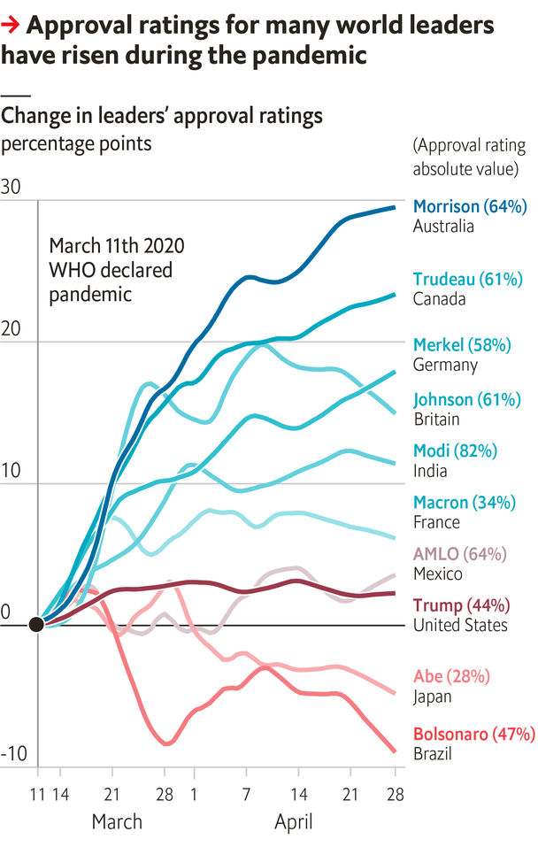

MANY A REGIME has been toppled by a plague, but so far covid-19 is having the opposite effect. Most leaders have seen their approval ratings rise, even as the disease has killed at least 250,000 people. Morning Consult, a pollster, has found that a group of ten politicians have enjoyed an average gain of nine percentage points since the World Health Organisation declared a pandemic on March 11th. The sentiment has been felt widely: in Australia and Canada, India and Germany.

Academics call this pattern the “rally-round-the-flag” effect. It has often benefited American presidents during international crises. Studies have found that surging patriotism and meeker opposition both contribute. Yet not all catastrophes are a boon. George W. Bush’s lacklustre response to Hurricane Katrina in 2005 punctured his ratings. Tony Blair’s fell after Islamists bombed London in 2005, as did François Hollande’s after the Paris attacks in 2015. Perhaps voters felt they had failed to police domestic terrorism well, whereas Americans saw the attacks in 2001 as an act of war.

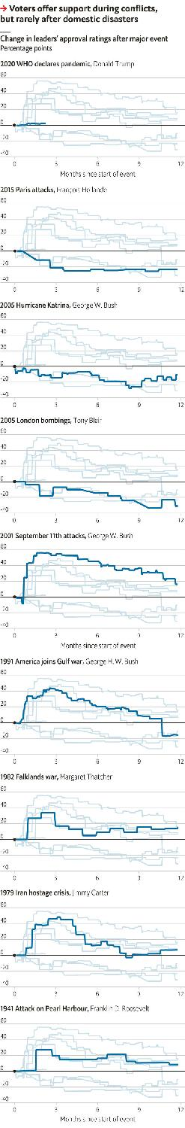

Today, voters have rallied round leaders who took covid-19 seriously. The largest bounces are in Australia, Canada and Germany, where death rates have been low among rich Western countries. Despite France’s bad outbreak, a solemn Emmanuel Macron has gained some credit. Britons got behind Boris Johnson at first. A recent dip may reflect fears that a tardy lockdown led to thousands of extra deaths.

The four leaders who have fared least well stand accused of ineptitude. Japan’s response to the outbreak compares well with most countries’, but not with its Asian neighbours. The presidents of America, Mexico and Brazil have all suggested that fears about covid-19 are overblown. Andrés Manuel López Obrador (AMLO) and Donald Trump have seen only modest bounces. Jair Bolsonaro has lost nine points.

The effects for ruling parties have been smaller. Angela Merkel’s CDU/CSU has risen by ten points, with others in single figures—suggesting that voters are rallying round leaders, not governments. History also shows that patriotic boosts are brief and recessions are costly in the polls.

Mr Trump is the only leader of the ten facing a vote soon. Despite 70,000 deaths, few Americans have changed their opinions of him yet, but he cannot afford to lose many supporters before November. ■

Sources: Gallup; Morning Consult; The Economist

This article was downloaded by calibre from <https://www.economist.com/graphic-detail/2020/05/09/covid-19-has-given-most-world-leaders-a-temporary-rise-in-popularity>

|  |  |  |  |
| --- | --- | --- | --- |
|  | Articles | Sections | Next |

|  |  |  |
| --- | --- | --- |
| Graphic detail | Sections |  |

Obituary

Willie Levi: A midwestern parable

.

|  |  |  |
| --- | --- | --- |
| Graphic detail | Sections |  |

|  |  |  |  |
| --- | --- | --- | --- |
|  | Articles | Sections | Next |

#### A midwestern parable

# Willie Levi died on April 23rd

The man whose case shone a sharp light on treatment of mentally disabled workers was 73

May 9th 2020 |

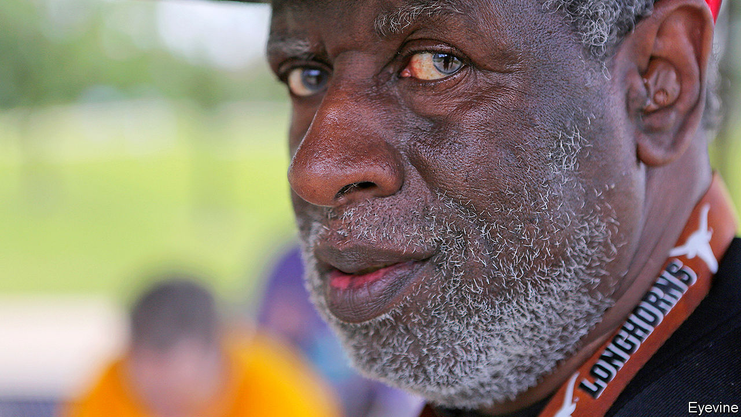

SINGING WAS something Willie Levi loved to do. When he was at the state school in Mexia, Texas, he belonged to a choir called the Sunshine Singers. They would tour round with a repertoire of hymns: “The Old Rugged Cross”, “What a Friend We Have in Jesus”. He sang more in church on Sundays: “Surely Goodness”, “Amazing Grace”. Along with the hymns he liked to shake his tambourine, to keep the beat. He could get music out of almost anything. If you gave him a comb, he could play it. And somewhere, in a pocket or a sock, he would keep a pair of spoons, the regular white plastic ones you might pick up in a coffee place. He could play those, too.

He also sang to the turkeys, or talked to them in their language, which was a cross between gobbling, whooping and singing. Turkeys were his work day in, day out, ever since he had been recruited by Henry’s Turkey Service in 1974 in Goldthwaite, Texas. It was the sort of job people like him, with a mental disability, seemed to end up with. He had tried portering and packing doughnuts, but nothing had quite worked out. In Goldthwaite his job was turkey insemination: catching the toms, all 40 thrashing pounds of them, milking their semen and running fast to impregnate the hens. When he and the others he worked with—mostly white, some black, all with a mental disability, all his brothers—were trucked 1,000 miles up to Iowa to handle turkeys there, things got harder. So hard, indeed, that their case marked a milestone for workers with mental disabilities across the United States.

The new job seemed okay at first. At the meatpacking plant in West Liberty he worked 12-hour days, but he was used to that. They would get there by 4.30am, lab coats and rubber boots on by 4.45, first bird out of the coop and flipped onto the shackle by 5. This was the section he worked in. The birds were usually angry, but once he’d hung them up he would give them a pat and croon a word or two. That went on for turkey after turkey, hundreds in a day. It was a tough, risky grapple, but he was skilled at it, and other brothers had it much worse: yanking out the guts or cutting out the heart and liver, which covered them in blood. At least he didn’t have to contort his fingers so constantly that his hands became hooks, as others’ did. It would have been tricky to play the spoons then.

The accommodation, too, seemed fine at the beginning. It was in an old schoolhouse on a rise outside the tiny town of Atalissa. The building was painted turquoise on the outside and red, blue and yellow inside. There was even a swing in the front yard. They had a gym and a pool table. The people in town, after a little while of wariness, became warm and kind to the “boys”, and returned his broad smile as he walked down the street. In the summer parade he rode on a float with other brothers, dressed as a clown in a pointy yellow hat. At socials he loved to dance with anyone.

Money, though, was a problem. He hardly had any. Granted, there was not a lot to spend it on in Atalissa, besides Mountain Dews and Honey Buns at the Mini Mart. But it was impossible to put aside any savings. His pay was meant to be $750 a month; he received $65. The rest was taken by Henry’s for bed, board, clothes, medical care (though they hardly had any) and rare outings. And it stayed the same for more than 30 years. The Fair Labour Standards Act of 1938 allowed workers with disabilities to be paid less if they were less productive, even if, like him, they were doing as good a job as they could. (“Hang ’em! Hang ’em!” the supervisor would shout.) Henry’s was exploiting them to the very limit of the law.

As the years passed, too, conditions got worse. He, like all the brothers, was getting older, not so fast or so alert at wrestling with big birds. Increasingly he was yelled at, called lazy, and told that he should get off his black butt and lift weights. Punishments came thick and fast: stand in the corner, go to your room, no TV, walk round the gym till supper time. The schoolhouse fell into disrepair and was overrun with mice and roaches, which fell from the ceiling as he ate. Mould grew on his clothes. He broke his kneecap, but had to work on. Two men ran away, and one of them was found frozen dead in a ditch; for a time the building was padlocked. Eleven men had already been retired and returned to Texas, but he was not sent, so he stayed and went on with the work. It was a long way back home, and possibly no one would know him any more.

When he walked into town he still smiled, as uncomplaining as ever. No one could tell the horrors from his face. But some had had suspicions for a while. In 1979 a reporter from the Des Moines Register had made inquiries. Nothing changed. The federal Labour Department noted in 1998 that Henry’s was underpaying its workers, but did not impose a fine. The Iowa Department of Human Services was alerted, but concluded that the men were Texans and therefore not theirs. It was not until 2009 that a state social worker went into the schoolhouse, found them all in the stinking rubbish, and rescued them. In 2011 a lawyer for the federal Equal Employment Opportunity Commission took up their case and won a jury verdict of $240m, the largest ever for the EEOC, for lost pay, abuse and discrimination. Legal caps reduced it to $1.6m, and by 2017 only about half had been extracted. But the point had been underlined. Workers with disabilities had to be properly paid and properly treated.

For Willie Levi, rescue was like a holiday. They went to the Super 8 Motel, slept in clean beds and had waffles for breakfast. From now on, he would be protected. He wouldn’t have to work with turkeys any more. He certainly wouldn’t eat them, ever again. And he could tell the true story to other people, especially to Dan Barry of the New York Times, who turned his notes from “the boys in the bunkhouse” into an unsparing documentary and a book. Mr Barry picked his portrait, in his red St Louis Cardinals cap, to be the first picture in it, as he had so often taken the lead in talking.

Back in Atalissa, the townsfolk felt lonely without them. The place seemed empty. In 2014 they tore the schoolhouse down, but memories were harder to lose. Many felt they should have noticed more, done something. The former pastor remarked that almost no one was in church now. He wondered what had happened to the guy with the tambourine, the one who always kept the beat.■

This article was downloaded by calibre from <https://www.economist.com/obituary/2020/05/09/willie-levi-died-on-april-23rd>

|  |  |  |  |
| --- | --- | --- | --- |
|  | Articles | Sections | Next |